Supplementary Table

Table 1:
Cox Proportional Hazards Model
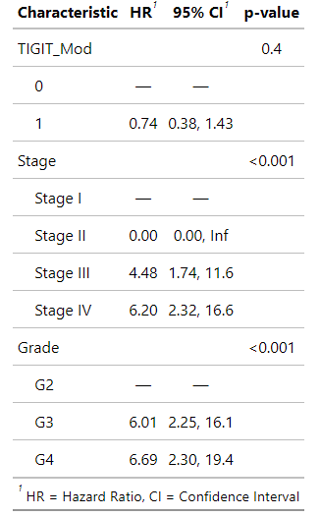
Table 1: Cox proportional hazards model analyzing multivariable effects on 5-year survival from TCGA PanCancer Atlas ccRCC transcriptomic data. Variables include TIGIT expression (TIGIT_Mod) based on Z-score (low=0 and high=1), tumor stage and grade. Grade 1 was excluded from analysis due to low sample size and subsequent overfitting of the regression model.

