Table 1: Clinical characteristics of the patients
 | Overall population=82 | Chemotherapy  n= 33 | Immunotherapy +/- CT  n=49
Age (years) (range) | 66 (37-91) | 67 (42-91) | 65 (37-84)
Sex
Man | 57 (70) | 24 (73) | 33 (67)
Woman | 25 (30) | 9 (27) | 16 (33)
Smoking status  Active or former smoker | 75 (91) | 30 (91) | 45 (92)
Never-smoker | 7 (9) | 3 (9) | 4 (8)
Histology
adenocarcinoma | 56 (68) | 24 (73) | 32 (66)
squamous cell carcinoma | 14 (17) | 6 (18) | 8 (16)
other | 12 (15) | 3 (9) | 9 (18)
PS
0-1 | 65 (79) | 26 (79) | 39 (80)
≥2 | 17 (21) | 7 (21) | 10 (20)
Stade / TNM
IIIB or IIIC | 5 (6) | 2 (6) | 3 (6)
IV | 77 (94) | 31 (94) | 46 (94)
PD-L1
< 50% | 26(32) | 13(39) | 13(27)
≥ 50% | 41(50) | 5 (15) | 36(73)
Non available (NA) | 15(18) | 15 (45) | 0 (0)
Number of metastatic sites
1 | 34 (41) | - (48) | 18 (37)
2 or more | 48(59) | 17 (52) | 31(53)
All variables are expressed as n (%), unless otherwise specified.

Supplemental material
Table S1 Plasma HGF expression level according to patient’s demographics characteristics
Parameters |  | Plasma HGF expression level (pg/mL) | T-test (p-value) | Khi2 (Relative Risk RR, 95%IC; p-value)
Patients | n= 49
Age | ≤ 65 years | 1440 ± 343.6 N=30 | 0.27 | 0.8; (0.3825 - 1.673); p = 0.77
Age | > 65 years | 1145 ± 190.9 N=18 | 0.27 | 0.8; (0.3825 - 1.673); p = 0.77
Sex | woman | 1632 ± 502.9 N=16 | 0.35 | 1 ; (0.449 - 2.226) ; p = 1
Sex | man | 1178 ± 228.9 N=32 | 0.35 | 1 ; (0.449 - 2.226) ; p = 1
Smoking status | No-smoker | 936.4 ± 312.9 N=4 | 0.60 | 0.3 ; (0.0372 - 2.984) ; p = 0.61
Smoking status | Active or weaned smoker | 1365 ± 244.4 N=44 | 0.60 | 0.3 ; (0.0372 - 2.984) ; p = 0.61
Number of metastatic sites | < 2 | 1250 ± 307.6 N=28 | 0.47 | 1.5 ; (0.7543 - 2.815) ; p = 0.12
Number of metastatic sites | ≥ 2 | 1600 ± 353.7 N=18 | 0.47 | 1.5 ; (0.7543 - 2.815) ; p = 0.12
Performance status | < 2 | 1041 ± 251.6 N=24 | 0.06 | 1.9 ; (0.7113 - 5.315) ; p = 0.13
Performance status | ≥ 2 | 1983 ± 665.6 N=9 | 0.06 | 1.9 ; (0.7113 - 5.315) ; p = 0.13
Histology | Adenocarcinoma | 970.4 ± 221.6 N=32 | 0.01 | 2.5 ; (1.026 - 6.090) ; p = 0.007
Histology | Other | 2047 ± 473.4 N=16 | 0.01 | 2.5 ; (1.026 - 6.090) ; p = 0.007
PD-L1 | < 50% | 1057 ± 218.5 N=12 | 0.15 | 0.9 ; (0.3710 -2.357) ; p = 1
PD-L1 | ≥ 50% | 1634 ± 323.2 N=31 | 0.15 | 0.9 ; (0.3710 -2.357) ; p = 1
PD-L1 | Low expression | 1165 ± 191.1 N=5 | 0.15 | 0.9 ; (0.3710 -2.357) ; p = 1
CD8 | High expression | ± 341.2 N=5 | p = 0.44 | 0.6; (0.1040 - 3.272 ; p = 1

Table S2: HGF levels and treatment group

HGF levels (pg/mL) and drug response
Treatment step | Drug response | ICIs (alone + Combo) |  | ICIs alone |  | Combo |  | Chemotherapy
 |  | (mean ± SEM) | P-value | (mean ± SEM) | P-value | HGF (mean ± SEM) | P-value | HGF (mean ± SEM) | P-value
Baseline | Responders | 1128 ± 232.8 | 0.148 | 790.8 ± 188.0 | 0.029 | 1465 ± 415.2 | 0.136 | 1766 ± 329.7 | 0.3576
Baseline | Non- responders | 1611 ± 432.7 | 0.148 | 2061 ± 631.0 | 0.029 | 776.4 ± 189.9 N | 0.136 | 1907 ± 223.6 | 0.3576
Baseline | No-progression | 1076 ± 202.6 | 0,048 | 811.1 ± 167.7 | 0.009 | 1357 ± 372.3 | 0.234 | 1909 ± 223.0 | 0,3047
Baseline | Progression | 1888 ± 555.0 | 0,048 | 2408 ± 786.9 | 0.009 | 848.1 ± 207.3 | 0.234 | 1690 ± 341.5 | 0,3047
First evaluation | Responders | 790.9 ± 158.0 | 0,044 | 427.2 ± 119.5 | 0.175 | 1094 ± 243.5 | 0.033 | 1919 ± 429.7 | 0.2312
First evaluation | Non- responders | 1620 ± 555.3 | 0,044 | 620.4 ± 168.0 | 0.175 | 2692 ± 1066 | 0.033 | 1534 ± 261.2 | 0.2312
First evaluation | No progression | 1044 ± 262.7 | 0,424 | 512.4 ± 128.7 | 0.496 | 1537 ± 461.7 | 0.349 | 1807 ± 301.5 | 0,2752
First evaluation | Progression | 1148 ± 497.2 | 0,424 | 514.7 ± 149.6 | 0.496 | 1939 ± 1034 | 0.349 | 1394 ± 298.8 | 0,2752

Table S3: Tumor response and primary resistance in univariate analysis
Immunotherapy alone (ICIs alone)
Parameters |  | Response Rate (%) | Odds ratio (OR) ;  95% CI; p-value | Progression rate (%) | Odds ratio (OR) ;  95% CI; p-value
Performans status (PS) | 0-1 (9) | 67 | 1.333(0.5292 - 3.360); p = 0.4167 | 22 | 0.6667 (0.1260 - 3.528); p = 0.3168
Performans status (PS) | >1 (6) | 50 | 1.333(0.5292 - 3.360); p = 0.4167 | 33 | 0.6667 (0.1260 - 3.528); p = 0.3168
Histology  (Adenocarcinoma. ADK) | ADK (16) | 81 | 17.33 (1.15 -14.35); p = 0.001 | 19 | 0.10 (0.02 - 0.63); p= 0.014
Histology  (Adenocarcinoma. ADK) | Others (10) | 20 | 17.33 (1.15 -14.35); p = 0.001 | 70 | 0.10 (0.02 - 0.63); p= 0.014
Metastatic sites | <2(10) | 50 | 0.89 (0.19 – 4.25); p =0.44 | 20 | 0.28 (0.05 - 1.73); p = 0.08
Metastatic sites | >2 (27) | 53) | 0.89 (0.19 – 4.25); p =0.44 | 47 | 0.28 (0.05 - 1.73); p = 0.08
mutation (Yes =1: no =0) | Yes (10) | 70 | 3.33 (0.63 – 15.17); p = 0.08 | 20 | 0.28 (0.05 - 1.73); p = 0.08
mutation (Yes =1: no =0) | No (17) | 41 | 3.33 (0.63 – 15.17); p = 0.08 | 47 | 0.28 (0.05 - 1.73); p = 0.08
KRAS mutation | Yes (8) | 63 | 1.85 (0.34 – 10.05); p = 0.24 | 25 | 0.46 (0.07 - 2.90); p = 0.2003
KRAS mutation | No (19) | 47 | 1.85 (0.34 – 10.05); p = 0.24 | 42 | 0.46 (0.07 - 2.90); p = 0.2003
HGF Baseline (pg/mL) | Low (6) | 83 | 9.00 (0.9 – 89.66); p = 0,02 | 0 | 0.07(0.003 – 1.32); p = 0,0092
HGF Baseline (pg/mL) | High (21) | 43 | 9.00 (0.9 – 89.66); p = 0,02 | 50 | 0.07(0.003 – 1.32); p = 0,0092
HGF First Evaluation (pg/mL) | Low (6) | 50 | 55.00 (2.83 - 1069); p < 0.001 | 33 | 0.5 (0.04 – 6.02); p = 0.29
HGF First Evaluation (pg/mL) | High (12) | 58 | 55.00 (2.83 - 1069); p < 0.001 | 25 | 0.5 (0.04 – 6.02); p = 0.29

Table S4: Patient’s survival according to Kaplan-Meir analysis
Immunotherapy: ICIs alone or ICIs + CT
Parameters |  | PFS (days) | HR; 95% CI; p-value | OS (days) | HR; 95% CI; p-value
HGF Baseline (pg/mL) | Low | 623 | 3.05 (1.33 – 7.01); p = 0.01 | 904 | 1.73 (0.64 – 4.67); p = 0.14
HGF Baseline (pg/mL) | High | 216 | 3.05 (1.33 – 7.01); p = 0.01 | 462 | 1.73 (0.64 – 4.67); p = 0.14
HGF First Evaluation (pg/mL) | Low | 841 | 2.529 (1.13 – 5.64); p = 0,03 | 1309 | 2.36 (0.79 – 7.02); p = 0.08
HGF First Evaluation (pg/mL) | High | 215 | 2.529 (1.13 – 5.64); p = 0,03 | 954 | 2.36 (0.79 – 7.02); p = 0.08
ICIs alone
HGF Baseline (pg/mL) | Low | 791 | 2.63 (1.12 - 6.14); p = 0.03 | undefined | 3.19 (1.15 - 8.84); p = 0.03
HGF Baseline (pg/mL) | High | 98.5 | 2.63 (1.12 - 6.14); p = 0.03 | 494 | 3.19 (1.15 - 8.84); p = 0.03
HGF First Evaluation (pg/mL) | Low | 816 | 2.84 (1.19 - 6.81); p = 0,02 | Undefined | 3.76 (1.31 - 10.79); p = 0,01
HGF First Evaluation (pg/mL) | High | 140 | 2.84 (1.19 - 6.81); p = 0,02 | 494 | 3.76 (1.31 - 10.79); p = 0,01
COMBO : ICIs + CT
HGF Baseline (pg/mL) | Low | Undefined | 1.83 (0.55 - 6.16); p = 0.56 | Undefined | 0.98 (0.20 - 4.94); p = 0.88
HGF Baseline (pg/mL) | High | 219 | 1.83 (0.55 - 6.16); p = 0.56 | Undefined | 0.98 (0.20 - 4.94); p = 0.88
HGF First Evaluation (pg/mL) | Low | Undefined | 1.87 (0.57 - 6.23); p = 0.31 | Undefined | 1.94 (0.39 - 9.76); p = 0.42
HGF First Evaluation (pg/mL) | High | 98.5 | 1.87 (0.57 - 6.23); p = 0.31 | 494 | 1.94 (0.39 - 9.76); p = 0.42
Chemotherapy (CT)
HGF Baseline (pg/mL) | Low | 92.5 | 0,66 (0.27 - 1.65); p = 0.38 | 431.5 | 0.84 (0.33 - 2.11); p = 0.70
 | High | 109 | 0,66 (0.27 - 1.65); p = 0.38 | 286 | 0.84 (0.33 - 2.11); p = 0.70
HGF First Evaluation (pg/mL) | Low | 145 | 0.90 (0.33 – 2.41); p = 0.018 | 275.5 | 0.44 (0.13 – 1.410); p = 0,17
HGF First Evaluation (pg/mL) | High | 98 | 0.90 (0.33 – 2.41); p = 0.018 | 286 | 0.44 (0.13 – 1.410); p = 0,17

Table S5: Patients’ survival in univariate analysis

Immunotherapy alone (ICIs alone)

 | PFS (days); HR; 95% CI; p-value |  |  | OS (days); HR; 95% CI; p-value
Performans status (PS) | 0-1 | 791 | 0.23 (0.06 - 0.84); p = 0.03 | 0-1 | Undefined | 0.15 (0.03 - 0.77); p = 0.03
Performans status (PS) | >1 | 170.5 | 0.23 (0.06 - 0.84); p = 0.03 | >1 | 407 | 0.15 (0.03 - 0.77); p = 0.03
Histology (Adenocarcinoma, ADK) | ADK | 399.5 | 3.30 (1.27 - 8.58); p = 0.01 | ADK | 972 | 3.93 (1.38 - 11.19); p = 0.01
Histology (Adenocarcinoma, ADK) | Others | 45 | 3.30 (1.27 - 8.58); p = 0.01 | Others | 300 | 3.93 (1.38 - 11.19); p = 0.01
Metastatic sites | <2 | 343 | 1.052 (0.4471 - 2.476); p = 0.91 | <2 | 972 | 0.70 (0.25 - 1.88); p = 0.47
Metastatic sites | >2 | 57 | 1.052 (0.4471 - 2.476); p = 0.91 | >2 | 725 | 0.70 (0.25 - 1.88); p = 0.47
Mutation (Yes =1: no =0) | Yes | 220 | 1.18 (0.53 - 2.66); p = 0.69 | Yes | 954 | 1.67 (0.61 - 4.60); p = 0.32
Mutation (Yes =1: no =0) | No | 296 | 1.18 (0.53 - 2.66); p = 0.69 | No | 725 | 1.67 (0.61 - 4.60); p = 0.32
KRAS mutation | Yes | 160.5 | 1.01 (0.42 - 2.43); p = 0.98 | Yes | 954 | 1.23 (0.42 - 3.59); p = 0.70
KRAS mutation | No | 296 | 1.01 (0.42 - 2.43); p = 0.98 | No | 727 | 1.23 (0.42 - 3.59); p = 0.70
HGF Baseline (pg/mL) | Low | 791 | 2.63 (1.12 - 6.14); p = 0.03 | Low | undefined | 3.19 (1.15 - 8.84); p = 0.03
HGF Baseline (pg/mL) | High | 98.5 | 2.63 (1.12 - 6.14); p = 0.03 | High | 494 | 3.19 (1.15 - 8.84); p = 0.03
HGF First Evaluation (pg/mL) | Low | 816 | 2.844 (1.19 - 6.81); p = 0.02 | Low | Undefined | 3.76 (1.31 - 10.79); p = 0.01
HGF First Evaluation (pg/mL) | High | 140 | 2.844 (1.19 - 6.81); p = 0.02 | High | 494 | 3.76 (1.31 - 10.79); p = 0.01

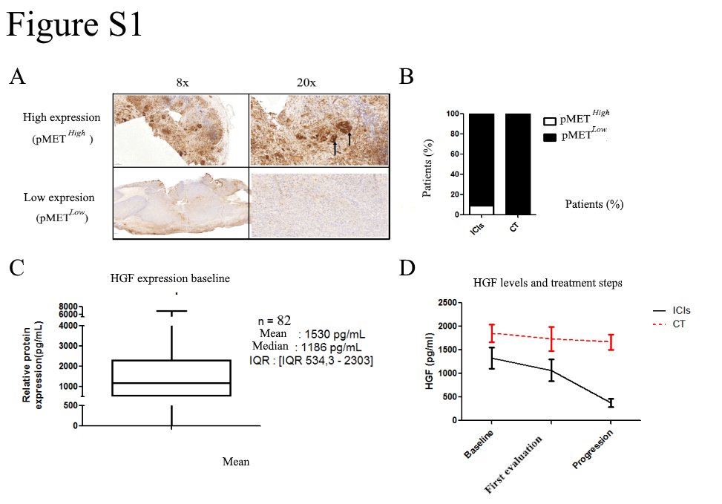

Figure S1: Expression of HGF/MET in NSCLC patients. A) Representative expression of pMET as assessed through IHC in NSCLC patients treated with ICIs (n = 21) or CT (n = 8) Based on staining intensity and the percentage of staining cells, patients were classified as either high or low expression; B) proportion of patients with high pMET expression. C) Median expression of HGF in global population. D) Plasma HGF expression level evolution during treatment

