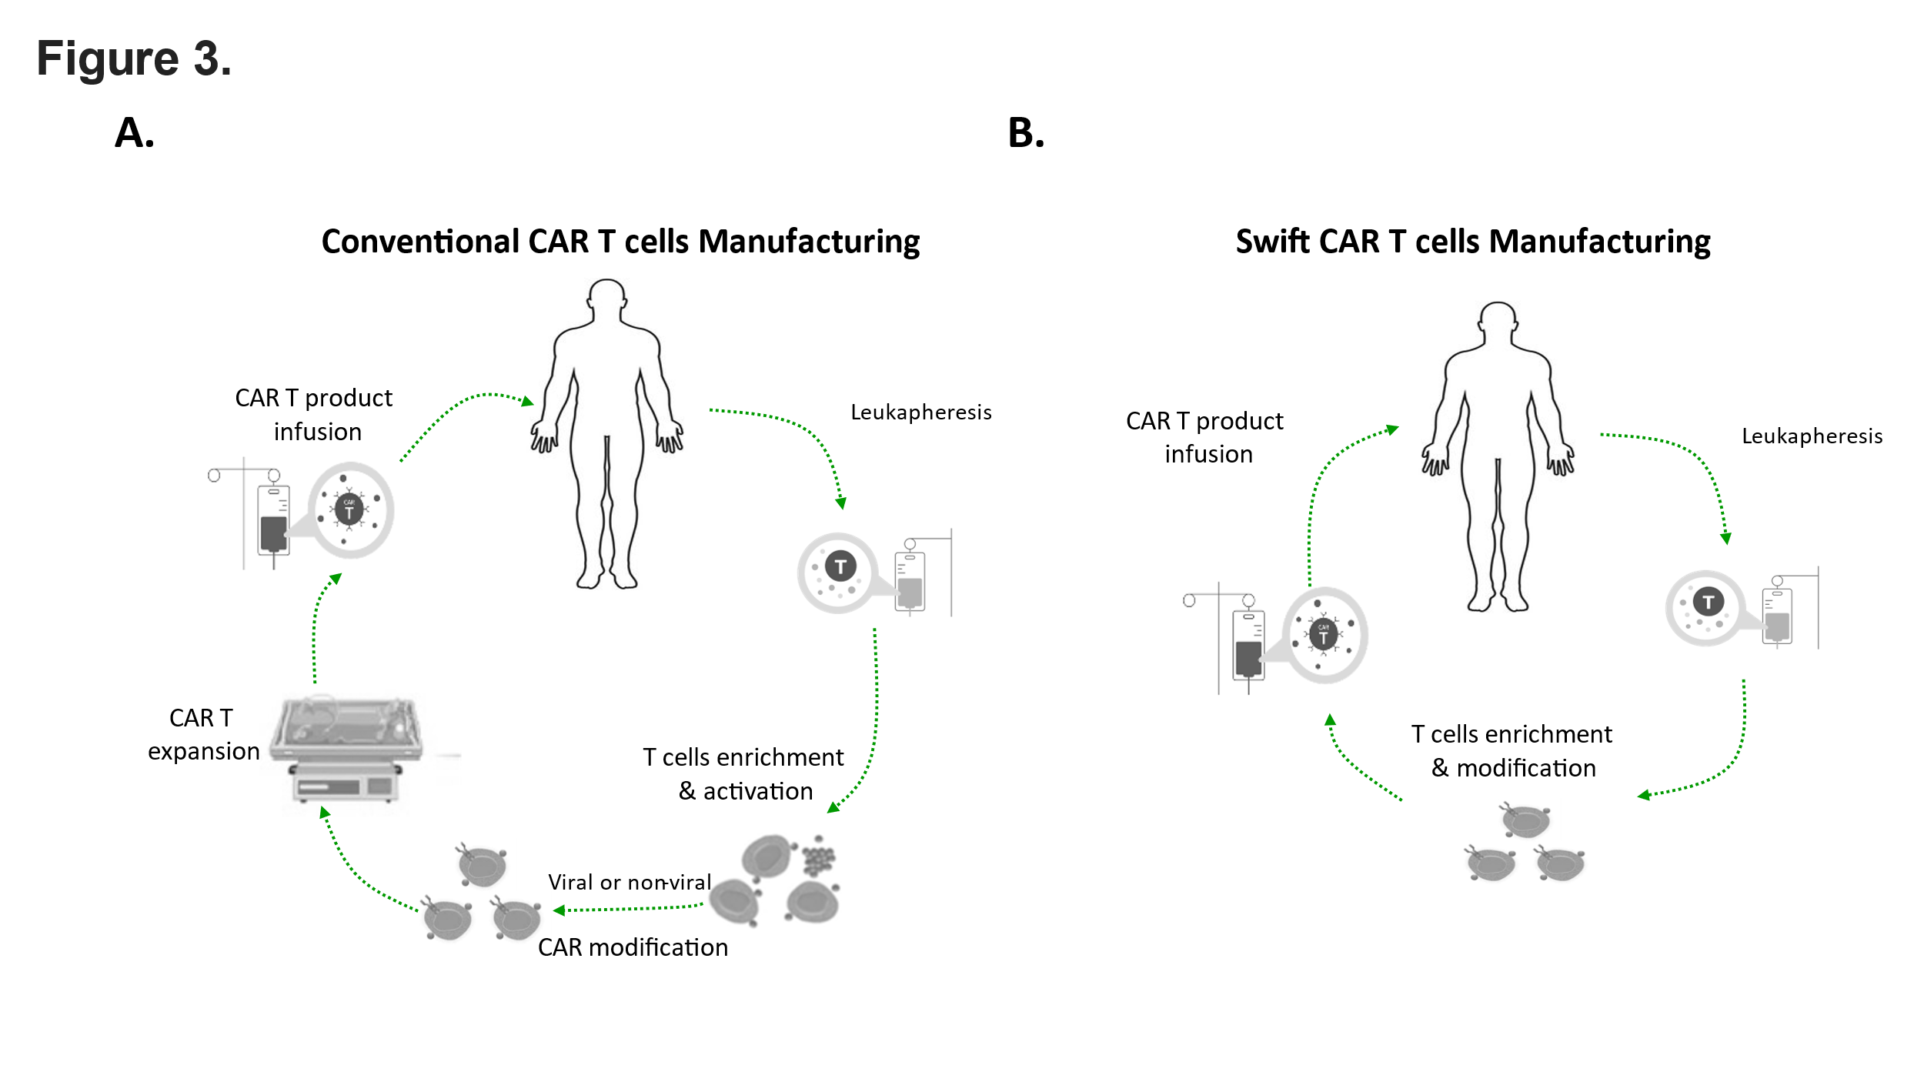
Figure 3. The CAR-T cell manufacturing process. (A) The conventional manufacturing process of CAR-T cells typically involves the following steps: (1) leukapheresis, where a patient's blood is processed to isolate white blood cells; (2) enrichment of T cells, followed by genetic modification with the CAR; (3) expansion of the modified CAR T cells in vitro; and finally, (4) infusion of the expanded CAR T cells back into the patients. (B) A swift CAR-T cell manufacturing process is implemented, bypassing T-cell activation and in vitro expansion. This approach allows for the provision of CAR T cells, which can engage tumor targets and undergo expansion directly within patients.

