Therapeutic potential of anti-ErbB3 chimeric antigen receptor natural killer cells against breast cancer

Supplementary Materials and Methods

Flow cytometry
For phenotyping of CAR-NK cells and expanded NK cells, anti-CD16-PE (BD Biosciences, USA), anti-CD158b-PE (BD Biosciences), anti-CD57-PE (BD Biosciences), anti-CD69-PE (BD Biosciences), anti-LAG3-PE (BD Biosciences), anti-NKG2A-PE (R&D systems, USA), anti-NKG2C-PE (R&D systems), anti-NKG2D-PE (BD Biosciences) anti-NKp30-PE (BD Biosciences), anti-NKp44-PE (BD Biosciences), anti-NKp46-PE (BD Biosciences), anti-NKp80-PE, anti-TIGIT-PE (BioLegend) antibodies were used. All antibody staining was performed on 1 × 10⁵ cells in 5 mL FACS tubes following the manufacturers' instructions. Appropriate isotype controls were used for each antibody. After antibody staining, samples were acquired on an Attune NxT flow cytometer (ThermoFisher Scientific, USA) and data were analyzed using FlowJo V10.9.0 software (FlowJo, LLC, USA) with a focus on gating live, single cells based on marker expression.
Tumor dissociation
Tumor tissues were dissociated according to the manual using a Gentle MACS dissociator (Miltenyi Biotec, Germany) and a tumor dissociation kit (Miltenyi Biotec). Dissociated cells were prepared for flow cytometry, and antibodies were used to stain for CD45 (Biolegend) and CD56 (BD Biosciences). After antibody staining, samples were collected on an Attune NxT flow cytometer (ThermoFisher Scientific, USA) and data were analyzed using FlowJo V10.9.0 software (FlowJo, LLC, USA).
Immunofluorescence Staining
Slides were deparaffinized and subjected to antigen retrieval by heating in 10 mM sodium citrate buffer (pH 6.0) using a microwave at 95-100°C for 20 minutes, followed by cooling at room temperature for 30 minutes. Slides were then washed with PBS. Blocking was performed with 10% rabbit serum at room temperature, after which slides were stained with CD45-FITC (BioLegend) for 2 hours at room temperature. Slides were washed with PBS, mounted using VECTASHIELD® Antifade Mounting Medium with DAPI (Vector Laboratories, USA), and analyzed using a fluorescence microscope. Quantification of stained images was performed using ImageJ (National Institutes of Health, USA) software.

Supplementary Figures

Fig. S1
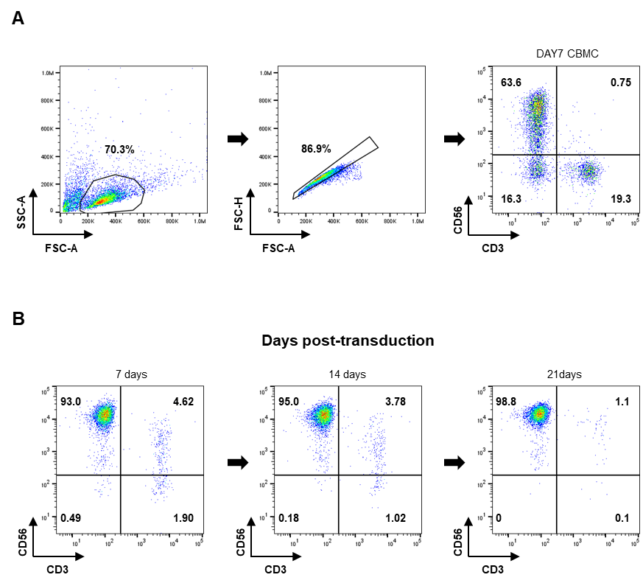

Supplementary Fig. S1. Population of cord blood-derived NK cells after CAR transduction
FACS analysis was performed at 7 days intervals to determine the percentage of NK cells after transduction. (A) Proportion of cord blood mononuclear cells (CBMCs) cultured for 7 days. (B) Proportion of NK cells identified at 7 days intervals after CAR transduction.

Fig. S2

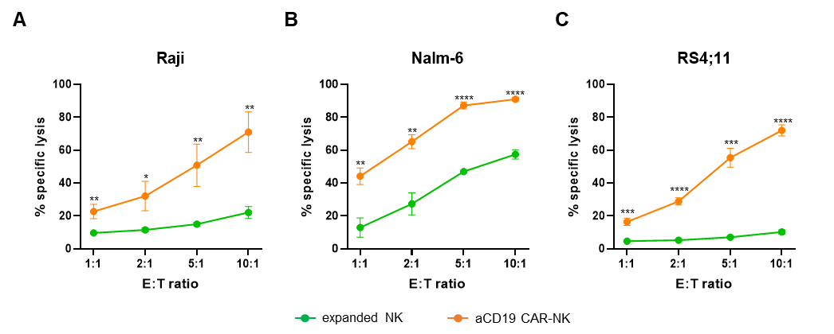
Supplementary Fig. S2. Cytolytic function of aCD19 CAR-NK against B-ALL (CD19⁺) cell lines
To confirm the cytotoxicity of aCD19 CAR-NK cells, various CD19⁺ cell lines (Raji, Nalm-6, RS4;11) were targeted. As a control, expanded NK cultured for 14 days was used. Cells were co-cultured for 4 hours. Quantitative assessment of killed cells was performed in the CFSE⁺FVD⁺ region. (A) Cytotoxicity assay for Raji (B) Cytotoxicity assay for Nalm-6 (C) Cytotoxicity assay for RS4;11. Data are presented as mean ± SD of three independent experiments (A, B, C). * P<0.05; ** P<0.01; *** P<0.001 and **** P<0.0001 based on Student’s t-test.

Fig. S3

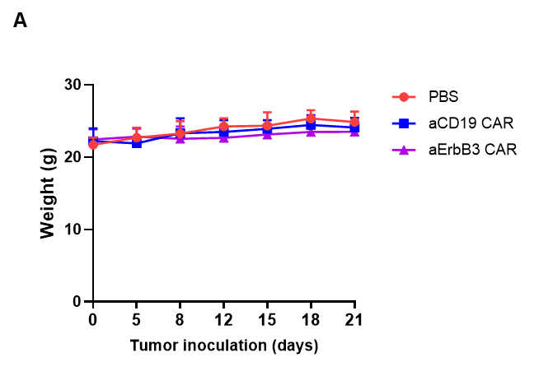
Supplementary Fig. S3. Safety evaluation of CAR-NK cell therapy in mice model
After tumor inoculation, CAR-NK cells were transferred 5 days later, and body weight changes were measured every 3-4 days. (A) Body weight changes of mice receiving different treatment.

Fig. S4
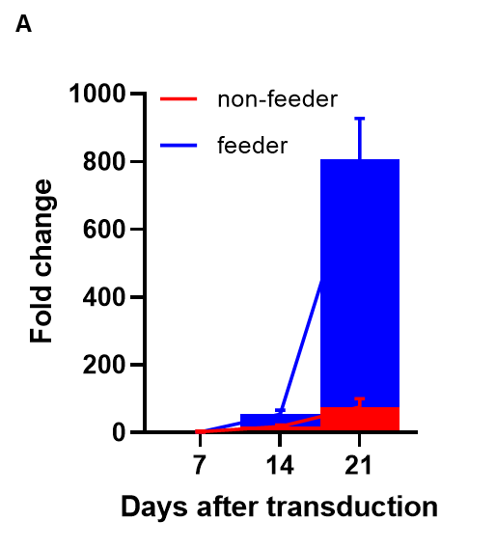
Supplementary Fig. S4. Fold expansion of CAR-NK cells with and without feeder cells
(A) CAR-NK cells were transduced and cultured either with K562-based feeder cells (blue) or without feeder cells (red). By day 21 post-transduction, CAR-NK cells expanded 806.6 ± 120.67-fold with feeder cells, compared to 75.6 ± 24.44-fold without feeder cells. Data are represented as mean ± SD of three independent experiments.

Table S1
Antigen | Clone | Fluorochrome | Source | Catalog number
CD3 | UCHT1 | FITC | BD Biosciences | 561807
CD16 | 3G8 | PE | BD Biosciences | 556619
CD45 | 2D1 | FITC | Biolegend | 368507
CD56 | NCAM 16 | PE-Cy-7 | BD Biosciences | 335791
CD56 | B159 | Per-CP 5 | BD Biosciences | 555517
CD57 | NK-1 | PE | BD Biosciences | 560844
CD69 | FN50 | PE | BD Biosciences | 555531
CD158b | CH-L | PE | BD Biosciences | 559785
ErbB3 | 1B4C3 | PE | Biolegend | 324706
Biotin | REA746 | PE | Miltenyi Biotec | 130-111-068
FMC63 | Y45 | PE-Cy7 | ACROBiosystems | FM3-Y45
IgG1 | RMG1-1 | PE-Cy7 | Biolegend | 406613
LAG3 | T47-530 | PE | BD Biosciences | 565616
NKG2A | # 131411 | PE | R&D Systems | FAB1059P
NKG2C | # 134591 | PE | R&D Systems | FAB138P
NKG2D | 1D11 | PE | BD Biosciences | 557940
NKp30 | p30-15 | PE | BD Biosciences | 558407
NKp44 | p44-8 | PE | BD Biosciences | 558563
NKp46 | 9E2/NKp46 | PE | BD Biosciences | 557991
NKp80 | 5D12 | PE | BD Biosciences | 566329
TIGIT | A15153G | PE | Biolegend | 372704

Supplemental Table S1. Antibodies used in flow cytometry studies. FITC, fluorescein isothiocyanate; PE, phycoerythrin; PE-Cy7, phycoerythrin-cyanin7

