Table S1 Tumor response in patients with driver-gene negative NSCLC CR, complete response; PR, partial response; SD, stable disease; PD progression disease; ORR, objective response rate; DCR, disease control rate; IBP, immunotherapy beyond progression; NIBP, non-immunotherapy beyond progression
Best response in second-line treatment, n (%) | IBP  (n=63) | NIBP  (n=19) | P value
CR | 0 (0) | 0 (0)
PR | 22 (34.9) | 5 (26.3)
SD | 23 (36.5) | 1 (5.3)
PD | 18 (28.6) | 13 (68.4)
ORR | 22 (34.9) | 5 (26.3) | 0.48
DCR | 45 (71.4) | 6 (31.6) | 0.002**
**P<0.01

Table S2 Grade 1-2 and 3-4 treatment-related adverse events in patients with advanced non-small cell lung cancer (NSCLC) and small cell lung cancer (SCLC) IBP, immunotherapy beyond progression; NIBP, non-immunotherapy beyond progression
Adverse Events, n (%) | Patients with NSCLC |  | P value | Patients with SCLC |  | P value
Adverse Events, n (%) | IBP  (n=78) | NIBP  (n=33) | P value | IBP  (n=31) | NIBP  (n=8) | P value
Grade 1-2 | 56 (71.8) | 25 (75.8) | 0.67 | 24 (77.4) | 4 (50.0) | 0.12
Grade 3-4  Grade 5 | 7 (9.0)  0 (0) | 6 (18.2)  0 (0) | 0.17 | 3 (9.7)  0 (0) | 3 (37.5)  0 (0) | 0.05
Total | 63 (80.8) | 31 (93.9) | 0.08 | 27 (87.1) | 7 (87.5) | 0.98

Table S3 Treatment-related adverse events of patients with NSCLC and SCLC ALT, alanine aminotransferase; AST, aspartate aminotransferase
 | Adverse Events, n | Patients with NSCLC |  | Total | Patients with SCLC |  | Total
 | Adverse Events, n | IBP  (n=78) | NIBP  (n=33) | Total | IBP  (n=31) | NIBP  (n=8) | Total
 | Anemia | 28 | 24 | 111 | 17 | 5 | 22
 | Hypothyrodism  ALT/AST evelated | 13  13 | 4  2 | 17 | 3  9 | 2  3 | 5
 | Hypothyrodism  ALT/AST evelated | 13  13 | 4  2 | 15 | 3  9 | 2  3 | 12
hypolymphocyte |  | 11 | 7 | 18 | 11 | 1 | 12
 | Pneuonia | 9 | 6 | 15 | 1 | 3 | 4
 | Thrombocytopenia | 8 | 1 | 9 | 4 | 4 | 8
 | Hyperuricemia | 7 | 2 | 9 | 3 | 1 | 4
 | Creatinine increased | 4 | 4 | 8 | 0 | 1 | 1
 | Leukopenia | 4 | 1 | 5 | 3 | 3 | 6
 | Hypokalemia | 3 | 0 | 3 | 2 | 0 | 2
 | Proteinria | 3 | 1 | 4 | 4 | 0 | 4
 | Hypocalcemia | 0 | 0 | 0 | 2 | 1 | 3
 | Bilirubin increased | 1 | 1 | 2 | 0 | 1 | 1
 | Arrhythmia | 1 | 1 | 2 | 0 | 0 | 0
 | Rash | 1 | 1 | 2 | 0 | 0 | 0
 | Hypoadrenocorticism | 1 | 1 | 2 | 0 | 0 | 0
 | Coagulopathy | 1 | 3 | 4 | 0 | 0 | 0
 | Diarrhea | 0 | 1 | 1 | 0 | 0 | 0

Table S4 Literature search strategy from four databases
Search: ((Carcinoma, Non-Small-Cell Lung[MeSH Terms]) OR ((((((((((Carcinoma, Non Small Cell Lung[Title/Abstract]) OR (Carcinomas, Non-Small-Cell Lung[Title/Abstract])) OR (Lung Carcinoma, Non-Small-Cell[Title/Abstract])) OR (Lung Carcinomas, Non-Small-Cell[Title/Abstract])) OR (Non-Small-Cell Lung Carcinomas[Title/Abstract])) OR (Non-Small-Cell Lung Carcinoma[Title/Abstract])) OR (Non Small Cell Lung Carcinoma[Title/Abstract])) OR (Carcinoma, Non-Small Cell Lung[Title/Abstract])) OR (Non-Small Cell Lung Carcinoma[Title/Abstract])) OR (Non-Small Cell Lung Cancer[Title/Abstract]) OR (Nonsmall Cell Lung Cancer[Title/Abstract])) OR (Carcinoma, Small-Cell Lung[MeSH Terms] OR ((((((((((Carcinoma, Small Cell Lung[Title/Abstract]) OR (Carcinomas, Small-Cell Lung[Title/Abstract])) OR (Lung Carcinoma, Small-Cell[Title/Abstract])) OR (Lung Carcinomas, Small-Cell[Title/Abstract])) OR (Small-Cell Lung Carcinomas[Title/Abstract])) OR (Small-Cell Lung Carcinoma[Title/Abstract])) OR (Small Cell Lung Carcinoma[Title/Abstract])) OR (Carcinoma, Small Cell Lung[Title/Abstract])) OR (Small Cell Lung Carcinoma[Title/Abstract])) OR (Small Cell Lung Cancer[Title/Abstract])) OR (Nonsmall Cell Lung Cancer[Title/Abstract])) OR (Adenocarcinoma of Lung[MeSH Terms]) OR (((Lung Adenocarcinomas[Title/Abstract]) OR (Lung Adenocarcinoma[Title/Abstract])) OR (Adenocarcinoma, Lung[Title/Abstract])) OR (Adenocarcinomas, Lung[Title/Abstract])) OR ((Carcinoma, Squamous Cell[MeSH Terms]) AND (Lung[MeSH Terms]) OR (((((((((((((((((Lung[Title/Abstract]) OR (Lungs[Title/Abstract])) AND (Carcinoma, Squamous Cell[Title/Abstract])) OR (Carcinomas, Squamous Cell[Title/Abstract])) OR (Squamous Cell Carcinomas[Title/Abstract])) OR (Squamous Cell Carcinoma[Title/Abstract])) OR (Carcinoma, Squamous[Title/Abstract])) OR (Carcinomas, Squamous[Title/Abstract])) OR (Squamous Carcinoma[Title/Abstract])) OR (Squamous Carcinomas[Title/Abstract])) OR (Carcinoma, Epidermoid[Title/Abstract])) OR (Carcinomas, Epidermoid[Title/Abstract])) OR (Epidermoid Carcinoma[Title/Abstract])) OR (Epidermoid Carcinomas[Title/Abstract])) OR (Carcinoma, Planocellular[Title/Abstract])) OR (Carcinomas, Planocellular[Title/Abstract])) OR (Planocellular Carcinoma[Title/Abstract])) OR (Planocellular Carcinomas[Title/Abstract])) OR ((Carcinoma, Large Cell[MeSH Terms]) AND (Lung[MeSH Terms]) OR (((((((Lung[Title/Abstract]) OR (Lungs[Title/Abstract])) AND (Carcinoma, Large Cell[Title/Abstract])) OR (Carcinomas, Large Cell[Title/Abstract])) OR (Cell Carcinoma, Large[Title/Abstract])) OR (Cell Carcinomas, Large[Title/Abstract])) OR (Large Cell Carcinoma[Title/Abstract])) OR (Large Cell Carcinomas[Title/Abstract])) AND ((Immunotherapy[MeSH Terms]) OR (Immune Checkpoint Inhibitors[MeSH Terms]) OR #15: (((((((((((((((((((((((((((((((((((((((((((((Immunotherapy[Title/Abstract]) OR (Immunotherapies[Title/Abstract])) OR (Immune Checkpoint Inhibitors[Title/Abstract])) OR (Checkpoint Inhibitors, Immune[Title/Abstract])) OR (Immune Checkpoint Inhibitor[Title/Abstract])) OR (Checkpoint Inhibitor, Immune[Title/Abstract])) OR (Immune Checkpoint Blockers[Title/Abstract])) OR (Checkpoint Blockers, Immune[Title/Abstract])) OR (Immune Checkpoint Blockade[Title/Abstract])) OR (Checkpoint Blockade, Immune[Title/Abstract])) OR (Immune Checkpoint Inhibition[Title/Abstract])) OR (Checkpoint Inhibition, Immune[Title/Abstract])) OR (PD-L1 Inhibitors[Title/Abstract])) OR (PD L1 Inhibitors[Title/Abstract])) OR (PD-L1 Inhibitor[Title/Abstract])) OR (PD L1 Inhibitor[Title/Abstract])) OR (Programmed Death-Ligand 1 Inhibitors[Title/Abstract])) OR (Programmed Death Ligand 1 Inhibitors[Title/Abstract])) OR (CTLA-4 Inhibitors[Title/Abstract])) OR (CTLA 4 Inhibitors[Title/Abstract])) OR (CTLA-4 Inhibitor[Title/Abstract])) OR (CTLA 4 Inhibitor[Title/Abstract])) OR (Cytotoxic T-Lymphocyte-Associated Protein 4 Inhibitors[Title/Abstract])) OR (Cytotoxic T Lymphocyte Associated Protein 4 Inhibitors[Title/Abstract])) OR (Cytotoxic T-Lymphocyte-Associated Protein 4 Inhibitor[Title/Abstract])) OR (Cytotoxic T Lymphocyte Associated Protein 4 Inhibitor[Title/Abstract])) OR (PD-1 Inhibitors[Title/Abstract])) OR (PD 1 Inhibitors[Title/Abstract])) OR (PD-1 Inhibitor[Title/Abstract])) OR (Inhibitor, PD-1[Title/Abstract])) OR (PD 1 Inhibitor[Title/Abstract])) OR (Programmed Cell Death Protein 1 Inhibitor[Title/Abstract])) OR (Programmed Cell Death Protein 1 Inhibitors[Title/Abstract])) OR (PD-1-PD-L1 Blockade[Title/Abstract])) OR (Blockade, PD-1-PD-L1[Title/Abstract])) OR (PD 1 PD L1 Blockade[Title/Abstract])) OR (Nivolumab[Title/Abstract])) OR (Pembrolizumab[Title/Abstract])) OR (Tislelizumab[Title/Abstract])) OR (Camrelizumab[Title/Abstract])) OR (Sintilimab[Title/Abstract])) OR (Durvalumab[Title/Abstract])) OR (Atezolizumab[Title/Abstract])) OR (Ipilimumab[Title/Abstract])) OR (Avelumab[Title/Abstract])) OR (Toripalimab[Title/Abstract])) AND (Retreatment[MeSH Terms] OR ((((((((((((((((((((Retreatment[Title/Abstract]) OR (Retreatments[Title/Abstract])) OR (Retreat[Title/Abstract])) OR (Retreated[Title/Abstract])) OR (Retreating[Title/Abstract])) OR (Retreats[Title/Abstract])) OR (Rechallenge[Title/Abstract])) OR (Rechallenged[Title/Abstract])) OR (Rechallenges[Title/Abstract])) OR (Rechallenging[Title/Abstract])) OR (Readministration[Title/Abstract])) OR (Restart[Title/Abstract])) OR (Restarted[Title/Abstract])) OR (Restarting[Title/Abstract])) OR (Restarts[Title/Abstract])) OR (Resume[Title/Abstract])) OR (Resumed[Title/Abstract])) OR (Resumes[Title/Abstract])) OR (Resuming[Title/Abstract])) OR (Reinduction[Title/Abstract])) OR (Reinductions[Title/Abstract]))
Databases | Results
Pubmed | 251
Web of Science | 394
Cochrane | 61
Embase | 489

Table S5 Study inclusion criteria
The inclusion criteria | (1) pathologically or cytologically confirmed NSCLC with driver-gene negative, including but not limited to adenocarcinoma lung cancer, squamous cell lung cancer, and large cell lung cancer; (2) pathologically or cytologically confirmed NSCLC with driver-gene negative, including but not limited to adenocarcinoma lung cancer, squamous cell lung cancer, and large cell lung cancer; (3) patients who were treated with at least two lines of immunotherapy; (4) the initial ICI discontinuation due to progressive disease (PD); (5) studies which reported any of the clinical end-points, including objective response rate (ORR), disease response rate (DCR), progression-free survival (PFS), and overall survival (OS)
The exclusion criteria | (1) studies that lacked the comparative control group; (2) pathologically or cytologically confirmed mixed with SCLC; (3) studies that lacked sufficient information for analysis; (4) animal studies; (5) fewer than 10 patients for each study; (6) case reports; (7) reviews and meta-analyses, editorials and letters to the editors.

Table S6 Characteristics of included studies
study | Study design | No. of patients | Pathological type | IBP vs. NIBP | HR
 |  |  |  |  | mPFS | mOS
Zhao et al. 2024 | Retrospective | 25 | NSCLC | 19 vs. 6 | 0.35 | 0.30
Russano et al. 2024 | Retrospective | 359 | NSCLC | 102 vs. 257 | 0.92 | 0.66
Musaelyan et al. 2024 | Retrospective | 113 | NSCLC | 52 vs. 61 | NA | 0.74
Wang et al. 2024 | Retrospective | 121 | NSCLC | 53 vs. 68 | 0.47 | 0.77
Yan et al. 2024 | Retrospective | 224 | NSCLC | 165 vs. 59 | 0.94 | NA
Cheng et al. 2023 | Retrospective | 169 | NSCLC | 93 vs. 76 | 0.68 | 0.55
Chen et al. 2023 | Retrospective | 141 | NSCLC | 99 vs. 42 | 0.62 | 0.48
Xu et al. 2023 | Retrospective | 94 | NSCLC | 42 vs. 52 | 0.58 | 0.58
Spira et al. 2021 | Retrospective | 490 | NSCLC | 149 vs. 341 | NA | 0.58
Ge et al. 2020 | Retrospective | 125 | NSCLC | 39 vs. 86 | 0.41 | 0.40
Gandara et al. 2018 | Retrospective | 94 | NSCLC | 7 vs. 87 | NA | 0.79
Cheng et al. | Retrospective | 82 | NSCLC | 63 vs. 19 | 0.29 | 0.13
Liu et al. 2024 | Retrospective | 170 | SCLC | 67 vs. 93 | 0.25 | NA
Li et al. 2022 | Retrospective | 100 | SCLC | 45 vs. 55 | 0.62 | 0.27
Cheng et al. 2024 | Retrospective | 39 | SCLC | 31 vs. 8 | 0.38 | 0.23

Table S7 The regimen of second-line immunotherapy combined with specific chemotherapy agents for patients with NSCLC
The regimen of immunotherapy combined with specific chemotherapy drugs | Patients received with immunotherapy combined with chemotherapy (n=37) | Patients received with immunotherapy plus anti-angiogenic therapy combined with chemotherapy (n=27)
Paclitaxel/Docetaxel | 18 | 19
Platinum | 2 | 1
Paclitaxel/Docetaxel+ Platinum | 12 | 4
Gemcitabine | 3 | 0
Pemetrexed | 2 | 3

Table S8 The regimen of second-line immunotherapy combined with specific chemotherapy agents for patients with SCLC
The regimen of immunotherapy combined with specific chemotherapy drugs | Patients received with immunotherapy combined with chemotherapy (n=12) | Patients received with immunotherapy plus anti-angiogenic therapy combined with chemotherapy (n=9)
Paclitaxel/Docetaxel | 4 | 3
Paclitaxel/Docetaxel+ Platinum | 4 | 2
Etoposide+ Platinum | 2 | 1
Irinotecan | 1 | 3
Irinotecan+ Platinum | 1 | 0

Figure S1 The RMST of PFS (a, b) and OS (c, d) with different-month windows of second-line treatment in the total patients with NSCLC. Arm 1 represents the IBP group, while Arm 2 represents the NIBP group. RMST, restricted mean survival time; IBP, immunotherapy beyond progression; NIBP, non-immunotherapy beyond progression; mPFS, median progression-free survival; mOS, median overall survival; HR, hazard ratio; CI, confidence interval.
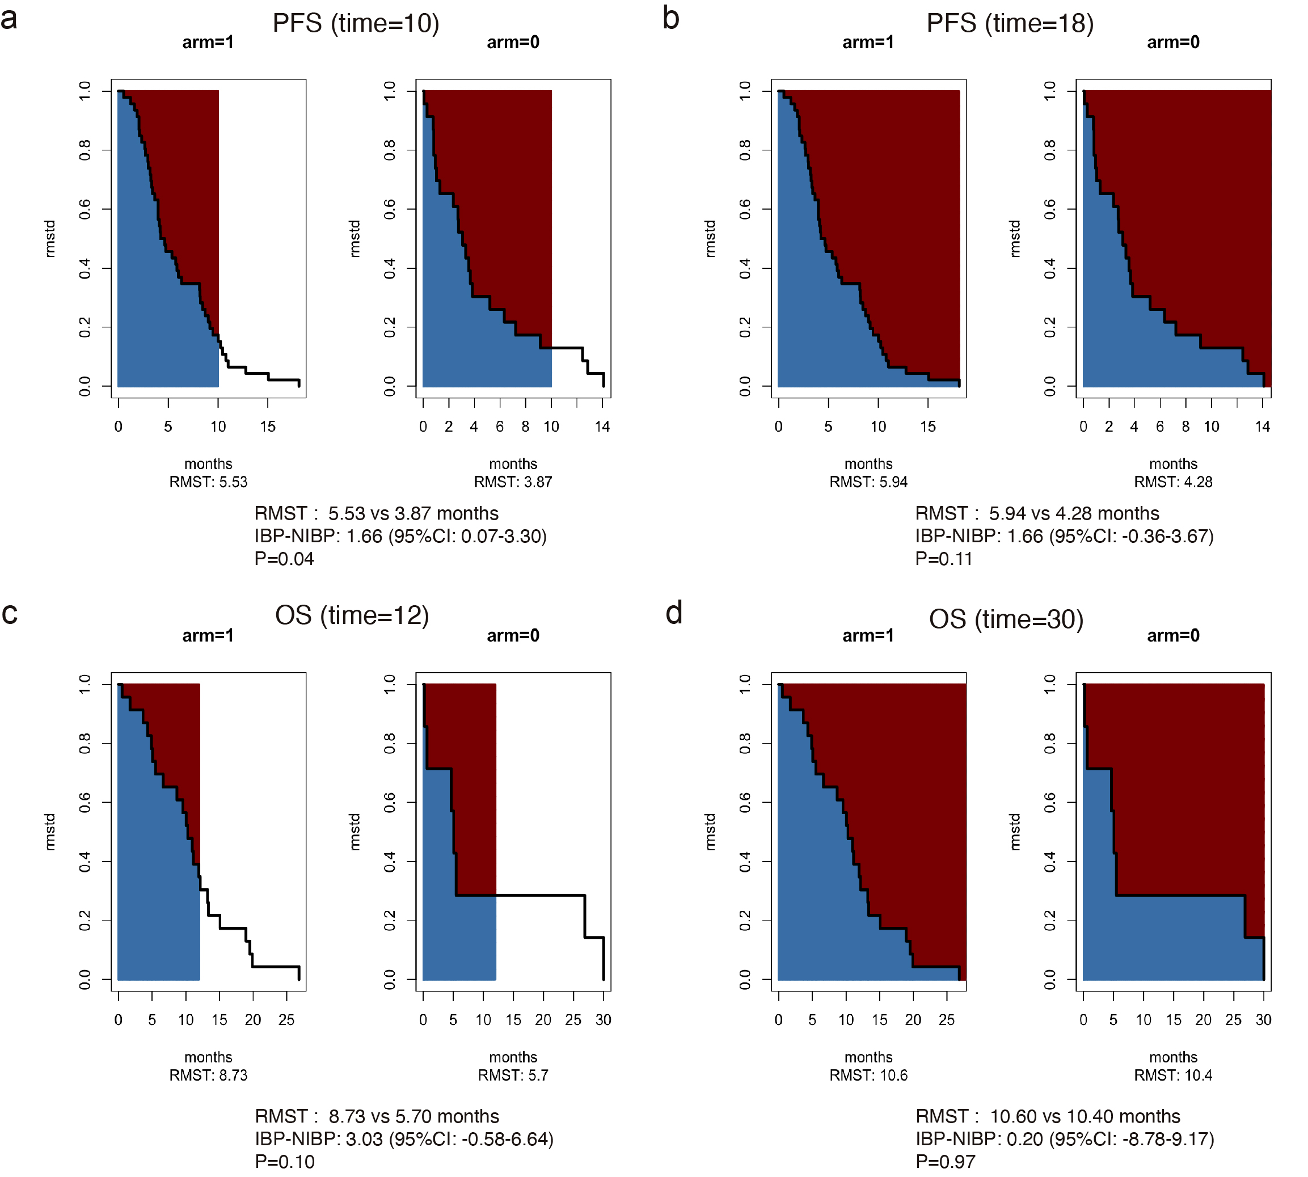

Figure S2 Kaplan-Meier curves of PFS and OS in patients with driver-gene positive NSCLC (a, b). IBP, immunotherapy beyond progression; NIBP, non-immunotherapy beyond progression; mPFS, median progression-free survival; mOS, median overall survival; HR, hazard ratio; CI, confidence interval.
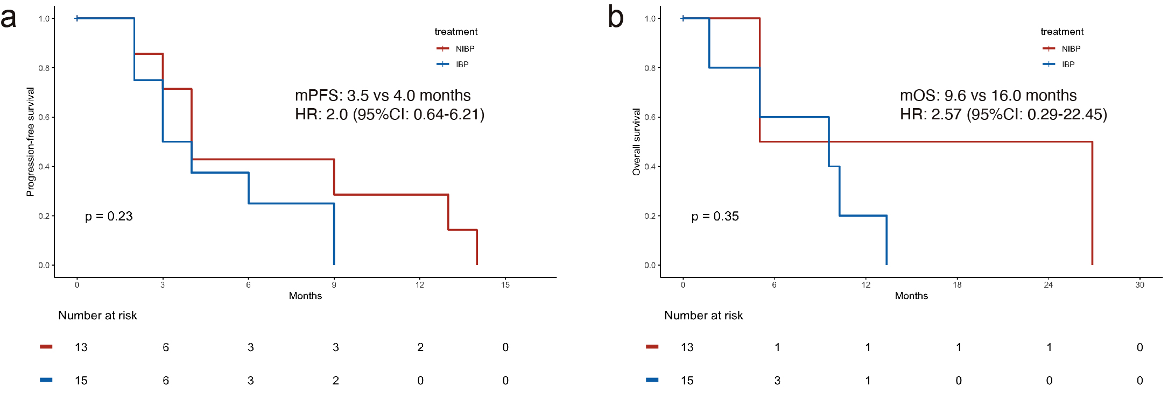

Figure S3 Forest plots of PFS (a) and OS (b) in patients with driver-gene negative of the IBP and NIBP groups. IO immunotherapy; ChT chemotherapy; A anti-angiogenic therapy.
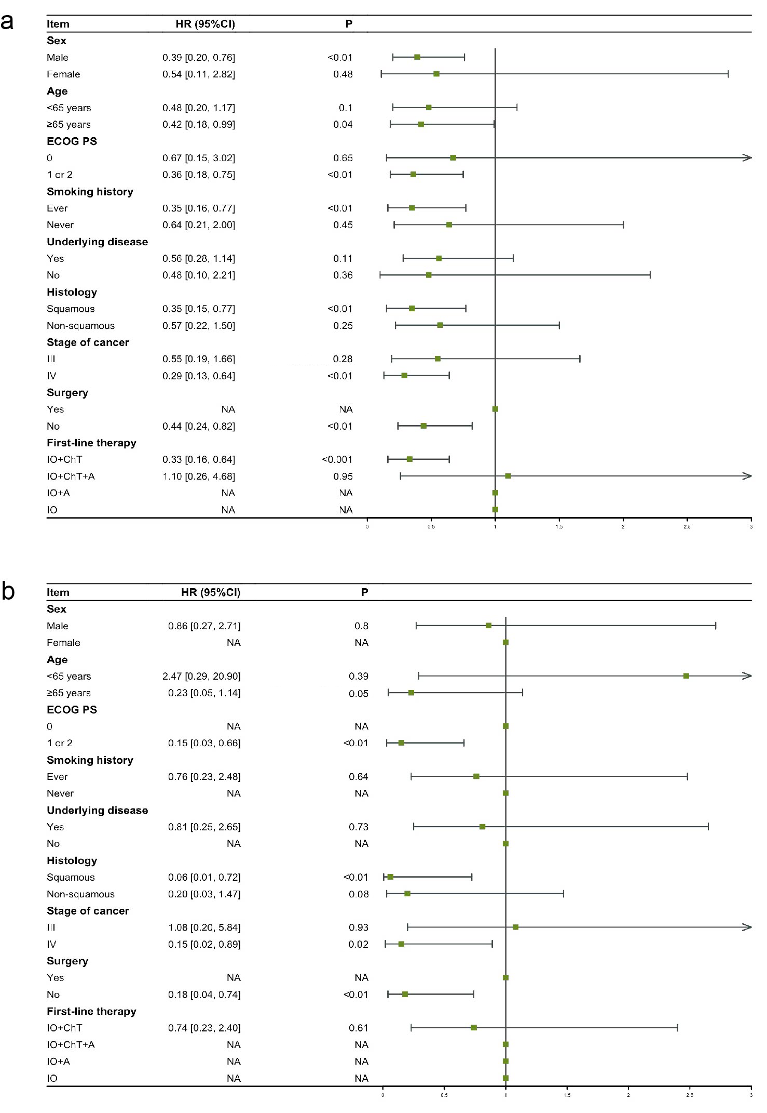

Figure S4 Kaplan-Meier curves of PFS (a) and OS (b) in the SD response to initial immunotherapy subgroup of patients with driver-gene negative NSCLC. IBP, immunotherapy beyond progression; NIBP, non-immunotherapy beyond progression; mPFS, median progression-free survival; mOS, median overall survival; HR, hazard ratio; CI, confidence interval.
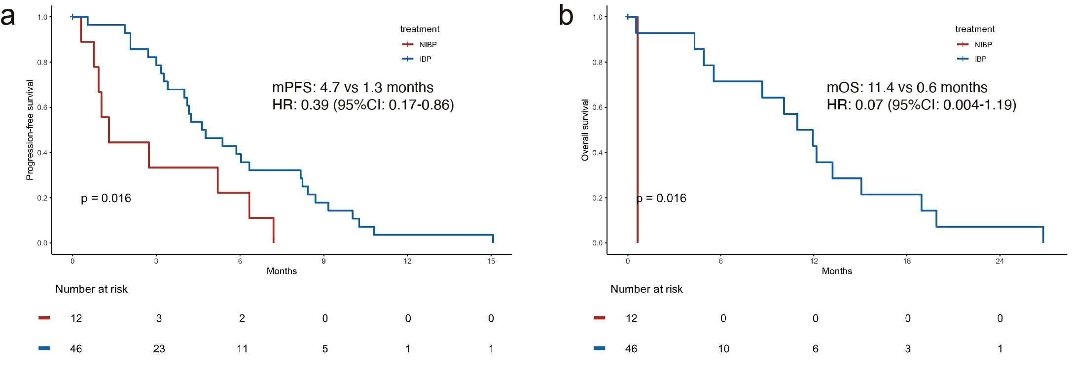

Figure S5 Forest plots of the hazard ratios for PFS (a) and OS (b) in the IBP group versus the NIBP group in patients with SCLC 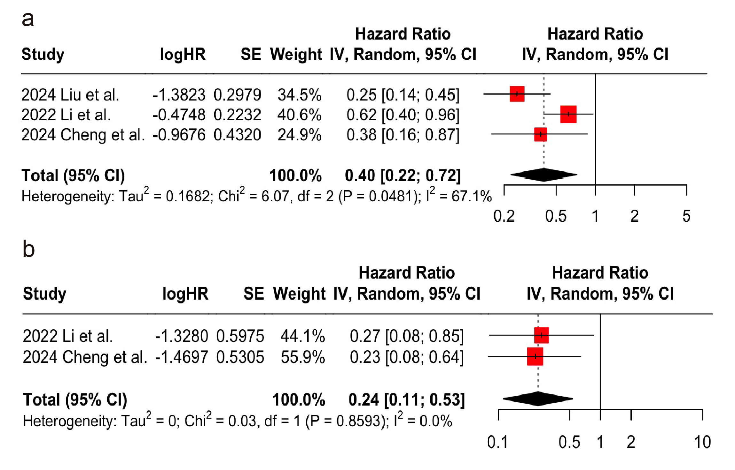

Figure S6 Flow chart of literature selection.
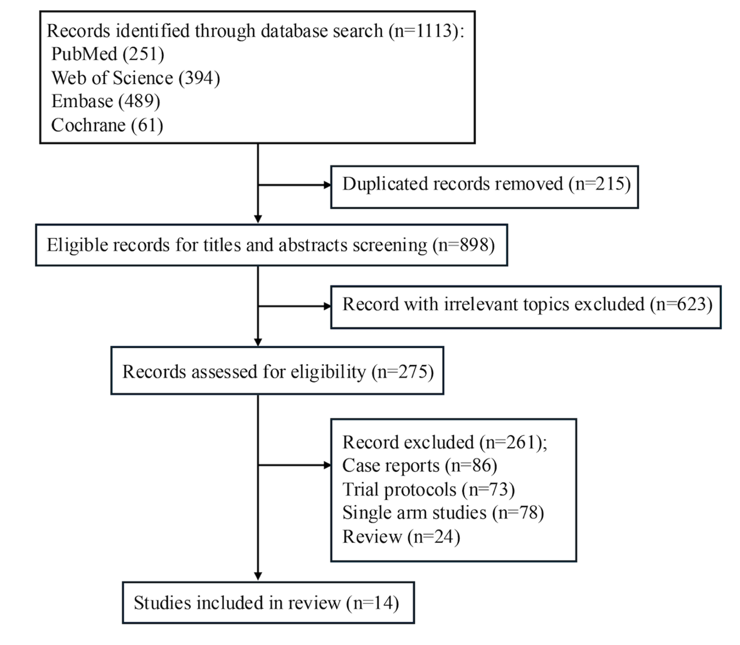

Figure S7 The funnel plot of the hazard ratios for PFS in the IBP group versus the NIBP group in NSCLC patients with driver-gene negative（Begg’s Test P=0.0763）
