Supplementary Table 1 The ICIs molecules involed in this study.
Anti PD-1 inhibitors,  n (%) | STPFS  (n = 57) | non-LTPFS/  non-STPFS  (n = 70) | LTPFS  (n = 44) | Grouping  population  (n = 171) | Total population  (n = 202)
Pembrolizumab | 43 (75.4) | 49 (70.0) | 35 (79.5) | 127 (74.3) | 152 (75.2)
Sintilimab* | 10 (17.5) | 17 (24.3) | 8 (18.2) | 35 (20.5) | 38 (18.8)
Nivolumab | 4 (7.1) | 4 (5.7) | 1 (2.3) | 9 (5.2) | 12 (5.9)
*Patients receiving first-line sintilimab monotherapy were enrolled in a multicenter phase II clinical trial (NCT03574402) at our center.

Supplementary Table 2 The distrubtion of driver gene alterations.
Driver gene alterations,  n (%) | STPFS  (n = 57) | non-LTPFS/  non-STPFS  (n = 70) | LTPFS  (n = 44) | Grouping  population  (n = 171) | Total population  (n = 202)
KRAS
G12C | 5 (8.7) | 11 (15.8) | 7 (16.0) | 23 (13.5) | 24 (11.9)
G12V | 3 (5.3) | 3 (4.3) | 1 (2.3) | 7 (4.1) | 7 (3.5)
G12D | 0 (0.0) | 4 (5.7) | 2 (4.5) | 6 (3.5) | 7 (3.5)
G13D | 0 (0.0) | 1 (1.4) | 0 (0.0) | 1 (0.6) | 2 (0.9)
Q61H | 1 (1.8) | 1 (1.4) | 0 (0.0) | 2 (1.1) | 3 (1.5)
G13S | 0 (0.0) | 0 (0.0) | 0 (0.0) | 0 (0.0) | 1 (0.5)
G12A | 0 (0.0) | 0 (0.0) | 0 (0.0) | 0 (0.0) | 1 (0.5)
NA | 2 (3.5) | 1 (1.4) | 2 (4.5) | 5 (2.9) | 5 (2.5)
HER2
Y772_A775dup | 0 (0.0) | 1 (1.4) | 0 (0.0) | 1 (0.6) | 1 (0.5)
RET
G810C | 1 (1.8) | 0 (0.0) | 0 (0.0) | 1 (0.6) | 1 (0.5)
BRAF
G469L | 0 (0.0) | 1 (1.4) | 0 (0.0) | 1 (0.6) | 1 (0.5)
K601E | 0 (0.0) | 1 (1.4) | 0 (0.0) | 1 (0.6) | 1 (0.5)
N5815S | 0 (0.0) | 0 (0.0) | 1 (2.3) | 1 (0.6) | 1 (0.5)
D594N | 0 (0.0) | 0 (0.0) | 0 (0.0) | 0 (0.0) | 1 (0.5)
Negative | 34 (59.6) | 39 (55.8) | 26 (59.1) | 99 (57.9) | 117 (57.9)
NA | 11 (19.3) | 7 (10.0) | 5 (11.3) | 23 (13.4) | 29 (14.3)

Supplementary Table 3 Efficacy and Safety of first-line ICIs monotherapy in real-world.
Characteristics | STPFS  (n = 57) | non-LTPFS/  non-STPFS  (n = 70) | LTPFS  (n = 44) | Grouping  population  (n = 171) | Total population  (n = 202)
Best overall response, n (%)
PR | 0 (0.0) | 31 (44.3) | 35 (79.5) | 66 (38.6) | 76 (37.6)
SD | 13 (22.8) | 37 (52.9) | 9 (20.5) | 59 (34.5) | 69 (34.2)
PD | 24 (42.1) | 1 (1.4) | 0 (0.0) | 25 (14.6) | 25 (12.4)
NA | 20 (35.1) | 1 (1.4) | 0 (0.0) | 21 (12.3) | 32 (15.8)
PFS, months  (95% CI) | 1.4  (1.3, 1.6) | 8.6  (7.1, 10.1) | 55.0  (47.9, 62.1) | 7.5  (5.2, 9.8) | 8.6  (5.9. 11.3)
OS, months  (95% CI) | 3.0  (0.9, 5.1) | 21.4  (16.3, 26.5) | NE  (NE, NE) | 23.0  (16.1, 29.9) | 20.6  (15.2, 26.0)
Any grade ≥ 3 AEs
With | 11 (19.3) | 13 (18.6) | 9 (20.5) | 33 (19.3) | 38 (18.8)
Without | 46 (80.7) | 57 (81.4) | 35 (79.5) | 138 (80.7) | 164 (81.2)
Any grade pneumonia
With | 3 (5.3) | 14 (20.0) | 6 (13.6) | 23 (13.5) | 24 (11.9)
Without | 54 (94.7) | 56 (80.0) | 38 (86.4) | 148 (86.5) | 178 (88.1)

Supplementary Table 4 Univariate and multivariate analyses of association between clinical characteristics with LTPFS compared to STPFS.
Factor | Univariate analysis |  |  |  | Multivariate analysis
Factor | OR | 95% CI | P | OR |  | 95% CI | P
Gender
Male vs. Female | 1.91 | 0.47-7.87 | 0.368
Age
≥ 65 vs. < 65 | 1.87 | 0.83-4.20 | 0.132
Smoking
Never vs. Ever | 0.72 | 0.28-1.84 | 0.494
Pathology
non-Sq vs. Squamous | 2.76 | 1.19-6.41 | 0.018 | 3.14 |  | 1.02-9.67 | 0.047
Organs
≤ 3 vs. > 3 | 3.13 | 1.38-7.11 | 0.006 | 4.13 |  | 1.27-13.92 | 0.022
Incidence of ≥ 3°AE
Without vs. With | 0.93 | 0.35-2.49 | 0.885
Incidence of pneumonia
Without vs. With | 0.35 | 0.08-1.50 | 0.157
ECOG PS
≥ 2 vs. 0-1 | 0.16 | 0.34-0.76 | 0.021 | 0.24 |  | 0.04-1.65 | 0.148
PD-L1, TPS
≥ 50% vs. < 50% | 2.52 | 0.89-7.18 | 0.083 | 2.93 |  | 0.79-10.79 | 0.105
Brain Metastases
With vs. Without | 1.02 | 0.41-2.55 | 0.960
Liver Metastases
With vs. Without | 0.05 | 0.01-0.36 | 0.003 | 0.09 |  | 0.01-0.91 | 0.041
Total BTS
> 71.0 vs. ≤ 71.0 | 0.35 | 0.16-0.79 | 0.012 | 0.78 |  | 0.25-2.47 | 0.67
Max BTS
> 50.0 vs. ≤ 50.0 | 0.51 | 0.23-1.16 | 0.107
LIPI score
Others vs. Good | 0.15 | 0.06-0.37 | 0.001 | 0.17 |  | 0.05-0.67 | 0.040

Supplementary Table 5 Clinial characterists in the circulating cytokines analysis cohort.
Characteristics | STPFS  (n = 9) | LTPFS  (n = 10) | Total population  (n = 19)
Age, median (range) | 59 (50, 76) | 66 (54, 82) | 64 (50, 82)
Gender, No. (%)
Female | 3 (33.3) | 1 (10.0) | 4 (21.1)
Male | 6 (66.7) | 9 (90.0) | 15 (78.9)
Smoking history, No. (%)
Current/ Former | 5 (55.6) | 8 (80.0) | 13 (68.4)
Never | 4 (44.4) | 2 (20.0) | 6 (31.6)
ECOG PS, No. (%)
0-1 | 8 (88.9) | 10 (100.0) | 18 (94.7)
≥ 2 | 1 (11.1) | 0 (0.0) | 8 (5.3)
Histology, No. (%)
Adenocarcinoma | 8 (11.1) | 4 (40.0) | 12 (63.2)
Squamous | 1 (88.9) | 4 (40.0) | 5 (26.3)
others | 0 (0.0) | 2 (20.0) | 2 (10.5)
PD-L1, No. (%)
TPS ≥ 50% | 3 (33.3) | 3 (30.0) | 6 (31.6)
TPS < 50%, ≥ 1% | 3 (33.3) | 2 (20.0) | 5 (26.4)
TPS < 1% | 2 (22.3) | 2 (20.0) | 4 (21.0)
Not available | 1 (11.1) | 3 (30.0) | 4 (21.0)
TMB, No. (%)
≥ 10 mut/Mb | 1 (11.1) | 2 (20.0) | 3 (15.8)
< 10 mut/Mb | 2 (22.2) | 1 (10.0) | 3 (15.8)
Not available | 6 (66.7) | 7 (70.0) | 13 (68.4)

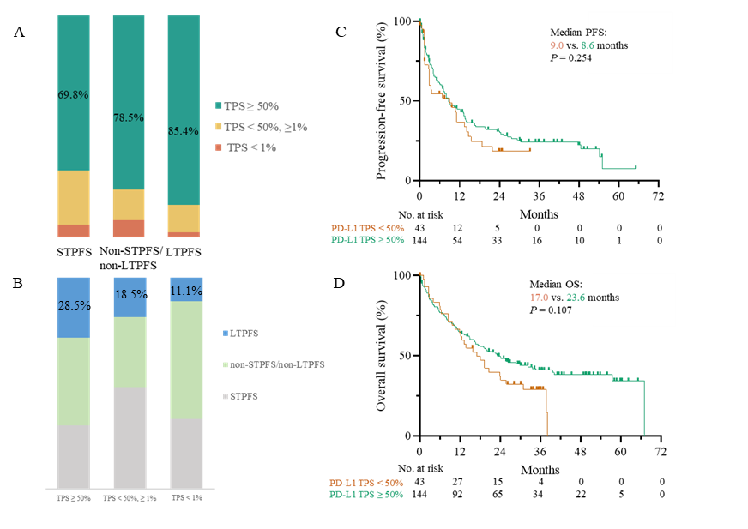
Supplementary Figure 1 Association between PD-L1 status and LTPFS. (A) Stacked bar graphs of percentage of patients with PD-L1 TPS < 1%, 1%–49%, and ≥ 50% in the LTPFS, STPFS, and non-STPFS/non-LTPFS groups. (B) Stacked bar graphs of percentage of patients with LTPFS, STPFS, and non-STPFS/non-LTPFS in the PD-L1 TPS < 1%, 1%–49%, and ≥ 50% groups. (C) Kaplan–Meier curves of PFS among patients with PD-L1 TPS < 50% and ≥ 50%. (D) Kaplan–Meier curves of OS among patients with PD-L1 TPS < 50% and ≥ 50%.

Supplementary Figure 2 Changes of several circulating cytokines from post-treatment to pre-treatment between LTPFS and STPFS. (a) Changes of CCL11. (b) Changes of IL1RA. (c) Changes of IL17A.

