Supplementary

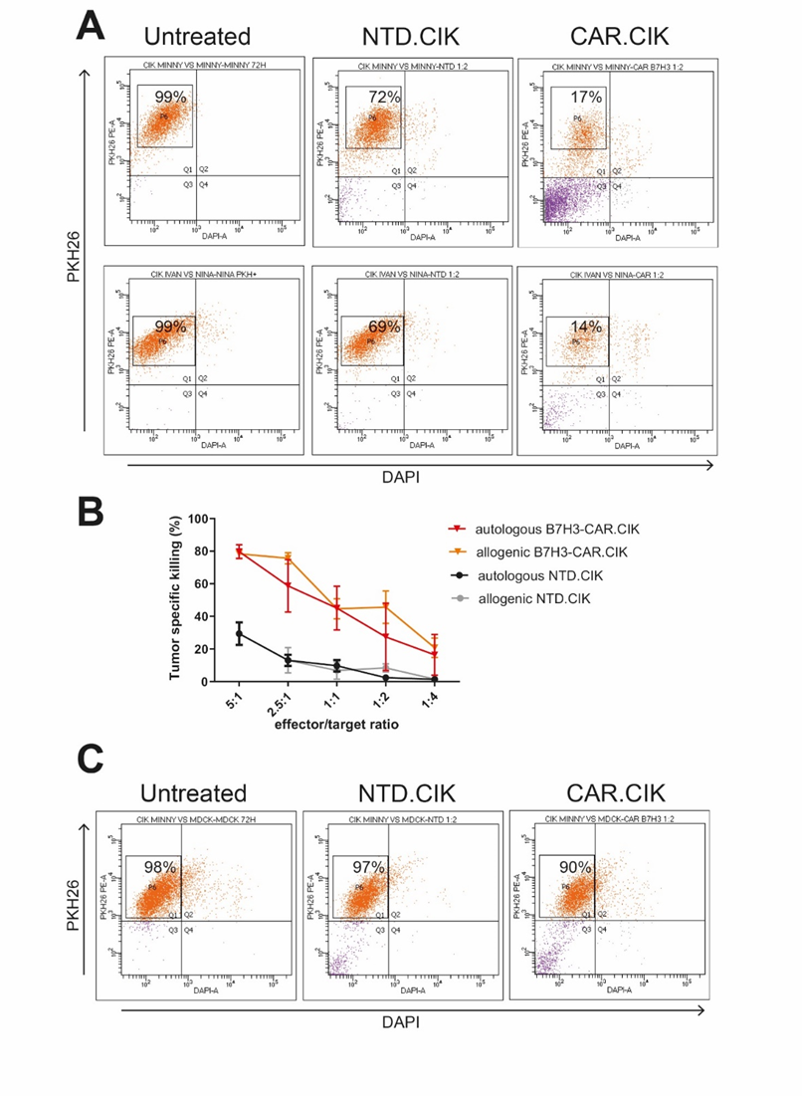
Suppl. Fig. 1. Graphical representation of canine B7-H3-CAR.CIK lymphocytes activity and specificity. (a) Flow cytometric assessment of canine B7-H3-CAR.CIK lymphocyte-mediated cytotoxicity against B7-H3-positive canine sarcoma targets (E:T 1:2). Viable residual tumor cells are represented by DAPI-PKH26+ cells. (b) Comparative analysis showing equivalent cytotoxic activity of canine B7-H3-CAR.CIK lymphocytes in both autologous and allogeneic settings. (c) Selective targeting demonstrated by flow cytometric analysis of canine B7-H3-CAR.CIK lymphocytes activity against B7-H3-negative MDCK cells (E:T 1:2). Viable residual MDCK cells are represented by DAPI-PKH26+ cells.
Suppl. Table 1. Semi-Quantitative Assessment Criteria for B7-H3 Immunohistochemical Expression*

Score | Proportion of stained cells | Intensity of staining
0 | ＜5% | No staining
1 | 5%-25% | Weak staining
2 | 26%-50% | Moderate staining
3 | 51%-100% | Strong staining
*Cascio et al. 2021 Veterinary Immunology and Immunopathology 232

Suppl. Table 2. B7-H3 expression by IHC on a panel of normal canine tissues.

Tissue | Score  (0-9) | Description
Kidney | Negative (0)
Heart | Negative (0)
Spleen | Low (2) | Weak staining of 30% of the cells, including endothelial cells and lymphoid cells of the follicular centre.
Lung | Low (3) | Strong staining of 10% of the cells, including bronchial epithelium.
Liver | Negative (0)
Oral mucosa | Negative (0) | Weak staining of less than 5% of the cells, including the basal cells of the mucosal epithelium.
Peripheral nerve | Negative (0)
Bone marrow | Negative (0) | Weak staining of less than 5% of the cells, including osteoblasts and few myeloid cells.
Skin | Negative (0) | Weak staining of less than 5% of the cells, including basal cells of the epidermis and hair follicles.
Lymph node | Low (2) | Moderate staining of 25% of the cells, including B-cells in the germinal centres and histiocytes.
Mammary gland | Low (2) | Moderate staining of 25% of the cells, including stromal cells (myofibroblasts and fibroblasts).

Suppl. Table 3. Primary and established cell line list

Cell lines | Histotype Origin | Reference
Penny | Chondroblastic osteosarcoma | Maniscalco et al. 2013*
Wall | Osteoblastic osteosarcoma | Maniscalco et al. 2013*
Desmon | Osteoblastic osteosarcoma | Maniscalco et al. 2013*
Pedro | Chondroblastic osteosarcoma | Maniscalco et al. 2013*
D22 | Pulmonary metastasis of osteosarcoma | ATCC CRL-6250
D17 | Osteoblastic osteosarcoma | ATCC CCL-183
Ivan | Fibrosarcoma | newly established
Nina | Osteoblastic osteosarcoma | newly established
Minny | Soft tissue sarcoma | newly established
*Maniscalco et al. Vet J. 2013 Jan;195(1):41-7.

