SUPPLEMENTARY DATA
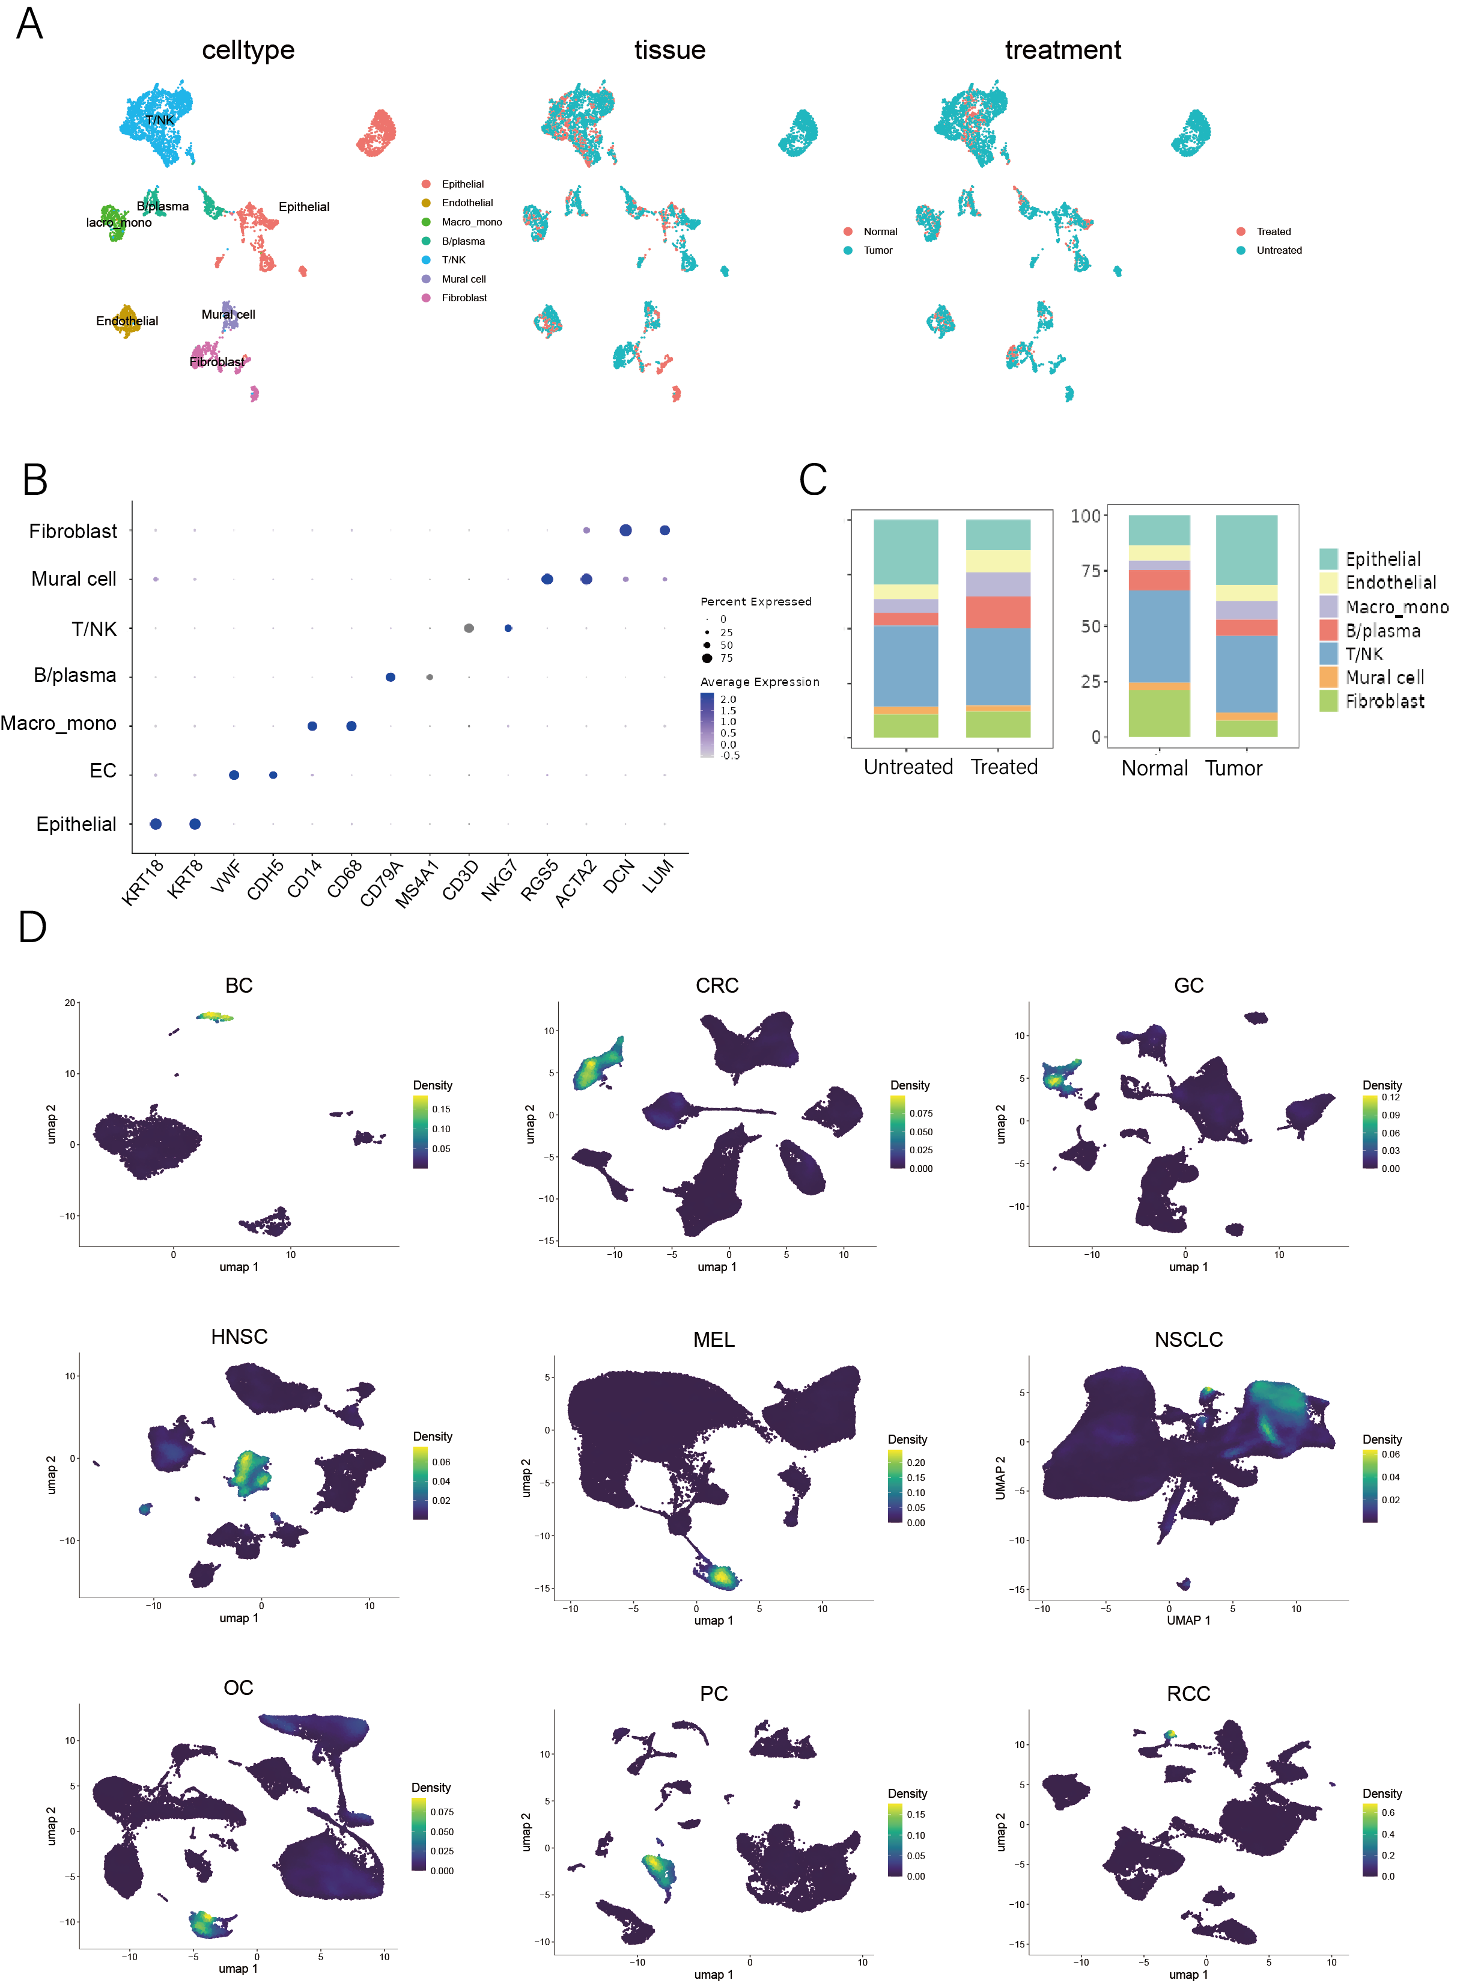
Fig.S1| Original scRNA-seq datasets and integrated data (down-sampled). A, UMAP plots of the integrated dataset (1000 cells were selected randomly from each dataset and integrated) labeled by major cell types, tissues, and treatments. B, Dot plot showing marker genes of each major cell type. C. Relative fraction of major cell types in different tissues and treatment statuses. D, UMAP plots showing ECs (annotated by VWF and PECAM1) in each original dataset.
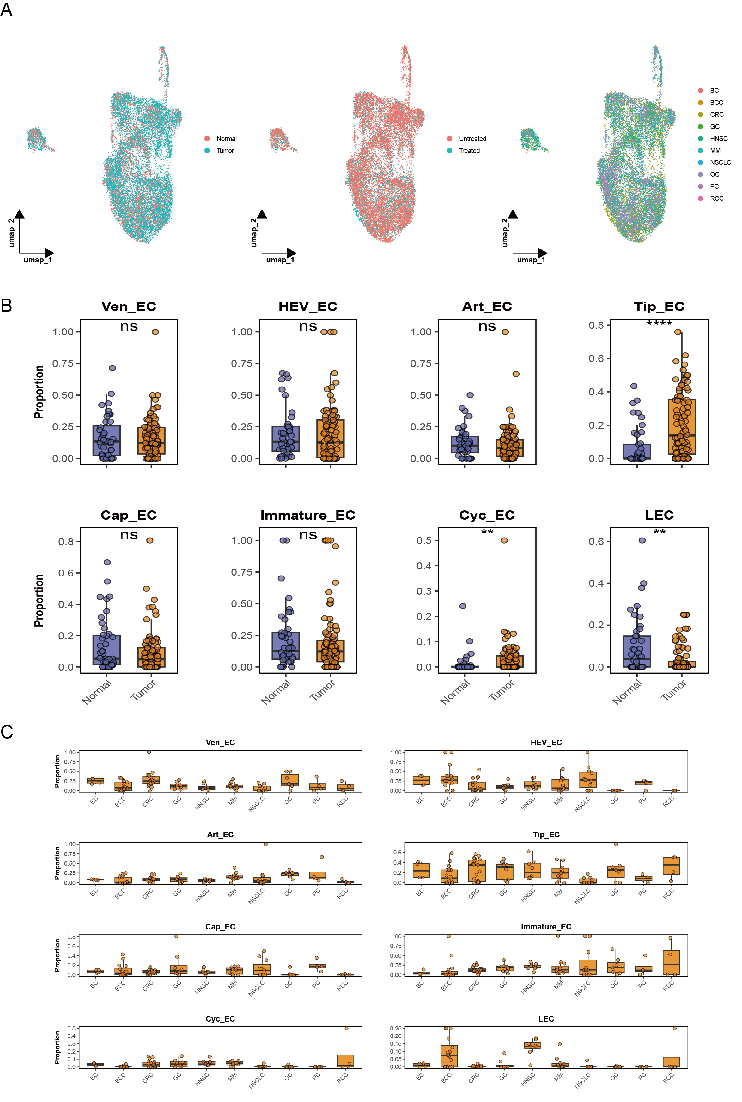
Fig.S2| A, UMAP plots of the integrated EC dataset labeled by tissues, treatments, and cancer types. B, Boxplots showing the fraction of each subcluster in the EC population in different tissues (each dot representing a sample that integrated into the dataset). C, Boxplots showing the fraction of each subcluster in the EC population in different malignancies (each dot representing a sample that integrated into the dataset). The Wilcoxon test was applied for Figure B.

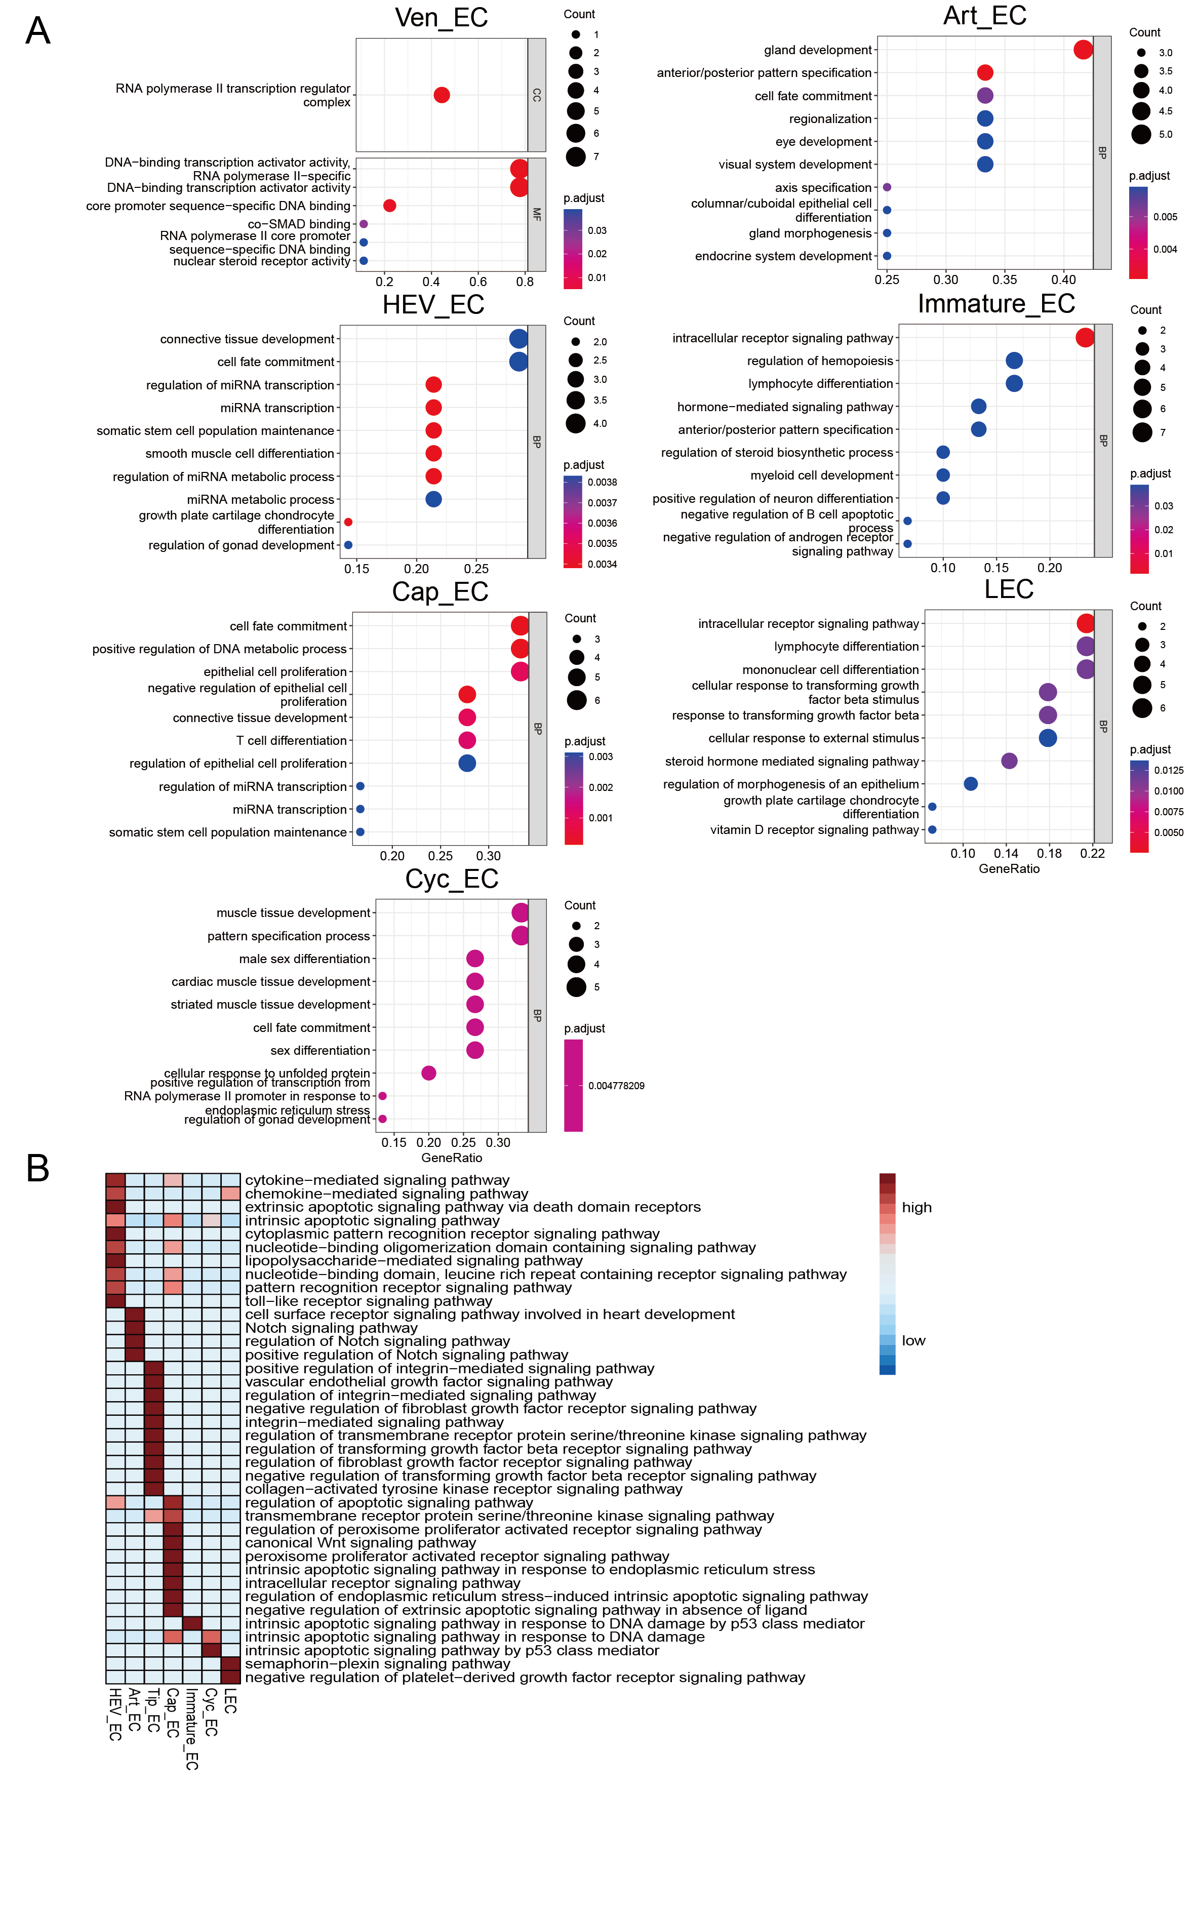
Fig. S3| GO analysis of EC subclusters. A, Top 10 functions enriched in each subcluster except Tip cells (shown in the main Fig. 2A). B, Signaling pathways enriched in each EC subcluster.

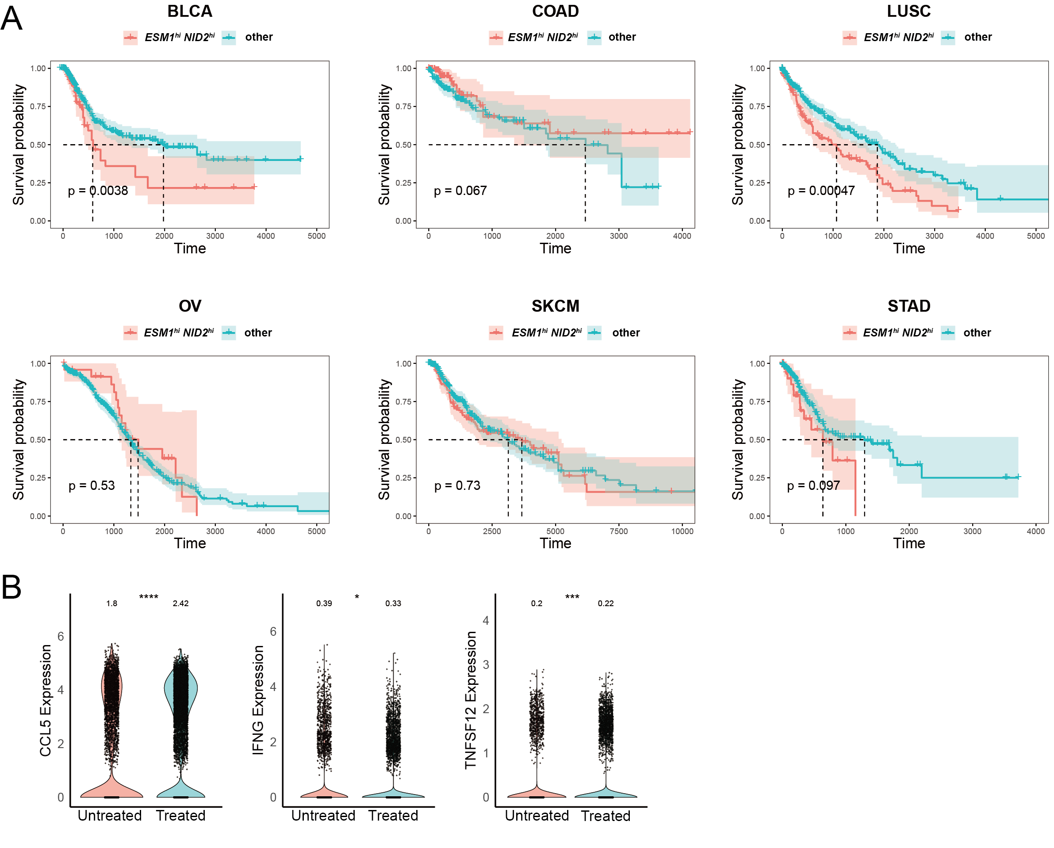
Fig. S4| A, Survival analysis of ESM1 and NID2 (tip-cell signatures) in TCGA datasets of different malignancies. B, Violin plots showing the expression of the typical cytokines secreted by T cells in different treatment conditions. Log-rank test was applied for Figure A. Wilcoxon test was applied for Figure B. BLCA, bladder cancer; COAD, colon adenocarcinoma; LUSC, lung squamous cell carcinoma; OV, ovarian cancer; SKCM, skin cutaneous melanoma; STAD, stomach adenocarcinoma.
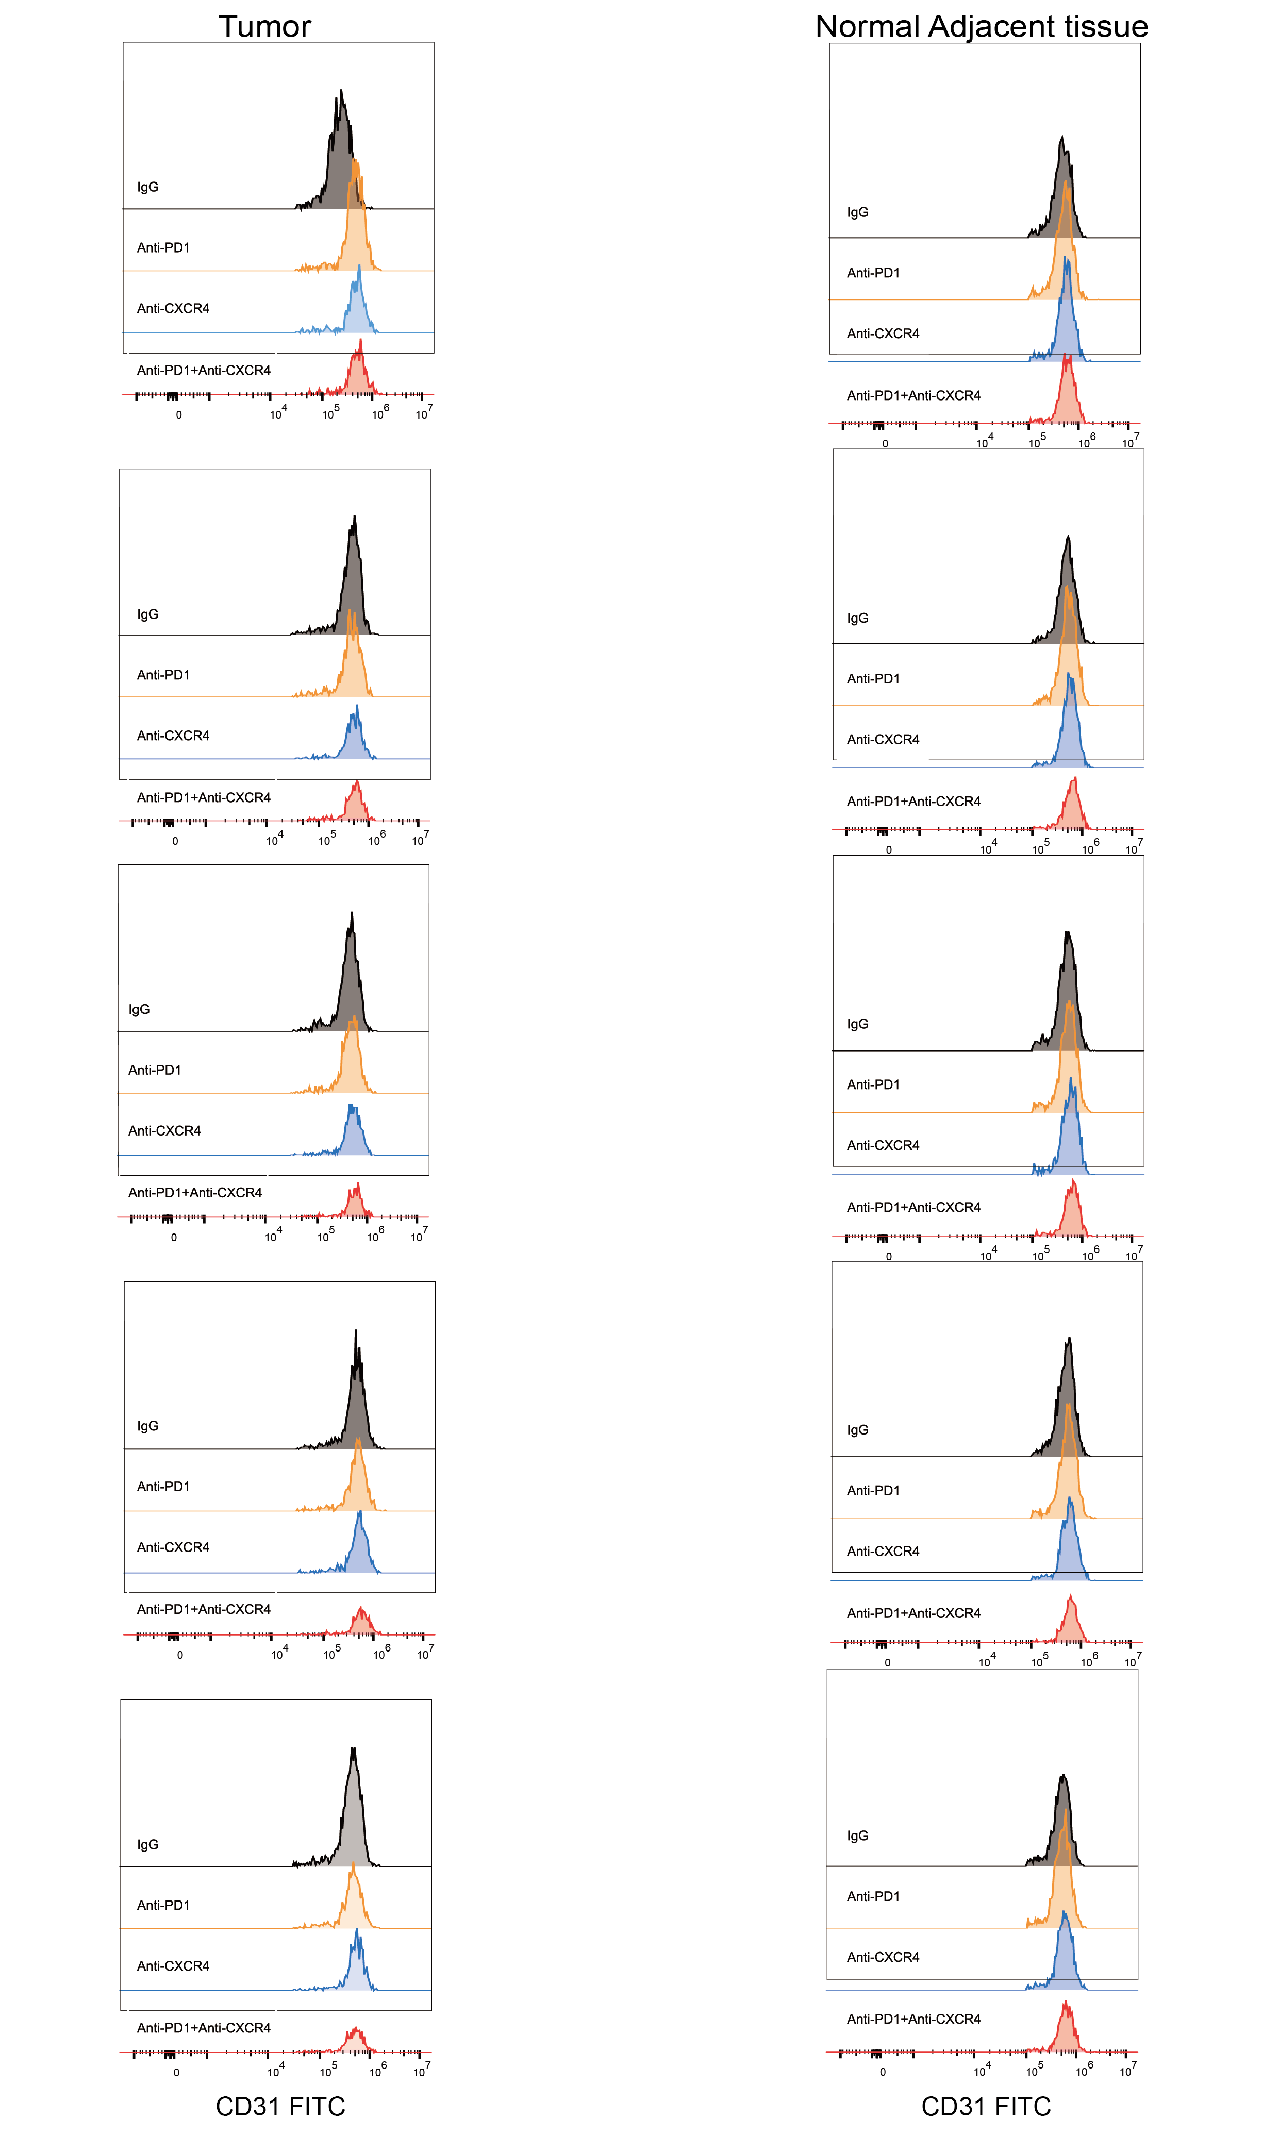
Fig.S5| Flow cytometry screening of CD31⁺ cells in tissues from each group.

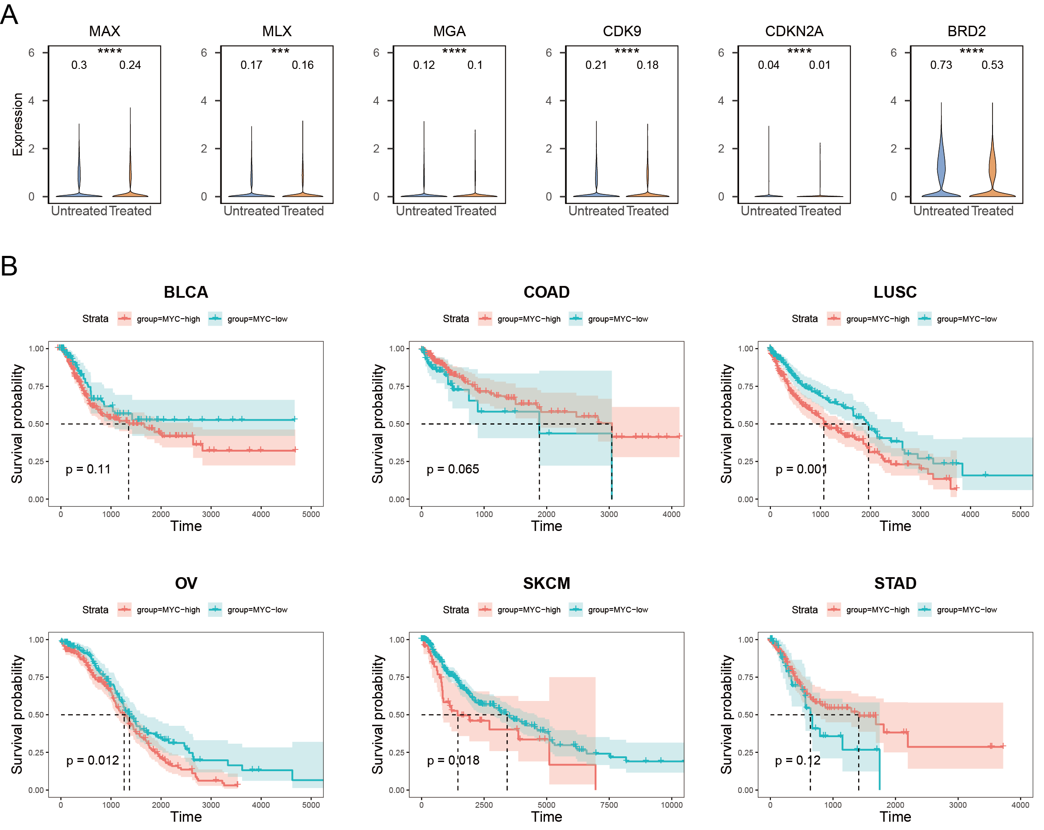
Fig.S6| A, Expression of MYC-cooperating genes in ECs of different treatment conditions. B, Survival analysis of MYC in TCGA datasets of different malignancies. Wilcoxon test was applied for Figure A. Log-rank test was applied for Figure B. BLCA, bladder cancer; COAD, colon adenocarcinoma; LUSC, lung squamous cell carcinoma; OV, ovarian cancer; SKCM, skin cutaneous melanoma; STAD, stomach adenocarcinoma.

