Integrative analysis of single-cell and bulk transcriptome data reveals age-related immune cell alterations in primary glioblastoma associated with prognosis

Zefan Jing, Bojun Qiu, Chenyang Ai, Chunhui Wang, Xinrun Wang, Boyang Li,
Lin Hou, Bin Yin, Wei Han*, Xiaozhong Peng*

Supplementary Figures

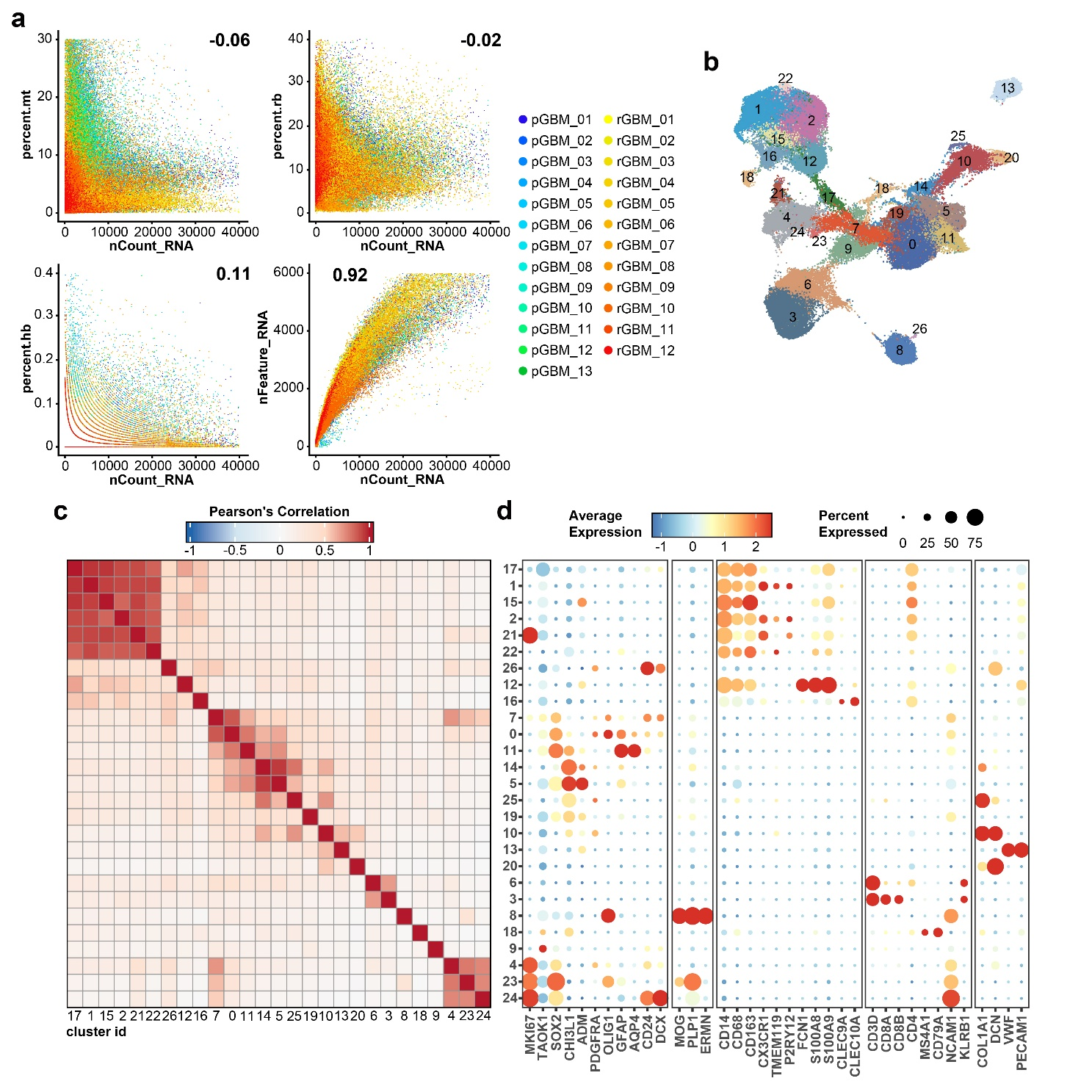
Supplementary Figure 1.
a Scatter plots showing the results of quality control for each scRNA-Seq data; colored by patients.
b UMAP visualization of 88,908 cells from 25 GBM patients, colored by cell clusters.
c Heatmap showing the Pearson's correlation of average gene expression level between clusters.
d Dot plot of representative feature genes among each cell cluster; dot size represents abundance, and color represents gene expression level.

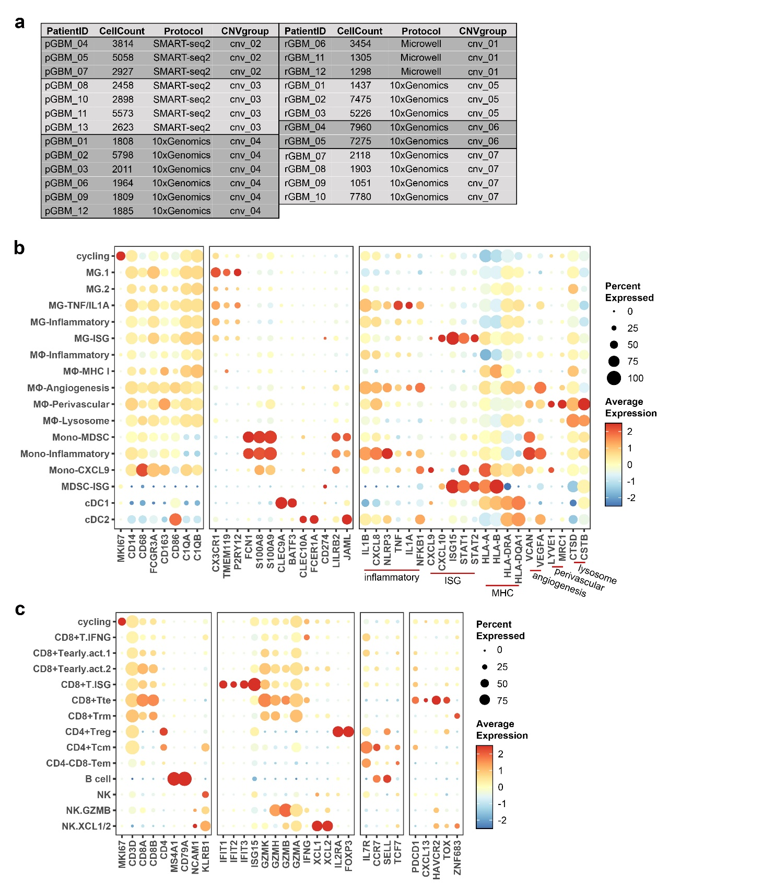
Supplementary Figure 2.
a Group information of scRNA-Seq data for CNVs estimation and heatmaps of CNVs results for each group, calculated using infercnv.
b Dot plot of representative feature genes among each myeloid cell subtypes.
c Dot plot of representative feature genes among each lymphoid cell subtypes.

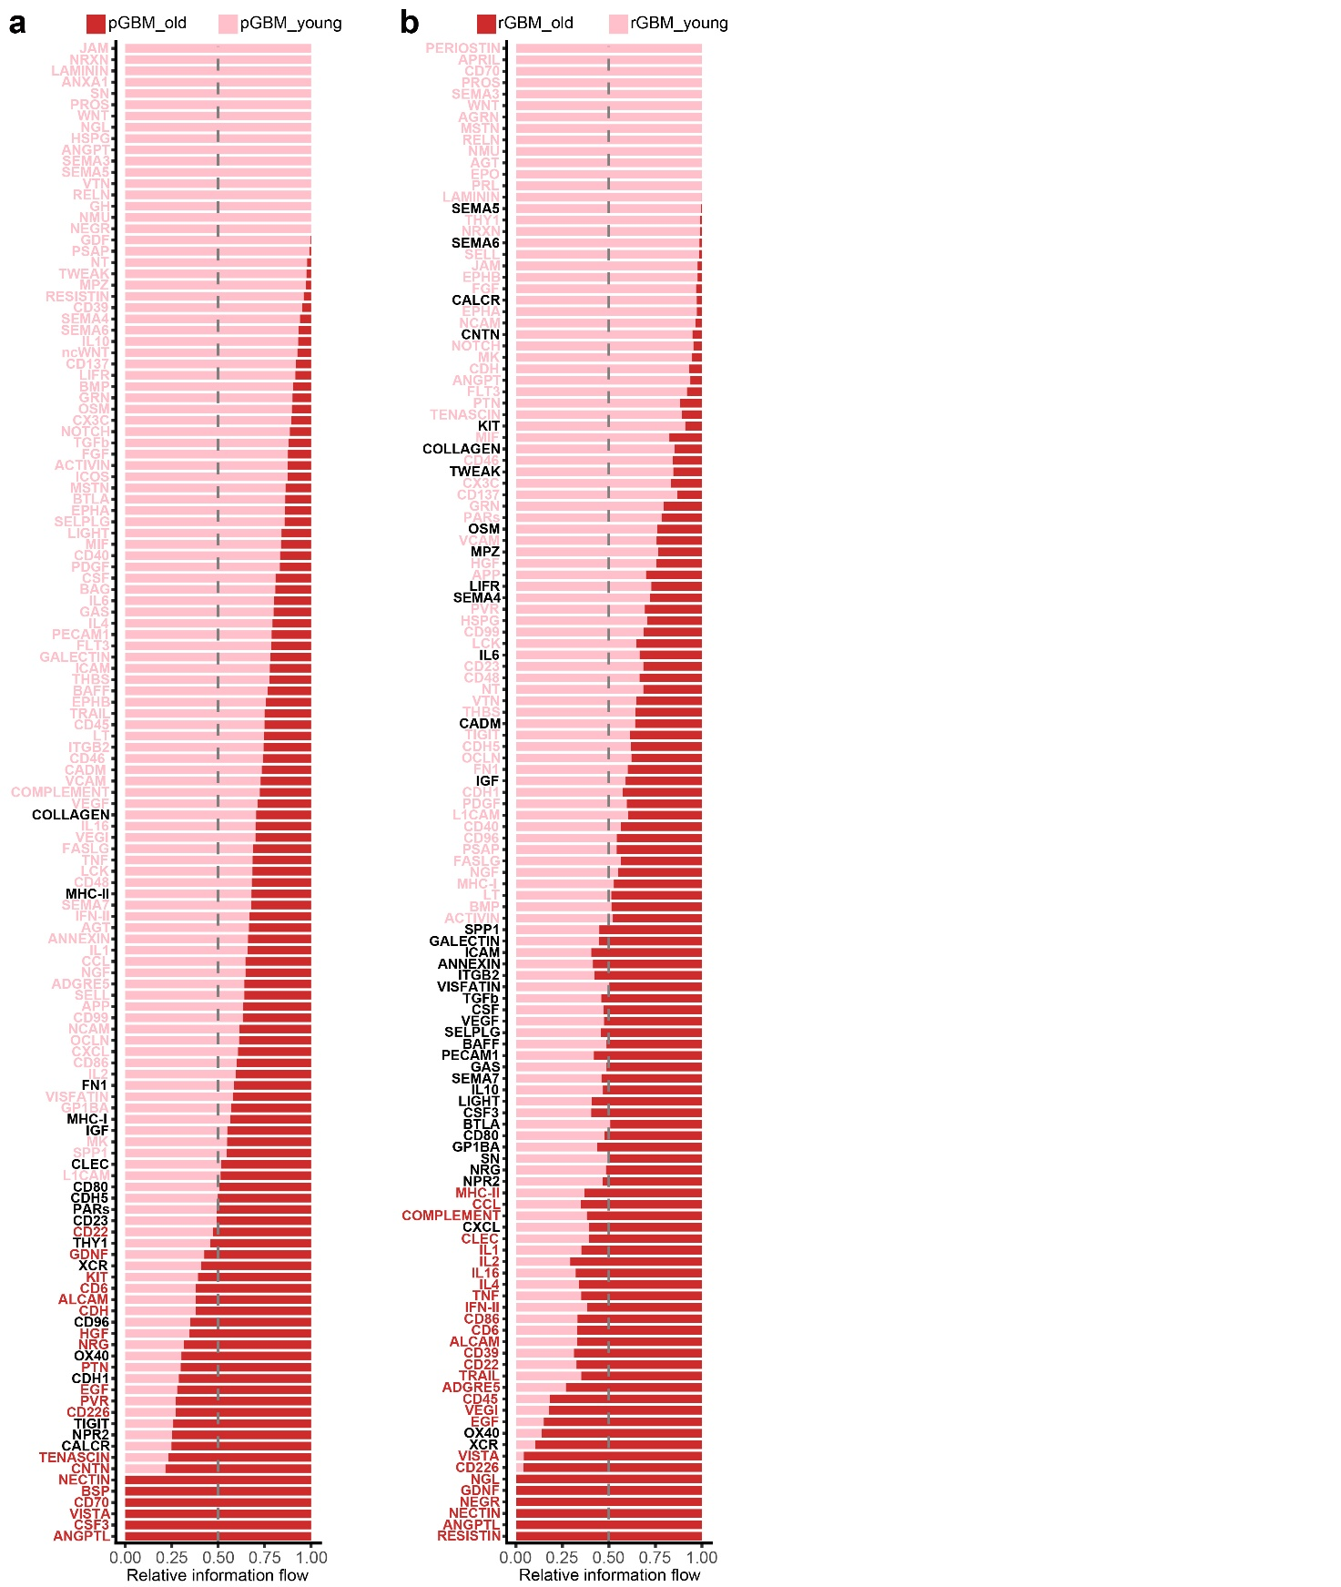
Supplementary Figure 3.
(a and b) Relative information flow (sum of interaction probability) of each pathway in pGBM (a) and rGBM (b), between young and elderly patients.

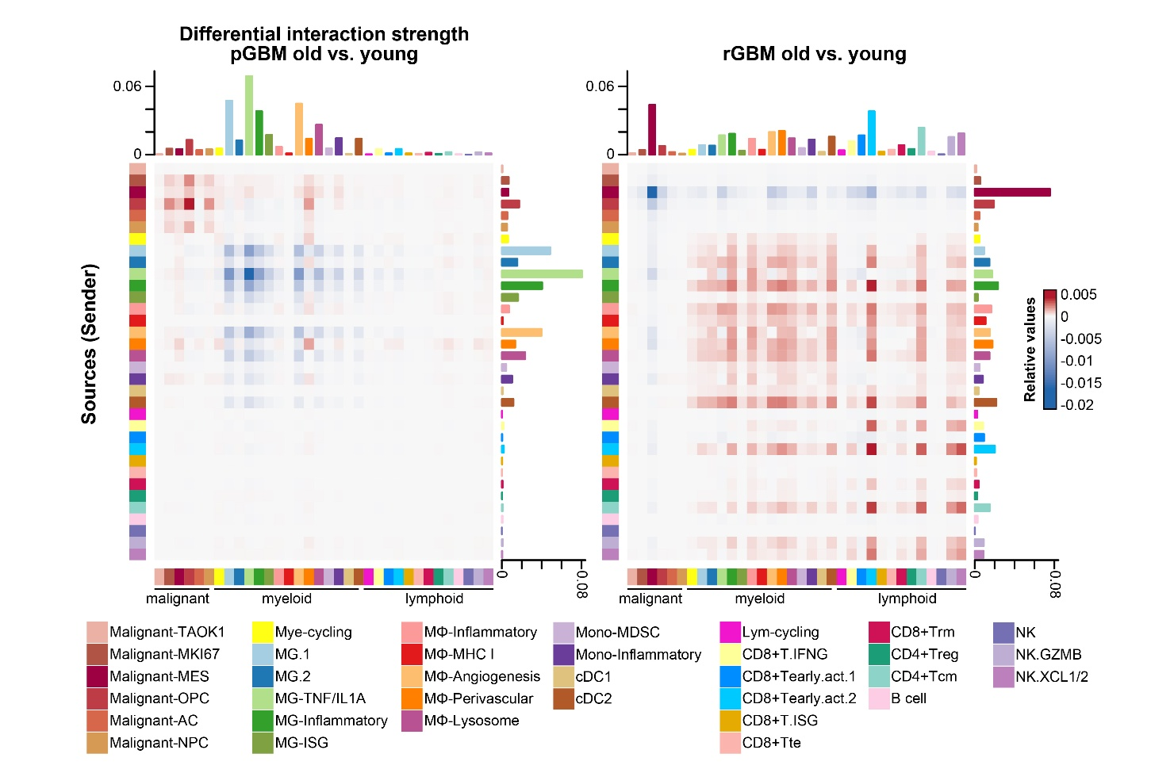
Supplementary Figure 4.
Heatmaps showing age-related differential interaction strength between each malignant and immune cell subtype in pGBM (left) and rGBM (right).

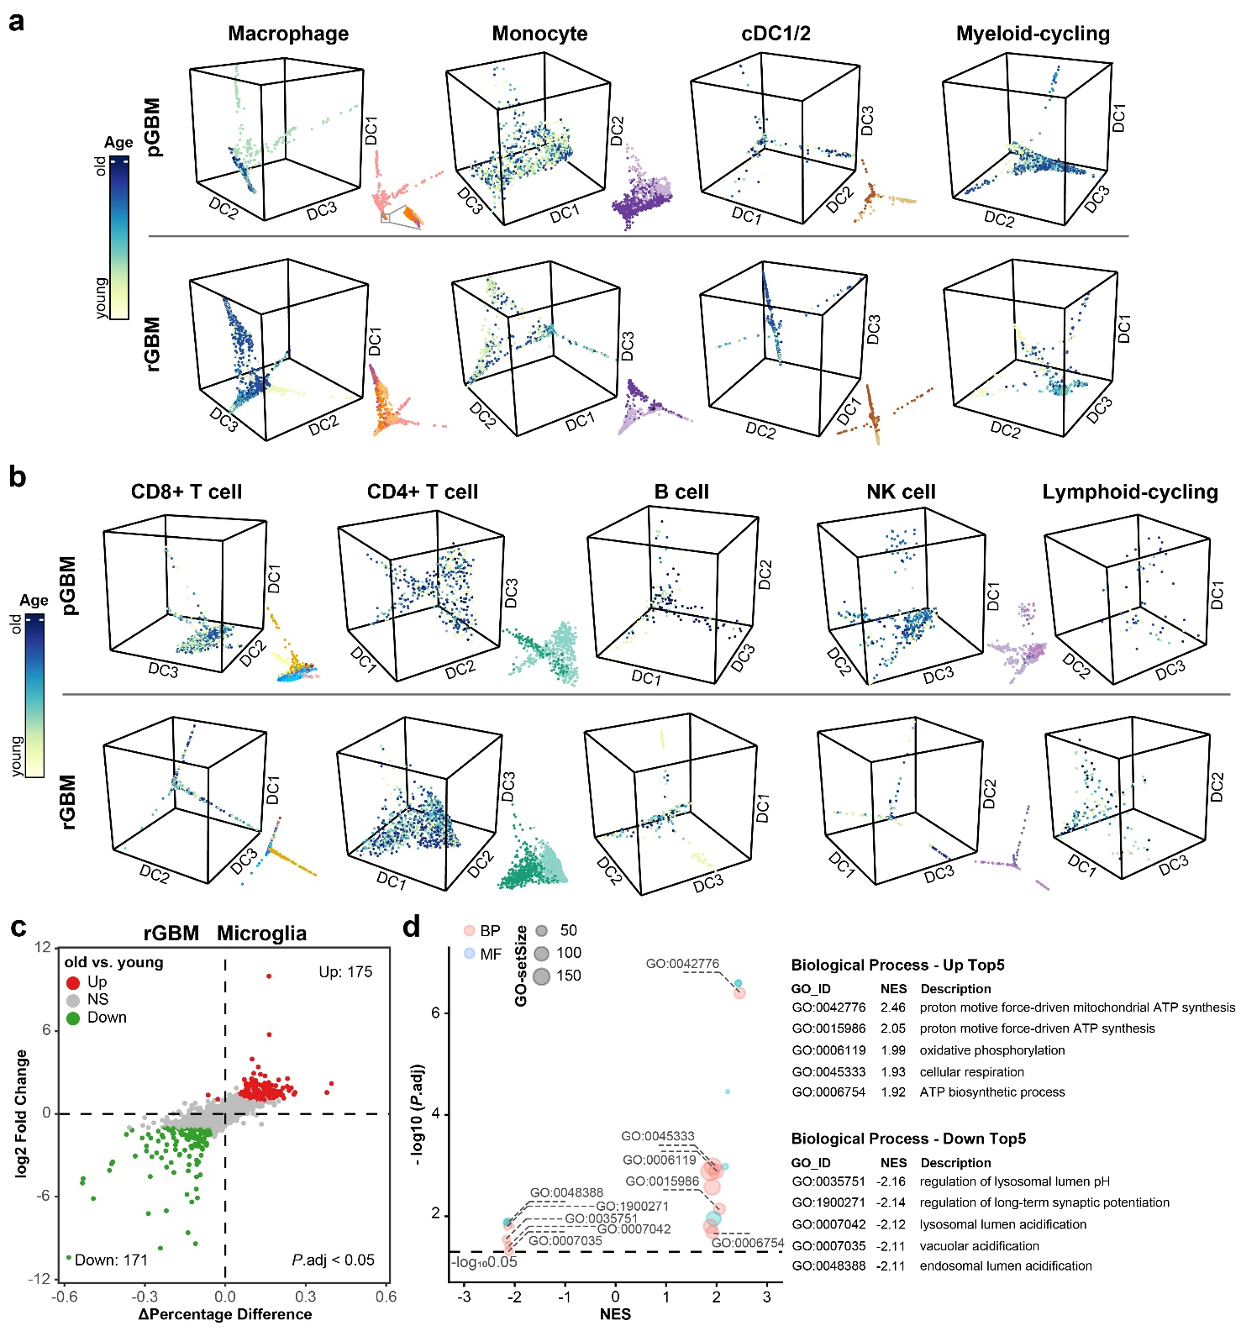
Supplementary Figure 5.
a 3D diffusion maps of myeloid cell in pGBM and rGBM scRNA-Seq, colored by patient age; the smaller projection in the lower right panel is colored by cell subtype, as shown in Figure 2g.
b 3D diffusion maps of lymphoid cell in pGBM and rGBM scRNA-Seq, colored by patient age; the smaller projection in the lower right panel is colored by cell subtype, as shown in Figure 2h.
c Volcano plot showing age-related DEGs from microglia in rGBM, with log2 Fold-Change in expression versus the difference in the percentage of cells expressing the gene (ΔPercentage Difference).
d Bubble chart displaying the significantly altered signal pathways for GSEA-GO enrichment analysis of age-related DEGs from microglia in rGBM.

