Table S1. Top 10 IPA results using DEGs between the KHK2455 and control groups.

No. | Ingenuity canonical pathways | -log(P-value) | z-score
1 | Phagosome Formation | 9.03 | 2.333
2 | Role of Pattern Recognition Receptors in Recognition of Bacteria and Viruses | 6.94 | 1
3 | Natural Killer Cell Signaling | 6.43 | 2.236
4 | Neutrophil Extracellular Trap Signaling Pathway | 6.35 | 0.816
5 | Fcγ Receptor-mediated Phagocytosis in Macrophages and Monocytes | 6.1 | 1
6 | HGF Signaling | 5.51 | ND
7 | Role of Macrophages, Fibroblasts and Endothelial Cells in Rheumatoid Arthritis | 5.32 | ND
8 | Macrophage Alternative Activation Signaling Pathway | 4.88 | 2
9 | Caveolar-mediated Endocytosis Signaling | 4.57 | ND
10 | IL-12 Signaling and Production in Macrophages | 4.52 | -2
A positive z-score suggests that the pathway was upregulated. ND indicates that the direction of the pathway regulation could not be determined.
DEG, differentially expressed gene; Fcγ, fragment crystallizable gamma; HGF, hepatocyte growth factor; IL, interleukin; IPA, Ingenuity Pathway Analysis; ND, not determined.

Table S2. Top 10 IPA results using DEGs between the anti–PD-L1 and control groups.

No. | Ingenuity canonical pathways | -log(P-value) | z-score
1 | Th1 and Th2 Activation Pathway | 46.8 | ND
2 | Th1 Pathway | 42 | 5.209
3 | Pathogen Induced Cytokine Storm Signaling Pathway | 39 | 6.172
4 | Th2 Pathway | 35 | 4.041
5 | Neuroinflammation Signaling Pathway | 30.6 | 4.95
6 | PD-1, PD-L1 cancer immunotherapy pathway | 27.9 | -3.128
7 | Granulocyte Adhesion and Diapedesis | 24.7 | ND
8 | IL-27 Signaling Pathway | 22.8 | 2.837
9 | Crosstalk between Dendritic Cells and Natural Killer Cells | 22.8 | 4.243
10 | Macrophage Alternative Activation Signaling Pathway | 21.8 | 2.711
A positive z-score suggests that the pathway was upregulated and a negative one suggests that the pathway was downregulated. ND indicates that the direction of the pathway regulation could not be determined.
DEG, differentially expressed gene; IL, interleukin; IPA, Ingenuity Pathway Analysis; ND, not determined; PD-1, programmed cell death protein 1; PD-L1, programmed death-ligand 1; Th, T-helper cell.

Table S3. Top 10 IPA results using DEGs between the combination and control groups.

No. | Ingenuity canonical pathways | -log(P-value) | z-score
1 | Pathogen Induced Cytokine Storm Signaling Pathway | 54.4 | 7.421
2 | Th1 and Th2 Activation Pathway | 53.3 | ND
3 | Th1 Pathway | 46.7 | 5.754
4 | Th2 Pathway | 39.6 | 3.889
5 | Neuroinflammation Signaling Pathway | 37.5 | 6.091
6 | Macrophage Alternative Activation Signaling Pathway | 34.2 | 3.55
7 | Macrophage Classical Activation Signaling Pathway | 32.8 | 4.802
8 | Granulocyte Adhesion and Diapedesis | 32.8 | ND
9 | IL-27 Signaling Pathway | 29.6 | 3.78
10 | Crosstalk between Dendritic Cells and Natural Killer Cells | 29.2 | 4.796
A positive z-score suggests that the pathway was upregulated and a negative one suggests that the pathway was downregulated. ND indicates that the direction of the pathway regulation could not be determined.
DEG, differentially expressed gene; IL, interleukin; IPA, Ingenuity Pathway Analysis; ND, not determined; Th, T-helper cell.

Table S4. Top 10 IPA results using DEGs identified both the combination vs control and combination vs anti–PD-L1 groups.

No. | Ingenuity canonical pathways | -log(P-value) | z-score
1 | Neuroinflammation Signaling Pathway | 18.4 | 3.9
2 | Neutrophil Extracellular Trap Signaling Pathway | 17.6 | 2.837
3 | Pathogen Induced Cytokine Storm Signaling Pathway | 17 | 4.472
4 | Neutrophil degranulation | 16.1 | 4.583
5 | Granulocyte Adhesion and Diapedesis | 15.3 | ND
6 | Role of Pattern Recognition Receptors in Recognition of Bacteria and Viruses | 15 | 3
7 | IL-12 Signaling and Production in Macrophages | 13.8 | -0.775
8 | Phagosome Formation | 12.9 | 4.583
9 | Macrophage Alternative Activation Signaling Pathway | 12.4 | 2.496
10 | Role of Osteoclasts in Rheumatoid Arthritis Signaling Pathway | 12.1 | 3.207
A positive z-score suggests that the pathway was upregulated and a negative one suggests that the pathway was downregulated. ND indicates that the direction of the pathway regulation could not be determined.
DEG, differentially expressed gene; IL, interleukin; IPA, Ingenuity Pathway Analysis; ND, not determined; PD-L1, programmed death-ligand 1.

Supplementary Figures
Figure S1. Effect of KHK2455, anti–CTLA-4 antibody, and their combination on the growth of mouse model bearing Pan02 and 4T1-Luc.
Tumor growth curves in each group. Day 0 was defined as the first day of treatment. Each plot represents the mean ± standard error of the tumor volume (mm³) (A) The control group was administered MC400, and KHK2455 groups were administered KHK2455 at a dose of 1mg/kg or 10 mg/kg (n = 10/group). (B) The control group was administered both 0.1 v/v% ethanol and the isotype control antibody, the KHK2455 group was administered both KHK2455 and the isotype control antibody, the anti–CTLA-4 group was administered both 0.1 v/v% ethanol and anti–CTLA-4 antibody, and the combination group was administered both KHK2455 and anti–CTLA-4 antibody (n = 20/group). Differences in tumor volume between groups were assessed using the Wilcoxon rank-sum test, and P-values were adjusted for multiple comparisons by Holm’s method. *, ** indicate statistical significance at P < 0.05 and P < 0.01, respectively.
MC400, methylcellulose 400; CTLA-4, cytotoxic T-lymphocyte-associated protein 4.
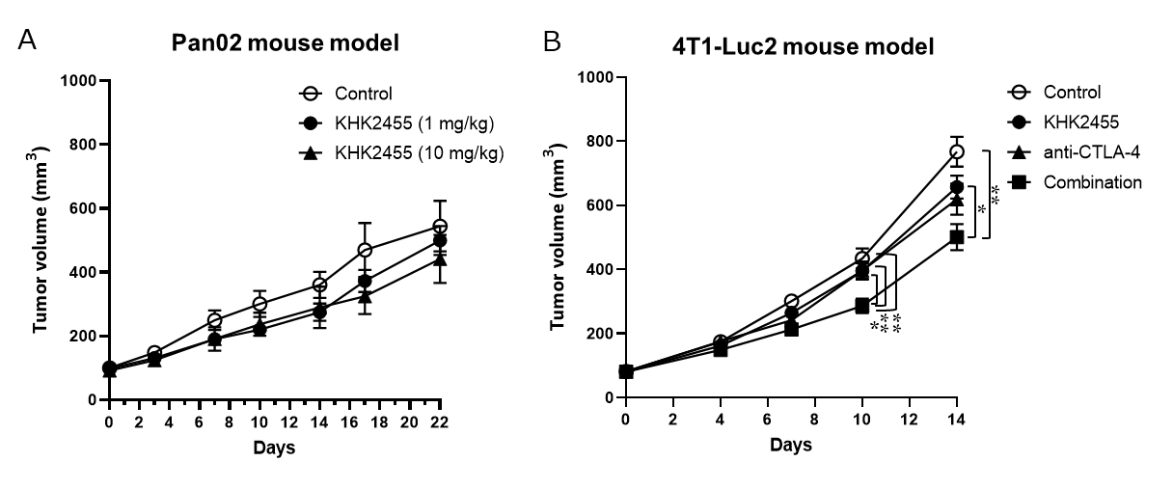
Figure S1

Figure S2. IDO1 inhibitory activity of KHK2455 in C57BL/6J mice treated with IFN-γ, and Ifng gene expression in mouse tumors treated with KHK2455, anti–PD-L1 antibody, or their combination.
(A) Kyn concentration in plasma was measured. The control group was administered MC400, the IFN-γ group was administered IFN-γ, and KHK2455 + IFN-γ groups were administered both KHK2455 (0.01 – 10 mg/kg) and IFN-γ. The dots represent individual plasma specimens, and the bars indicate the mean values (n = 4/group). (B) Ifng gene expression in tumors. The dots represent individual tumors, and the bars indicate the mean values (n = 7/group).
Ifng, interferon gamma; Kyn, kynurenine; MC400, methylcellulose 400; PD-L1, programmed death-ligand 1.
Figure S2
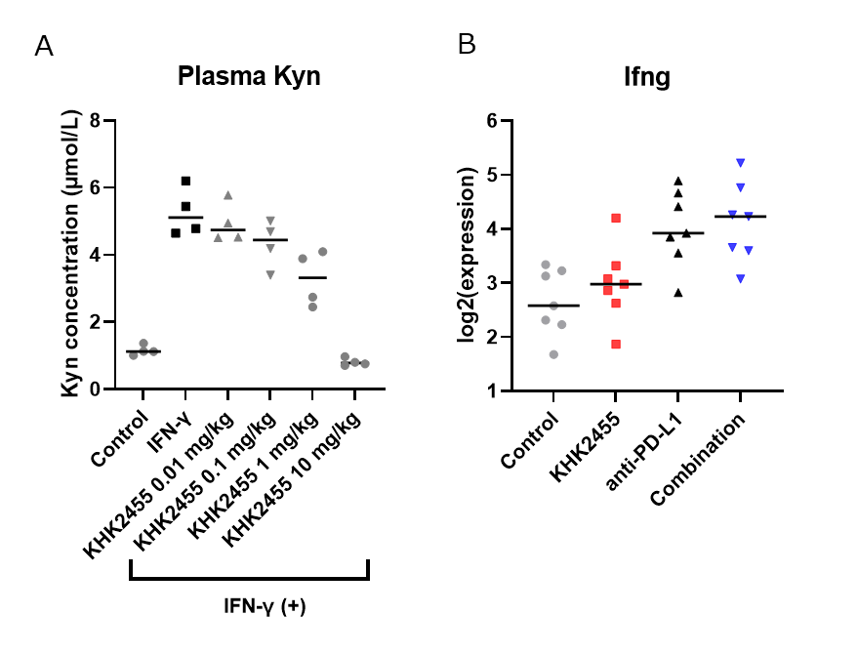

Figure S3. Individual tumor volume change of B16.F10.Luc.NY-ESO-1 melanoma in C57BL/6J mice.
(A) Each line represents the tumor volume change of an individual mouse (n = 15/group). (B) Mice with available gene expression data were classified into responder and non-responder subgroups within each treatment group. Black and gray lines represent responders and non-responders, respectively.
Combo, combination; PD-L1, programmed death-ligand 1.
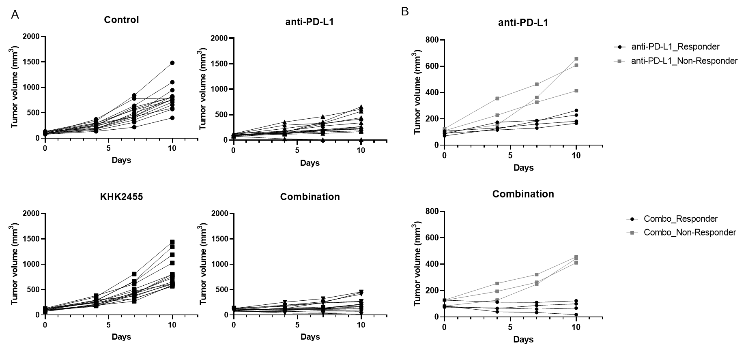
Figure S3

Figure S4. Abundance of immune cells in tumors from responder and non-responder mice treated with KHK2455, anti–PD-L1 antibody, or their combination.
The dots represent individual tumors, and the bars indicate the mean values (n = 7 for control, KHK2455 groups; n = 4 for responders in the anti-PD-L1 and combination groups; n =3 for non-responders in the anti-PD-L1 and combination groups). Differences in each cell type score between responders in the combination and anti–PD-L1 groups were assessed using the Wilcoxon rank-sum test.
PD-L1, programmed death-ligand 1; R, responder; NR, non-responder.
Figure S4
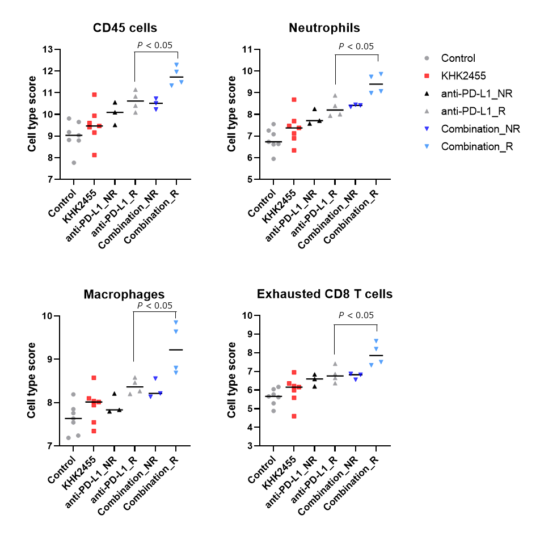

Supplementary Methods
Establishment of B16.F10 cells with a stable expression of human NY-ESO-1
The expression plasmid DNA of human NY-ESO1 was constructed by incorporating the synthesized sequence, gccacc (Kozak)-NY-ESO1 (NM_001327_CDS), into pDON-5 Neo (Takara Bio). A recombinant retroviral vector was produced by transfecting the expression plasmid DNA, pGP vector, and pE-Ampho vector into G3T-hi cells. The retroviral vector was then used to infect mouse melanoma cells expressing luciferase, B16-F10-Luc (gifted from Takashi Murakami, Saitama Medical University, Saitama, Japan), to obtain B16.F10.Luc.NY-ESO-1 cells.

Animal experiments
Two independent pharmacological studies were conducted using the B16.F10.Luc.NY-ESO-1 mouse model. Study 1 was designed to evaluate the long-term antitumor efficacy of the test articles. Tumor growth was monitored for up to 43 days following treatment initiation (n = 10 per group). Study 2 was performed to evaluate immune-related gene expression changes in the tumor microenvironment induced by each treatment. To this end, tumors and blood samples were collected on day 10 days after treatment initiation (n = 15 per group).
C57BL/6J mice (JAX® Mice Strain, female, 5 or 6 weeks old) were obtained from Charles River Laboratories Japan. B16.F10.Luc.NY-ESO-1 cells (1 × 10⁶ cells/0.05 mL/mouse) suspended in PBS were subcutaneously inoculated into C57BL/6J mice. Seven days after the inoculation (designated as day 0), the mice were divided into four groups (group 1: control group to which both MC400 and the isotype control antibody were administered; group 2: KHK2455 group to which both KHK2455 and the isotype control antibody were administered; group 3: anti–PD-L1 group to which both MC400 and anti–PD-L1 antibody were administered; and group 4: combination group to which both KHK2455 and anti–PD-L1 antibody were administered). In Study 2, an additional 15 mice were prepared for sample collection without any treatment for use as the baseline control group. In Study 1, KHK2455 or MC400 was orally administered once daily for 21 days (day 0 to 20), and in Study 2, for 10 days (day 0 to 9), at a dose of 10 mg/kg. Additionally, anti–PD-L1 antibody or the isotype control antibody was intraperitoneally administered at a dose of 100 μg/mouse on days 0, 2, and 4 in both Study 1 and Study 2.
The tumor volume at each time point ($V$) was calculated as follows:
$$V= \frac{1}{2} × D_{L} × D_{s}^{2}$$
where D_{L} and D_{s} represent the long and short diameters (mm), respectively.
The area under the curve of tumor volume–time, V_{AUC}, was calculated as follows:
$$V_{AUC}=(V_{day0}+V_{day4})×4×\frac{1}{2}+(V_{day4}+V_{day7})×3×\frac{1}{2}+(V_{day7}+V_{day10})×3×\frac{1}{2}$$
Tumor growth inhibition (TGI) was calculated as follows:
$$TGI \left(\%\right)=\left[1 - \frac{\left(T_{t} - T_{0}\right)}{\left(C_{t} - C_{0}\right)}\right]×100$$
where T_{t} and C_{t} represent the mean tumor volumes of the treatment and control groups at a given time point, respectively, and T₀ and C₀ represent the corresponding baseline means at the start of treatment (day 0).
The AUC-based TGI (TGI_AUC) was calculated as follows:
$$TGI_AUC \left(\%\right)=\left[1 - \frac{\left({AUC}_{treated}\right)}{\left({AUC}_{control}\right)}\right]×100$$
where AUC_{treated} and AUC_{control} represent the mean tumor volume–time AUC for the treatment and control groups, respectively.

Pharmacological evaluation in the Pan02 mouse model
C57BL/6 mice (C57BL/6NCrSlc, female, 6 weeks old) purchased from Japan SLC, Inc. were used for the pharmacological study using Pan02 cells. Pan02 cells (2 × 10⁶ cells/0.05 mL/mouse) suspended in RPMI 1640 medium without phenol red (Invitrogen) were subcutaneously inoculated into C57BL/6J mice. Twenty-five days after the inoculation (designated as day 0), the mice were divided into three groups (n = 10 per group; group 1: control group to which MC400 was administered; group 2: KHK2455 1 mg/kg group; group 3: KHK2455 10 mg/kg group). KHK2455 or MC400 were orally administered twice a day for 22 days (from day 0 to 21) at a dose of 1mg/kg or 10 mg/kg.

Pharmacological evaluation in the 4T1-Luc2 mouse model
BALB/c mice (female, 5 weeks old) purchased from Charles River Laboratories Japan were used for the pharmacological study using 4T1-luc2 cells. 4T1-luc2 cells (1 × 10⁶ cells/0.05 mL/mouse) suspended in DPBS (Life Technologies) were subcutaneously inoculated into BALB/c mice. Four days after the inoculation (designated as day 0), the mice were divided into four groups (n = 20 per group; group 1: control group to which both 0.1 v/v% ethanol and the isotype control antibody (mouse IgG2b isotype control: clone MPC-11, Bio X Cell) were administered; group 2: KHK2455 group to which both KHK2455 and the isotype control antibody were administered; group 3: anti–CTLA-4 group to which both 0.1 v/v% ethanol and anti–CTLA-4 antibody (clone 9D9, Bio X Cell) were administered; and group 4: combination group to which both KHK2455 and anti–CTLA-4 antibody were administered). KHK2455 or 0.1 v/v% ethanol was administered ad libitum via the drinking water from day 0 for 14 days. Anti–CTLA-4 antibody or the isotype control antibody was intravenously administered once a day on days 0, 3, and 6 at a dose of 100 μg/mouse.

Pharmacological evaluation in the C57BL/6J mouse treated with IFN-γ
C57BL/6J mice (female, 6 weeks old) were purchased from Charles River Laboratories Japan. Mice were divided into 6 groups (n = 4 per group). On the following day, mice in each group were orally administered either MC400 or KHK2455 (0.01 – 10 mg/kg). Approximately 1 hour later, mice received an intravenous injection of either 0.1 % BSA in DPBS (0.1 % BSA/DPBS) or IFN-γ (100 μg/kg, R&D systems, dissolved in 0.1 % BSA/DPBS). Twenty-four hours after treatment with either 0.1 % BSA/DPBS or IFN-γ, whole blood was collected and used for analyzing Kyn concentration by the liquid chromatography-tandem mass spectrometry analysis.

Preparation of the plasma and tumors for liquid chromatography-tandem mass spectrometry and nCounter analyses
Whole blood and tumors were collected from 15 untreated mice on day 0 for the baseline control and from 60 mice treated with the test and control agents on day 10 (groups 1–4). For each group, five and seven mice were randomly selected from the 15 mice and used for Kyn and Trp measurements in the tumor and plasma specimens and for the gene expression analysis in tumors, respectively. To prepare the tumor homogenate for the measurement of Kyn and Trp, frozen tumor samples were homogenized with a 3-fold quantity of water using TissueLyser II (Qiagen), and the tumor homogenates were centrifuged (8000 × g, 5 min) at 4°C. The supernatants were collected and stored at or below −20°C until the liquid chromatography-tandem mass spectrometry analysis was performed.

Liquid chromatography-tandem mass spectrometry analysis
L-Kyn (Sigma-Aldrich) and L-Trp (Fujifilm Wako Pure Chemical Corporation) were used as standards. L-Kyn (ring-D4) (d4-Kyn, Buchem B.V.) and L-Trp (Indole-D5, 98%) (d5-Trp, Cambridge Isotope Laboratories) were used as internal standards. The plasma and tumor homogenate samples were subjected to protein precipitation with trifluoroacetic acid, and the mixture was centrifuged (5000 × g, room temperature, 10 min). The supernatant was mixed with 0.05 vol% formic acid/methanol (75/25, v/v) and injected onto an Atlantis T3 column (3 µm, 4.6 mm × 75 mm) (Waters) coupled to a liquid chromatography-tandem mass spectrometry system consisting of Agilent 1200 (Agilent Technologies), HTC PAL (CTC Analytics), and API5000 mass spectrometer (AB SCIEX) using positive electrospray ionization mode. The mobile phase A was 0.05 vol% formic acid, and the mobile phase B was methanol. The gradient program was set as follows: mobile phase B was held at 5% for 0.2 min, gradually increased to 70% for 3.3 min (from 0.2 to 3.5 min), further increased to 90% for 1.5 min (from 3.51 to 5 min), and then decreased to 5% and held for 2 min (from 5.01 to 7 min). The flow rate was set at 0.6 mL/min. Multiple reaction monitoring was used to detect the analytes. The Q1/Q3 transitions were at m/z 205.1 > 146.4 for Trp, m/z 209.0 > 94.2 for Kyn, m/z 209.8 > 150.2 for d5-Trp, m/z 212.8 > 98.3 for d4-Kyn. The Kyn and Trp concentrations in the tumor specimens were individually calculated by multiplying the measured concentration (μmol/L) by the dilution factor (4-fold for the preparation of tumor homogenate) and expressed in units of μmol/L with the assumption that the specific volume of the tumor specimen is 1 mL/g. The Kyn/Trp ratio in the plasma or tumor specimens was individually calculated using the following equation:
$$\text{Kyn}\text{/}\text{Trp}\text{ ratio (}\text{nM}\text{/}\text{μM}\text{) = }\frac{\text{Kyn concentration (μmol/L)}}{\text{Trp concentration (μmol/L)}}\text{ × 1000}$$

Immune-related gene expression analysis
Total RNA was extracted from mouse tumor specimens collected on day 10 using NucleoSpin RNA (MACHEREY-NAGEL). The concentration and quality of the RNA were assessed using Agilent 2200 TapeStation (Agilent). The nCounter Mouse PanCancer IO 360 Panel plate loaded with RNA samples was analyzed by the nCounter Analysis System (NanoString Technologies) according to the procedures for hybridization, detection, and scanning. These experiments were conducted at Takara Bio Inc.
The raw data were analyzed using the nSolver Analysis Software program 4.0 and the Advanced Analysis software program 2.0 (NanoString Technologies) with the default parameter setting to obtain normalized gene expression data, differentially expressed genes (DEGs) between the groups, and the cell type profiling scores. Genes with a fold change ≥ 1.5 or < 0.67 and a P-value < 0.05 were considered significantly differentially expressed. Gene signature scoring was performed using R (R-4.0.2) and its package “singscore” with a simpleScore function. The pathway analysis was performed using the Ingenuity Pathway Analysis software program (IPA, Content version: 111725566, QIAGEN). The default parameter setting was applied.

Statistical analysis
Differences between the two groups were examined using the Wilcoxon rank-sum test. Survival curves were analyzed using the Kaplan–Meier method, and survival comparisons between groups were performed using the log-rank test with Bonferroni correction for multiple comparisons. Differences in V_{AUC} observed in the B16.F10.Luc.NY-ESO-1 model across treatment groups were evaluated using closed testing procedures with the hierarchical evaluation described below. The antitumor activity of the combination therapy was first confirmed by analyzing the difference between groups 1 and 4. The superiority of the combination therapy over each monotherapy was subsequently evaluated by analyzing the differences between groups 2 and 4 and groups 3 and 4. When the V_{AUC} of group 4 was significantly smaller than those of groups 2 and 3, the antitumor activity of the combination therapy was regarded to be superior to that of each monotherapy. For other multiple comparisons, the Holm method was used to correct for multiple tests. All analyses were performed with R (R-4.0.2). In this study, an adjusted P < 0.05 was considered significant.

