Defining alteration in bone marrow mesenchymal stem cells (MSC) from acute myeloid leukemia and exploring cultured MSC-conditioned media as a novel anti-leukemia therapy agent

Manasi Nagare^{1,10}, Monalisa Sahoo¹, Manju Sengar^{3,10}, Sachin Punatar^{3,10}, Navin Khattry^{3,10}, Anant Gokarn^{3,10}, Bhausaheb Bagal^{3,10}, Hasmukh Jain^{3,10}, Sumeet Mirgh^{3,10}, Sridhar Epari^{4,10}, Tanuja Shet^{9,10}, Trupti Pradhan¹, Shweta Shirsat¹, Madan Barkume², Caroline Mathen¹¹, Poonam Gera^{7,10}, Rohit Kumar Verma⁶, Elveera Saldanha^{6,10}, Pratik Chandrani^{6,10}, Jitendra Gawde⁸, Shubhada Chiplunkar^{5,10}, Jyoti Kode^{1,10*}

Figure | Page No.
Supplementary Figure S1 | 2
Supplementary Figure S2 | 3
Supplementary Figure S3 | 4
Supplementary Figure S4 | 5
Supplementary Figure S5 | 6
Supplementary Figure S6 | 7
Supplementary Figure S7 | 7
Supplementary Figure S8 | 8
Supplementary Figure S9 | 8
Supplementary Figure S10 | 9
Supplementary Figure S11 | 10
Supplementary Figure S12 | 10
Supplementary Figure S13 | 11
Supplementary Figure S14 | 11
Supplementary Figure S15 | 12
Supplementary Figure S16 | 13
Supplementary Figure S17 | 14
Supplementary Figure S18 | 15
Supplementary Figure S19 | 15
Supplementary Video SV1 | 16

Supplementary Figure S1

Fig. S1 Morphological evaluation in AML-BM-MSC. The figure depicts the bright-field microscopic images of mesenchymal stem cells isolated from AML bone marrow. AML-BM-MSC isolated from 4 different patients were cultured up to passage P5, and images were captured at a scale of 100µm with 20x magnification.

Supplementary Figure 2:

Fig. S2 Multicolor immunophenotyping of AML-BM-MSC Panel [A] depicts a scatter plot of isolated and cultured AML-BM-MSC and histogram plots describing mean fluorescence intensities (MFI) of expressed markers. Top right labels in blue indicate percent positive cells, and green labels represent MFI values. Panel [B] and [C] represent bar graph marker expressions in AML patient-derived BM-MSC and their representative MFI values in the table. The experiment was conducted in (n=3) biological samples.

Supplementary Figure S3
Fig. S3: Ultrastructural morphological differences in AML-BM-MSC and healthy UC-MSC by TEM. The electron micrographs of AML-BM-MSC and UC-MSC exhibit variations in terms of [A] cytoplasmic density, altered number of cellular vesicles and mitochondrial morphology. [B] The values within each panel denote vesicle count. [C] Bar graphs exhibit quantification of enumerated intracellular vesicles. The experiment was conducted in 2 biological and 2 technical replicates. All images were captured at a magnification of 10000x. Significant p-values are highlighted and accompanied by the Mean ± SEM values. For the enumeration experiment (n=5), different sections were counted for both cell types.

Supplementary Figure S4

Fig. S4 Ultrastructural morphological alterations in UC-MSC co-cultured with OCI-AML2 cells. UC-MSC quantification. [A] Mitochondrial number, [B] Intracellular vesicle count and [C] ER Luminal width in control and co-cultured UC-MSC. Number of fields counted n=3. The experiment was conducted using three biological replicates and two technical replicates. Significant p-values are highlighted and accompanied by the Mean ± SEM values. Images were captured and analyzed at 3000x and 5000x, respectively.

Supplementary Figure S5:

Fig. S5 Gene expression profiling in AML-BM-MSC Panel [A] shows differential gene expression with Limma-voom package using R software. Overlapping region signifies overlapping genes from both DESeq2 and Limma-voom. Panel [B] depicts enriched pathways belonging to biological processes, cellular components and molecular functions. Panel [C] shows bar graph of significantly enriched pathway by Over representation analysis (ORA) with FDR $≤$ 0.05 as significant. Panel [D] demonstrates gene ontology conducted to obtain enriched biological processes (BP) with FDR $≤$ 0.05 as significant.

Supplementary Figure S6:

Fig. S6 Data validation by quantitative real-time PCR. Bar graph showing fold change difference in inflammasome pathway gene (NLRP3, IL-18, and CASP-1) expression over 18S rRNA in AML-BM-MSC compared to UC-MSC. The experiment was conducted with three technical replicates.

Supplementary Figure S7
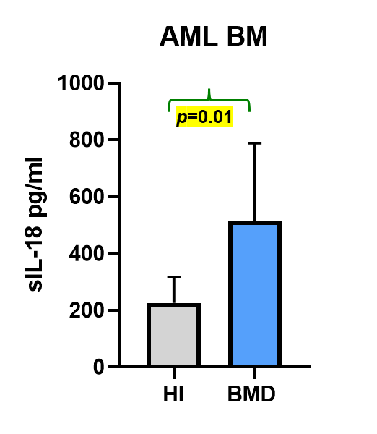
Fig S7: sIL-18 secretion in AML patient bone marrow plasma at diagnosis. Bar graphs depicting sIL-18 concentration in pg/ml in AML BM plasma (n=4) at diagnosis in comparison to healthy individual peripheral blood plasma (n=5). Significant p-values are highlighted in yellow.
Supplementary Figure 8:

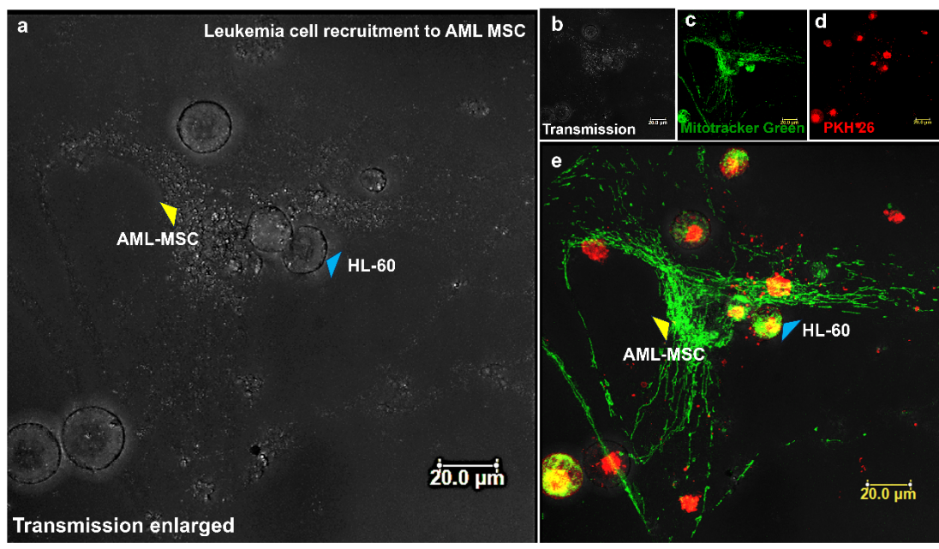
Fig. S8: Recruitment of HL-60 to AML-MSC Panel (a) demonstrates magnified transmission image showing HL-60 cells (blue arrow) located next to AML-MSC (yellow arrow). Panel (b) shows smaller transmission image of that shown in panel (a). Panels (c) and (d) show Mito-tracker green (AML-MSC) and PKH-26 red (HL-60) cells. Leukemic blasts are aligning next to the MSC, ii] Leukemic factors released from HL-60 (Lipid membrane labeled red) being carried through red vesicles are observed with MSC (stained green with mitochondria tracker). Panel (e) demonstrates Leukemic blast showing dual color yellow due to transfer of green mitochondria within red labeled HL-60. Images are captured at a scale of 20µm.

Supplementary Figure S9
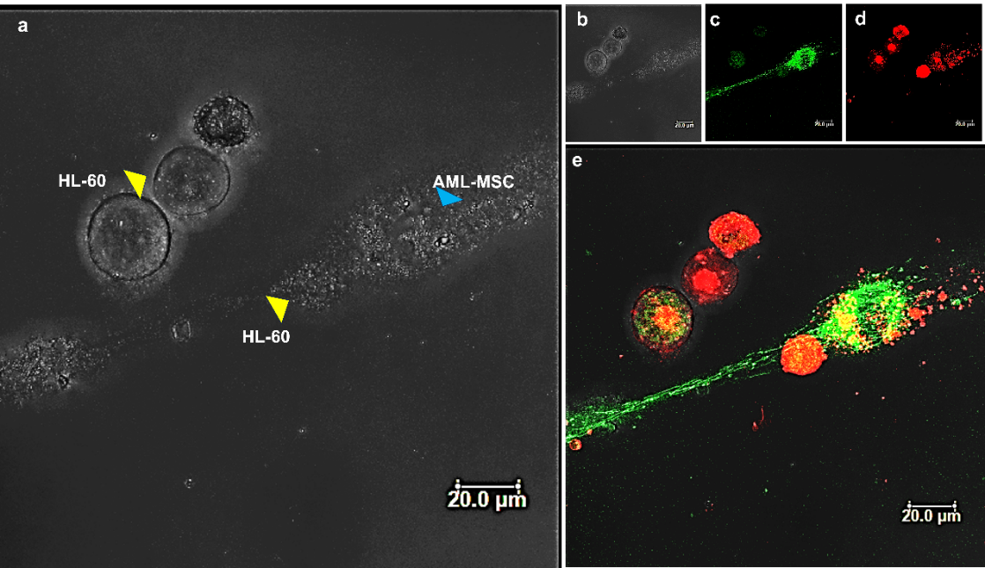
Fig. S9: Recruitment of HL-60 to AML-MSC Panel (a) demonstrates a magnified transmission image showing HL-60 cells (blue arrow) located next to AML-MSC (yellow arrow). Panel (b) shows a smaller transmission image as that of panel a. Panels (c) and (d) show Mito-tracker green (AML-MSC) and PKH-26 red (HL-60) cells. Leukemic blasts are aligning next to the MSC, ii] Leukemic factors released from HL-60 (Lipid membrane labeled red) being carried through red vesicles are observed with MSC (stained green with mitochondria tracker). Panel (e) demonstrates Leukemic blast showing dual color yellow due to transfer of green mitochondria within red labeled HL-60.

Supplementary Figure S10
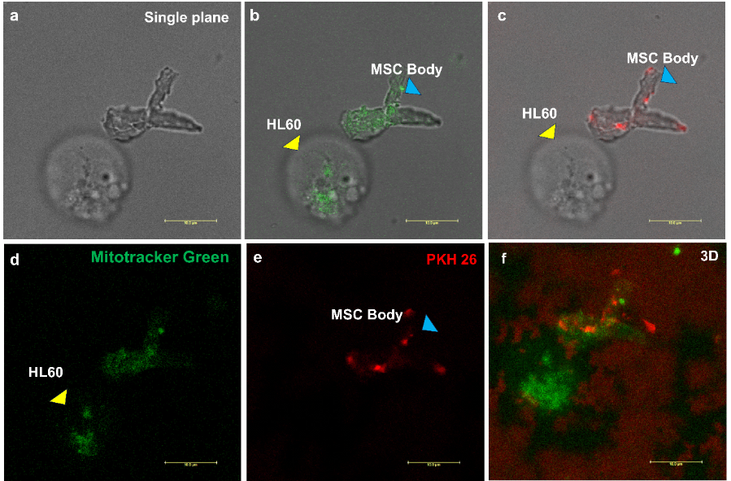

Fig. S10: Interaction of AML-MSC originating MSC body with leukemia cell (HL-60) Panel (a) demonstrates transmission image of MSC body interacting with HL-60 (leukemia cell line). Panel (b) and (c) demonstrate merged transmission and stained image of showing HL-60 cells (green) located next to AML-MSC (red). Panel (d) and (e) show Mito-tracker green stained (HL-60) and PKH26 stained (AML-MSC). Panel (f) shows merged image demonstrating MSC body interaction with HL-60 cells. Leukemic blasts are aligning next to the MSC, Leukemic factors released from HL-60 (Lipid membrane labeled red) being carried through red vesicles are observed with MSC (stained green with mitochondria tracker). Panel e demonstrates Leukemic blast showing dual color yellow due to transfer of green mitochondria within red labeled HL-60.

Supplementary Figure S11:
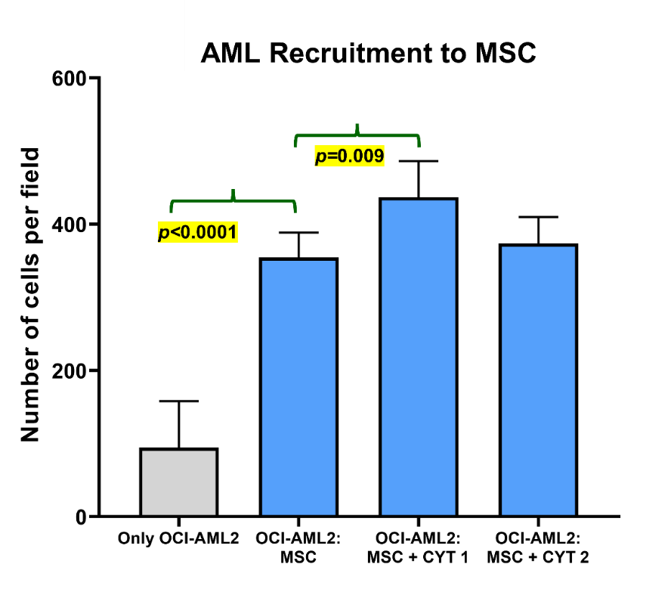
Fig. S11 Trans well migratory potential of OCI-AML2 cells to AML-BM-MSC. The bar graph illustrates the recruitment of OCI-AML2 to AML-BM-MSC in trans well cultures within 24 hours. p-value <0.05 was considered significant and is highlighted in yellow.

Supplementary Figure S12

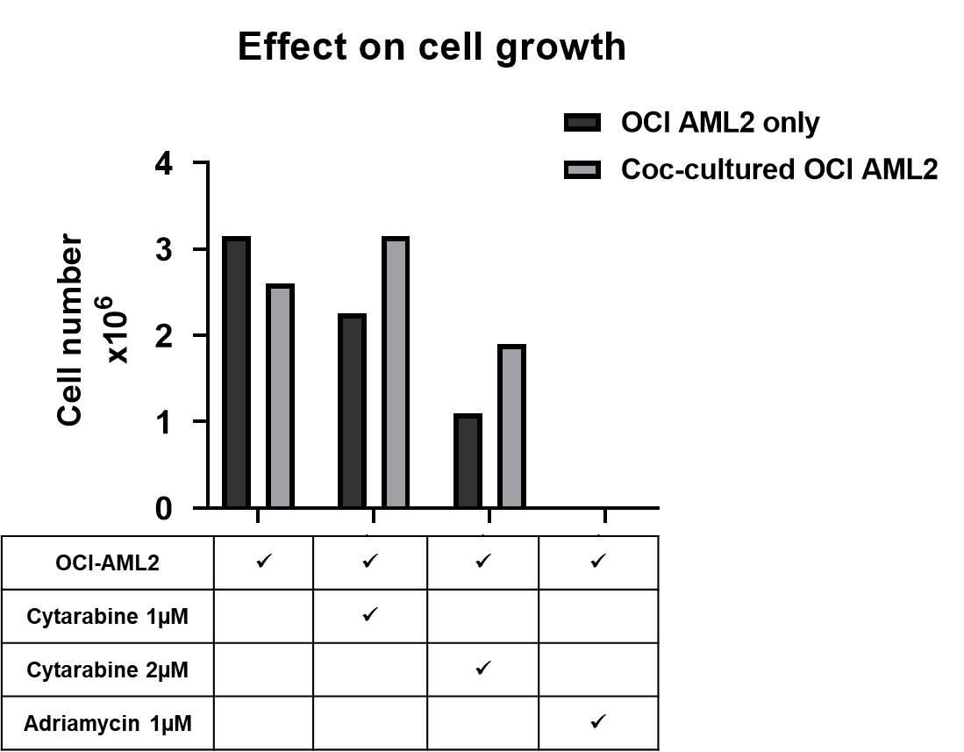

Fig. S12 Enumeration of viable OCI-AML2 in single and co-cultures Figure shows representative bar graphs of OCI-AML2 cells cultured in single or in co-cultures with AML-BM-MSC, evaluated for viability by trypan blue staining. The experiment was conducted using two biological replicates.

Supplementary Figure S13
Fig. S13 Cell cycle modulation effect of OCI-AML2 in response to cytarabine treatment was found to have a marginal effect.

Supplementary Figure S14:
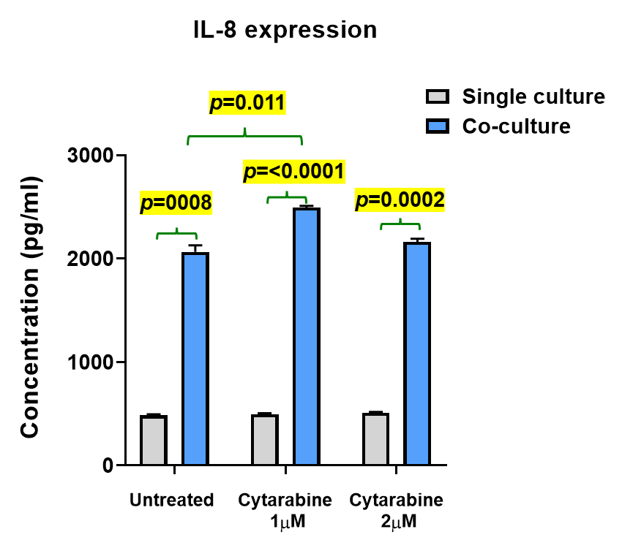
Fig. S14 Soluble IL-8 levels in OCI-AML2 single and co-culture supernatants. Alteration in cell cycle phase analysis of OCI-AML2 cells as single and co-cultured with AML-BM-MSC for 48 hours in the presence of cytarabine as a standard histogram and bar graph. Significant P-values are highlighted and accompanied by the Mean ± SEM values.

Supplementary Figure S15:

Fig. S15: PD-MSC-CM composition. Values are represented in pg/ml

Supplementary Figure 16:
Fig. S16 PD-MSC-CM composition of growth factors. Values are represented in pg/ml

Supplementary Figure 17:

Fig. S17 Effect of PD-MSC-CM on mitochondrial membrane potential in OCI-AML2 cells [A] Panel represents the (a) FSC vs SSC scatter plots of OCI-AML2 cells. Subpanel (b) represents control OCI-AML2 cell scatter gated for dual expression of J-aggregates (y-axis) and Monomers at (x-axis). Subpanels (c-h) represent the dual-stained scatter plots of OCI-AML2 cells treated with N-BM-MSC-CM (n=1) and PD-MSC-CM (n=5). [B] Mitochondrial membrane potential determination in PD-MSC-CM-34 in the presence of Cytarabine treatment. FSC vs SSC scatter plots of OCI-AML2 cells are depicted as (a) control, (b) Cytarabine (1µM), (c) CCCP (5µM) as a positive control, (d) PD-MSC-CM-34 treated and (e) PD-MSC-CM-34 in the presence of Cytarabine (1µM).

Supplementary Figure S18:

Fig. S18 OCI-AML2 inflammasome activation model was treated with MCC950 and PD-MSC-CM. Panel [A] depicts cell region with puncta marked for line intensity, [B] Line intensity graph where top right values indicated maximum intensity projected, and [C] 3D interactive plots of OCI-AML2 cell.

Supplementary Figure S19:

Fig. S19 In vivo efficacy assay in an immunodeficient mouse model
Panel [A] depicts line graphs for relative tumor volumes of ETP-ALL BM-MSC-CM-treated NOD-SCID mice. The experiment was conducted for 30 days, and tumor volumes were recorded every fourth day. Mice treated with ADR were used as a positive control. Panel [B] represents the fold change values of inflammasome pathway gene expressions by microarray analysis.

Supplementary Video 2
SV1: Mitochondrial transfer from MSC to AML cells

Supplementary video SV2
Evaluation of mitochondrial transfer in AML-BM-MSC to OCI-AML2 cells. Live mitochondrial transfer between AML-BM-MSC and OCI-AML2 cells is demonstrated in the above figure. Green circles represent the projected images of PKH67-stained OCI-AML2 cells. Red elongated to irregular structures represent the Mito-tracker CMX ROX-stained mitochondria in AML-BM-MSC. The image represents a snapshot of live cell imaging at a scale of 3 µm and 100x magnification by a 3i spinning disc confocal microscope.

