Supplementary Figure 1.
Distribution of propensity scores between the patients treated with nivolumab plus cabozantinib and pembrolizumab plus lenvatinib

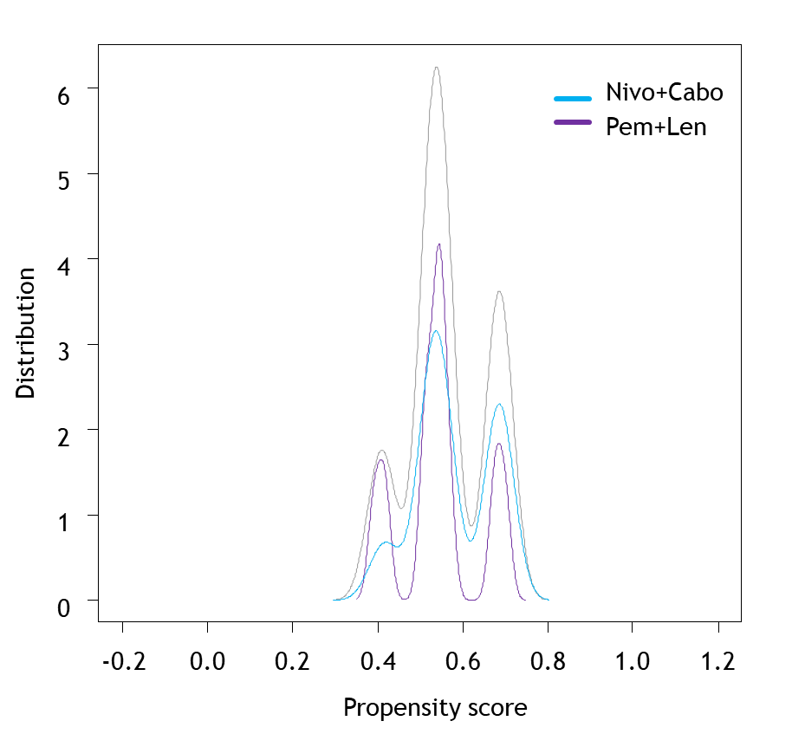

Supplementary Figure 2.
Kaplan-Meier curves of 2nd-line PFS in mRCC patients treated with axitinib versus cabozantinib for progression after nivolumab plus cabozantinib or pembrolizumab plus lenvatinib
PFS: Progression-free survival, mRCC: metastatic renal cell carcinoma
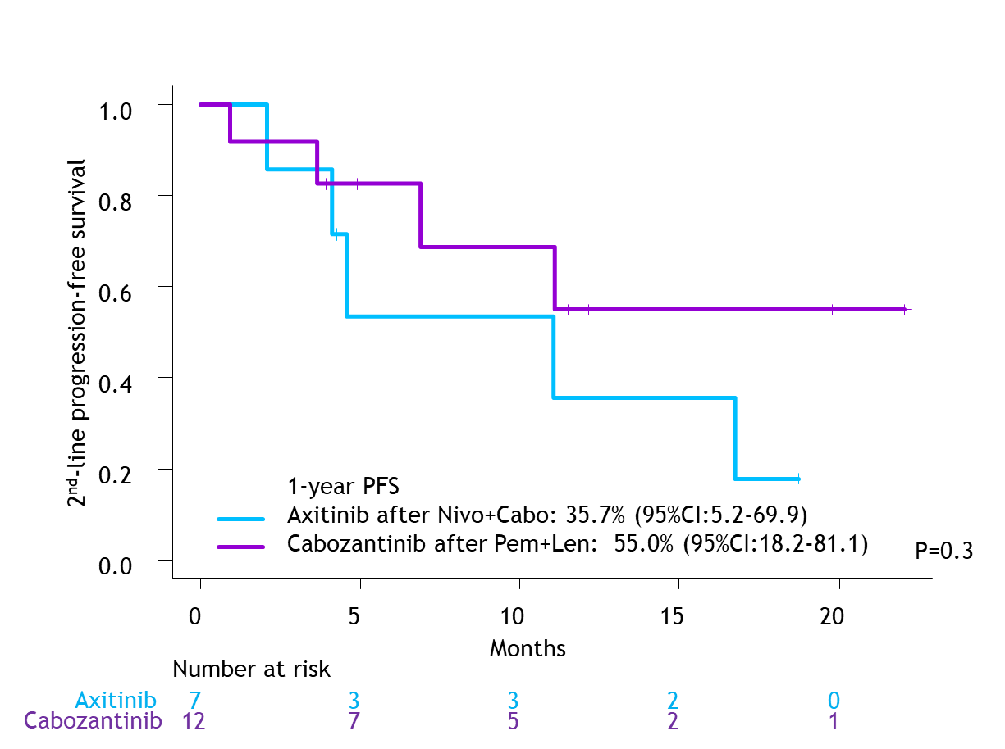

Supplementary Table 1.
Safety profiles in matched cohorts treated with nivolumab + cabozantinib versus pembrolizumab + Lenvatinib
 |  | Matched cohort
 |  | Nivo+Cabo | Pem+Len | P-value
Number of pts. |  | 74 | 74
Initial TKI dose reduction, n(%) |  | 25 (34) | 16 (22) | 0.14
TKI dose reduction during treatment, n(%) |  | 53 (72) | 52 (70) | 1
Discontinuation due to AEs, n(%) |  | 17 (23) | 18 (24) | 1
Any grade TrAEs, n(%) |  | 67 (92) | 69 (93) | 0.8
Severe TrAEs, n(%) |  | 23 (31) | 34 (46) | 0.091
Severe IrAEs, n(%) |  | 16 (22) | 22 (30) | 0.5
TrAE: Treatment-related adverse events, IrAE: Immune-related adverse events, Nivo: Nivolumab, Cabo: Cabozantinib, Pem: Pembrolizumab, Len: Lenvatinib, TKI: Tyrosine kinase inhibitor

Supplementary Table 2.
Mentenace dosage at closest follow-up in all patients treated with nivolumab + cabozantinib versus pembrolizumab + lenvatinib
 |  | Overall cohort
 |  | Nivo+Cabo |  | Pem+Len
Number of pts. |  | 81 |  | 104
Maintenace TKI dosage, n(%) |  | 40mg | 28 (35) | 20mg | 31 (30)
 |  | 20mg | 43 (53) | 14mg | 17 (16)
 |  | 10mg | 6 (7.4) | 10mg | 28 (27)
 |  | 0mg | 1 (1.2) | 8mg | 9 (8.7)
 |  | ND | 3 (3.7) | 7mg* | 2 (1.9)
 |  |  |  | 5mg* | 2 (1.9)
 |  |  |  | 4mg | 12 (12)
 |  |  |  | 2mg* | 1 (1.0)
 |  |  |  | 0mg | 2 (1.9)
 |  |  |  | ND | 0
TKI: Tyrosine kinase inhibitor, ND: No data
*10mg and/or 4mg tablet(s) every other day

Supplementary Table 3.
Study demographics and oncologic/safety outcomes of 1st-line ICI-based conbination therapy for mRCC

