Supplementary Materials

Supplementary Table S1. Clinical and demographic characteristics of study cohort
Lineage | N | Percentage | Female (%) | Median Age (IQR) | Median Age (IQR), Female | Median Age (IQR), Male
Anal Carcinoma | 181 | 0.7 | 71.3 | 64 (56, 71) | 64 (57, 71) | 63 (56, 69)
Anaplastic Thyroid Carcinoma | 29 | 0.1 | 37.9 | 66 (58, 72) | 66 (58, 74) | 68 (59, 72)
Bladder cancer - non-urothelial | 72 | 0.3 | 51.4 | 70 (64, 76) | 68 (62, 75) | 71 (65, 76)
Bladder cancer - urothelial | 1624 | 6.1 | 27.8 | 74 (66, 80) | 73 (64, 79) | 74 (66, 80)
Bone Cancer - Chondrosarcoma | 14 | 0.1 | 28.6 | 60 (54, 68) | 62 (61, 66) | 58 (53, 68)
Bone Cancer - Chordoma | 1 | 0 | 0 | 61 (61, 61) | NA | 61 (61, 61)
Bone Cancer - Giant Cell Tumor of the Bone | 1 | 0 | 0 | 41 (41, 41) | NA | 41 (41, 41)
Bone Cancer - Ewing Sarcoma | 1 | 0 | 100 | 26 (26, 26) | 26 (26, 26) | NA
Bone Cancer - Osteosarcoma | 9 | 0 | 33.3 | 70 (60, 76) | 70 (54, 70) | 70 (61, 77)
Breast Carcinoma | 1150 | 4.3 | 99 | 60 (51, 69) | 60 (50, 69) | 72 (65, 83)
Cancer of Unknown Primary | 755 | 2.8 | 48.6 | 68 (60, 75) | 68 (59, 75) | 68 (60, 75)
Central Nervous System Cancers - Adult Intracranial and Spinal Ependymoma (Excluding Subependymoma) | 2 | 0 | 50 | 33 (30, 36) | 28 (28, 28) | 38 (38, 38)
Central Nervous System Cancers - Meningiomas | 6 | 0 | 50 | 60 (53, 65) | 57 (41, 62) | 63 (58, 64)
Cervical Cancer | 1188 | 4.4 | 100 | 53 (43, 63) | 53 (43, 63) | NA
Cholangiocarcinoma | 136 | 0.5 | 55.1 | 67 (61, 74) | 66 (58, 74) | 68 (62, 74)
Colorectal Adenocarcinoma | 939 | 3.5 | 52.5 | 68 (57, 77) | 70 (60, 78) | 66 (53, 75)
Esophageal Carcinoma | 202 | 0.8 | 34.2 | 67 (61, 75) | 66 (59, 74) | 68 (62, 75)
Esophagogastric Junction Carcinoma | 649 | 2.4 | 15.6 | 67 (59, 74) | 69 (61, 78) | 66 (58, 73)
Extrahepatic Bile Duct Adenocarcinoma | 27 | 0.1 | 40.7 | 66 (60, 76) | 73 (61, 75) | 66 (58, 78)
Female Genital Tract Malignancy | 371 | 1.4 | 99.7 | 65 (58, 72) | 65 (58, 72) | 50 (50, 50)
Gastric Adenocarcinoma | 382 | 1.4 | 39.5 | 71 (60, 78) | 72 (62, 80) | 70 (60, 77)
Gastrointestinal Stromal Tumors (GIST) | 5 | 0 | 60 | 67 (62, 71) | 62 (60, 72) | 69 (68, 70)
Glioblastoma | 81 | 0.3 | 39.5 | 51 (41, 64) | 47 (35, 68) | 53 (43, 62)
Head and Neck Cancers | 1352 | 5.1 | 24.3 | 65 (58, 72) | 66 (58, 74) | 65 (58, 72)
Kidney Cancer | 799 | 3 | 28.8 | 64 (56, 72) | 65 (58, 73) | 64 (55, 71)
Liver Hepatocellular Carcinoma | 28 | 0.1 | 25 | 67 (62, 74) | 58 (54, 72) | 67 (63, 74)
Low Grade Glioma | 7 | 0 | 57.1 | 49 (46, 56) | 48 (38, 53) | 49 (48, 64)
Lung Bronchioloalveolar carcinoma (BAC) | 1 | 0 | 100 | 64 (64, 64) | 64 (64, 64) | NA
Lung Non-small cell lung cancer (NSCLC) | 8855 | 33.1 | 46.6 | 68 (62, 75) | 69 (62, 75) | 68 (62, 75)
Lung Small Cell Cancer (SCLC) | 67 | 0.3 | 62.7 | 68 (62, 74) | 68 (62, 74) | 68 (64, 75)
Lymphoma | 9 | 0 | 33.3 | 70 (58, 72) | 53 (43, 62) | 72 (68, 74)
Male Genital Tract Malignancy | 9 | 0 | 0 | 43 (33, 64) | NA | 43 (33, 64)
Malignant Histiocytosis | 1 | 0 | 100 | 54 (54, 54) | 54 (54, 54) | NA
Malignant Pleural Mesothelioma | 30 | 0.1 | 43.3 | 77 (68, 83) | 74 (63, 82) | 78 (76, 83)
Malignant Solitary Fibrous Tumor of the Pleura (MSFT) | 1 | 0 | 100 | 73 (73, 73) | 73 (73, 73) | NA
Melanoma | 1449 | 5.4 | 40 | 70 (61, 79) | 68 (59, 76) | 71 (63, 80)
Merkel Cell Carcinoma (MCC) | 62 | 0.2 | 29 | 76 (70, 80) | 76 (69, 80) | 76 (71, 80)
Neuroendocrine tumors | 176 | 0.7 | 48.9 | 66 (54, 74) | 62 (50, 74) | 68 (59, 74)
Nodal Diffuse Large B-Cell Lymphoma | 3 | 0 | 66.7 | 62 (58, 62) | 62 (62, 62) | 55 (55, 55)
Non Epithelial Ovarian Cancer (non-EOC) | 27 | 0.1 | 100 | 56 (45, 62) | 56 (45, 62) | NA
Non-Melanoma Skin Cancers - Basal Cell Skin Cancer | 13 | 0 | 15.4 | 66 (60, 78) | 69 (64, 74) | 66 (60, 78)
Non-Melanoma Skin Cancers - Squamous Cell Skin Cancer | 176 | 0.7 | 30.1 | 73 (65, 83) | 75 (66, 83) | 73 (64, 83)
Other | 76 | 0.3 | 48.7 | 69 (58, 77) | 67 (52, 77) | 69 (60, 78)
Ovarian Surface Epithelial Carcinomas | 1009 | 3.8 | 100 | 65 (57, 71) | 65 (57, 71) | NA
Pancreatic Adenocarcinoma | 135 | 0.5 | 46.7 | 68 (61, 75) | 69 (62, 75) | 67 (60, 74)
Penile Cancer | 36 | 0.1 | 0 | 75 (62, 81) | NA | 75 (62, 81)
Peripheral Nervous System Tumors | 7 | 0 | 57.1 | 60 (46, 64) | 54 (47, 62) | 62 (36, 64)
Pituitary carcinomas, Oligodendroglioma | 1 | 0 | 0 | 67 (67, 67) | NA | 67 (67, 67)
Prostatic Adenocarcinoma | 165 | 0.6 | 0 | 70 (63, 77) | NA | 70 (63, 77)
Retroperitoneal or Peritoneal Sarcoma | 11 | 0 | 54.5 | 60 (48, 74) | 62 (46, 74) | 60 (54, 75)
Salivary Gland Tumors | 120 | 0.4 | 42.5 | 67 (57, 77) | 70 (60, 76) | 67 (55, 77)
Small Intestinal Malignancies | 81 | 0.3 | 35.8 | 68 (59, 77) | 71 (66, 81) | 65 (58, 75)
Soft Tissue Sarcoma - Well-Differentiated/Dedifferentiated Liposarcoma (WD-DDLS) for Retroperitoneal Sarcomas | 15 | 0.1 | 40 | 61 (59, 66) | 66 (62, 74) | 60 (58, 65)
Soft Tissue Tumors | 240 | 0.9 | 41.2 | 68 (53, 77) | 66 (52, 76) | 69 (54, 78)
Thymic Carcinoma | 38 | 0.1 | 31.6 | 62 (54, 73) | 66 (58, 74) | 62 (51, 72)
Thyroid Carcinoma | 68 | 0.3 | 35.3 | 68 (58, 74) | 68 (64, 73) | 68 (54, 74)
Uterine Neoplasms - Endometrial carcinoma | 2520 | 9.4 | 100 | 65 (58, 72) | 65 (58, 72) | NA
Uterine Serous Carcinoma | 1111 | 4.2 | 99.9 | 68 (63, 73) | 68 (63, 73) | 75 (75, 75)
Uveal Melanoma | 15 | 0.1 | 40 | 74 (69, 76) | 74 (66, 75) | 74 (70, 76)
Vulvar Cancer (squamous cell carcinoma) | 218 | 0.8 | 100 | 68 (59, 76) | 68 (59, 76) | NA
Total | 26756 | 100 | 57.4 | 67 (59, 75) | 66 (58, 74) | 68 (61, 76)

Supplementary Table S2. Clinical and demographic characteristics of discordant cohort
Lineage | N | Percentage | Female (%) | Median Age (IQR) | Median Age (IQR), Female | Median Age (IQR), Male
Anal Carcinoma | 37 | 0.7 | 70.3 | 65 (58, 70) | 67 (57, 72) | 63 (58, 66)
Anaplastic Thyroid Carcinoma | 5 | 0.1 | 40 | 55 (53, 58) | 52 (48, 55) | 55 (54, 65)
Bladder cancer - non-urothelial | 22 | 0.4 | 45.5 | 69 (65, 73) | 66 (64, 71) | 71 (67, 74)
Bladder cancer - urothelial | 443 | 8.7 | 26.9 | 74 (66, 80) | 73 (65, 78) | 74 (66, 81)
Bone Cancer - Chondrosarcoma | 1 | 0 | 0 | 43 (43, 43) | NA | 43 (43, 43)
Bone Cancer – Ewing Sarcoma | 1 | 0 | 100 | 26 (26, 26) | 26 (26, 26) | NA
Bone Cancer – Osteosarcoma | 1 | 0 | 0 | 60 (60, 60) | NA | 60 (60, 60)
Breast Carcinoma | 192 | 3.8 | 97.9 | 61 (51, 70) | 61 (51, 70) | 74 (61, 84)
Cancer of Unknown Primary | 123 | 2.4 | 46.3 | 69 (61, 75) | 66 (60, 74) | 70 (62, 76)
Cervical Cancer | 205 | 4 | 100 | 55 (46, 63) | 55 (46, 63) | NA
Cholangiocarcinoma | 15 | 0.3 | 46.7 | 65 (61, 72) | 71 (63, 76) | 64 (58, 68)
Colorectal Adenocarcinoma | 139 | 2.7 | 46 | 65 (56, 75) | 64 (52, 73) | 67 (57, 78)
Esophageal Carcinoma | 40 | 0.8 | 32.5 | 69 (63, 78) | 68 (63, 78) | 72 (64, 78)
Esophagogastric Junction Carcinoma | 72 | 1.4 | 16.7 | 69 (61, 77) | 66 (60, 77) | 70 (62, 77)
Extrahepatic Bile Duct Adenocarcinoma | 5 | 0.1 | 40 | 66 (45, 76) | 59 (50, 68) | 66 (56, 72)
Female Genital Tract Malignancy | 38 | 0.7 | 100 | 66 (63, 74) | 66 (63, 74) | NA
Gastric Adenocarcinoma | 48 | 0.9 | 52.1 | 66 (59, 76) | 66 (62, 77) | 65 (59, 74)
Glioblastoma | 6 | 0.1 | 50 | 44 (28, 57) | 56 (42, 70) | 32 (20, 44)
Head and Neck Cancers | 215 | 4.2 | 25.6 | 66 (61, 72) | 66 (61, 75) | 66 (61, 72)
Kidney Cancer | 62 | 1.2 | 27.4 | 64 (60, 73) | 62 (57, 74) | 65 (62, 72)
Liver Hepatocellular Carcinoma | 6 | 0.1 | 16.7 | 66 (60, 69) | 58 (58, 58) | 67 (66, 70)
Lung Bronchioloalveolar carcinoma (BAC) | 1 | 0 | 100 | 64 (64, 64) | 64 (64, 64) | NA
Lung Non-small cell lung cancer (NSCLC) | 2433 | 47.8 | 47.9 | 68 (63, 75) | 69 (63, 76) | 68 (62, 75)
Lung Small Cell Cancer (SCLC) | 18 | 0.4 | 61.1 | 67 (62, 74) | 65 (62, 72) | 72 (64, 75)
Lymphoma | 4 | 0.1 | 50 | 56 (48, 60) | 43 (38, 48) | 62 (60, 65)
Male Genital Tract Malignancy | 2 | 0 | 0 | 48 (41, 56) | NA | 48 (41, 56)
Malignant Histiocytosis | 1 | 0 | 100 | 54 (54, 54) | 54 (54, 54) | NA
Malignant Pleural Mesothelioma | 1 | 0 | 100 | 51 (51, 51) | 51 (51, 51) | NA
Melanoma | 195 | 3.8 | 42.1 | 65 (56, 73) | 64 (54, 72) | 65 (56, 75)
Neuroendocrine tumors | 18 | 0.4 | 61.1 | 65 (56, 73) | 60 (52, 71) | 72 (64, 76)
Nodal Diffuse Large B-Cell Lymphoma | 2 | 0 | 100 | 62 (62, 62) | 62 (62, 62) | NA
Non Epithelial Ovarian Cancer (non-EOC) | 3 | 0.1 | 100 | 51 (42, 52) | 51 (42, 52) | NA
Non-Melanoma Skin Cancers - Squamous Cell Skin Cancer | 11 | 0.2 | 27.3 | 67 (63, 70) | 66 (63, 69) | 67 (64, 70)
Other | 8 | 0.2 | 12.5 | 68 (59, 73) | 60 (60, 60) | 69 (62, 73)
Ovarian Surface Epithelial Carcinomas | 102 | 2 | 100 | 62 (55, 71) | 62 (55, 71) | NA
Pancreatic Adenocarcinoma | 17 | 0.3 | 58.8 | 66 (63, 72) | 66 (62, 73) | 64 (63, 70)
Penile Cancer | 11 | 0.2 | 0 | 80 (78, 82) | NA | 80 (78, 82)
Peripheral Nervous System Tumors | 1 | 0 | 0 | 9 (9, 9) | NA | 9 (9, 9)
Prostatic Adenocarcinoma | 20 | 0.4 | 0 | 66 (57, 71) | NA | 66 (57, 71)
Salivary Gland Tumors | 13 | 0.3 | 30.8 | 61 (55, 69) | 60 (58, 63) | 64 (55, 69)
Small Intestinal Malignancies | 12 | 0.2 | 50 | 64 (58, 75) | 74 (67, 82) | 58 (56, 60)
Soft Tissue Tumors | 19 | 0.4 | 63.2 | 70 (62, 76) | 68 (62, 74) | 71 (65, 78)
Thymic Carcinoma | 2 | 0 | 50 | 63 (56, 70) | 76 (76, 76) | 50 (50, 50)
Thyroid Carcinoma | 5 | 0.1 | 20 | 69 (61, 72) | 69 (69, 69) | 66 (61, 73)
Uterine Neoplasms - Endometrial carcinoma | 386 | 7.6 | 100 | 64 (57, 72) | 64 (57, 72) | NA
Uterine Serous Carcinoma | 90 | 1.8 | 100 | 69 (63, 74) | 69 (63, 74) | NA
Vulvar Cancer (squamous cell carcinoma) | 35 | 0.7 | 100 | 66 (60, 76) | 66 (60, 76) | NA
Total | 5086 | 100 | 54.6 | 67 (61, 75) | 66 (59, 74) | 68 (62, 76)

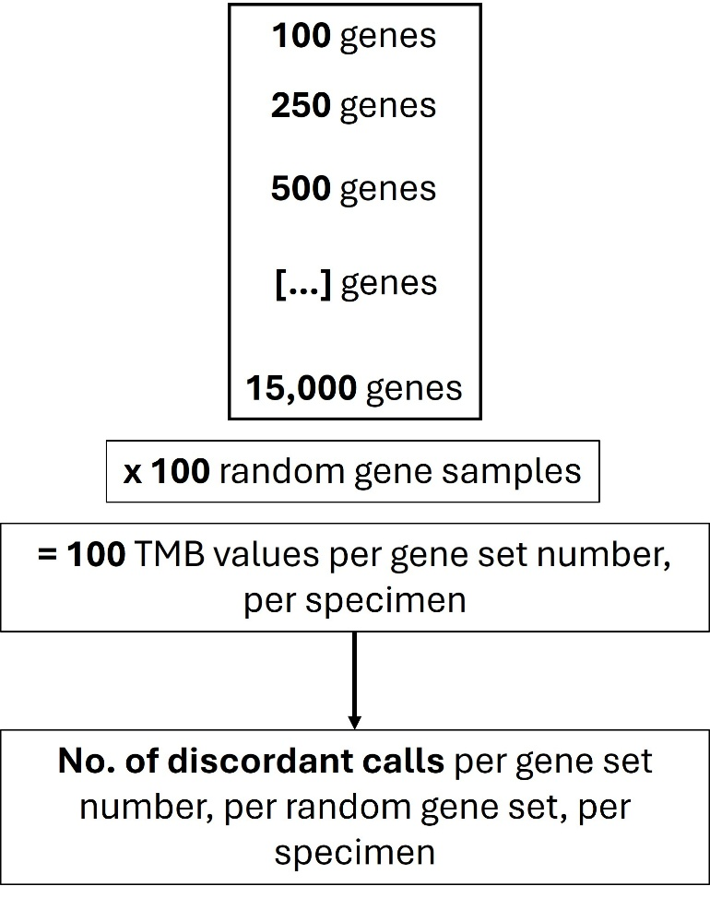
Supplementary Fig. S1. In silico gene sampling strategy. Genes sets of increasing size (100 to 15,000 genes, by increments of 250 genes) were randomly sampled 100x, to generate 100 TMB values per gene set number, per specimen. The number of discordant calls from WES per gene set number, per random gene set, and per specimen were determined. The rate of discordance for each gene set size corresponding to each WES-TMB value is shown in the heat map in Fig. 3d.

Supplementary Figure S2. TMB values for WES and three different gene panels. (a) Mean values with standard deviation. (b) Median values with interquartile range.
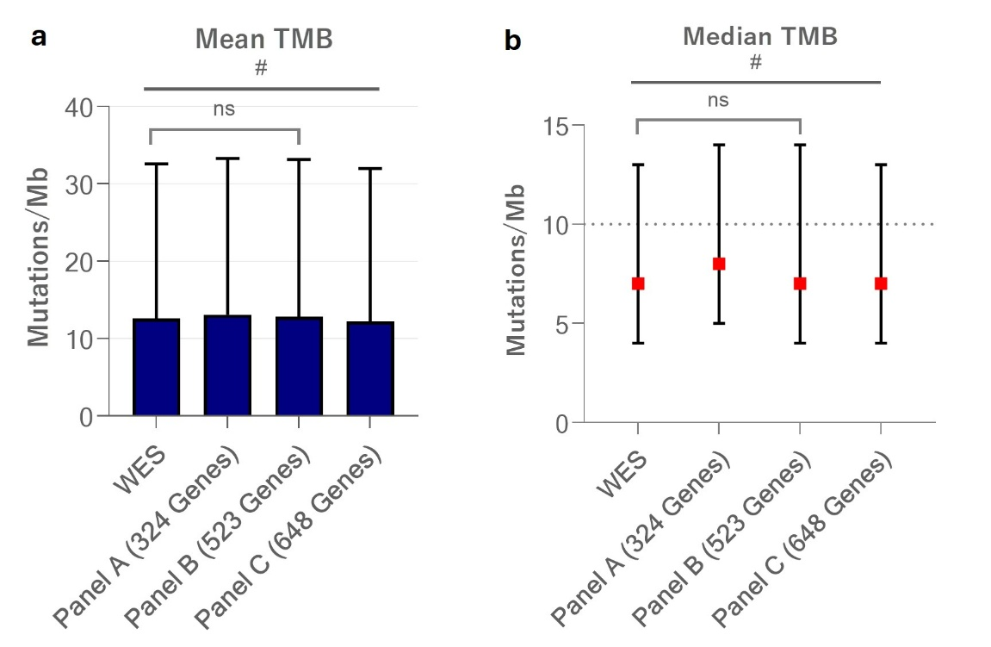

Supplementary Figure S3. Overlap of cases that were discordant across all three simulated panels.
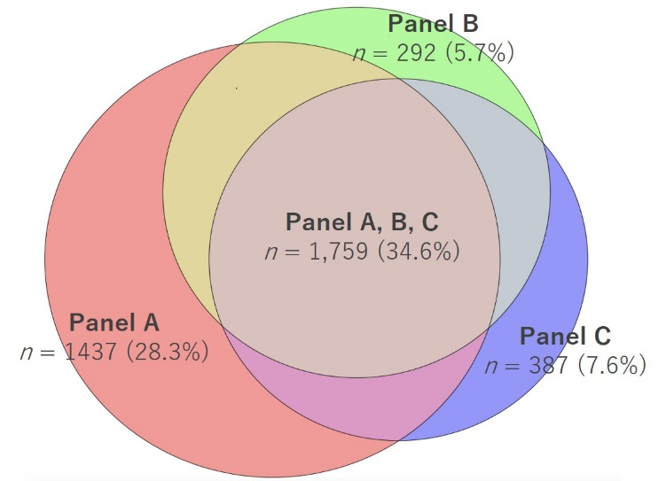

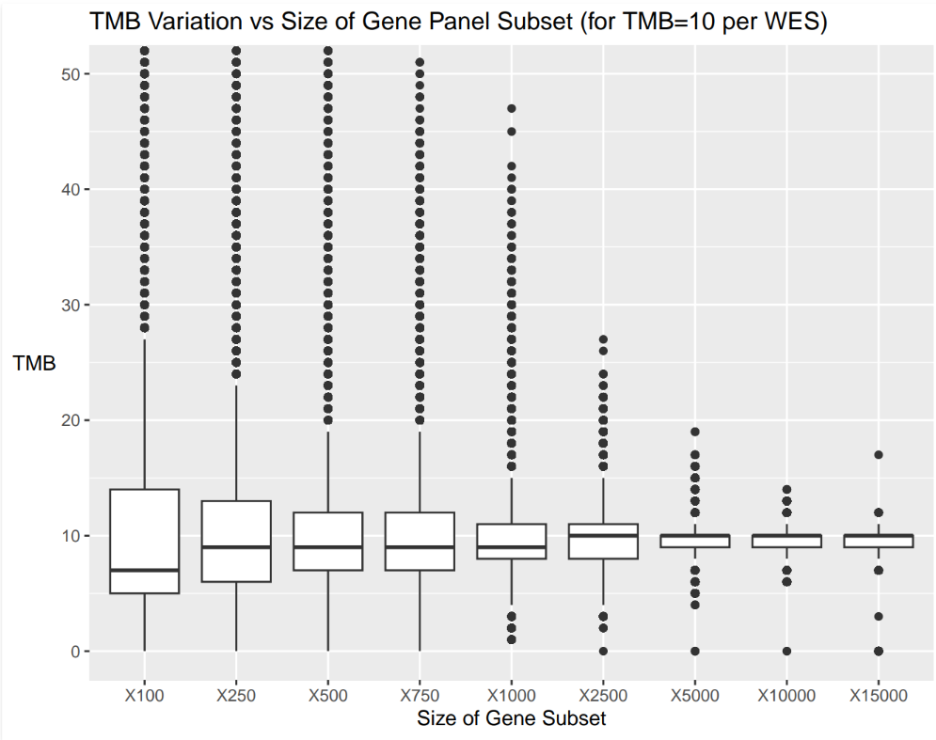
Supplementary Figure S4. Variation in TMB calls increases with decreasing gene panel size. All cases with a WES-TMB call of 10 mutations/Mb were analyzed. TMB calls were determined for each 100 random gene sets per sample, per gene panel size (i.e., 100 calls/sample/panel size). TMB variation versus the size of the gene panel subset is shown.

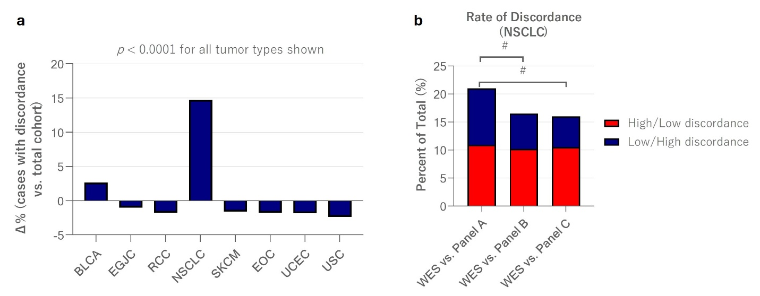
Supplementary Figure S5. TMB discordance was enriched in NSCLC cases. (a) The lineage composition of the cohort of discordant cases versus the total cohort of cases is shown. e.g., NSCLC cases made up a larger percentage of the discordant cases than the total cohort. Fisher’s exact test was used for statistical testing, comparing the frequency of each lineage in the discordant cohort to the frequency of each lineage in the total cohort (# indicates p<0.0001). BLCA, urothelial bladder carcinoma; EGJC, esophagogastric junction carcinoma; RCC, renal cell carcinoma; NSCLC, non-small cell lung cancer; SKCM, skin cutaneous melanoma; EOC, epithelial ovarian cancer; UCEC, uterine corpus endometrial carcinoma; USC, uterine serous carcinoma. (b) Rates of discordance in NSCLC cases, stratified by WES-High/panel-Low discordance and WES-Low/panel-High discordance. # indicates p<0.0001 (Fisher’s exact test). Discordance rate and distribution of WES-High/panel-Low versus WES-Low/panel-High in NSCLC cases was also significantly different from the total cohort shown in Fig. 3b (Fisher’s exact test, p<0.0001).

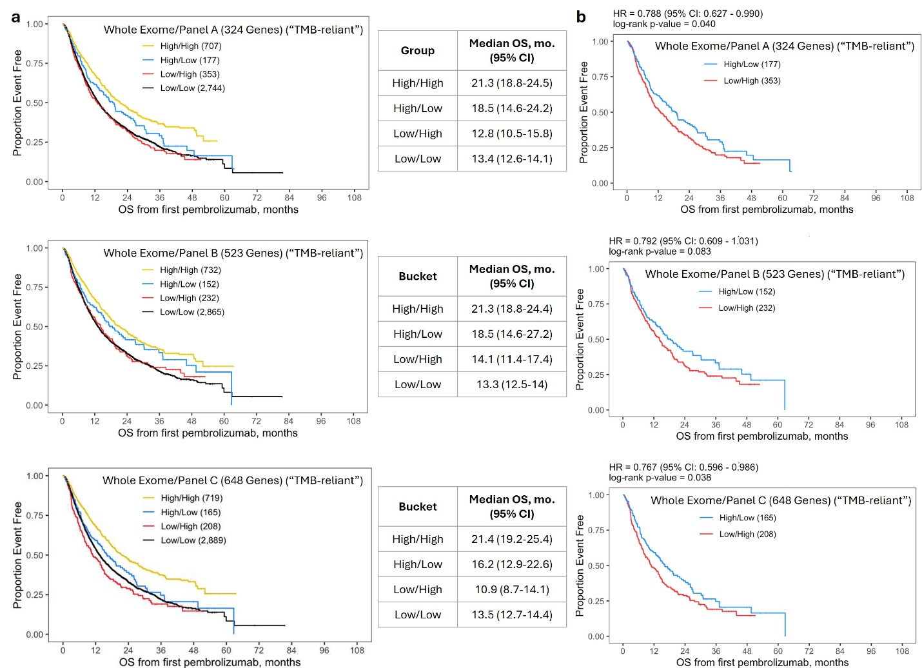
Supplementary Figure S6. Discordance in panel-TMB vs. WES-TMB correlates with clinically significant differences in pembrolizumab-specific OS. A “TMB-reliant” cohort (n = 3,981) was created by filtering to exclude all cases that were MSI-High/MMRd, PD-L1+, and/or had an indication for pembrolizumab or pembrolizumab combination therapy outside of TMB-High (endometrial carcinoma including uterine serous carcinoma, cutaneous malignancies (melanoma, squamous cell skin cancers), triple negative breast cancer, Merkel cell carcinoma, urothelial carcinoma, extrahepatic bile duct, non-small cell lung carcinoma, liver hepatocellular carcinoma, kidney, head and neck cancers, cholangiocarcinoma, mesothelioma, nodal diffuse large B cell lymphoma, and pediatric CNS tumors). Alveolar soft-part sarcomas were also excluded due to having an atezolizumab indication. (a) Kaplan-Meier curves show OS for concordant (High/High and Low/Low) cases and discordant (High/Low and Low/High) cases. High/High and Low/Low indicate cases where WES-TMB and the panel were concordant. High/Low indicates cases where WES-called the tumor TMB-High, but the panel called it TMB-low. Low/High indicates cases where WES-TMB called the case TMB-Low, but the panel called it TMB-High. Median OS and 95% confidence intervals (CI) are shown to the right. (b) Kaplan-Meier curves show OS for discordant cases only, with hazard ratios (HRs) and 95% CIs at the top.

Supplementary Fig. S7. Discordant tumor types in “TMB-reliant” cohort. The percentage of each tumor type composing the discordant cohort is shown. CRC, colorectal carcinoma; CUP, carcinoma of unknown primary; BRCA, breast carcinoma; EGJC, esophagogastric junction carcinoma; AC, anal carcinoma; FGTM, female genital tract malignancies; GC, gastric carcinoma; OSEC, ovarian surface epithelial carcinomas; CC, cervical carcinoma; STS, soft tissue sarcomas; NET, neuroendocrine tumor; PDAC, pancreatic adenocarcinoma; BLCA-non-UC, bladder carcinoma – non-urothelial; SGT, salivary gland tumor; SIM, small intestinal malignancy; EC, esophageal carcinoma; SCLC, small cell lung cancer; PC, penile carcinoma; PRAD, prostatic adenocarcinoma; ATC, anaplastic thyroid carcinoma; THCA, thryroid carcinoma; GBM, glioblastoma; MGMT, male genital tract malignancy; CHS, chondrosarcoma; ES, Ewing sarcoma; OSA, osteosarcoma; BAC, lung bronchioloalveolar carcinoma; MH, malignant histiocytosis; PNS, peripheral nervous system tumor; TC, thymic carcinoma; VSCC, vulvar squamous cell carcinoma.

