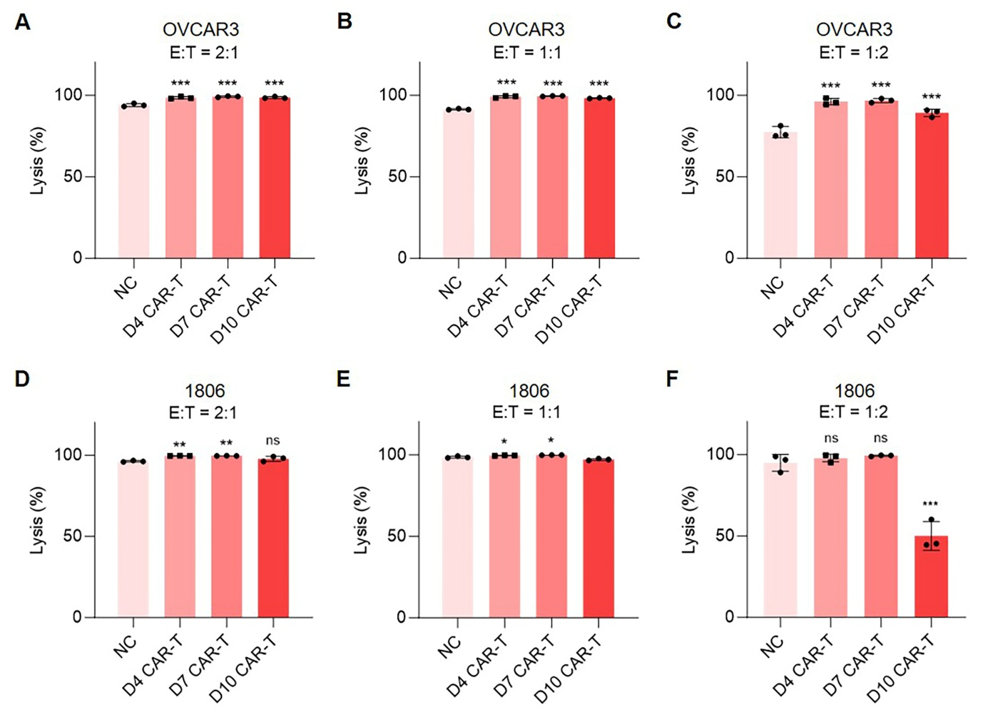
Fig. S1 The short-term cytotoxicity of SS-preconnditioned CAR-T cells on OVCAR3 and 1806 tumor cells.
(A-F) Preconditioend CAR-T cells were co-cultured with OVCAR3 and 1806 cells at the E:T ratios of 2:1, 1:1, and 1:2 for 24 hours. Cell lysis rates were measured through the luciferase reporter assay. Data are present as means ± SEM from three different donors. ns, not significant; *, p < 0.05; **, p < 0.01; ***, p < 0.001; one-way ANOVA.
Fig. S2 SS preconditioning enhanced the persistence of both anti-MSLN and anti-CD70 CAR-T cells.
(A-B) RTCA results showing the cytotoxicity of SS-MSLN-CAR-T cells against OVCAR3 (A) and 1806 (B) cells at the E:T ratio of 1:2. (C-H) Long-term cytotoxicity of SS-MSLN-CAR-T cells against OVCAR3, 1806 and CAPAN-2 cells at the E:T ratios of 2:1 (C-E) and 1:1 (F-H). (I) Anti-CD70 CAR-T cells were preconditioned with SS-5 for 1 hour on day 7 and flow cytometry was used to detect the proportion of Tscm. (J-K) Long-term cytotoxicity of preconditioned anti-CD70 CAR-T cells angainst 786-0 (J) and U87 (K) cells at indicated E:T ratios. Data are present as means ± SEM from three different donors. ns, not significant; *, p < 0.05; **, p < 0.01; ***, p < 0.001; two-way ANOVA (C-H, J-K) and t-test (I).

Fig. S3 Injection of SS-MSLN-CAR-T cells did not affect the body weight of mice.
(A) Detect of CAR-T number after intravenous injection. (B) The weight of mice was measured every 2-3 days. Data are present as means ± SEM. ns, not significant; two-way ANOVA.

Table S1 Antibody information
Name | Brand | Number
PE anti-huamn CD69 | Biolegend | 310906
APC anti-human CD25 | Biolegend | 302610
APC anti-human CD279 (PD-1) Antibody | Biolegend | 379208
PE anti-human CD223 (LAG-3) Antibody | Biolegend | 369306
FITC anti-human CD366 (Tim-3) Antibody | Biolegend | 345022
PE anti-human CD62L Antibody | Biolegend | 304806
APC anti-human CD45RO Antibody | Biolegend | 304210
FITC anti-human CD3 | Biolegend | 317306
PE-Labeled Human MSLN/Mesothelin Protein | Kactus Biosystems | MSL-HM480P
Annexin V-PE/7-AAD Apoptosis Detection Kit | Vazyme | A213-02
PE anti-human CD70 Antibody | Biolegend | 355104
CD18 (LFA-1 beta) Antibody | Thermo Fisher Scientific | BMS103

Table S2 DEG list
#id | Control-1-Count | Control-2-Count | SS-1-Count | SS-2-Count | Control-1-FPKM | Control-2-FPKM | SS-1-FPKM | SS-2-FPKM | log2FoldChange | pvalue | qvalue | significant
IL2RA | 5254 | 5501 | 11960 | 12215 | 39.924214 | 40.444436 | 83.021449 | 77.78827 | 1.041132985 | 4.54E-32 | 7.82E-29 | up
TNFSF11 | 236 | 244 | 779 | 942 | 2.608308 | 2.599674 | 7.838185 | 8.70195 | 1.709284919 | 4.61E-25 | 3.97E-22 | up
MS4A1 | 495 | 620 | 161 | 153 | 3.610764 | 4.29266 | 1.07981 | 0.943394 | -1.950667222 | 1.40E-22 | 9.65E-20 | down
EMP1 | 197 | 249 | 737 | 813 | 0.810305 | 0.98797 | 2.768154 | 2.802149 | 1.67058559 | 5.72E-22 | 3.75E-19 | up
CCR2 | 629 | 718 | 1784 | 1657 | 4.328166 | 5.166554 | 11.288218 | 9.56164 | 1.230389566 | 4.02E-20 | 1.91E-17 | up
SAPCD2 | 2093 | 1916 | 5300 | 4511 | 13.283304 | 11.765502 | 30.753839 | 24.049876 | 1.166786541 | 2.11E-19 | 8.79E-17 | up
MMP25 | 1711 | 1349 | 4393 | 3810 | 11.494202 | 8.694706 | 26.741996 | 21.233964 | 1.29430047 | 8.47E-19 | 3.15E-16 | up
CDKN2A | 375 | 306 | 896 | 1010 | 8.420766 | 6.569265 | 18.607192 | 19.067817 | 1.349520986 | 5.56E-16 | 1.22E-13 | up
SMTN | 655 | 609 | 1344 | 1493 | 4.773707 | 4.296027 | 8.973377 | 8.997472 | 1.03391589 | 8.34E-15 | 1.49E-12 | up
RASGRP4 | 140 | 143 | 427 | 486 | 1.102609 | 1.118312 | 3.048821 | 3.263981 | 1.558651298 | 5.55E-14 | 8.22E-12 | up
MAP1A | 768 | 647 | 1541 | 1669 | 1.771671 | 1.44331 | 3.245564 | 3.224294 | 1.047983393 | 6.64E-14 | 9.53E-12 | up
CDKN2B | 87 | 103 | 351 | 348 | 0.543872 | 0.62556 | 2.011712 | 1.825051 | 1.754687577 | 3.33E-13 | 3.99E-11 | up
MEF2C | 222 | 243 | 76 | 80 | 0.80123 | 0.846354 | 0.185075 | 0.223064 | -1.703546832 | 3.60E-10 | 2.27E-08 | down
KCNK1 | 156 | 201 | 463 | 444 | 1.835188 | 2.283077 | 4.982527 | 4.381319 | 1.223322973 | 4.61E-09 | 2.25E-07 | up
BASP1 | 339 | 341 | 163 | 167 | 4.601823 | 4.450658 | 1.99387 | 1.881583 | -1.171888027 | 5.83E-08 | 2.20E-06 | down
AMOTL1 | 189 | 191 | 420 | 455 | 0.495851 | 0.487803 | 1.031435 | 0.961816 | 1.073353976 | 6.89E-08 | 2.57E-06 | up
SSTR3 | 353 | 317 | 159 | 159 | 2.241218 | 1.961763 | 0.909229 | 0.837974 | -1.205687591 | 7.54E-08 | 2.79E-06 | down
CTSF | 412 | 409 | 218 | 209 | 4.870134 | 4.705736 | 2.358345 | 2.07923 | -1.070447904 | 8.84E-08 | 3.22E-06 | down
CD80 | 120 | 107 | 276 | 336 | 1.061622 | 0.913782 | 2.235368 | 2.495217 | 1.295289446 | 1.24E-07 | 4.31E-06 | up
MELTF | 101 | 67 | 320 | 229 | 0.740436 | 0.432625 | 2.038429 | 1.313355 | 1.583593853 | 2.98E-07 | 9.35E-06 | up
DACT1 | 172 | 151 | 43 | 73 | 1.073018 | 0.909086 | 0.247499 | 0.383786 | -1.621300485 | 1.80E-06 | 4.55E-05 | down
LAMB3 | 62 | 73 | 188 | 197 | 0.282481 | 0.319566 | 0.846196 | 0.83897 | 1.385561487 | 3.66E-06 | 8.62E-05 | up
KLRK1-AS1 | 211 | 253 | 105 | 120 | 1.811772 | 2.101656 | 0.817062 | 0.861659 | -1.172178897 | 5.11E-06 | 0.000115925 | down
SPIB | 98 | 134 | 33 | 44 | 0.627884 | 0.826402 | 0.190356 | 0.23291 | -1.719900296 | 9.00E-06 | 0.000190461 | down
CCR10 | 146 | 107 | 310 | 289 | 1.993852 | 1.409548 | 3.881911 | 3.315623 | 1.112099022 | 1.71E-05 | 0.000320481 | up
VSIG10 | 64 | 97 | 172 | 226 | 0.308442 | 0.455879 | 0.764292 | 0.962312 | 1.177190991 | 0.000107735 | 0.001564031 | up
CCDC74A | 46 | 45 | 141 | 116 | 0.715158 | 0.683302 | 2.284618 | 1.599447 | 1.375545664 | 0.000201149 | 0.002641782 | up
HRH4 | 80 | 111 | 28 | 44 | 0.530765 | 0.712913 | 0.167534 | 0.241513 | -1.539915051 | 0.000256858 | 0.003219962 | down
CXCL8 | 42 | 49 | 106 | 141 | 0.590304 | 0.687352 | 1.411282 | 1.721766 | 1.307104938 | 0.000404587 | 0.004699824 | up
PTPRF | 76 | 53 | 151 | 169 | 0.233021 | 0.156326 | 0.42241 | 0.441505 | 1.173327836 | 0.00043595 | 0.004993783 | up
CRACD | 43 | 41 | 121 | 101 | 0.142493 | 0.134202 | 0.383315 | 0.296358 | 1.278898473 | 0.001037121 | 0.00999889 | up
MAML3 | 68 | 60 | 145 | 136 | 0.241503 | 0.204245 | 0.468183 | 0.403855 | 1.00633489 | 0.002648961 | 0.021304578 | up
COBLL1 | 69 | 120 | 33 | 52 | 0.173804 | 0.2968 | 0.074746 | 0.110074 | -1.281318395 | 0.002777233 | 0.022065706 | down
SIGLEC6 | 80 | 155 | 63 | 48 | 0.558917 | 0.998534 | 0.392269 | 0.303579 | -1.189517072 | 0.003002684 | 0.02343795 | down
MIR29B2CHG | 94 | 128 | 56 | 60 | 1.00848 | 1.337998 | 0.54409 | 0.541366 | -1.06024314 | 0.003309191 | 0.025342258 | down
FCRL3 | 40 | 52 | 14 | 17 | 0.208249 | 0.263295 | 0.079106 | 0.071224 | -1.696958853 | 0.004155274 | 0.030241528 | down
IL24 | 80 | 86 | 40 | 40 | 0.919287 | 0.959623 | 0.418599 | 0.384184 | -1.180033692 | 0.004276212 | 0.030893219 | down
FAXC | 19 | 35 | 69 | 82 | 0.038163 | 0.071396 | 0.131187 | 0.166625 | 1.3607629 | 0.004839787 | 0.034036624 | up
CENPS-CORT | 8 | 36 | 58 | 91 | 0.121034 | 0.59467 | 0.904816 | 1.359741 | 1.641375398 | 0.005140083 | 0.035460655 | up
EVI5 | 24 | 44 | 95 | 81 | 0.069737 | 0.124292 | 0.253852 | 0.199637 | 1.259281402 | 0.005151088 | 0.03551879 | up
GAS7 | 127 | 110 | 45 | 83 | 0.375922 | 0.321655 | 0.118786 | 0.211842 | -1.035762939 | 0.005224689 | 0.03588262 | down
ITGB3 | 30 | 25 | 53 | 99 | 0.120716 | 0.096118 | 0.194928 | 0.336957 | 1.317584791 | 0.007365339 | 0.04658966 | up
CAPN5 | 127 | 94 | 48 | 74 | 0.679301 | 0.505727 | 0.239828 | 0.339192 | -1.002858715 | 0.007741182 | 0.048399746 | down

