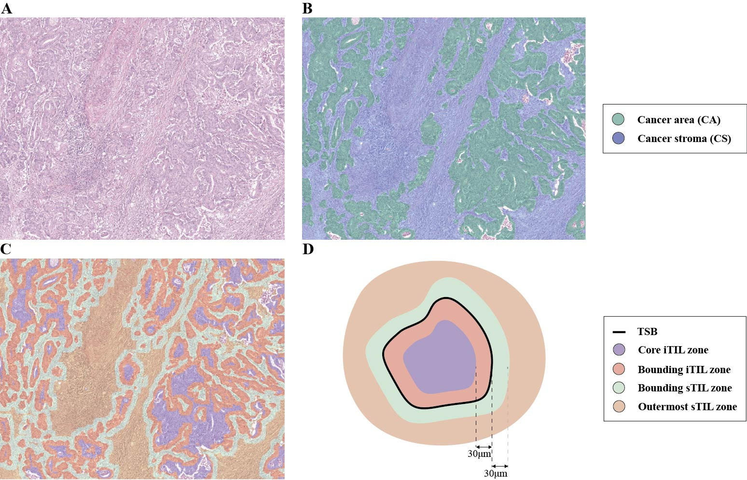
Supplementary Figure 1. AI-based segmentation and spatial zone definition for TIL analysis along the tumor–stromal border.
(A) Representative H&E-stained whole-slide image. (B) AI-based segmentation of cancer area (CA, green) and cancer stroma (CS, blue). (C) Visualization of spatial zones defined relative to the tumor-stromal border (TSB) overlaid on the H&E image: core iTIL (purple), bounding iTIL (red), bounding sTIL (green), and outermost sTIL (orange). (D) Schematic illustration of spatial zone definitions: core iTIL (purple, > 30 μm inside tumor), bounding iTIL (red, 0–30 μm inside tumor), bounding sTIL (green, 0–30 μm inside stroma), and outermost sTIL (orange, > 30 μm inside stroma). Each zone is defined based on perpendicular distance from the TSB (black line).
Abbreviations: CA, cancer area; CS, cancer stroma; H&E, Hematoxylin and Eosin; iTIL, intratumoral TIL; sTIL, stromal TIL; TIL, tumor-infiltrating lymphocyte; TSB, tumor-stromal border.
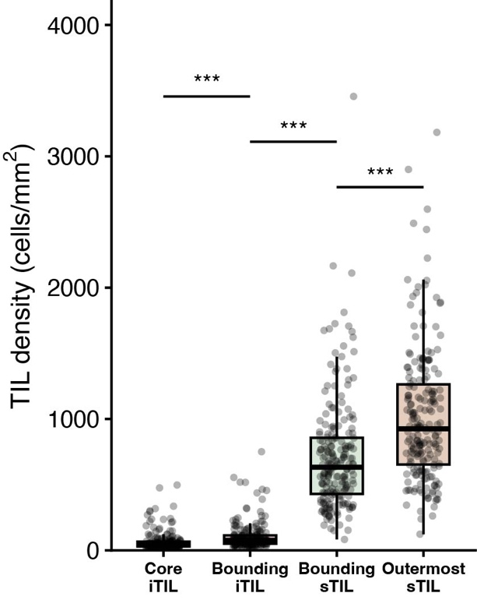
Supplementary Figure 2. TIL density distribution across TSB-related zones.
TIL density (cells/mm²) measured across four TSB-related zones. Statistical comparisons between adjacent zones were performed using the Wilcoxon signed-rank test. *** indicates p < 0.001.
Abbreviations: TIL, tumor-infiltrating lymphocyte; TSB, tumor-stromal border.

Supplementary Table 1. Pearson correlation coefficient of TIL score evaluation between the AI model and three pathologists.
Comparison | iTIL |  | sTIL
 | r | p-value | r | p-value
AI vs. Pathologist A | 0.80 | < 0.001 | 0.70 | < 0.001
AI vs. Pathologist B | 0.23 | 0.056 | 0.64 | < 0.001
AI vs. Pathologist C | 0.69 | < 0.001 | 0.75 | < 0.001
AI-Pathologist Mean Correlation | 0.57 | - | 0.70 | -
Pathologist A vs. Pathologist B | 0.40 | 0.024 | 0.68 | < 0.001
Pathologist A vs. Pathologist C | 0.66 | < 0.001 | 0.79 | < 0.001
Pathologist B vs. Pathologist C | 0.34 | 0.056 | 0.62 | < 0.001
Inter-Pathologist Mean Correlation | 0.47 | - | 0.70 | -
*r = Pearson correlation coefficient
Abbreviations: AI, artificial intelligence; iTIL, intratumoral tumor-infiltrating lymphocyte; sTIL, stromal tumor-infiltrating lymphocyte; TIL, tumor-infiltrating lymphocyte.

Supplementary Table 2. Spatial area distribution of TSB-defined zones and prognostic performance of the TSB score across boundary distances.
Boundary distance | Cancer area  (% of total iTIL area*) |  | Cancer stroma  (% of total sTIL area*) |  | TSB score HR †  (95% CI) | p-value
Boundary distance | Core  iTIL zone | Bounding iTIL zone | Bounding sTIL zone | Outermost sTIL zone | TSB score HR †  (95% CI) | p-value
30 µm | 53.07 | 46.93 | 41.28 | 58.72 | 0.20  (0.10–0.38) | <0.001
50 µm | 44.04 | 55.96 | 53.05 | 46.95 | 0.22  (0.12–0.42) | <0.001
100 µm | 34.98 | 65.02 | 69.94 | 30.06 | 0.28  (0.15–0.51) | <0.001
150 µm | 32.36 | 67.64 | 78.48 | 21.52 | 0.28  (0.15–0.51) | <0.001
Abbreviations: CI, confidence interval; HR, hazard ratio; iTIL, intratumoral tumor-infiltrating lymphocyte; sTIL, stromal tumor-infiltrating lymphocyte; TSB, tumor-stromal border.
*Area percentages represent the proportion of each zone relative to the total iTIL or sTIL compartment area, respectively. Each value represents the slide-level average across the cohort.
†HR represents the hazard ratio for TSB score (high vs. low) for recurrence-free survival.

