A

B
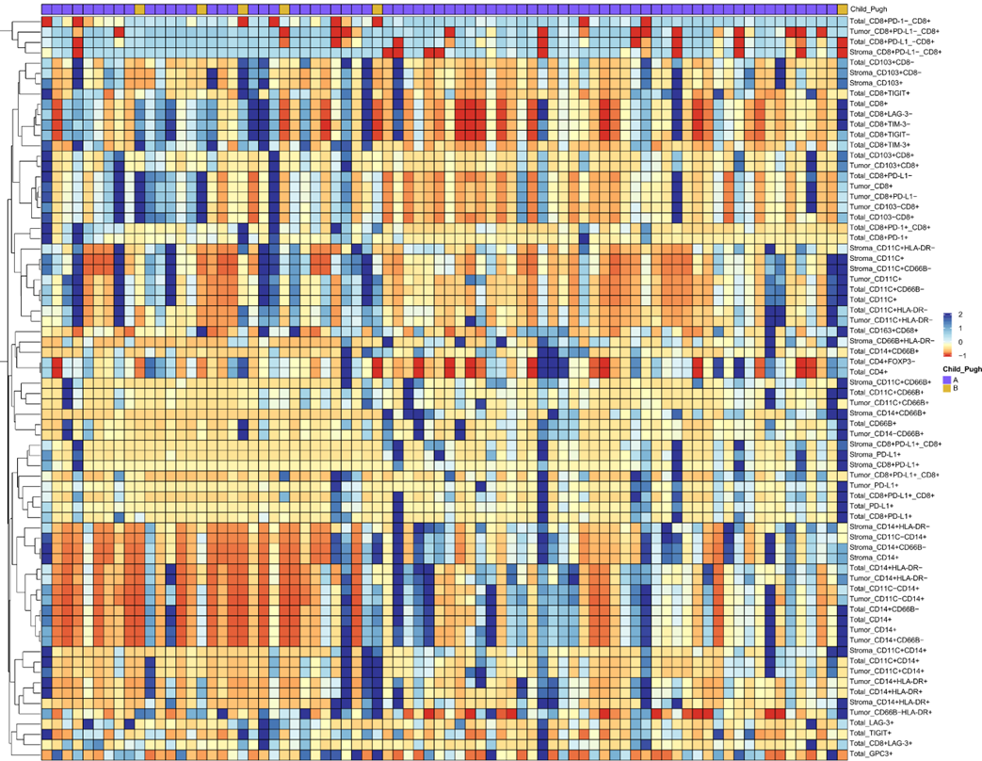

C

D

E

F

G

Supplementary figure 1. The heatmap of positive rate of TIICs grouped by clinical features. Patients were grouped by BCLC stage (A), child pugh (B), CNLC stage (C), drink history (D), smoke history (E), macro vascular invasion (F) and micro vascular invasion (G).

A

B

C

D

E

F
Supplementary figure 2. The heatmap of positive rate of TIICs grouped by peripheral blood inflammation index score. Patients were grouped by CAR (A), LMR (B), mGPS (C), NLR (D), PI (E) and PLR (F).

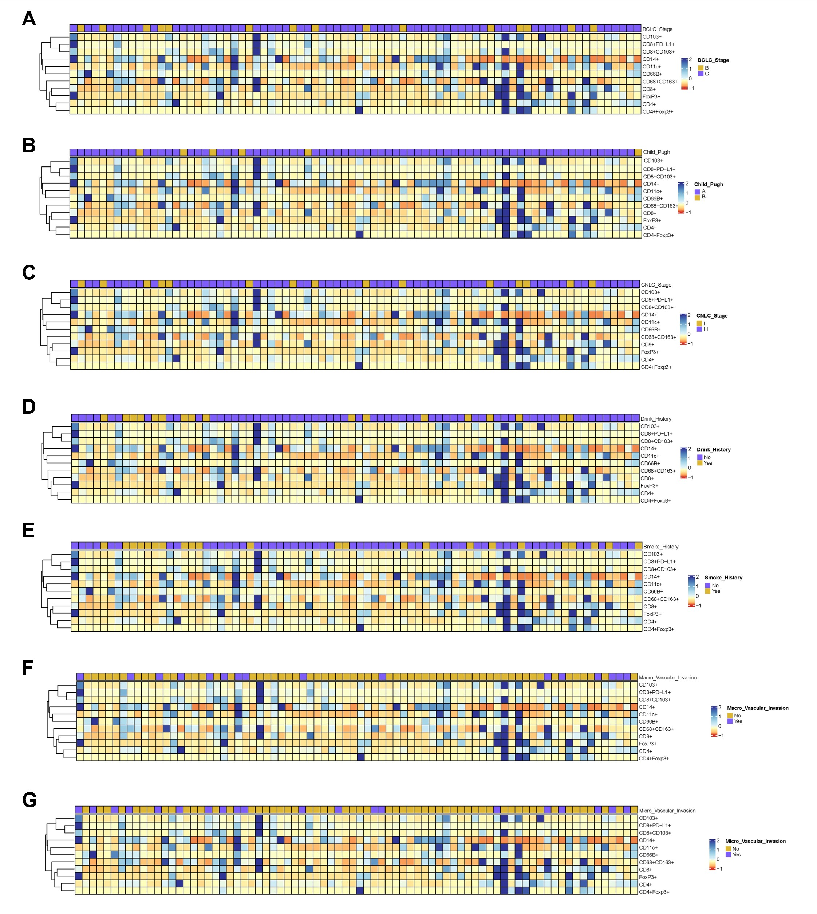

Supplementary figure 3. The heatmap of spatial profiling of TIICs grouped by clinical features. Patients were grouped by BCLC stage (A), child pugh (B), CNLC stage (C), drink history (D), smoke history (E), macro vascular invasion (F) and micro vascular invasion (G).

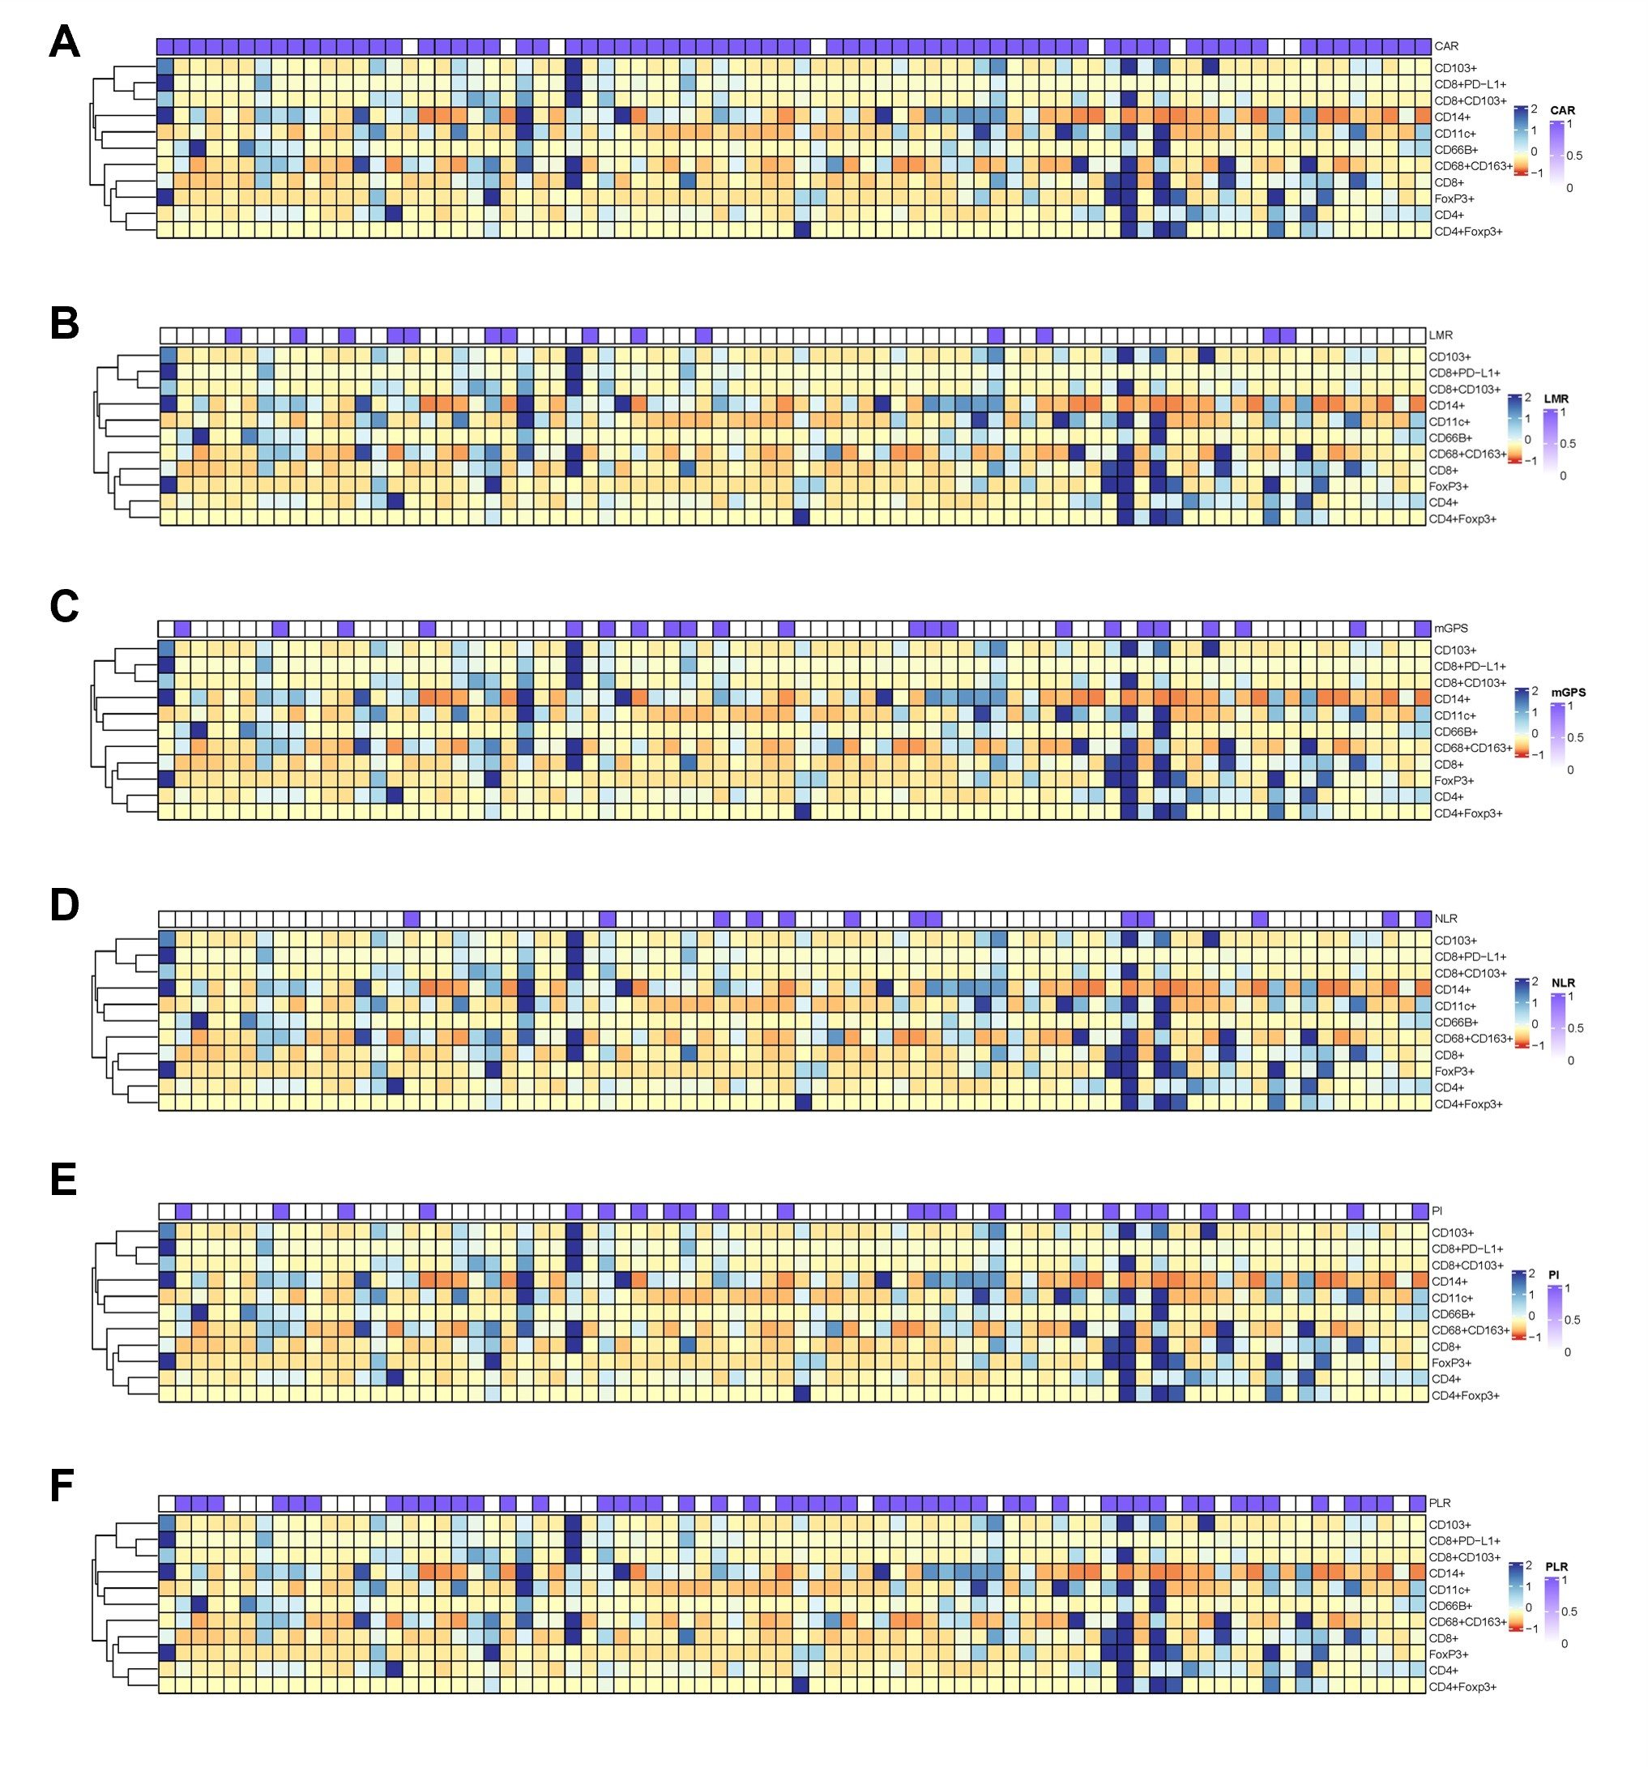

Supplementary figure 4. The heatmap of spatial profiling of TIICs grouped by peripheral blood inflammation index score. Patients were grouped by CAR (A), LMR (B), mGPS (C), NLR (D), PI (E) and PLR (F).

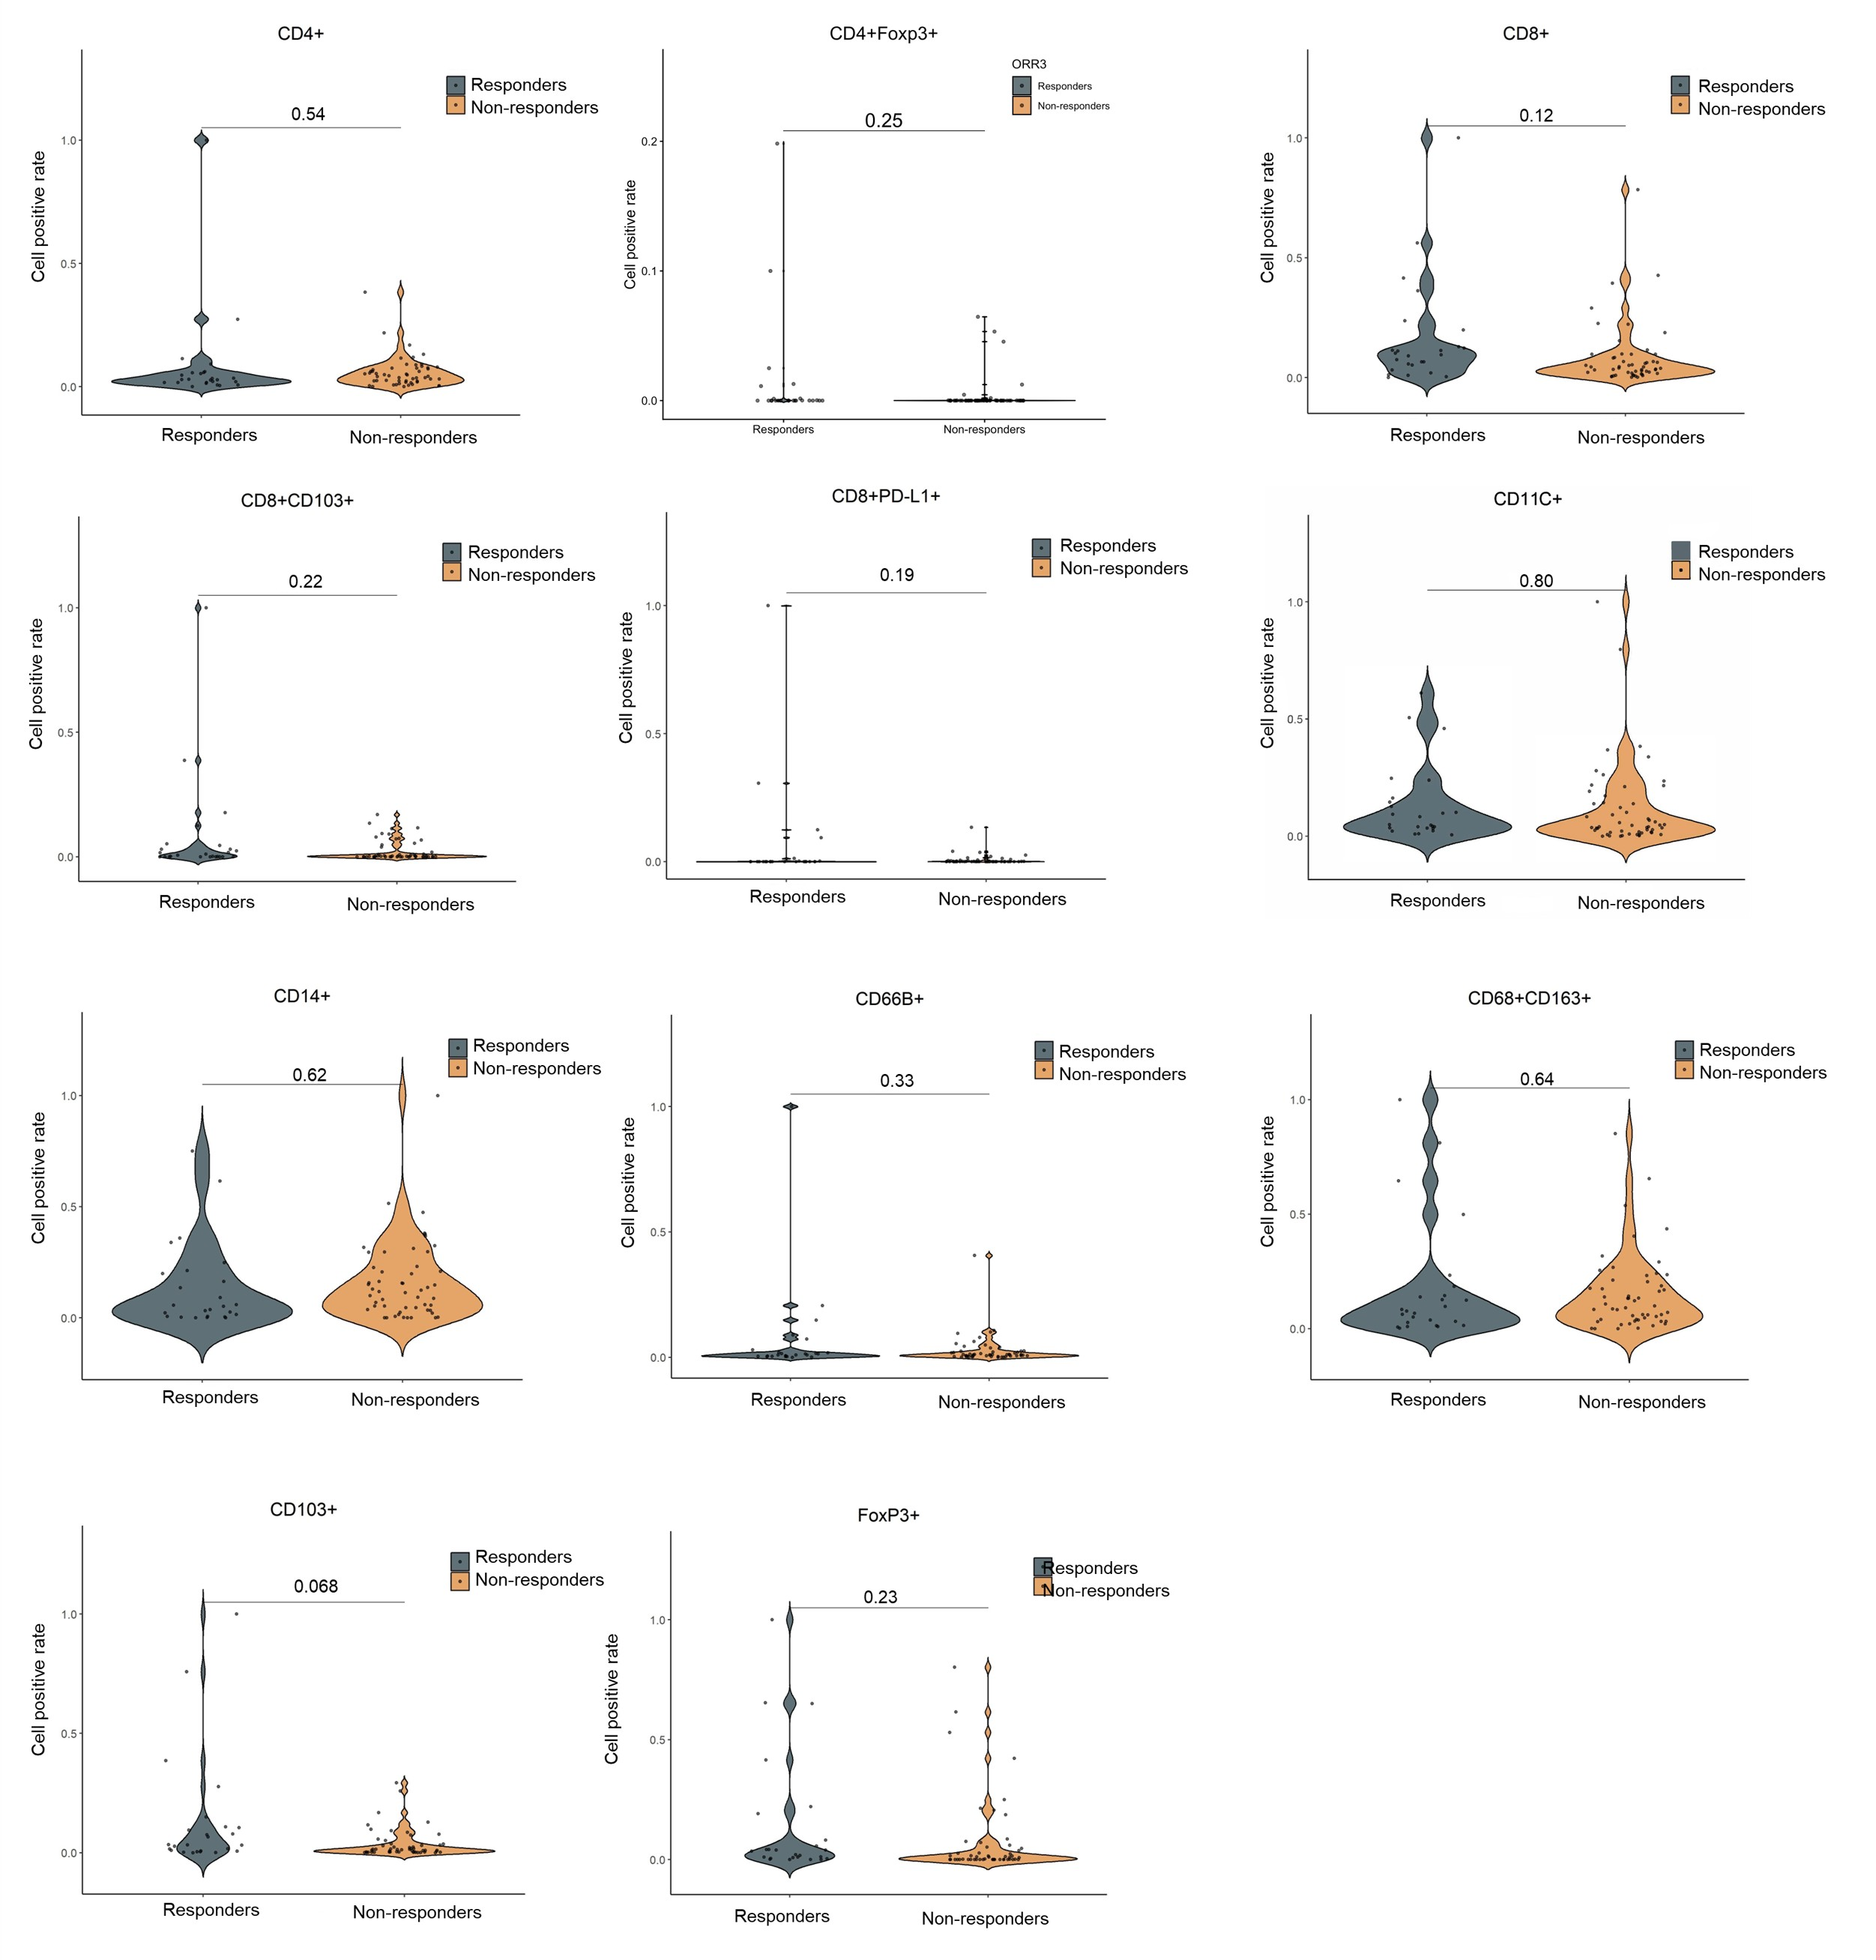

Supplementary figure 5. Differences in spatial profiling of TIICs across ORR groups (Responders vs. Non-responders) in HCC.

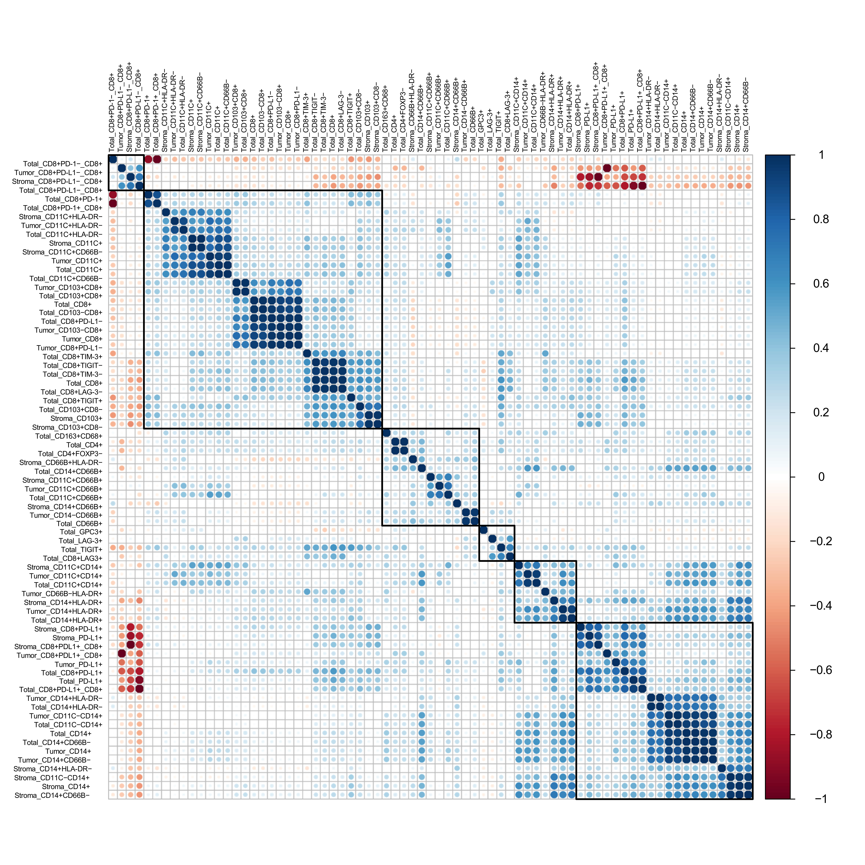
Supplementary figure 6. The correlation of TIICs in HCC.

