Supplementary Figures Page Number

Figure S1 2
Figure S2 3
Figure S3 4
Figure S4 5
Figure S5 6
Figure S6 7-8
Figure S7 9
Figure S8 10
Figure S9 11
Figure S10 12
Figure S11 13-14
Figure S12 15
Figure S13 16
Figure S14 17
Figure S15 18
Figure S16 19-20

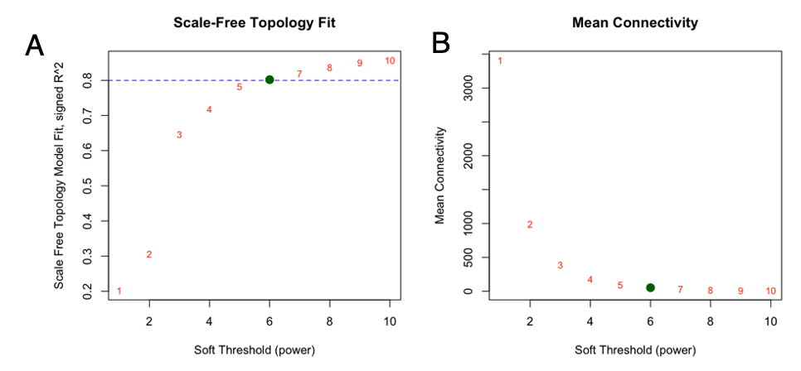
Supplementary Figure S1. Selection of Weight Gene Co-Expression Network Analysis soft-thresholding power. (A) Scale-free topology fit index (signed R²) across candidate soft-thresholding powers (β). The dashed line indicates the heuristic threshold R² = 0.8, commonly used to select a network in which the connectivity distribution approximately approximates a power-law on a log–log scale, consistent with the scale-free topology assumption used in biologically interpretable gene co-expression networks. (B) Mean network connectivity (average node degree) as a function of β, reflecting changes in network sparsity with increasing thresholding power. The selected power (β = 6) represents the smallest value that satisfies the scale-free topology criterion (R² > 0.8) while maintaining sufficient connectivity for robust and biologically meaningful co-expression structure.

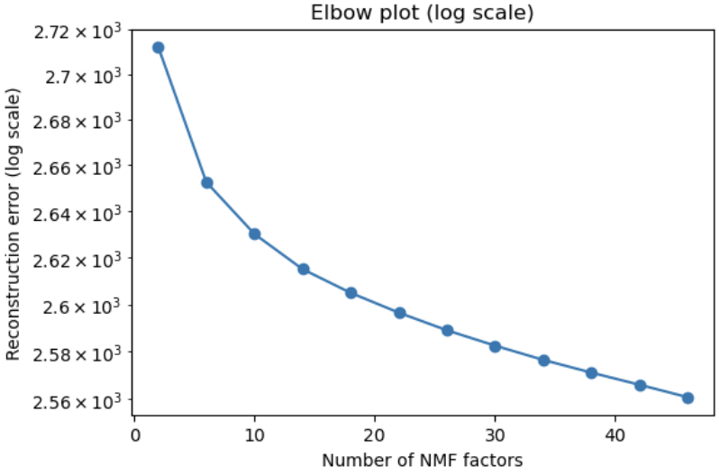

Supplementary Figure S2. Selection of the optimal number of consensus non-negative matrix factorization (cNMF) components based on reconstruction error. Reconstruction error (log scale) across a range of cNMF component counts. Increasing the number of components improves model fit, as reflected by decreasing reconstruction error; however, gains plateau beyond the elbow point, indicating an optimal balance between model complexity and explanatory power.

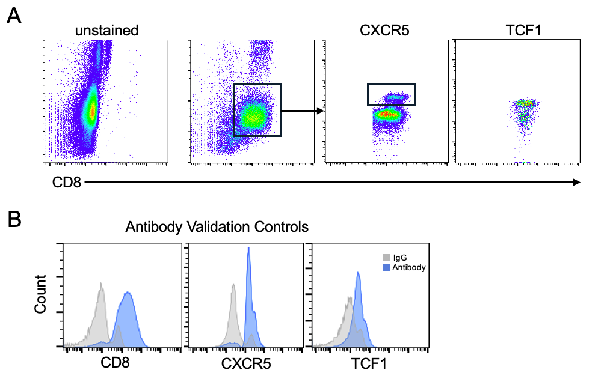

Figure S3. Flow cytometry gating strategy and antibody validation for detection of CXCR5⁺ and TCF1⁺ CD8⁺ T cells. (A) Representative flow cytometry plots showing the gating strategy used to identify CXCR5⁺ and TCF1⁺ cells within the CD8⁺ T cell population. Isolated CD8⁺ T cells were stained using the flow cytometry antibody panel described in the Methods. Unstained cells were used to establish background fluorescence, followed by gating on CD8⁺ T cells and subsequent assessment of CXCR5 and TCF1 expression. The CXCR5⁺ population was identified as a distinct population within the CD8⁺ T cell gate. (B) Antibody validation controls for CD8, CXCR5, and TCF1 staining. Isolated CXCR5⁺CD8⁺ T cells were stained with either normal IgG control antibody or the indicated marker-specific antibodies and analyzed by flow cytometry. Gray histograms represent IgG control staining, and blue histograms represent specific antibody staining.

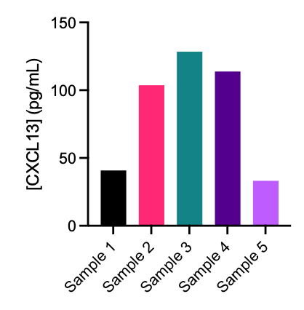

Supplementary Figure S4. CXCL13 secretion by primary tumor-derived ccRCC cell cultures. CXCL13 concentrations from five independent primary ccRCC cell cultures were quantified by ELISA demonstrating expression within all cell cultures.

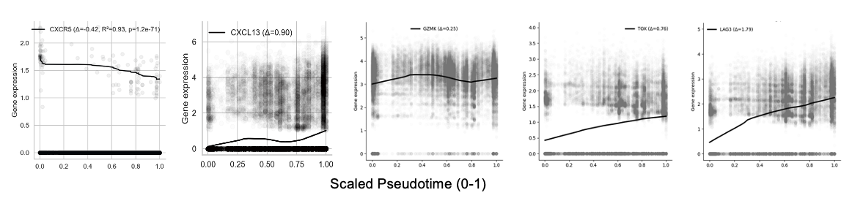

Supplementary Figure S5. Pseudotime dynamics of selected genes in ccRCC. Gene expression trends along cells ordered by pseudotime, including CXCR5, CXCL13, GZMK, TOX, and LAG3. Curves represent LOWESS-smoothed fits of library size normalized expression across scaled min-max scaled pseudotime. For the CXCR5 plot, LOWESS was estimated from non-zero values, while still showing all CXCR5 expression values for transparency.

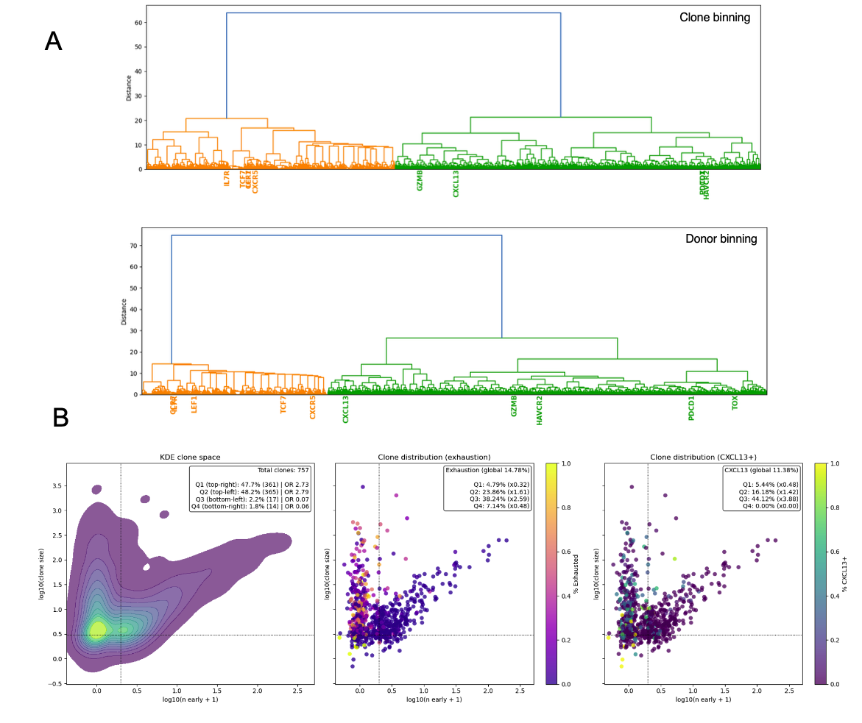
Supplementary Figure S6. Clonotype-resolved analysis of stem-like gene expression patterns and clonal composition in CD8⁺ T cells (A) Dendrograms showing gene expression patterns across binned Pseudotime to prevent overdominance of specific clones or donors. Genes cluster into two modules with distinct trajectories and are displayed as hierarchical trees. Top: cells grouped by pseudotime bin and clone identity. Bottom: cells grouped by pseudotime bin and donor. Highlighted genes mark key clusters. Vertical lines indicate clones containing ≥1 stem-like cell; horizontal line marks clones with ≥3 total cells. (B) Left: relationship between clone size and number of stem-like CD8⁺ T cells per clone shown as kernel density plot. Middle: same relationship as scatter plot showing points colored by the fraction of exhausted CD8⁺ T cells per clone. Right: same plot colored by percent CXCL13⁺ cells. Insets show the distribution of exhausted-cell fractions and clone densities across quadrants.

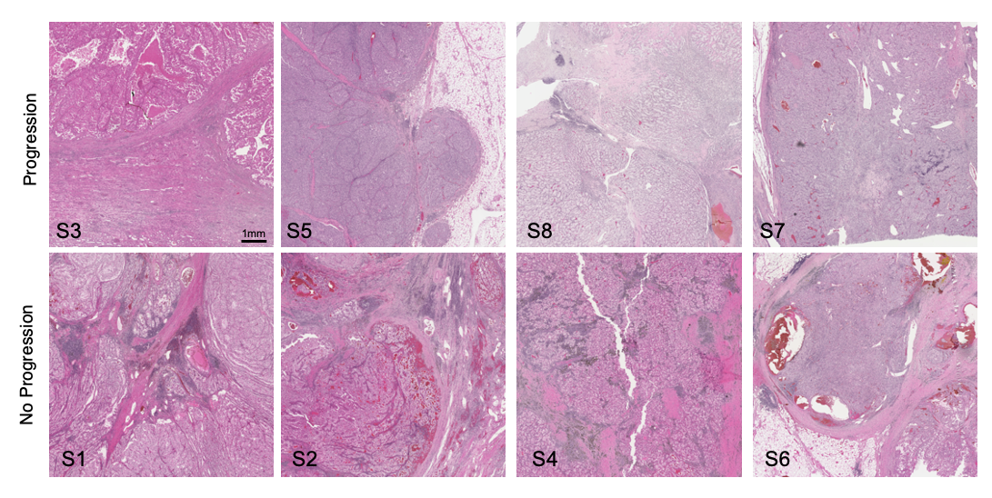
Supplementary Figure S7. Representative H&E sections corresponding to spatial transcriptomic capture areas. Representative hematoxylin and eosin (H&E)–stained sections from ccRCC tumors demonstrating the regions selected for spatial transcriptomic profiling. Images are aligned to the sequenced capture areas shown in Fig 5A. Samples are shown across progression and no progression groups.

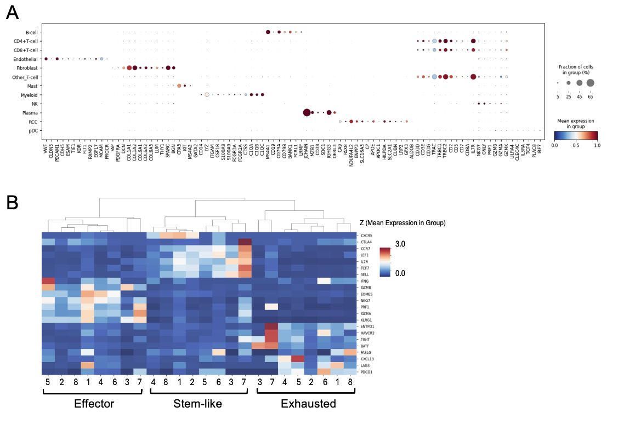
Supplementary Figure S8. Validation of spatial cell-type and CD8⁺ T cell state annotations. (A) Dot plot showing expression of canonical marker genes across annotated cell types derived from spatial transcriptomic data, confirming expected lineage-specific expression patterns. Dot size represents the percentage of cells expressing each gene, and color indicates mean expression, scaled per gene. (B) Heatmap showing the average expression of selected CD8⁺ T-cell marker genes derived from scRNA-seq data. Gene ordering is based on hierarchical clustering of Z-scored mean expression values, following variance stabilization of single cell estimated expression values. Samples are stratified into effector, stem-like, and exhausted CD8⁺ T cell groups. These three functional states form distinct clusters based on their characteristic marker gene expression profiles, supporting the criteria used for CD8⁺ T cell annotation.

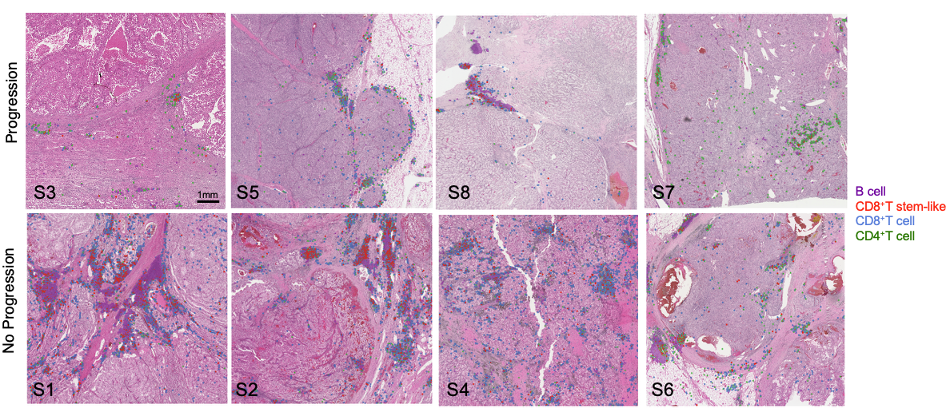
Supplementary Figure S9. Spatial distribution of lymphocyte subsets across all analyzed ccRCC tumor sections. Representative hematoxylin and eosin (H&E)–stained sections from all analyzed tumors, with spatial transcriptomic cell annotations overlaid. Cells are colored by broad lymphocyte subsets, including B cells, CD4⁺T cells, CD8⁺ T cells, and CXCR5-expressing stem-like CD8⁺ T cells, as indicated in the legend. Samples are grouped by progression status (progression vs no progression). ENACT-style polygons labeled as CD8⁺T cell stem-like were expanded for visualization purposes. These images illustrate the heterogeneous spatial distribution of lymphocyte populations across tumor sections and provide context for the representative regions shown in Fig 6A.

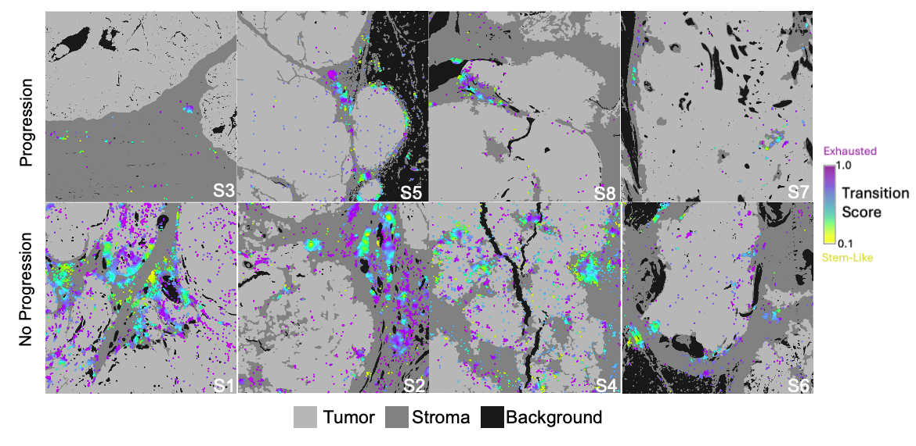
Supplementary Figure S10. Spatial distribution of CD8⁺ T cell stem–exhaustion scores across ccRCC tumor sections. Gaussian-smoothed spatial maps of CD8⁺ T cell stem-like/exhaustion scores overlaid on tumor sections from all analyzed samples. These maps reveal heterogeneous spatial patterns of inferred CD8⁺ T cell states, ranging from stem-like to more exhausted phenotypes, across ccRCC tumors. This cohort-wide view provides context for the representative regions shown in Fig. 6C. Tumor sections are grouped by tumors that progressed or did not progress to metastatic disease.

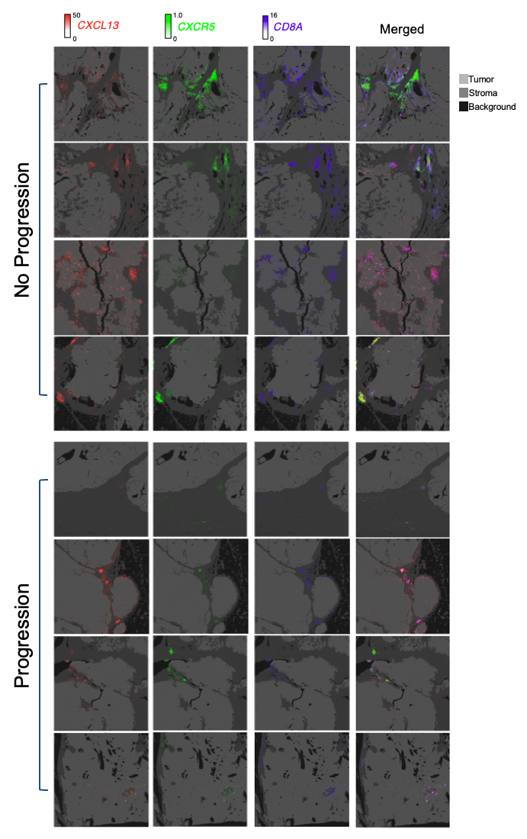
Supplementary Figure S11. Spatial distribution of CXCL13, CXCR5, and CD8A estimated expression across ccRCC tumor sections. Spatial transcriptomic maps of CXCL13, CXCR5, and CD8A scVI-normalized expression overlaid on tumor sections across all analyzed samples. Gene expression values were variance-stabilized and clipped to the 1st–99th percentile range for visualization. These maps demonstrate heterogeneous spatial expression patterns of CXCL13 and CXCR5 and highlight regions of co-localization with CD8⁺ T cells. This figure provides cohort-wide context for the representative regions shown in Fig. 6B. Tumor sections are grouped by tumors that progressed or did not progress to metastatic disease.

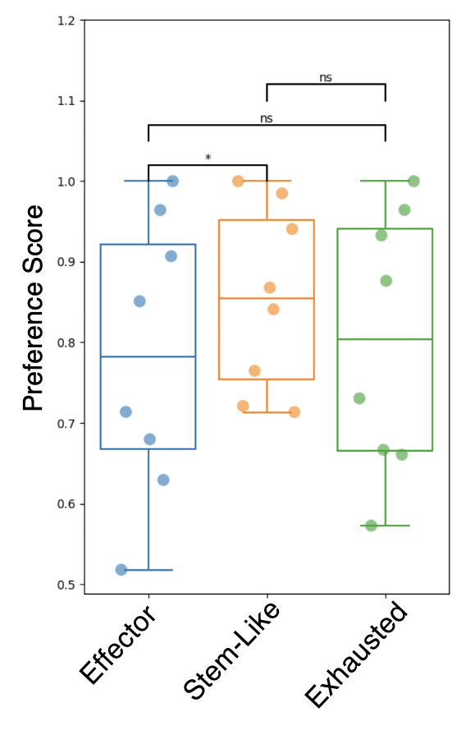
Supplementary Figure S12. Pairwise comparison of spatial preference scores across CD8⁺ T cell groups. Each point represents the slide-level difference in stromal preference for each of the three CD8⁺ T cell states, computed as the fraction of spots assigned to stroma relative to total spots in stroma and tumor compartments. Boxplots summarize distributions across slides. Statistical significance was assessed using a paired Wilcoxon signed-rank test (* p < 0.05, ns=not significant).

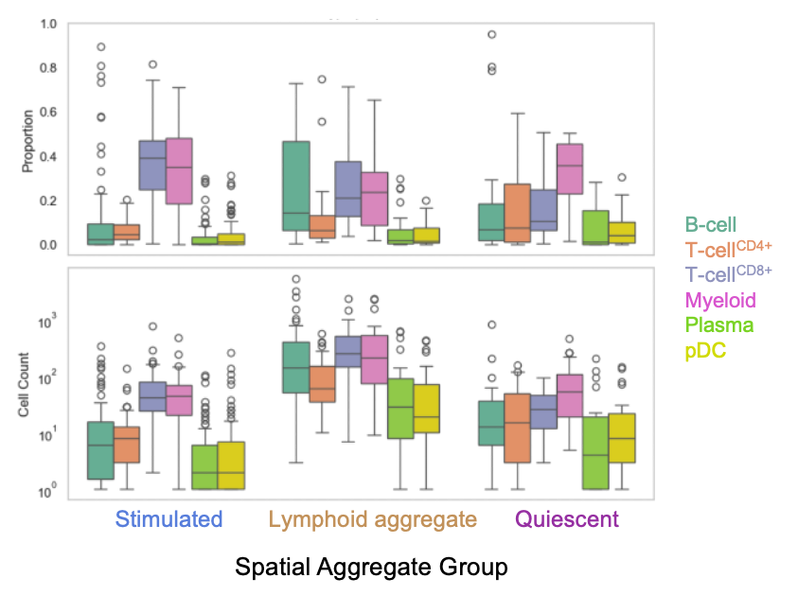
Supplementary Figure S13. Spatial clustering identifies distinct immune niches with divergent cellular composition. Proportions and absolute counts of major immune populations are shown across spatial aggregate groups (stimulated, lymphoid aggregate, and quiescent), with rare cell types (such as MAIT, NK, gamma T-cells) excluded.

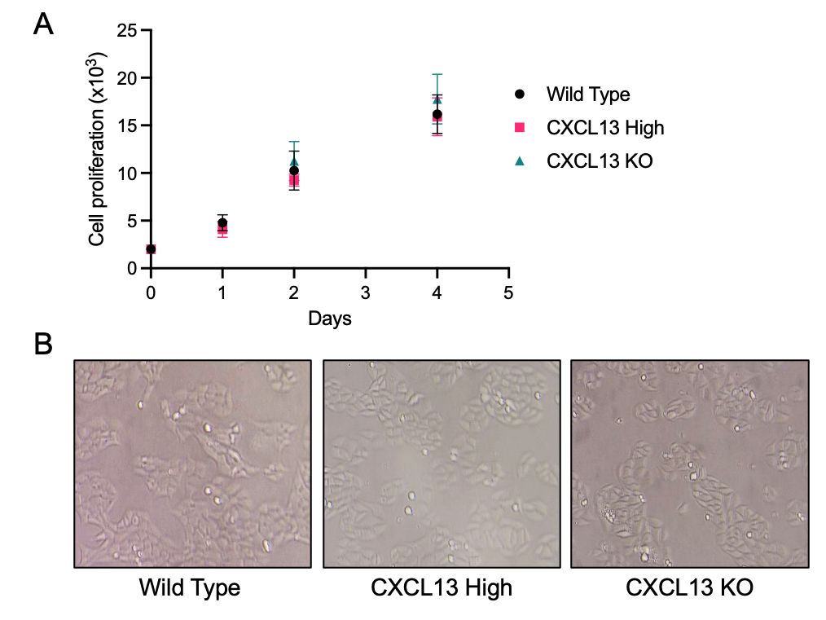

Supplementary Figure S14. CXCL13 modulation does not alter RENCA cell proliferation or morphology in vitro. (A) In vitro proliferation of wild-type RENCA cells, CXCL13 overexpressing (”High”) RENCA cells, and CXCL13 knockout (KO) RENCA cells. 2x10⁴ RENCA cells plated in 6 well plates and measured over 4 days in 6-well plates. Data are shown as mean ± SD. No significant difference was noted at each time point (Kruskal-Wallis test, P>0.05 for all). (B) Representative images of wild-type, CXCL13 High, and CXCL13 KO RENCA cells demonstrating similar adherent morphology across the three cell lines.

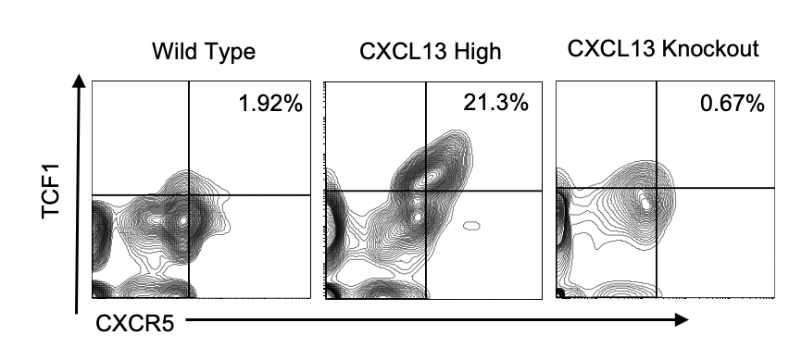
Supplementary Figure S15. Flow cytometry for identification of CXCR5⁺TCF1⁺ CD8⁺ T cells in RENCA tumor models. Representative flow cytometry plots showing TCF1 and CXCR5 expression among CD8⁺ T cells isolated from RENCA tumors generated from wild type, CXCL13-high, and CXCL13-knockout cells. Tumors were dissociated, CD8⁺ T cells were enriched using a Miltenyi bead-based isolation protocol, and cells were analyzed by flow cytometry for CXCR5 and TCF1 expression. CXCL13-high tumors demonstrated enrichment of TCF1⁺CXCR5⁺ CD8⁺ T cells compared with wild type and CXCL13-knockout tumors.
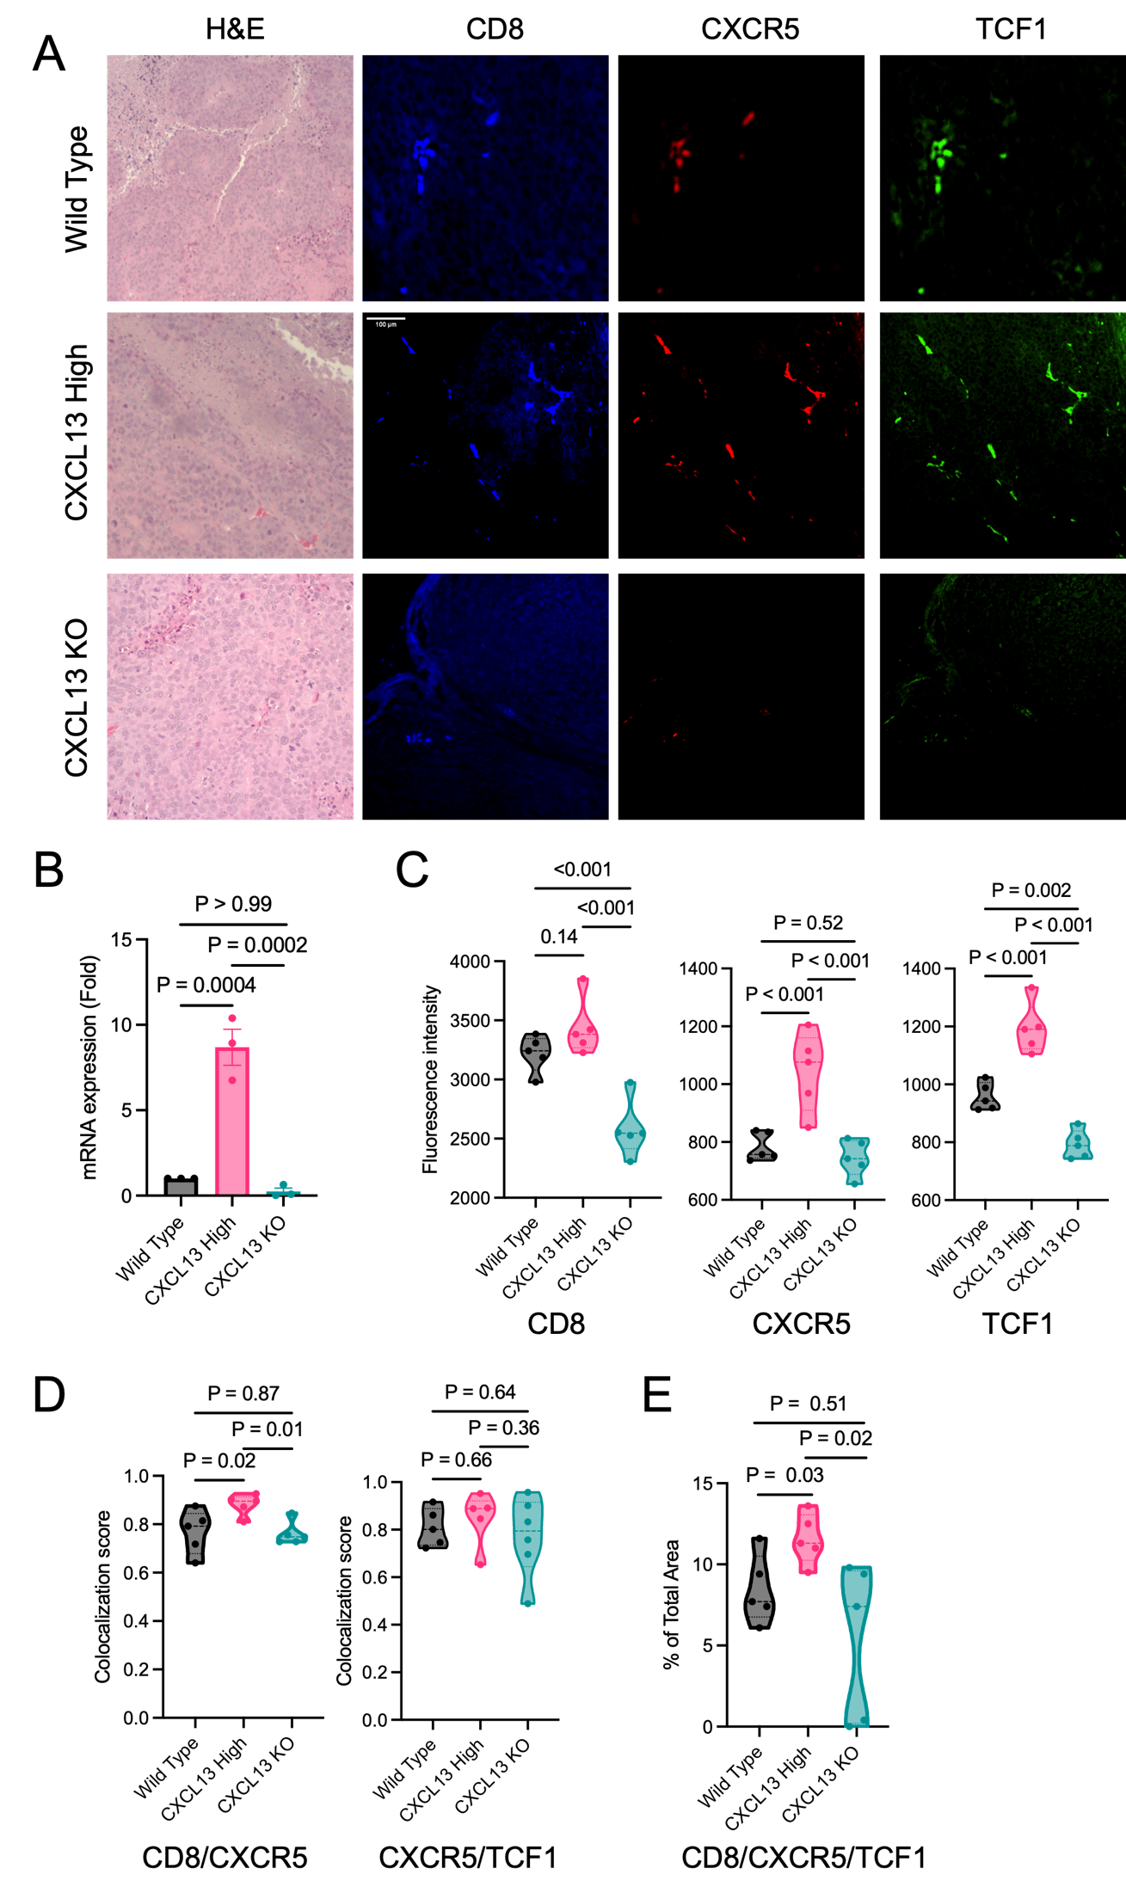
Figure S16. Evaluation of CD8, CXCR5 and TCF1 expression in RENCA tumor models.
(A) Representative H&E and multiplex immunofluorescence images of RENCA tumors generated from wild type, CXCL13 high, and CXCL13 knockout cells. Tumor sections were stained for CD8, CXCR5, and TCF1. (B) Validation of Cxcl13 expression in wild type, CXCL13 high, and CXCL13 knockout RENCA cells by qPCR. (N=3, Mann-Whitney test). (C) Quantification of CD8, CXCR5, and TCF1 fluorescence intensity from tumor sections. CXCL13 high tumors demonstrated increased CD8, CXCR5, and TCF1 fluorescence intensity compared with CXCL13 knockout tumors. (D) Colocalization analysis of CD8/CXCR5 and CXCR5/TCF1 staining. CXCL13 high tumors showed increased CD8/CXCR5 colocalization compared with wild type and CXCL13 knockout tumors, and CXCR5/TCF1 colocalization was maintained across groups. (E) Quantification of the percentage of sampled tumor area demonstrating triple colocalization of CD8, CXCR5, and TCF1 staining. CXCL13 high tumors demonstrated increased CD8/CXCR5/TCF1 colocalized area compared with wild type and CXCL13 knockout tumors. To assess fluorescence intensity and colocalization, 5 random regions were sampled per tumor. Mann-Whitney test was used for comparison.

