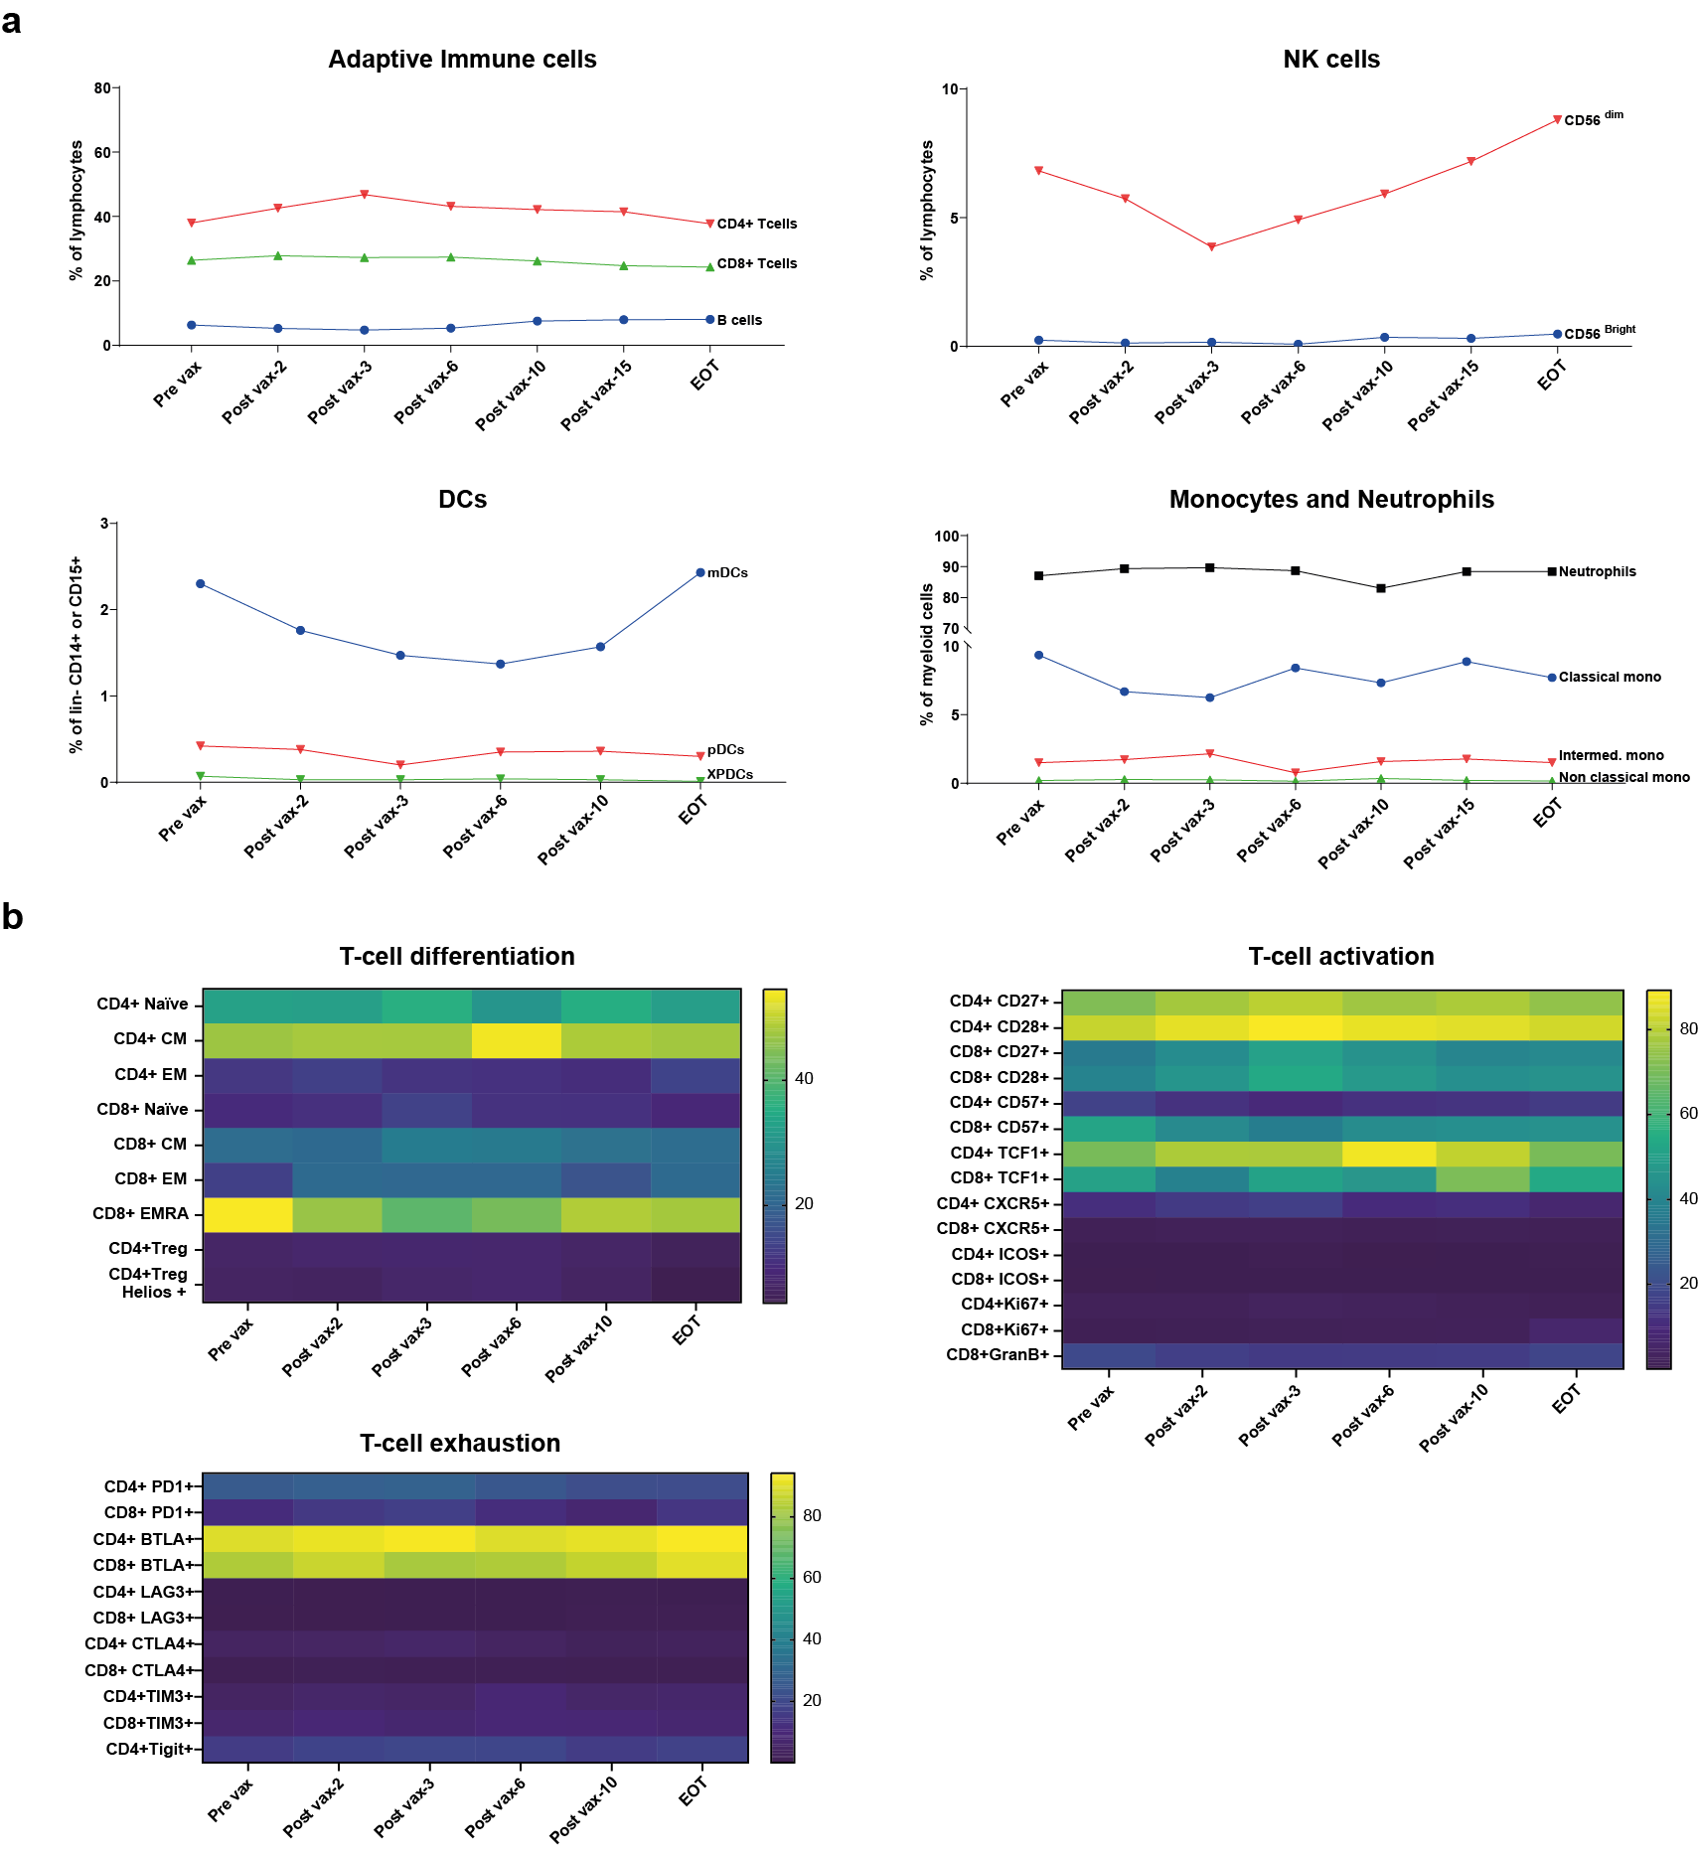
Supplementary Fig. 1. Immune profiling. a, Longitudinal frequency of main adaptive and innate immune cells in peripheral blood over vaccine program period. b, Heatmap representations of relative frequency of T-cell subtypes in peripheral blood over vaccine program period. EOT: End of treatment.

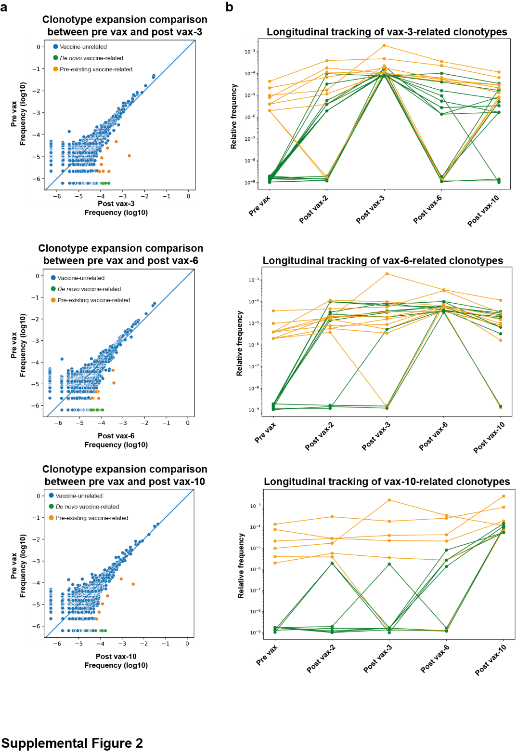
Supplementary Fig. 2. Longitudinal tracking of vaccine-related T-cell clonotypes in the blood after several vaccines. a, Scatter plot showing clonotype counts of T cells in blood, comparing before the first (Pre vax) and after vax-3 (top), vax-6 (middle) or vax-10 (bottom). The colored clonotypes represent significantly expanded T-cell clones after vaccine, split in pre-existing (orange) and newly expanded (de novo, green) clones, or not expanded T-cell clones after the vaccine (blue). b, Dynamics of identified vax-3-related (top), vax-6-related (middle) and vax-10-related (bottom) clonotypes across timepoints.

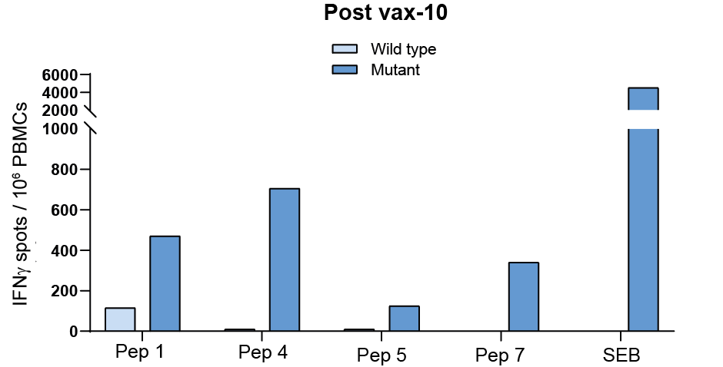
Supplementary Fig. 3. T-cell responses against cognate wild-type vaccine peptides. Vaccine-specific T-cell responses compared to corresponding wild-type peptide-specific T-cell responses of PBMCs after vax-10 and post in vitro stimulation, performed by IFN-γ ELISpot.

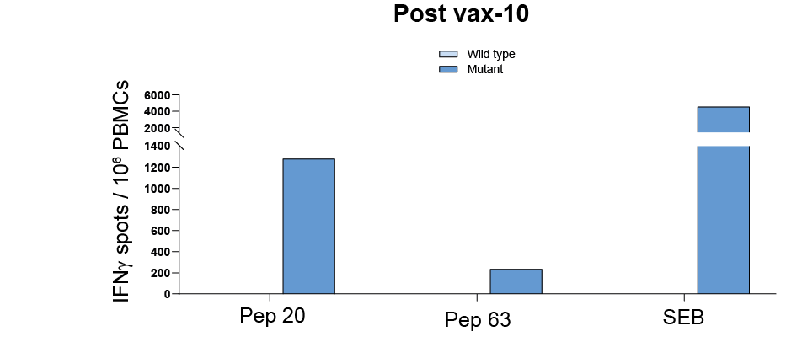
Supplementary Fig. 4. T-cell responses against cognate wild-type short length peptides. Identified short-length peptide-specific T-cell responses compared to corresponding wild-type peptide-specific T-cell responses of PBMCs after vax-10 and post in vitro stimulation, performed by IFN-γ ELISpot.

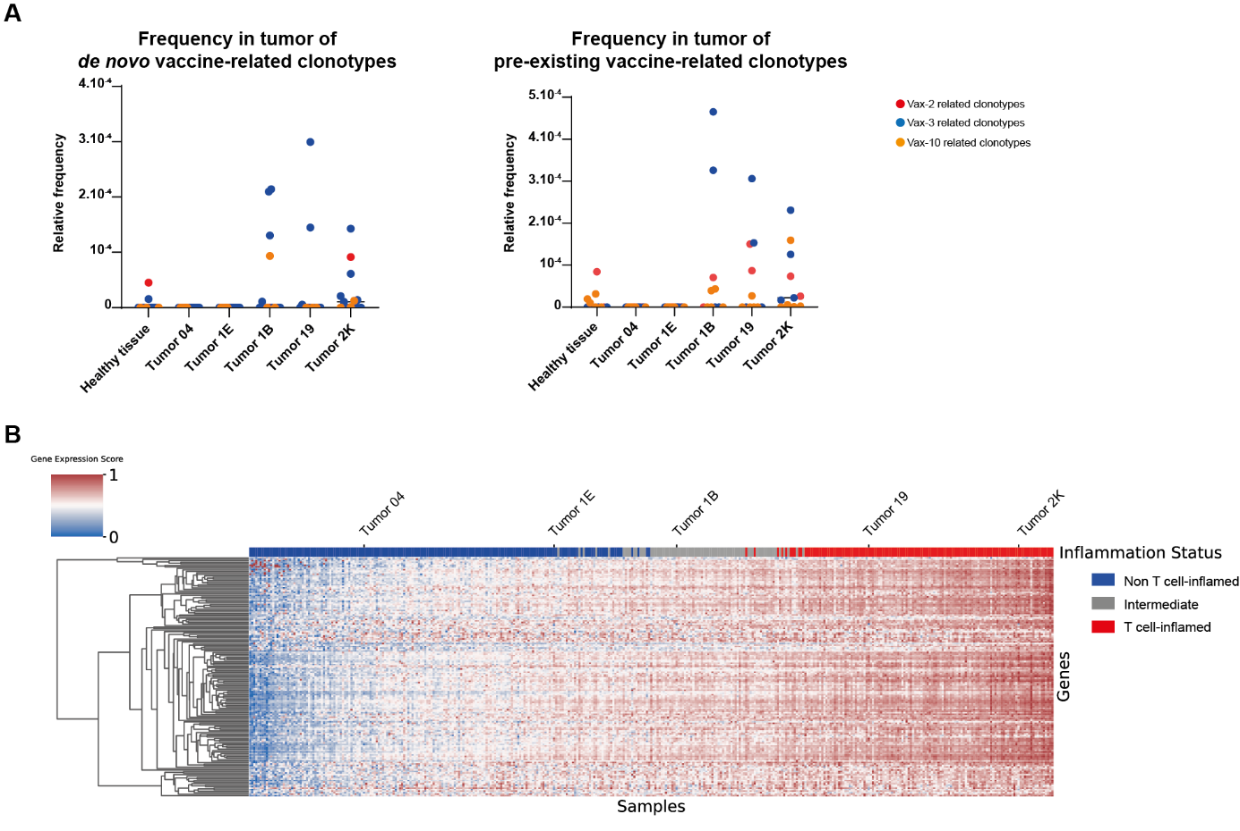
Supplementary Fig. 5. Detection of vaccine-related clonotypes of interest in tumor samples. a, Frequencies of vaccine-related clonotypes in tumor samples and adjacent endometrial healthy tissue. b, Inflammation ranking of the patient’s tumor samples compared to TCGA ovarian cancer tissues.

Supplementary Table 1. List of neoantigen peptides included in the vaccine.
Supplementary Table 2. List of additional short-length neoantigen peptides.

