Supplemental material

Fourth-Generation Chimeric Antigen Receptor T Cells Targeting Mucin 1 for Enhanced Anti-tumor Activity against Breast Cancer
Kamonlapat Supimon^{1,2}, Thanich Sangsuwannukul^{1,2}, Nunghathai Sawasdee^{1,2}, Kornkan Choomee^{1,2}, Krissada Natungnuy^{1,2}, Saowaluck Nganrungreung³, Pinpat Tripatara³, Siwanon Jirawatnotai^{3,4}, Doonyapat Sa-nguanraksa⁵, Malee Warnnissorn⁶, Chanitra Thuwajit⁷, Seiji Okada⁸, Mutita Junking^{1,2,*}, and Pa-thai Yenchitsomanus^{1,2,*}
¹ Siriraj Center of Research Excellence for Cancer Immunotherapy (SiCORE-CIT), Research Department, Faculty of Medicine Siriraj Hospital, Mahidol University, Bangkok, Thailand.
² Division of Molecular Medicine, Research Department, Faculty of Medicine Siriraj Hospital, Mahidol University, Bangkok, Thailand.
³ Department of Pharmacology, Faculty of Medicine Siriraj Hospital, Mahidol University, Bangkok, Thailand.
⁴ Siriraj Center of Research Excellence (SiCORE) for Systems Pharmacology, Department of Pharmacology, Faculty of Medicine, Siriraj Hospital, Mahidol University, Bangkok, Thailand.
⁵ Division of Head-Neck and Breast Surgery, Department of Surgery, Faculty of Medicine Siriraj Hospital, Mahidol University, Bangkok, Thailand
⁶ Department of Pathology, Faculty of Medicine Siriraj Hospital, Mahidol University, Bangkok, Thailand
⁷ Department of Immunology, Faculty of Medicine Siriraj Hospital, Mahidol University, Bangkok, Thailand.
⁸ Division of Hematopoiesis, Joint Research Center for Human Retrovirus Infection, Kumamoto University, 2-2-1 Honjo, Chuo-ku, Kumamoto 860-0811, Japan.

*Corresponding Author Pa-thai Yenchitsomanus (ptyench@gmail.com) and
Mutita Junking (mjunking@gmail.com)
Division of Molecular Medicine, Research Department, Faculty of Medicine Siriraj Hospital, Mahidol University, Bangkok 10700, Thailand
Tel: 66-2-419-2777 Fax: 66-2-411-0169

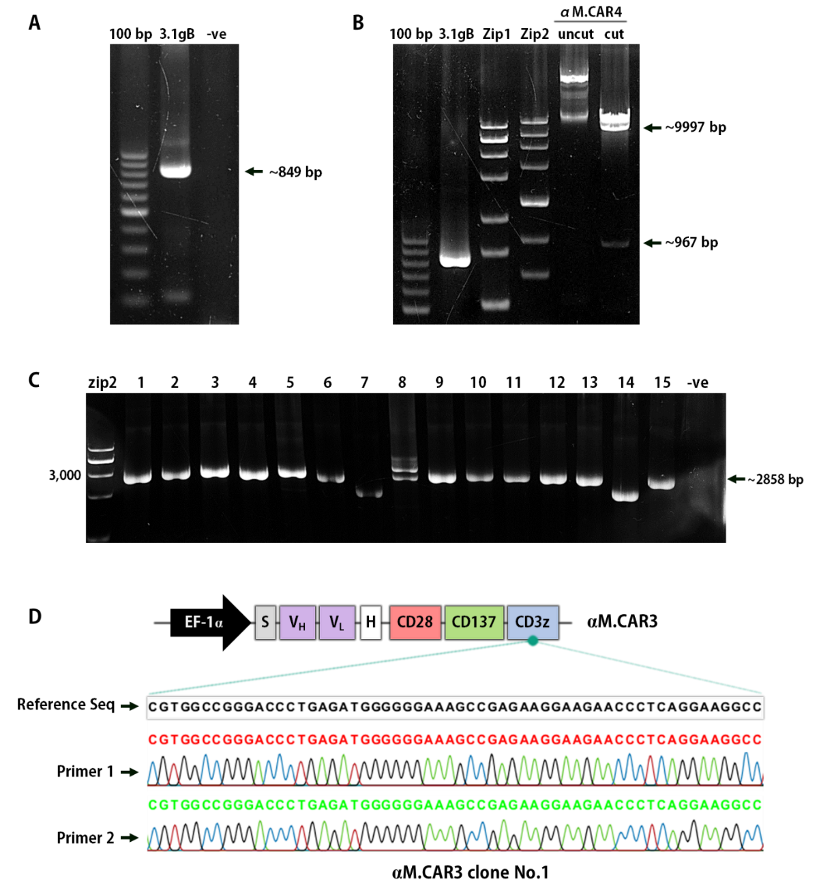
Supplementary Fig 1 Construction of the αM.CAR3 lentiviral vector. (A) Amplified CAR3 DNA products, with an expected product size of approximately 850 base pairs. (B) Digestion of the CAR3 DNA (labeled as 3.1gB) and αM.CAR4 vector with specific restriction enzymes, in comparison with an undigested product. (C) Screening of transformed E. coli colonies using colony PCR, yielding an expected product size of around 2860 base pairs. (D) Confirmation of the αM.CAR3 lentiviral vector's nucleotide sequences through Sanger DNA sequencing.

Supplementary Table 1 Clinicopathological features of breast cancer patients
Patient characteristics | Total | MUC1^{High} | MUC1^{Low} | p-value
Case, % (n) | 100% (59) | 81.36% (48) | 18.64% (11) | <0.001*
Age at diagnosis (years)  Median (range) | 50.11 (26.74-87.32) | 49.69 (26.74-87.32) | 50.13 (35.02-74.18) | 0.6365
Gender, % (n)
Female  Male | 100% (59)  0 | 100% (48)  0 | 100% (11)  0 | 1.000  -
Subtypes of BC, % (n) |  |  |  | 0.9107
Luminal A | 22.03% (13) | 20.83% (10) | 27.27% (3)
Luminal B | 33.90% (20) | 35.42% (17) | 27.27% (3)
HER2⁺ | 5.08% (3) | 6.25% (3) | 0.00% (0)
TNBC | 38.98% (23) | 37.50% (18) | 45.45% (5)
Clinical staging, % (n) |  |  |  | 0.0949
Stage I-II | 52.54% (31) | 58.33% (28) | 27.27% (3)
Stage III-IV | 47.46% (28) | 41.67% (20) | 72.73% (8)
Histological grade, % (n) |  |  |  | 0.3580
WD | 6.78% (4) | 8.33% (4) | 0.00% (0)
MD | 44.07% (26) | 39.58% (19) | 63.64% (7)
PD | 49.15% (29) | 52.08% (25) | 36.36% (4)
Staining score: MUC1^{High}=2-3, MUC1^{Low}=0-1. Data were analyzed using unpaired t-test for MUC1^{High} versus MUC1^{Low}; age at diagnosis; and gender. Other variables including subtypes of BC, clinical staging, and histological grade were analyzed using Fisher’s exact test. HER2, Human epidermal growth factor receptor 2; TNBC, Triple negative breast cancer; WD, Well Differentiation; MD, Moderate Differentiation; PD, Poor Differentiation.

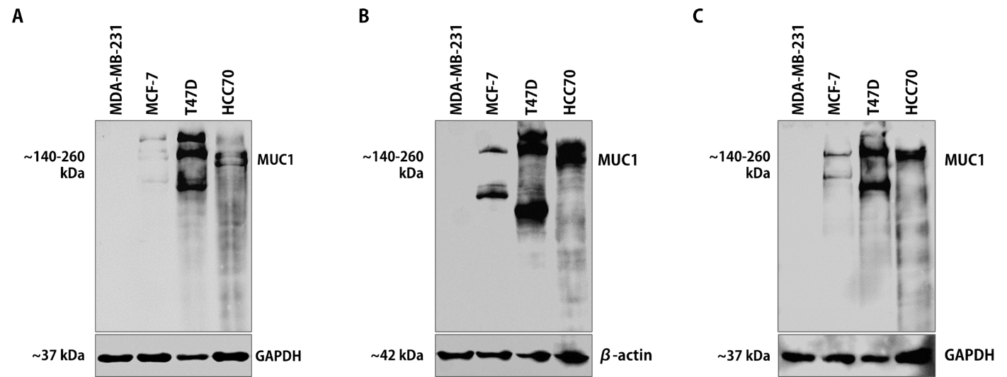
Supplementary Fig 2 Full immunoblotting of MUC1 protein in the indicated BC cell lines. The glycosylated MUC1 protein is detected within the molecular weight range of 140-260 kDa, varying according to the specific cell lines. Housekeeping proteins, GAPDH or β-actin, are utilized as loading controls.

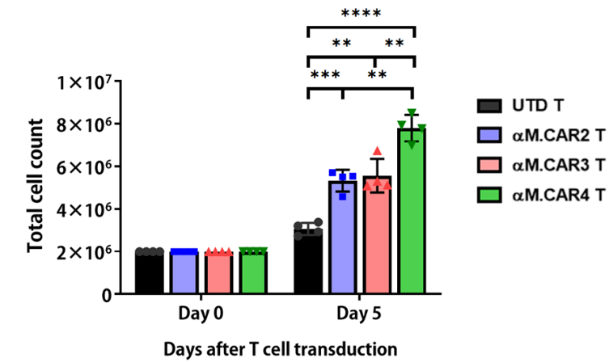
Supplementary Fig 3 Cellular proliferation of the generated αM.CAR T cells at five days post-transduction.

