Supplementary Material

Supplementary Text
Materials and Methods
Subjects: Exclusion criteria included: pregnancy; LDH ≥ 5x upper limits of normal; cytotoxic chemotherapy, interferon, or radiation therapy within 4 weeks; CTLA-4 antibody within 8 weeks; PD-1/PD-L1 Ab within 2 weeks; monoamine oxidase inhibitor use within 3 weeks; known or suspected allergies to therapeutic agents; multiple brain metastases; Class III-IV heart disease; significant pulmonary dysfunction or peripheral vascular disease; use of any UGT1A9 (UDP-glucuronosyltransferase) inhibitor; or significant autoimmune disorder or immune deficiency.
Epacadostat (INCB024360; BSC #766086): Epacadostat is a small-molecule inhibitor specific for IDO1, with potency in the nanomolar range (IC₅₀=7.1–12.7 nM). It reduces conversion of Trp to Kyn and reverses IDO1-mediated suppression of T-cell proliferation in a dose-dependent manner (EC₅₀=17.7 nM), with potency consistent with its inhibition of Trp-to-Kyn conversion^{1, 2}. It does not inhibit tryptophan 2,3-dioxygenase (TDO) or IDO2, nor does it influence Trp transporters. It has >1000-fold selectivity against a number of kinases, ion channels, receptors, and transporters, and does not significantly induce or inhibit cytochrome P450 enzymes.
Vaccine composition: All subjects received a vaccine comprising 12 melanoma peptides (12MP) restricted by HLA-A1, -A2, or -A3, as described (NSC # 728925)³: A1 peptides: DAEKSDICTDEY (Tyrosinase ₂₄₀₋₂₅₁, which has a substitution of Ser for Cys at residue 244), SSDVIPIGTY (Tyrosinase ₁₄₆₋₁₅₆), EADPTGHSY (MAGE-A1 ₁₆₁₋₁₆₉), EVDPIGHLY (MAGE-A3 ₁₆₈₋₁₇₆); A2 peptides: YMDGTMSQV (Tyrosinase _{369-377D}), IMDQVPFSV (gp100 _{209-217,} 209-2M), YLEPGPVTA (gp100 ₂₈₀₋₂₈₈), GLYDGMEHL (MAGE-A10 ₂₅₄₋₂₆₂); and A3 peptides: ALLAVGATK (gp100 ₁₇₋₂₅), LIYRRRLMK (gp100 ₆₁₄₋₆₂₂), SLFRAVITK (MAGE-A1 ₉₆₋₁₀₄ ), and ASGPGGGAPR (NY-ESO-1 ₅₃₋₆₂). ASGPGGGAPR, originally reported to be immunogenic in association with HLA-A31, is naturally processed and presented also by HLA-A*0301 (A3) on human cells⁴. It also includes a peptide from tetanus toxoid that induces CD4⁺ helper T cell responses: AQYIKANSKFIGITEL⁵(NSC #728927). Combination of 12MP plus tetanus peptide is referred to as MELITAC 12.1.
Peptides for vaccines were synthesized and purified (> 95%) under GMP conditions (Multiple Peptide Systems, now PolyPeptide Laboratories, San Diego, CA). After solubilization, each peptide was sterile-filtered, mixed, vialed and lyophilized under GMP conditions by Merck Biosciences AG Clinalfa (Läufelingen, Switzerland) in single-use vials. Vials were submitted to quality-assurance studies including sterility, identity, purity, potency, general safety, pyrogenicity, and stability in accordance with CFR guidelines and BB-IND #9847 and IND #15691.
ELIspot assays. Multiscreen HTS sterile polyvinylidene difluoride filter plates (Millipore, Burlington, MA, USA) were prewet with 70% methanol and were coated with anti-IFN-γ mAb (Pierce Endogen). Effector cells were plated at 200,000 PBMC per well and pulsed with synthetic peptide (10 mcg/ml each), in quadruplicate, with 12MP and tetanus peptide evaluated separately. Plates were incubated at 37°C and 5% CO2 for 18–20 h. After washing, the plates were incubated with a biotin-labeled anti-IFN-γ Ab (Pierce Endogen). The plates were washed again and incubated with streptavidin conjugated to alkaline phosphatase (BD Pharmingen). After washing, the plates were developed with NBT/5-bromo-4-chloro-3-indolyl phosphate substrate-Toluidine salt (Pierce). Plates were read using an automated plate reader (Bioreader; BIO-SYS GmbH, Karben, Germany). Negative controls included irrelevant peptide from HIV gag protein, and no peptide. Positive controls included each of the following: a mixture of viral peptides (CEF peptide pool⁶), phorbol myristate acetate (PMA)-ionomycin and phytohaemagglutinin (PHA).

Evaluation of T-cell responses was based on the following definitions at each assay time point:
N_{vax}= number of T-cells responding to vaccine peptide; N_{neg}= number T-cells responding to maximum negative control; R_{vax}= N_{vax}/N_{neg}. For evaluations of PBMC, a subject was considered to have a T-cell response to vaccination (binary yes/no) at each time point after baseline, by direct ELIspot assay only if all the following criteria were met: (1) N_{vax} exceeded N_{neg} by at least 20 / 100,000 CD8+ or CD4+ cells (0.02%), (2) (N_{vax} – 1 SD) ≥ (N_{neg} + 1 SD), and (3) R_{vax} after vaccination ≥ 2 x R_{vax} pre-vaccine, as described. Fold-increases less than one were set to one to indicate no response and to prevent overinflating adjusted fold-increases due to pre-vaccine ratios less than one, or division by zero, while not affecting the determination of response. Negative control values of zero were set to 0.1 spots/100,000 cells to avoid dividing by zero in calculating fold-increases. The proportion of responding cells per 100,000 CD8+ T cells or CD4+ T cells was determination of the proportions of those cells in PBMC, by flow cytometry. The antibodies used for surface staining included: CD3 Horizon v450 (UCHT1), CD8 PE-Cy7 (RPA-T8), CD4- Fitc (RPA-T4), CD56-PE (B159), CD14-PerCP-Cy5.5 (M5E2), and CD19-APC (HIB19) from BDBiosciences (San Jose, CA). Aqua live/dead marker (Molecular Probes/Invitrogen) was used at 1:600 to exclude dead cells. Cells were acquired on a FACSCanto II flow cytometer (BD Biosciences) maintained in the Carter Immunology Center at the University of Virginia. Flow Jo software (BD Biosciences) was used to analyze data. Gating of live lymphocyte populations was based on forward and side scatter parameters and exclusion of Aqua⁺ cells. CD4⁺ cells were gated on CD3⁺ live lymphocytes. The proportions of PBMC expressing CD4 or CD8, respectively, were defined as CD3+CD4+ lymphocytes and CD3+CD8+ live lymphocytes among total PBMC.

Assay consistency is represented by interassay coefficients of variation (CVs) calculated for the response of normal donor PBMC to the CEF peptide pool. For the normal donor, the mean number of spots among the assays used in this report was 340/100,000 cells, and CV was 10%.
For analysis of T cell responses by tumor infiltrating lymphocytes (TIL) to peptides in the vaccines, cryopreserved single cell suspensions of tumor biopsies were thawed into RPMI + 10% human AB serum containing DNAase, and were stimulated in vitro with 40 mcg/ml of each of 12MP by incubating 2h at 37ºC in 5% CO2. They were then spun down and resuspended in fresh complete media with 50 Cetus units/ml IL-2 and cultured in the presence of low dose IL-2, blocking antibody to PD-1 (pembrolizumab, 5 mcg/ml, provided from clinical pharmacy as unused), and agonistic antibody to CD28 (Biolegend, San Diego, CA; Cat#302934, 0.2 mcg/ml), for 21 days, with replacement of AIM V serum-free media, cytokine, and antibodies periodically. After 21 days of culture, viable lymphocytes were enumerated, and samples with adequate numbers were tested in an IFNγ ELIspot assay for reactivity to each of the peptides relevant for the subject’s Class I HLA type, using C1R-A2 as antigen presenting cells.

Kynurenin:tryptophan ratios in serum. Serum levels of Kyn and Trp were determined at World Wide Clinical trials (Austin, TX) using a validated liquid chromatography and tandem mass spectrometry (LC/MS/MS) assay. The method was validated for a range of 40 to 20,000 ng/mL for Trp and 4 to 2000 ng/mL for Kyn. Samples containing Trp, Kyn, and the internal standards, tryptophan-D5, and kynurenine-D6 was extracted using solid-phase extraction (SPE) and analyzed by a Sciex API 4000 LC-MS-MS equipped with an HPLC column. The peak area of the m/z 205.1 → 118.1 Trp product ion was measured against the peak area of the m/z 210.1 → 122.1 Trp-D5 internal standard product ion. The peak area of the m/z 209.1 → 94.0 Kyn product ion was measured against the peak area of the m/z 215.1 → 98.0 Kyn-D6 internal standard product ion. Quantitation was performed using separate weighted (1/x2 for each analyte) linear least squares regression analyses generated from calibration standards prepared on the day of extraction.

IDO1 expression in tumor biopsies. FFPE samples of the tumor biopsies were evaluated for IDO1 gene expression (mRNA) with RNAscope RNA in situ hybridization (ISH) by Advanced Cell Diagnostics (ACD; Hayward, CA). Antigen retrieval was performed by incubation at 95ºC x 10 min, then treatment with Protease III (ACD Reagent #2003796) x 40 min. ISH for IDO1 mRNA was performed by hybridization with IDO1 oligos (catalog #602688), using an automated platform (Leica Bond Rx). The slides were then hybridized sequentially with preamplifer oligos, amplifier oligos, and AP-labelled oligos, then developed with chromogen precipitate. Positive control on each sample used RNAscope probe for peptidylprolyl isomerase B (PPIB, catalog #313908) to assess RNA integrity, and a negative control probe for bacterial dihydrodipicolinate reductase (dapB, catalog #312038). Gill’s hematoxylin was used as a counterstain. Specific RNA signal was defined by punctate red dots, which were imaged on an Aperio AT2 digital scanner with a 40x objective. Staining in each cell was scored visually by a scientist on a scale of 0 to 3 per cell, grouping cells into 4 bins (0 = 0 dots/cell; 1 = 1-3/cell; 2 = 4-9/cell; 3 = ≥10 dots/cell). In 3 regions of interest (ROI) per sample, 3 cell types were evaluated (tumor cells; intratumoral stromal and tumor-infiltrating immune cells, and peritumoral stromal immune cells). For each of these 3 cell types/regions, the percentage in each bin was defined, and an H-score (between 0 and 300) was defined as; 0 x (% in bin 0) + 1 x (% in bin 1) + 2 x (% in bin 2) + 3 x (% in bin 3).

Statistical Considerations: Gene expression analyses: Briefly, data quality control metrics were assessed and normalization of raw counts was performed using recommended parameters, with housekeeping probes selected based on the geNorm algorithm and the counts within each lane normalized against the geometric mean of the selected housekeeping probes and positive control probes from the same lane. Differential gene expression analysis was performed in the platform by the Fast method developed by Nanostring using the Generalized Linear Model for count data, assuming a negative binomial distribution with covariate correction to account for the paired patient samples and adjustment of P values for false discovery rate (FDR) correction using the Benjamini-Hochberg method. Differentially expressed genes (DEGs) were defined as genes with a |fold-change| ≥ 1.5 and adjusted-p < 0.05.

References Cited in Supplementary Text
1. Koblish HK, Hansbury MJ, Bowman KJ, Yang G, Neilan CL, Haley PJ, Burn TC, Waeltz P, Sparks RB, Yue EW, Combs AP, Scherle PA, Vaddi K, Fridman JS. Hydroxyamidine inhibitors of indoleamine-2,3-dioxygenase potently suppress systemic tryptophan catabolism and the growth of IDO-expressing tumors. Mol Cancer Ther. 2010;9(2):489-98.
2. Liu X, Shin N, Koblish HK, Yang G, Wang Q, Wang K, Leffet L, Hansbury MJ, Thomas B, Rupar M, Waeltz P, Bowman KJ, Polam P, Sparks RB, Yue EW, Li Y, Wynn R, Fridman JS, Burn TC, Combs AP, Newton RC, Scherle PA. Selective inhibition of IDO1 effectively regulates mediators of antitumor immunity. Blood. 2010;115(17):3520-30.
3. Slingluff CL, Jr., Petroni GR, Chianese-Bullock KA, Smolkin ME, Hibbitts S, Murphy C, Johansen N, Grosh WW, Yamshchikov GV, P.Y. N, Patterson JW, Fink R, Rehm PK. Immunologic and clinical outcomes of a randomized phase II trial of two multipeptide vaccines for melanoma in the adjuvant setting. Clinical Cancer Research. 2007;13(21):6386-95. doi: 10.1158/1078-0432.CCR-07-0486. PubMed PMID: 17975151.
4. Hogan KT, Sutton JN, Chu KU, Busby JA, Shabanowitz J, Hunt DF, Slingluff CL, Jr. Use of selected reaction monitoring mass spectrometry for the detection of specific MHC class I peptide antigens on A3 supertype family members. Cancer Immunol Immunother. 2005;54(4):359-71. Epub 2004/09/21. doi: 10.1007/s00262-004-0592-y. PubMed PMID: 15378283.
5. Slingluff CL, Jr., Yamshchikov G, Neese P, Galavotti H, Eastham S, Engelhard VH, Kittlesen D, Deacon D, Hibbitts S, Grosh WW, Petroni G, Cohen R, Wiernasz C, Patterson JW, Conway BP, Ross WG. Phase I trial of a melanoma vaccine with gp100(280-288) peptide and tetanus helper peptide in adjuvant: immunologic and clinical outcomes. Clinical Cancer Research. 2001;7(10):3012-24.
6. Currier JR, Kuta EG, Turk E, Earhart LB, Loomis-Price L, Janetzki S, Ferrari G, Birx DL, Cox JH. A panel of MHC class I restricted viral peptides for use as a quality control for vaccine trial ELISPOT assays. J Immunol Methods. 2002;260(1-2):157-72. Epub 2002/01/17. PubMed PMID: 11792386.

Supplementary Table 1. Prior therapies for participants with resectable melanoma
Subject  ID # | Prior Therapies other than surgery
2 | Mel51 melanoma vaccine trial (NCT00977145); GM-CSF
4 | None
7 | None
8 | None
10 | None
11 | Information not available

Supplementary Table 2. Treatment-related adverse events by subject and overall
 | CITN-04 subject number: max AE grade |  |  |  |  |  |  |  |  |  |  | Total #  w AEs | % of  subjects | # pts with AE by max grade
Adverse event | 1 | 2 | 3 | 4 | 5 | 6 | 7 | 8 | 9 | 10 | 11 | Total #  w AEs | % of  subjects | Grade 1 | Grade 2 | Grade 3
Injection site reaction | 2 | 1 | 3 | 2 | 1 | 1 | 1 | 2 | 1 | 1 |  | 10 | 91% | 6 | 3 | 1
Fatigue |  |  |  | 1 | 1 |  |  | 1 | 1 | 1 |  | 5 | 45% | 5
Nausea |  | 1 |  | 2 | 1 | 1 |  |  |  |  |  | 4 | 36% | 3 | 1
Skin induration |  |  |  | 1 |  |  | 2 |  |  | 1 |  | 3 | 27% | 2 | 1
Hypokalemia |  |  |  |  | 1 | 1 |  |  |  |  |  | 2 | 18% | 2
Abdominal pain |  |  |  |  |  |  | 1 |  |  | 1 |  | 2 | 18% | 2
AST increased |  | 2 |  |  |  |  |  | 1 | 1 |  |  | 2 | 18% | 1 | 1
Chills | 1 |  | 1 |  |  |  |  |  |  |  |  | 2 | 18% | 2
Creatinine increased | 1 |  |  |  |  |  |  |  | 1 |  |  | 2 | 18% | 2
Flu-like symptoms |  |  |  | 1 |  |  |  | 1 |  |  |  | 2 | 18% | 2
Lymphocyte count decreased |  |  |  |  | 2 | 1 |  |  |  |  |  | 2 | 18% | 1 | 1
Platelet count decreased | 1 |  |  |  | 3 |  |  |  |  |  |  | 2 | 18% | 1 |  | 1
White blood cell decreased | 1 |  |  |  |  | 1 |  |  |  |  |  | 2 | 18% | 2
ALT increased |  | 3 |  |  |  |  |  |  |  |  |  | 1 | 9% |  |  | 1
Anemia |  |  |  |  |  |  |  | 1 |  |  |  | 1 | 9% | 1
Anorexia |  |  |  | 1 |  |  |  |  |  |  |  | 1 | 9% | 1
Arthralgia |  |  |  |  |  |  |  | 1 |  |  |  | 1 | 9% | 1
Bloating |  | 1 |  |  |  |  |  |  |  |  |  | 1 | 9% | 1
Constipation |  |  |  |  | 1 |  |  |  |  |  |  | 1 | 9% | 1
Cytokine release syndrome |  |  |  |  |  |  | 1 |  |  |  |  | 1 | 9% | 1
Diarrhea |  |  | 1 |  |  |  |  |  |  |  |  | 1 | 9% | 1
Fever |  |  |  | 1 |  |  |  |  |  |  |  | 1 | 9% | 1
Headache |  |  |  |  |  |  |  | 1 |  |  |  | 1 | 9% | 1
Hyponatremia |  | 1 |  |  |  |  |  |  |  |  |  | 1 | 9% | 1
Hypophosphatemia |  |  |  |  | 2 |  |  |  |  |  |  | 1 | 9% |  | 1
Infections and infestations – other |  |  |  |  |  |  |  |  | 1 |  |  | 2 | 9% | 1
Myalgia |  |  |  |  |  |  |  | 1 |  |  |  | 1 | 9% | 1
Pain, other (breast, chest wall, extremity, NOS) |  |  |  |  |  | 2 |  |  |  |  |  | 1 | 9% |  | 1
Pruritis |  | 1 |  |  |  |  |  |  |  |  |  | 1 | 9% | 1
Rash – maculopapular |  |  |  |  |  |  |  |  | 1 |  |  | 1 | 9% | 1
Skin ulceration |  |  |  | 2 |  |  |  |  |  |  |  | 1 | 9% |  | 1
Vomiting |  |  |  | 2 |  |  |  |  |  |  |  | 1 | 9% |  | 1

Supplementary Table 3. Evaluation of Kyn, Trp, and epacadostat in the TME
Assay  Method | Pt ID | Day on Study | Tissue ROI | Trp (mcg/g) |  | Kyn  (mcg/g) | Kyn/Trp  ratio | Reduction in Kyn/Trp ratio v D0 | Epacadostat (mcg/g) | Kyn/Epacadostat  ratio
MALDI-FTICR | 4 | D21 | Entire section | 16.97 |  | BLLOD | 0.01 | -- | -- | --
MALDI-FTICR | 4 |  | Tumor | 15.69 |  | 3.16 | 0.20 | -- | -- | --
MALDI-FTICR | 4 |  | Tumor Epidermis | 26.91 |  | 16.96 | 0.63 | -- | -- | --
MALDI-FTICR | 4 | D42 | Entire section | 19.38 |  | 10.95 | 0.57 | -- | -- | --
MALDI-FTICR | 4 |  | Tumor | 19.57 |  | 41.63 | 2.13 | -- | -- | --
MALDI-FTICR | 4 |  | Tumor Epidermis | 17.11 |  | 20.54 | 1.20 | -- | -- | --
MALDI-FTICR | 4 |  | Necrosis | 25.30 |  | 2.03 | 0.08 | -- | -- | --
MALDI-FTICR | 6 | D0 | Entire section | 1.62 |  | 4.36 | 2.69 | 0% | -- | --
MALDI-FTICR | 6 |  | Tumor | 1.39 |  | 7.62 | 5.48 | 0% | -- | --
MALDI-FTICR | 6 |  | Stroma | 1.82 |  | BLLOD* | 0.16 | 0% | -- | --
MALDI-FTICR | 6 | D21 | Entire section | 14.50 |  | 3.78 | 0.26 | 90% | -- | --
MALDI-FTICR | 6 |  | Tumor | 17.25 |  | 5.95 | 0.35 | 94% | -- | --
MALDI-FTICR | 6 |  | Stroma | 2.00 |  | BLOD | 0.15 | 6% | -- | --
MALDI-FTICR | 10 | D0 | Entire section | 77.14 |  | 8.68 | 0.11 | 0% | -- | --
MALDI-FTICR | 10 |  | Tumor | 79.64 |  | 9.15 | 0.11 | 0% | -- | --
MALDI-FTICR | 10 | D42 | Entire section | 25.19 |  | BLLOD | 0.01 | 91% | -- | --
MALDI-FTICR | 10 |  | Tumor | 25.79 |  | BLLOD | 0.01 | 91% | -- | --
MALDI-FTICR | 10 |  | Necrosis | 24.01 |  | BLLOD | 0.01 | 91% | -- | --
LC-MS | 4 | D21 | Tumor | 6.4 | 0.31 |  | 0.05 | -- | 0.6 | 0.52
LC-MS | 4 | D42 | Tumor | 16.1 | 3.74 |  | 0.23 | -- | 1.0 | 3.74
LC-MS | 4 | D42 | Tumor epithelium | 4.0 | 1.37 |  | 0.34 | -- | BLLOD | --
LC-MS | 6 | D0 | Tumor | 0.9 | 0.94 |  | 1.04 | 0% | n.d. | --
LC-MS | 6 | D21 | Tumor | 1.3 | 0.85 |  | 0.65 | 38% | 0.28 | 3.04
LC-MS | 9 | D21 | Tumor | 3.7 | 2.02 |  | 0.55 | -- | 0.98 | 2.06
LC-MS | 10 | D0 | Tumor | 14.8 | 0.8 |  | 0.05 | 0% | -- | --
LC-MS | 10 | D21 | Tumor infiltrate | 4.3 | 0.62 |  | 0.14 | -- | 0.31 | 2.0
LC-MS | 10 | D21 | Tumor | 5.0 | 0.85 |  | 0.17 | no | 0.44 | 1.9
LC-MS | 10 | D42 | Tumor | 3.4 | 0.28 |  | 0.08 | no | 0.82 | 0.3
*BLLOD (below lower limit of detection): calculated as 0.3 mcg/g tissue

Supplementary Table 4. Expression of IDO1 and PD-L1 in melanoma metastases in CITN-04, by immunohistochemistry
Subject  ID | Date of Tumor specimen* | IDO1 % staining |  |  | PD-L1  % Staining
Subject  ID | Date of Tumor specimen* | % melanoma cells staining for IDO1 | % macrophages staining for IDO1 | Vessels (% staining) | PD-L1  % Staining
1 | D0 | 15-20 | 10 | 0 | 10
1 | D21 | 15-20 | 0 | 0 | <1
1 | D42 | 15-20 | 10 | 0 | 30
2 | D0 | 5-10 | 5 | 0 | 1
2 | D21 | 0 | 0 | 0 | 0
2 | D42 | 10-15 | 10 | 0 | 10-15
3 | D0 | NE** | 40-50 | 0 | 20-30 ***
3 | D21 | NE | 40-50 | 0 | 20-30 ***
4 | D0 | 0 | 5 | 0 | <1
4 | D21 (1) | <1 | 15 | 0 | <1
4 | D21 (2) | NE | NE | NE | NE
4 | D42 | 0 | 15 | 0 | 5-10
5 | D0 | 1 | 30 | 5 | 20-25
5 | D21 | 5 | 30 | 10 | 20-25
5 | D42 | 1 | 30 | 30-40 | 5
5 | D112 | 5 | 30 | 30-40 | 15
6 | D0 | 75 | 10 | 0 | 20
6 | D21 | 30 | 15 | 5 | 5
6 | D42 | 30 | 15 | 5 | <1%
7 | D0 (1) | 1 | 0 | 30-40 | 3
7 | D0 (2) | 1 | 0 | 60-80 | 3
7 | D21 (1) | 1 | 0 | 60-80 | 3
7 | D21 (2) | 1 | 0 | 60-80 | 0
8 | D0 | 0 | 0 | 0 | 0
8 | D21 | 0 | 0 | 0 | 0
9 | D0 | 40 | 10 | 0 | 75
9 | D21 | 40 | 15 | 0 | 75
9 | D42 | NE | NE | NE | NE
10 | D0 (1) | <1 | 10 | 20 | 0
10 | D0 (2) | 1 | 0 | 20 | 0
10 | D21 | 5 | 10 | 20 | 0
10 | D42 (1) | 5-10 | 10 | 20 | 0
10 | D42 (2) | 1-2 | 10 | 20 | 0
10 | D42 (3) | 30 | 10 | 10 | <5
11 | D0 | 0 | 10 | 0 | 20
* when more then one sample was evaluated at a given time point, each is numbered 1-3 in parentheses.
** NE = not evaluable: sample too small or no definite tumor cells evident.
*** PD-L1 staining only evident on macrophages

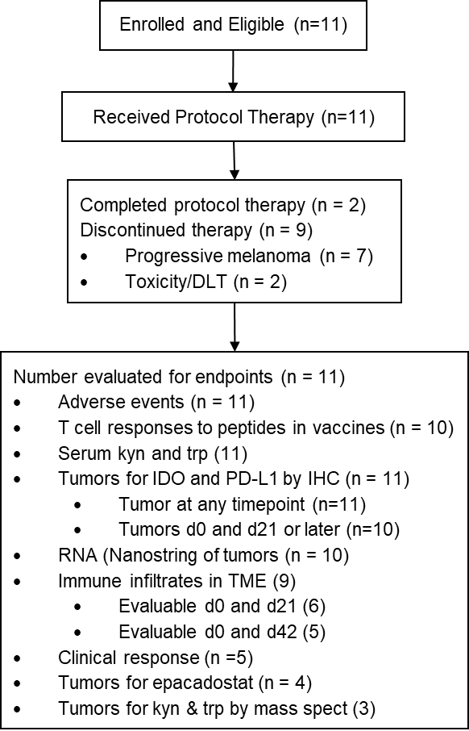

Supplementary Figure 1. CONSORT Diagram

A
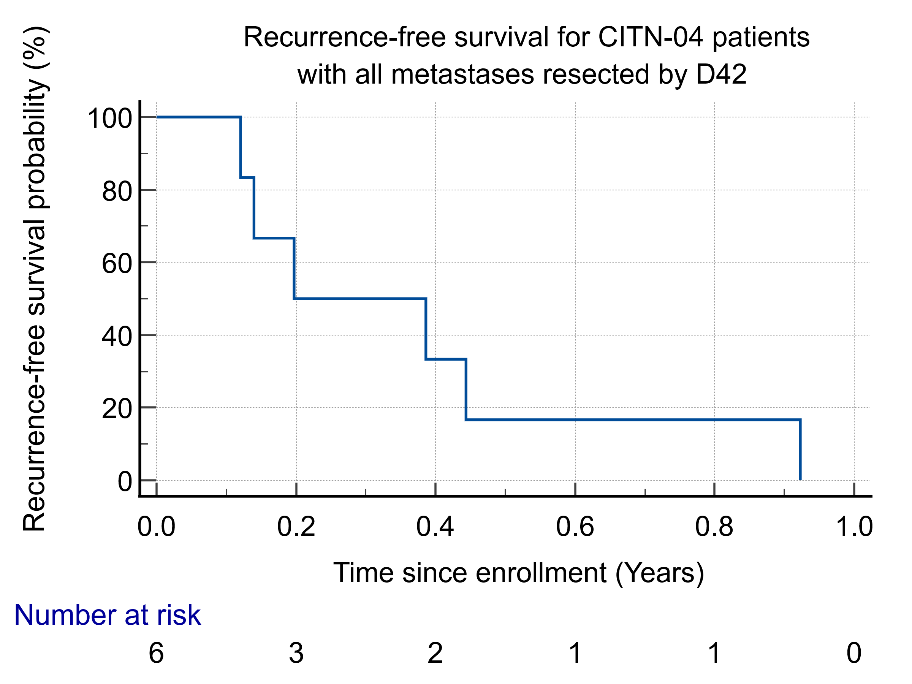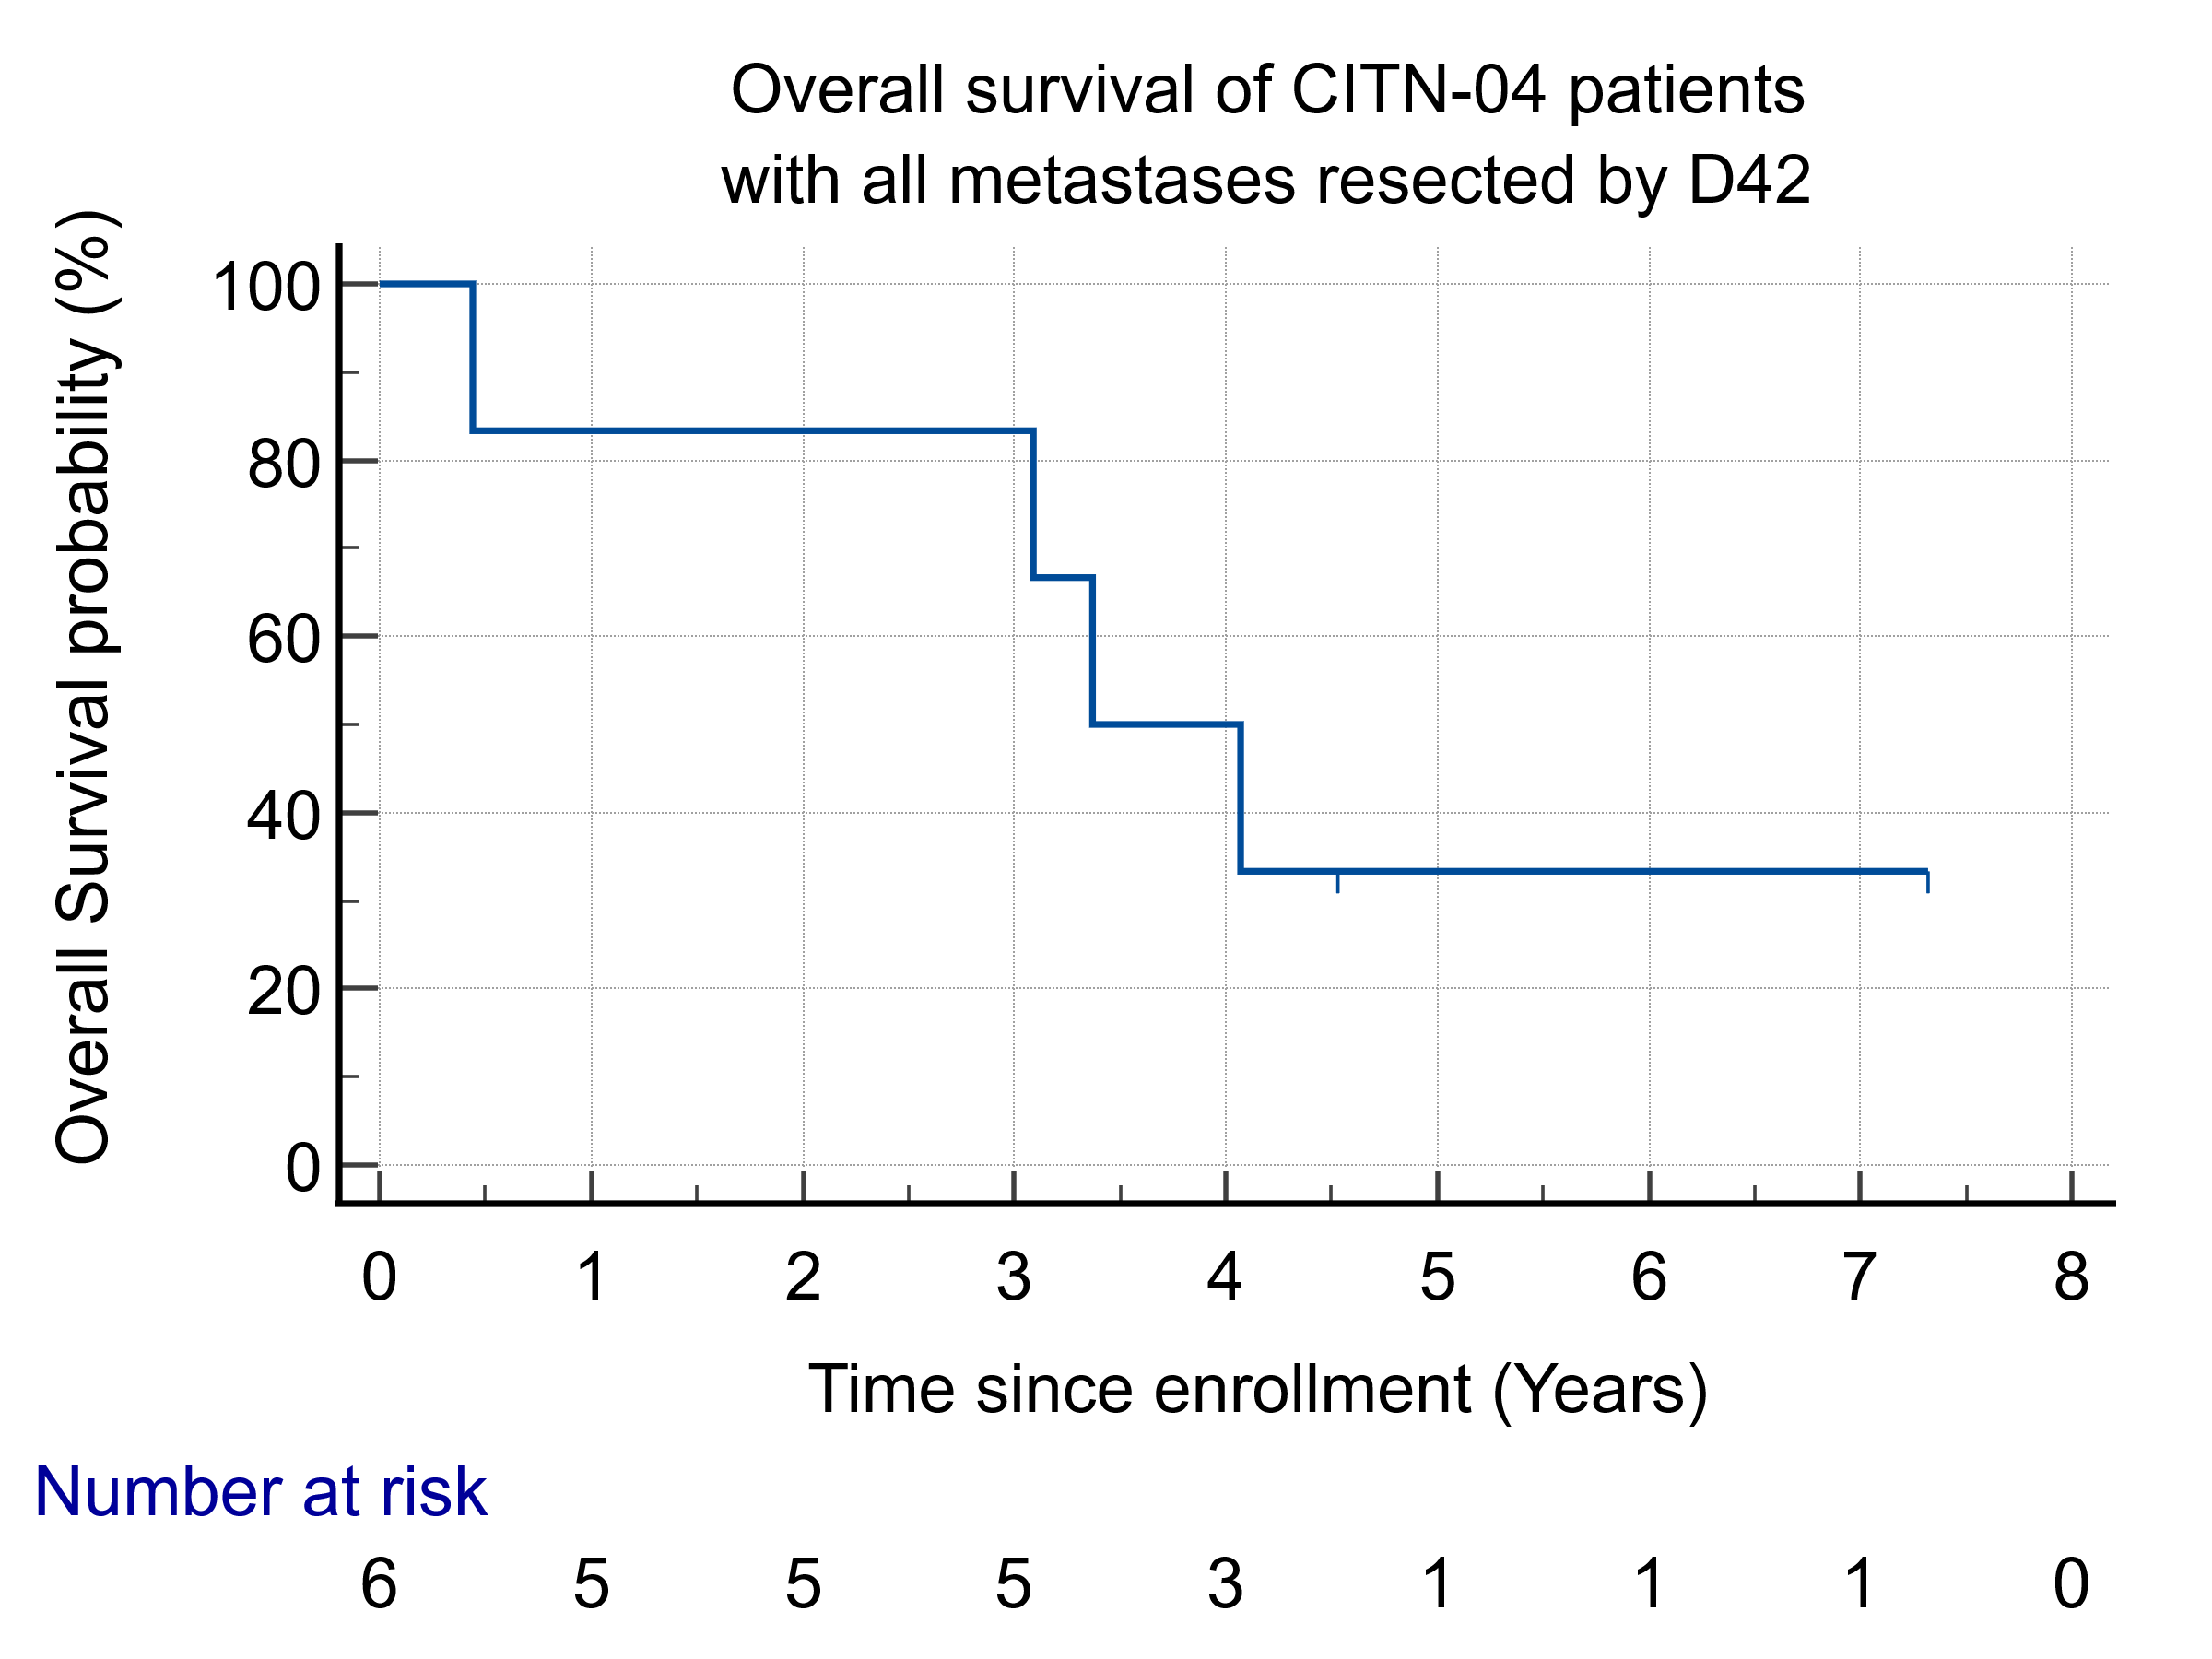
Supplementary Figure 2. Recurrence-free survival (RFS, A) and overall survival (OS, B) outcomes are shown in Kaplan-Meier curves. Median RFS was 0.197 years; Median OS was 3.37 years. The two participants alive at last followup were alive with disease.

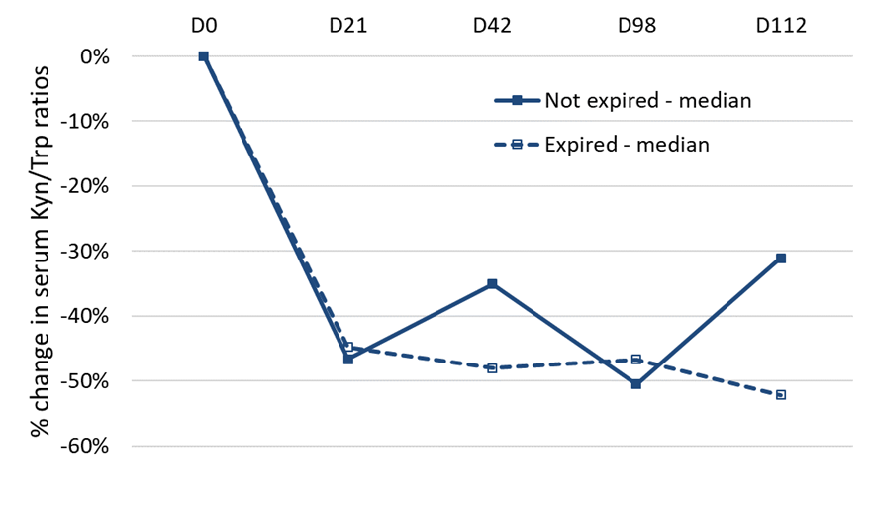
Supplementary Figure 3: Changes in serum Kyn/Trp ratio on epacadostat as a function of expiration date. Serum was evaluated for kynurenine and tryptophan days 0, 21, 42, 98, 112. The proportional decrease in Kyn/Trp ratio was determined. Four patients received drug that had passed its stated expiration date. Median Kyn/Try ratios for those four patients are presented (solid line), as well as median Kyn/Trp ratios for the seven patients who did not receive drug past its expiration date (dotted line).
A B
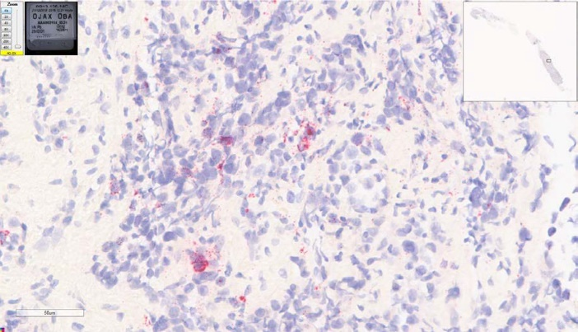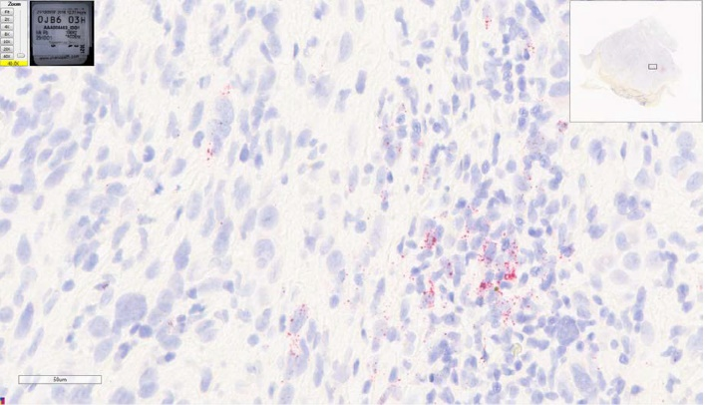
C D
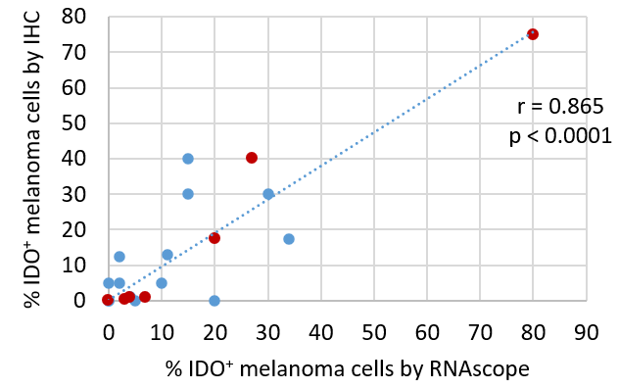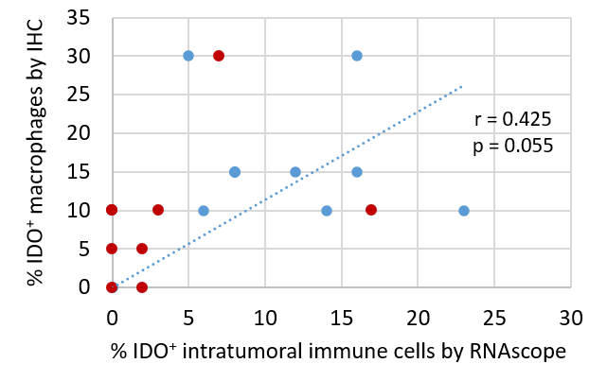
E F
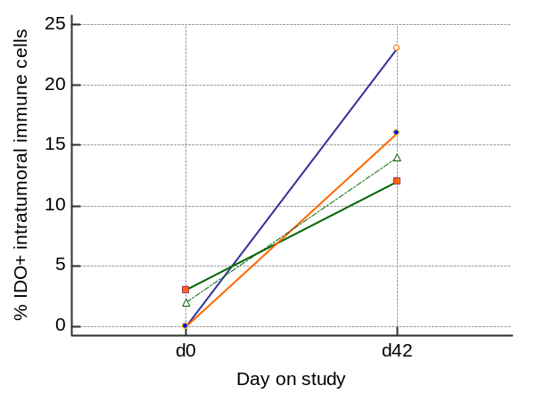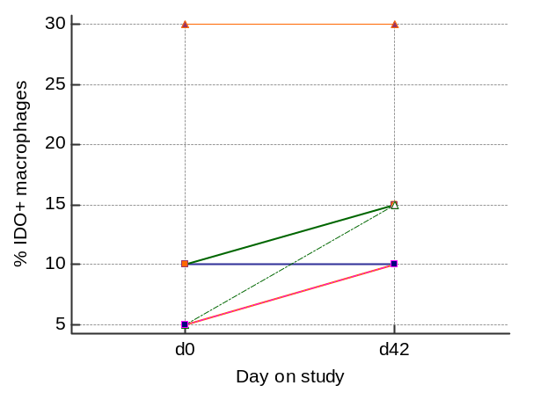
Supplementary Figure 4. IDO1 expression by RNAscope and detection by immunohistochemistry (IHC). Examples of RNAscope staining for IDO1 mRNA are shown for Subject 1 (D42) in A and subject 4 (D21) in B. The specimen in A had H-scores of 58 for tumor cells, 23 for intratumoral stromal and tumor infiltrating immune cells. The specimen in B had H-scores of 11 for tumor cells, 8 for intratumoral stromal and tumor infiltrating immune cells. For both, peritumoral stromal immune cells were not evaluable. C, D: Associations are shown for IDO1 expression by RNAscope (mRNA) and IDO1 protein detection IHC for melanoma cells (p<0.0001, C) and intratumoral immune cells (p = 0.055, D). Solid red circles mark baseline samples, blue circles mark later samples). Changes in intratumoral IDO1 from D0 to D42 are shown for available samples by RNA scope in E for the percent of intratumoral immune cells (p = 0.0158, paired T test, Medcalc, n = 4) and in F by IHC for IDO1+ macrophages (p = 0.0422, paired T test, Medcalc, n = 6).

