Appendix 2. Funnel plots

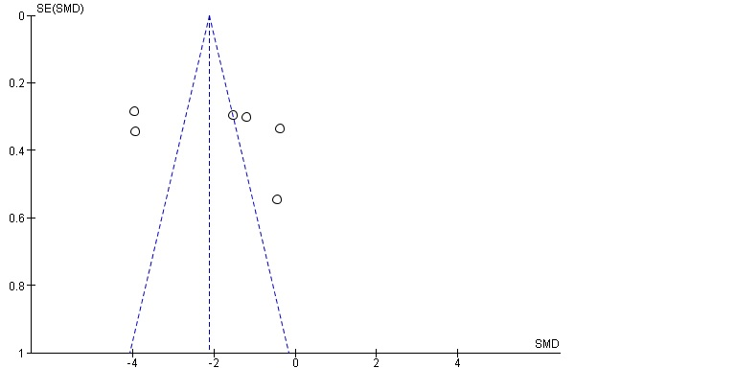
Pain Funnel plot.

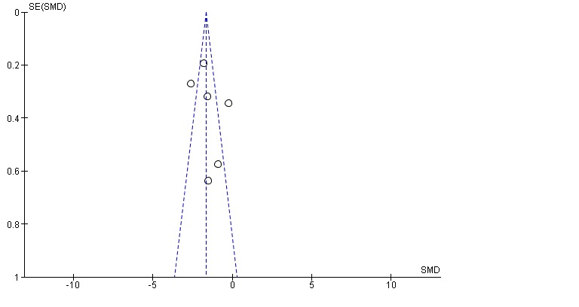

Symptom Severity Scale Funnel plot.

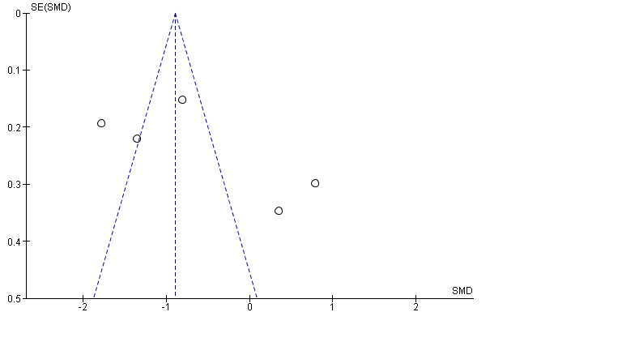

Functional Status Scale Funnel plot.

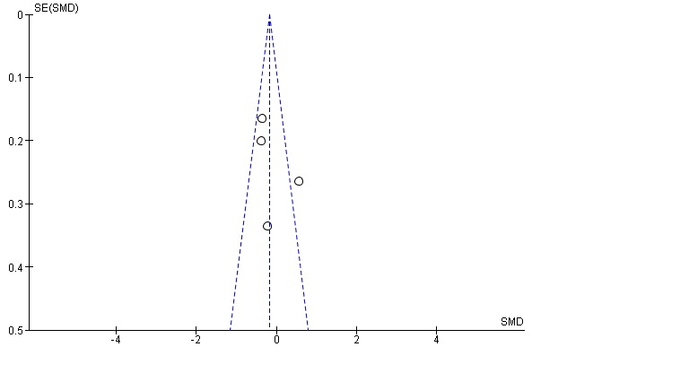

Nerve motor conduction Funnel plot.

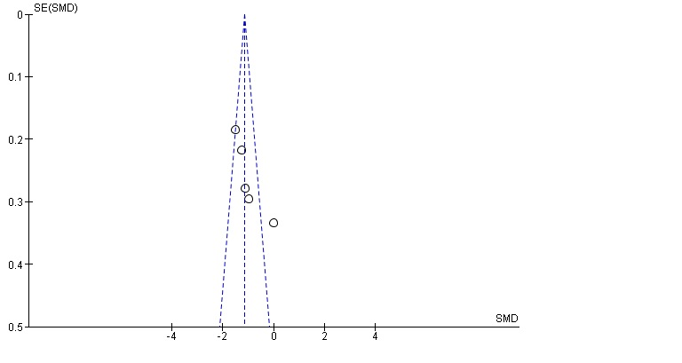
Figure 6. Nerve sensory conduction Funnel plot.

