Supplementary information

Intersexual conflict influences female reproductive success in a female-dispersing primate
Journal: Behavioral Ecology and Sociobiology
Marie L. Manguette, Andrew M. Robbins, Thomas Breuer, Emma J. Stokes, Richard J. Parnell & Martha M. Robbins

Corresponding author:
Marie L. Manguette
Max Planck Institute for Evolutionary Anthropology, Deutscher Platz 6, 04103 Leipzig, Germany
Email: marie_manguette@eva.mpg.de

Table S1: Summary of the study groups used for this study. First and last years of observation as a reproductive group. Number of reproductive group-years and female-years for each group. Number of observed births, surviving births and censored cases (infants who haven’t reach age 4 at the end of the study). Visits per year is the average number of visits to the clearing per year of observation as a reproductive group. Group status is the status of the group at the end of the study period: the silverback disappeared, the group disintegrated and no longer exists (group disintegrated), the females transferred out and the group became non-reproductive or all-male, or the silverback became solitary again (non-reproductive group) or the group is still present in the study as a reproductive group (present).
SB name | Years observed | Group- years | Female- years | Births | Surviving infants to age 4 | Censored | Visits per year | Group status
FFF | +1995-1996 | 1.1 | 2.2 | 2 | 1 |  | 63 | Group disintegrated
Bas | +1995-2003 | 7.0 | 10.3 | 1 | 1 |  | 41 | Non-Reproductive group
Bay | 2005-2015+ | 10.7 | 45.0 | 7 | 3 | 2 | 26 | Present
Bom | +2007-2009 | 2.6 | 6.2 | 1 |  |  | 1 | Non-Reproductive group
Bon | +1995-1999 | 3.8 | 3.8 | 1 | 1 |  | 18 | Group disintegrated
Bor | 2014-2015+ | 0.7 | 0.7 | 1 |  | 1 | 19 | Present
Car | +1995-1999 | 4.8 | 18.3 | 8 | 2 |  | 21 | Group disintegrated
Cli | +1995-2001 | 6.3 | 23.8 | 5 | 4 |  | 35 | Group disintegrated
Con | 2001-2015+ | 14.6 | 63.7 | 14 | 7 | 3 | 15 | Present
Cor | 2006-2015+ | 9.0 | 50.9 | 12 | 2 | 6 | 16 | Present
Dil | 2013-2015+ | 2.2 | 6.5 | 1 |  | 1 | 20 | Present
Duk | +1995-2000 | 4.4 | 13.3 | 4 | 2 |  | 10 | Group disintegrated
Dwa | 1996-2013 | 17.3 | 83.6 | 16 | 12 |  | 29 | Non-Reproductive group
Eme | +1995-2002 | 6.8 | 34.5 | 7 | 4 |  | 2 | Group disintegrated
Fra | 2000-2001 | 1.4 | 2.6 | 1 |  |  | 17 | Group disintegrated
Geo | 1995-2015+ | 18.4 | 58.5 | 12 | 6 | 1 | 35 | Present
Gra | +2000-2006 | 6.3 | 8.8 | 2 | 1 |  | 3 | Group disintegrated
Gre | 2004-2015+ | 11.9 | 79.2 | 18 | 9 | 1 | 30 | Present
Isa | 2008-2015+ | 7.8 | 18.6 | 2 | 2 |  | 4 | Present
Jac | 2012-2015+ | 3.8 | 28.1 | 8 |  | 6 | 12 | Present
Kha | 1996-2015+ | 15.2 | 78.7 | 15 | 6 | 2 | 10 | Present
Mor | 2003-2012 | 8.6 | 36.3 | 8 | 6 |  | 10 | Non-Reproductive Group
Mun | 2011-2015+ | 4.9 | 13.3 | 3 |  | 3 | 2 | Present
New | 2006-2015+ | 7.6 | 20.8 | 2 |  | 1 | 5 | Present
Ob1 | +1995-2007 | 12.4 | 34.1 | 10 | 3 |  | 17 | Group disintegrated
Pok | 2013-2015+ | 2.3 | 8.2 | 3 |  | 3 | 4 | Present
Sah | 2013-2015+ | 2.5 | 9.0 | 4 |  | 4 | 38 | Present
San | +1995-2015+ | 20.3 | 47.0 | 10 | 3 | 1 | 13 | Present
Sas | +1995-2005 | 9.9 | 30.9 | 8 | 2 |  | ? | Group disintegrated
Sco | 2013-2015+ | 2.8 | 5.3 | 2 |  | 2 | 6 | Present
Sol | +1995-2000 | 3.9 | 5.0 | 2 |  |  | 38 | Group disintegrated
Sto | 2006-2015 | 8.9 | 20.7 | 3 | 3 |  | 8 | Non-Reproductive group
Sul | 2000-2007 | 6.2 | 7.0 | 3 |  |  | 15 | Group disintegrated
Tub | 2010-2015+ | 5.3 | 26.1 | 8 |  | 5 | 7 | Present
Vid | 2008-2015+ | 7.2 | 25.0 | 7 | 3 | 3 | 19 | Present
Zul | +2000-2015+ | 15.2 | 69.2 | 17 | 9 | 1 | 36 | Present
+ indicates that the reproductive group started before or ended after the observation period. ? information for this group not available

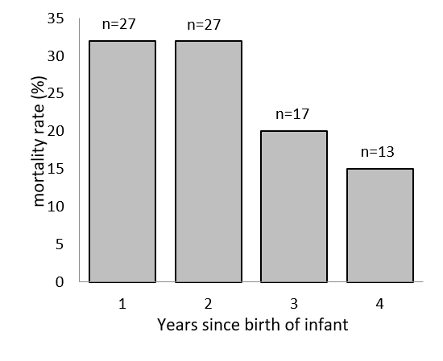
Fig S1: Infant mortality until weaning

