Journal: Behavioral Ecology and Sociobiology
DOI: 10.1007/s00265-019-2791-8

In utero behavioral imprinting to predation risk in pups of the bank vole
Thorbjörn Sievert^{1*†}, Arjane Kerkhoven^{2*}, Marko Haapakoski¹, Kevin D. Matson², Olga Ylönen¹ & Hannu Ylönen¹

¹ Konnevesi Research Station, Department of Biological and Environmental Science, P.O. Box 35, FI-40014 Jyväskylä, University of Jyväskylä, Finland
² Resource Ecology Group, Environmental Sciences Department, Wageningen University, 6700 AA Wageningen, Netherlands
*These authors contributed equally to this work.
† thorbjoern.t.sievert@jyu.fi

Supplemental material

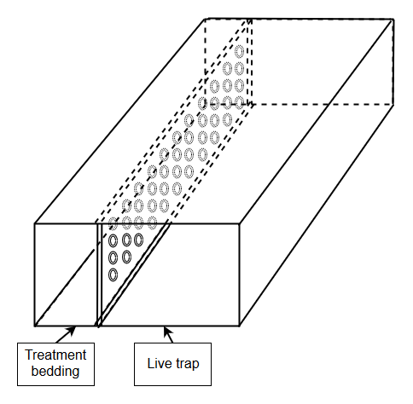
Figure A: Treatment chamber. The odor cue is separated from the trap compartment by a mesh to avoid odor contamination. Closing mechanism not shown.
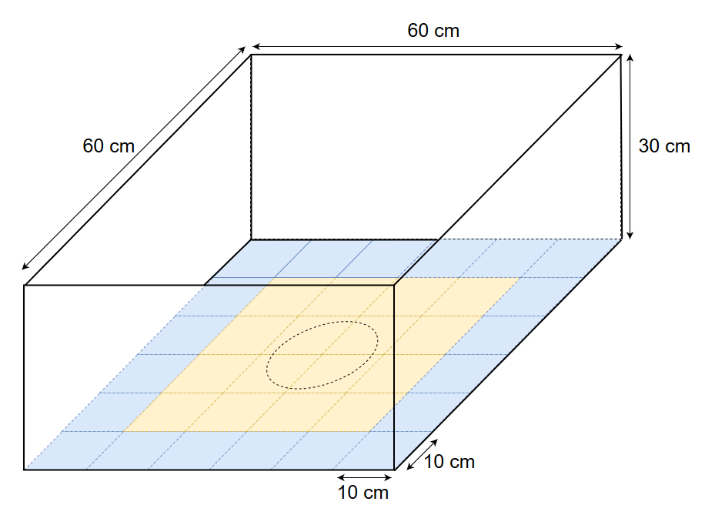
Figure B: Open-field arena with different zones for behavioral studies. The blue area is considered as “border zone” and orange area as “central zone”. Color does not reflect actual color, but only serves as visualization.

Phi | p | ΔAIC | Weight
Treatment | Sex | 0.000 | 0.306
Treatment | Treatment + Sex | 1.237 | 0.165
1 | Sex | 1.836 | 0.122
Treatment + Sex | Sex | 1.884 | 0.119
1 | Treatment + Sex | 3.041 | 0.067
Treatment + Sex | Treatment + Sex | 3.117 | 0.064
Sex | Sex | 3.810 | 0.046
Table S1: Model selection table. ‘Phi’ is the estimate of survival and ‘p’ the capture probability. Only the seven first models are shown.

Fixed effect | Random effect | DF | ΔAIC | Weight
Treatment(pup) + Sex + Test age | 1|mother | 7 | 0.00 | 0.277
Treatment(pup) + Test age | 1|mother | 6 | 0.29 | 0.240
Treatment(pup) | 1|mother | 5 | 0.80 | 0.186
Treatment(pup) + Sex | 1|mother | 6 | 0.98 | 0.170
Treatment(pup) * Sex | 1|mother | 8 | 3.44 | 0.050
Treatment(pup) + Sex + Treatment(mother) + Test age | 1|mother | 9 | 4.06 | 0.036
Treatment(pup) + Sex + Treatment(mother) | 1|mother | 8 | 4.89 | 0.024
Table S2: Model selection table for the total distanced moved. Only the seven first models are shown.

Fixed effect | Random effect | DF | ΔAIC | Weight
Treatment(pup) * Treatment(mother) + Sex + Test age | 1|mother | 12 | 0.00 | 0.893
Treatment(pup) * Treatment(mother) + Test age | 1|mother | 11 | 4.25 | 0.107
Treatment(pup) * Treatment(mother) * Sex | 1|mother | 19 | 22.27 | 0.000
Treatment(pup) * Treatment(mother) + Sex | 1|mother | 11 | 39.58 | 0.000
Treatment(pup) * Treatment(mother) | 1|mother | 10 | 46.71 | 0.000
Treatment(pup) + Test age | 1|mother | 5 | 197.20 | 0.000
Treatment(pup) + Treatment(mother) +Sex + Test age | 1|mother | 8 | 202.62 | 0.000
Table S3: Model selection table for the proportion of time in the center zone. Only the seven first models are shown.

Fixed effect | Random effect | DF | ΔAIC | Weight
Movement bouts (border) * treatment(pup) + Test age | 1|mother | 9 | 0.00 | 0.171
Movement bouts (border) * treatment(pup) | 1|mother | 8 | 0.31 | 0.146
Movement bouts (border) + treatment(pup) + Test age | 1|mother | 7 | 1.06 | 0.100
Movement bouts (border) + treatment(pup) | 1|mother | 6 | 1.86 | 0.067
Movement bouts (border) * treatment(pup) + treatment(mother) | 1|mother | 10 | 1.94 | 0.065
Movement bouts (border) | 1|mother | 4 | 2.06 | 0.061
Movement bouts (border) * treatment(pup) + Sex | 1|mother | 9 | 2.18 | 0.057
Table S3: Model selection table for the time spent in the border zone. Only the seven first models are shown.

Fixed effect | Random effect | DF | ΔAIC | Weight
Movement bouts (border) * treatment(pup) + Test age | 1|mother | 9 | 0.00 | 0.171
Movement bouts (border) + treatment(pup) | 1|mother | 8 | 0.31 | 0.146
Movement bouts (border) * treatment(pup) + Test age | 1|mother | 7 | 1.06 | 0.100
Movement bouts (border) + treatment(pup) | 1|mother | 6 | 1.86 | 0.067
Movement bouts (border) * treatment(pup) * treatment(mother) | 1|mother | 10 | 1.94 | 0.065
Movement bouts (border) | 1|mother | 4 | 2.06 | 0.061
Movement bouts (border) * treatment(pup) + Sex | 1|mother | 9 | 2.18 | 0.057
Table S4: Model selection table for the time spent in the border zone. Only the seven first models are shown.

Fixed effect | Random effect | DF | ΔAIC | Weight
Movement bouts (center) * treatment(pup) + Test age | 1|mother | 9 | 0.00 | 0.189
Movement bouts (center) + treatment(pup) + Test age | 1|mother | 7 | 1.05 | 0.112
Movement bouts (center) * treatment(pup) | 1|mother | 8 | 1.47 | 0.091
Movement bouts (center) + treatment(pup) | 1|mother | 6 | 2.05 | 0.068
Movement bouts (center) | 1|mother | 4 | 2.07 | 0.067
Movement bouts (center) * treatment(pup) + Sex | 1|mother | 9 | 2.40 | 0.057
Movement bouts (center) * treatment(pup) + treatment(mother) | 1|mother | 10 | 2.79 | 0.047
Table S5: Model selection table for the time spent in the center zone. Only the seven first models are shown.

