Predator personality and prey detection: inter-individual variation in responses to cryptic and conspicuous prey
Behavioral Ecology and Sociobiology
Andrew Szopa-Comley^{1*}, William Gregory Donald¹, Christos C. Ioannou¹
¹School of Biological Sciences, University of Bristol, Bristol, BS8 1TQ, U.K.
*a.szopa-comley@bristol.ac.uk

Supplementary methods and results for models analysing the time taken to attack prey, defined as the time difference between leaving the refuge and an attack
Whereas the main paper presents results from models in which the time taken to attack was defined as the time difference between first encountering prey and attack, the Supplementary Material contains analyses conducted with an alternative definition of the time taken to attack, defined with respect to the time when the fish first left the refuge. All Cox proportional hazards (Cox PH) models featuring the time taken to attack as a response within the main results section are reproduced using the alternative definition. Apart from the change in the definition of the response variable, the key details of these models (such as the explanatory variables, stratification factors and individual-level random effects included) remain as presented in the main paper. Instead of restricting the analysis to trials where fish encountered prey, these models were fitted to data from trials where fish had left the refuge (sample sizes are given below). Similar results were obtained regardless of the definition of the time taken to attack.

Difference in attack rates between treatments
Replicating the results presented in the main paper, fish were significantly slower to attack cryptic prey compared to conspicuous prey, when the time taken to attack was relative to emergence from the refuge (Cox PH, 82 observed attacks in 194 trials where fish left the refuge: χ² = 23.1, P < 0.001; Fig. S1). When the time taken to attack was defined in this way, the rate at which cryptic prey were attacked was substantially reduced, approximately four-fold, relative to the rate of attack in trials with conspicuous prey (hazard ratio (HR) = 0.262, 95% confidence intervals: 0.149-0.460). There was also evidence for inter-individual variation in the time taken by fish to attack prey, as demonstrated by the relatively poor performance of models lacking a random effect term for individual identity when compared to the full model (Cox PH: χ² = 79.5, P < 0.001).
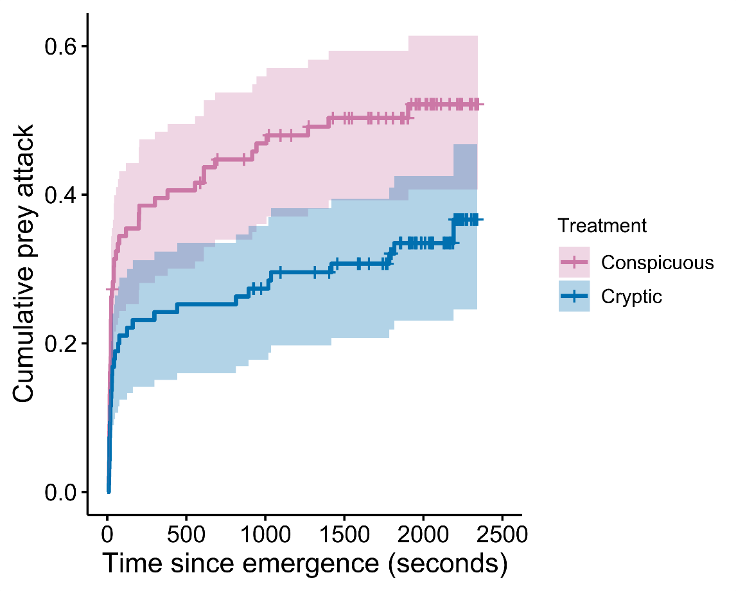
Fig. S1. Cumulative event curve showing the effect of prey treatment (conspicuous vs. cryptic) on the probability that fish had attacked prey (defined with respect to emergence from the refuge) before a given time during an experimental trial. Shading surrounding the cumulative event curves indicates 95% confidence intervals. Crosses indicate experimental trials which ended before prey were encountered or an attack was made.

Inter-individual variation in the time taken to attack
When the time taken to attack was defined relative to emergence from the refuge, the degree of inter-individual variation in the time taken to attack was similar in both the cryptic and conspicuous treatments. Including a random effect term for individual identity significantly improved the model fit to a similar extent for both conspicuous (Cox PH, 50 observed attacks in 99 trials where fish left the refuge, no. of individuals = 52, χ² = 14.7, P < 0.001) and cryptic treatments (Cox PH, 32 observed attacks in 95 trials where fish left the refuge, no. of individuals = 51: χ² = 10.8, P = 0.001). Model estimates of the variance associated with the individual-level random effect term suggested that variation between individuals in the time taken to attack conspicuous prey was lower (estimated variance of individual-level random effect: 2.70, 95% confidence intervals: 0.77-7.66) than variation between individuals in the response to cryptic prey (estimated variance of individual-level random effect: 6.05, 95% confidence intervals: 0.99-18.5). However, like the results from models in which the time taken to attack was defined relative to prey encounter, these estimates were associated with a high degree of uncertainty in both treatments as indicated by the wide and overlapping 95% confidence intervals. This prevented any firm conclusions from being drawn on the question of whether inter-individual differences in the time taken to attack prey were more or less pronounced in either treatment. Additionally, there was also no effect of the time taken to first leave the refuge (boldness) in either treatment on the time taken to attack, defined relative to the when fish left the refuge (conspicuous treatment, Cox PH: χ² = 2.02, P = 0.155; cryptic treatment, Cox PH: χ ² = 1.25, P = 0.263).

Relationship between the behaviour of individual fish towards conspicuous prey and their response to cryptic prey
Fish which attacked cryptic prey in at least one experimental trial were also significantly quicker to attack conspicuous prey than those which never attacked the prey in any of the cryptic treatment trials, when the time taken to attack was defined with respect to the moment fish left the refuge (Cox PH, 50 attacks in 97 trials: χ² = 35.1, P < 0.001; Fig. S2).
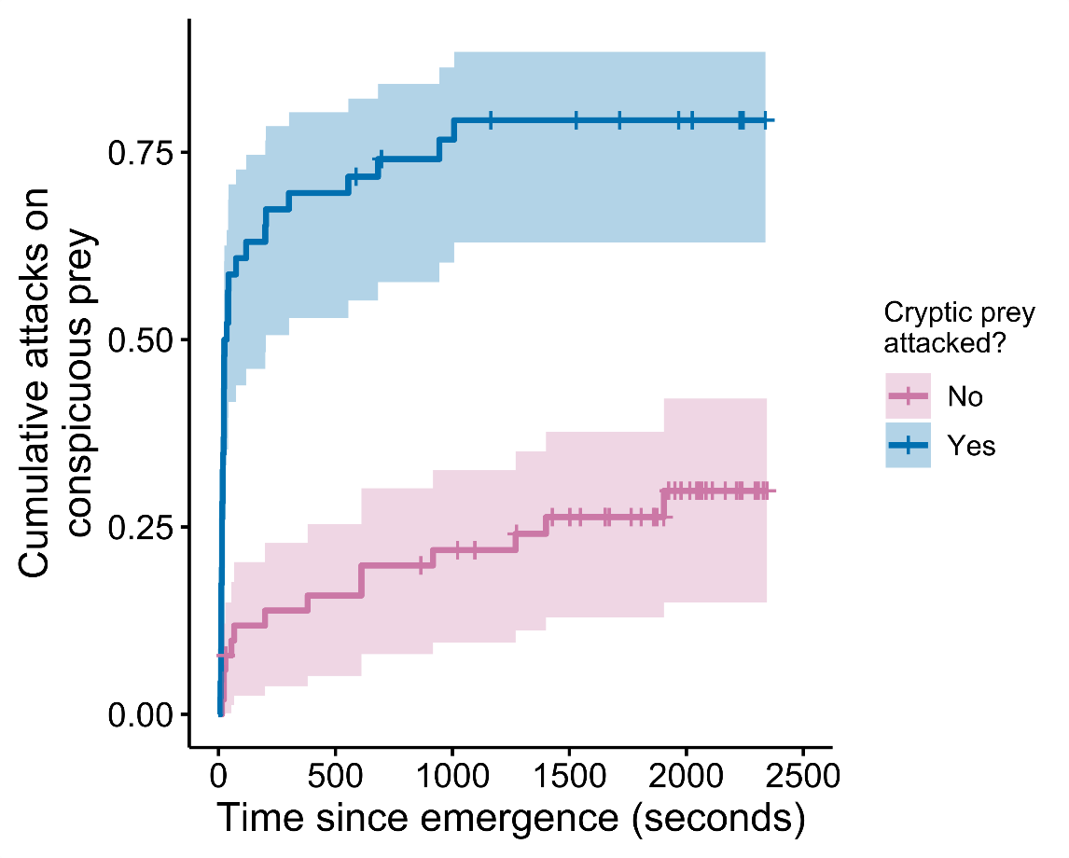
Fig. S2. Cumulative event curve showing how the probability of attacking conspicuous prey before a given time during an experimental trial is influenced by whether or not fish had attacked prey during trials with cryptic prey. The blue and purple curves represent fish which attacked cryptic prey in at least one experimental trial (blue), and those which did not attack cryptic prey at all (red), respectively. The time taken to attack prey was calculated using the time to first leave the refuge as the starting point. Shading surrounding the cumulative event curve indicates 95% confidence intervals. Crosses indicate experimental trials which ended before prey were encountered or an attack occurred.

