SUPPLEMENTARY MATERIALS
Behavioural Ecology and Sociobiology

Duration of female parental care and their survival in the little auk Alle alle - are these two traits linked?
Katarzyna Wojczulanis-Jakubas^{1,*}, Marina Jiménez-Muñoz^{2,3}, Dariusz Jakubas¹, Dorota Kidawa¹, Nina Karnovsky⁴, Diana Cole², Eleni Matechou²
¹Department of Vertebrate Ecology and Zoology, Faculty of Biology, University of Gdańsk, Wita Stwosza 59, 80-308 Gdansk, Poland
²School of Mathematics, Statistics and Actuarial Science, University of Kent, Sibson Building, University of Kent, Canterbury, CT2 7FS UK
³German Centre for Integrative Biodiversity Research (iDiv) Halle-Jena-Leipzig, Leipzig, Germany
⁴Department of Biology, Pomona College, 175 West Sixth Street, Claremont, CA 91711, USA
* Corresponding author: biokwj@univ.gda.pl
Table S1 Number of individuals captured (First) and recaptured in Hornsund per sex in every year of the study
Sex | Captures | Year 20..
Sex | Captures | 01 | 02 | 04 | 05 | 06 | 07 | 08 | 09 | 10 | 11 | 12 | 14 | 15 | 16 | 17
Females | Total | 18 | 21 | 1 | 37 | 67 | 7 | 2 | 12 | 8 | 89 | 111 | 102 | 49 | 60 | 47
Females | First | 18 | 18 | 0 | 35 | 46 | 1 | 1 | 11 | 5 | 74 | 56 | 53 | 23 | 21 | -
Females | Recaptured | - | 3 | 1 | 2 | 21 | 6 | 1 | 1 | 3 | 15 | 55 | 49 | 26 | 39 | 47
Males | Total | 18 | 20 | 1 | 36 | 60 | 9 | 2 | 14 | 10 | 92 | 120 | 104 | 45 | 65 | 51
Males | First | 18 | 15 | 0 | 34 | 40 | 0 | 2 | 9 | 9 | 81 | 57 | 59 | 26 | 25 | -
Males | Recaptured | - | 5 | 1 | 2 | 20 | 9 | 0 | 5 | 1 | 11 | 63 | 45 | 19 | 40 | 51

Table S2 Total number of individuals captured (First) and recaptured in Magdalenefjorden per sex in every year of the study
Sex | Captures | Year 20..
Sex | Captures | 07 | 08 | 09 | 10 | 11
Females | Total | 33 | 33 | 66 | 64 | 24
Females | First | 33 | 33 | 49 | 23 | -
Females | Recaptured | 0 | 0 | 17 | 41 | 24
Males | Total | 29 | 36 | 58 | 64 | 26
Males | First | 29 | 36 | 36 | 30 | -
Males | Recaptured | 0 | 0 | 22 | 34 | 26

Table S3 Ranking of all fitted models based on Akaike information criterion (AIC) for full capture. The three top models with ∆ AIC < 2 also presented in the main text. Site – breeding colony
Model | No. parameters | ∆ AIC
Φ site , p site | 4 | 0.00
Φ site , p sex, site | 5 | 1.29
Φ sex, site , p site | 5 | 1.99
Φ site , p sex, site, sex * site | 6 | 2.53
Φ sex, site , p sex, site | 6 | 3.21
Φ sex, site, sex * site, p sex | 6 | 3.21
Φ sex, site, sex * site , p site | 6 | 3.98
Φ sex,site , p sex, site, sex * site | 7 | 4.40
Φ sex, site, sex * site , p sex, site | 7 | 5.20
Φ sex, site, sex * site , p sex, site, sex, site | 8 | 6.35
Φ site, p | 3 | 64.15
Φ site, p sex | 4 | 65.62
Φ sex, site, p sex | 5 | 67.56
Φ, p | 2 | 121.26
Φ sex, site, p | 4 | 66.14
Φ , p sex, site, sex * site | 5 | 68.14
Φ , p sex | 3 | 123.21
Φ , p site | 3 | 116.45
Φ , p sex, site | 4 | 117.77
Φ sex, p site | 4 | 118.39
Φ , p sex, site, sex * site | 5 | 119.32
Φ sex, p sex, site | 5 | 119.76
Φ sex , p sex, site, sex * site | 6 | 121.24
Φ , p sex | 3 | 122.65
Φ sex, p sex | 4 | 124.63

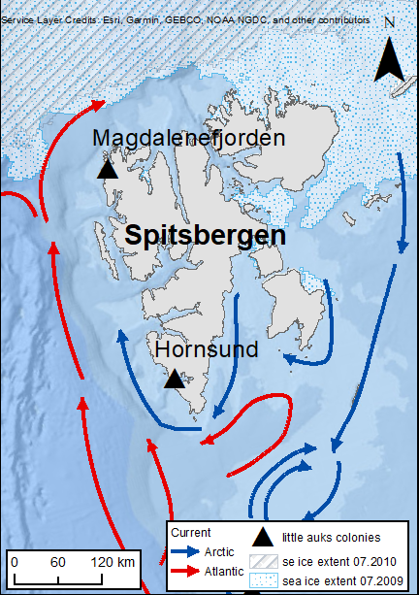

Figure S1 Location of Hornsund and Magdalenefjorden colonies (triangles), and oceanographic conditions around the colonies (red arrows – warm Atlantic waters, blue arrows – cold Arctic waters). Data sources: sea ice extent: Multisensor Analyzed Sea Ice Extent - Northern Hemisphere (MASIE-NH), Version 1 with 4 km grid cell size (National Ice Center (NIC) NSIDC, 2010); ocean currents after (Loeng, & Drinkwater 2007) modified; background bathymetric map of Arctic Ocean - The Arctic Ocean Basemap from ArcGIS Map Services (https://services.arcgisonline.com/arcgis/services)

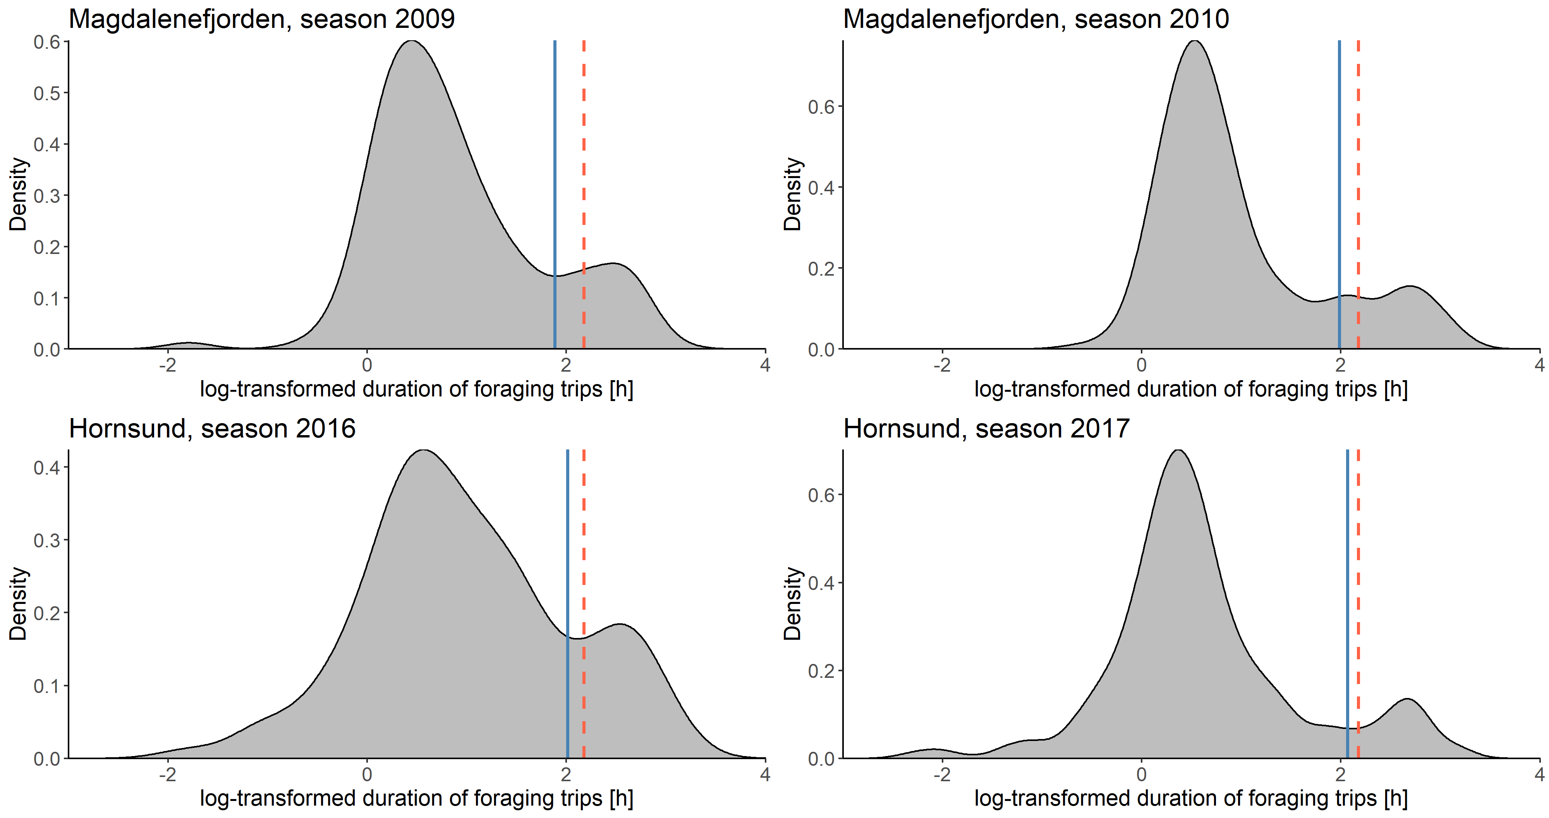

Figure S2 Density distribution of duration of foraging trips in each study seasons. Blue and red vertical lines denote cut-off values to split data into short (ST) and long (LT) trips based on algorithms proposed by (Welcker et al. 2009) and (Wojczulanis-Jakubas et al. 2010), respectively

Inter-annual/colony variation in duration of female parental care, duration of nesting period, parents foraging strategies, and chick diet.
Here, we present detailed inter-annual comparisons which has not been presented in the main text of the paper. Apart from parameters already considered in the paper for inter-colony comparisons, we also analysed here food loads energy content delivered to chicks by the little auk parents.
The chick diet data have been collected for other studies purposes and analysed using methodology described in (Jakubas et al. 2011; Kidawa et al. 2015; Grissot et al. 2019) and here only energy content of sampled food loads (calculated following methodology used in Jakubas et al 2011) was considered. To analyse that we used linear regression model.
The analyses were performed for all the seasons which for females brood desertion was recorded and relevant data were available. Thus, basically five seasons were considered - three from Hornsund (2004, 2016, 2017) and two from Magdalenefjorden (2009 and 2010). However, due to missing some data for season 2004, in some analyses only four years were included. In all the analyses we applied a modelling approach with year or colony as an explanatory variable, and pair-wise t-tests as post-hoc analyses. For analysis of number of feedings we utilized generalized linear model with Poisson error distribution. When analysing duration of foraging trips we considered short (ST) and long trips (LT) separately, each case using linear mixed models (with Gaussian error distribution), with birds identity as a random effect included in the model to account for multiple flights of the same individuals.
Duration of female parental care. The studied colonies differed considerably and this result being the core of the study is presented in the main text. However, inter-seasonal differences were also found for Hornsund colony (Fig. S3), and briefly discussed in the main text.
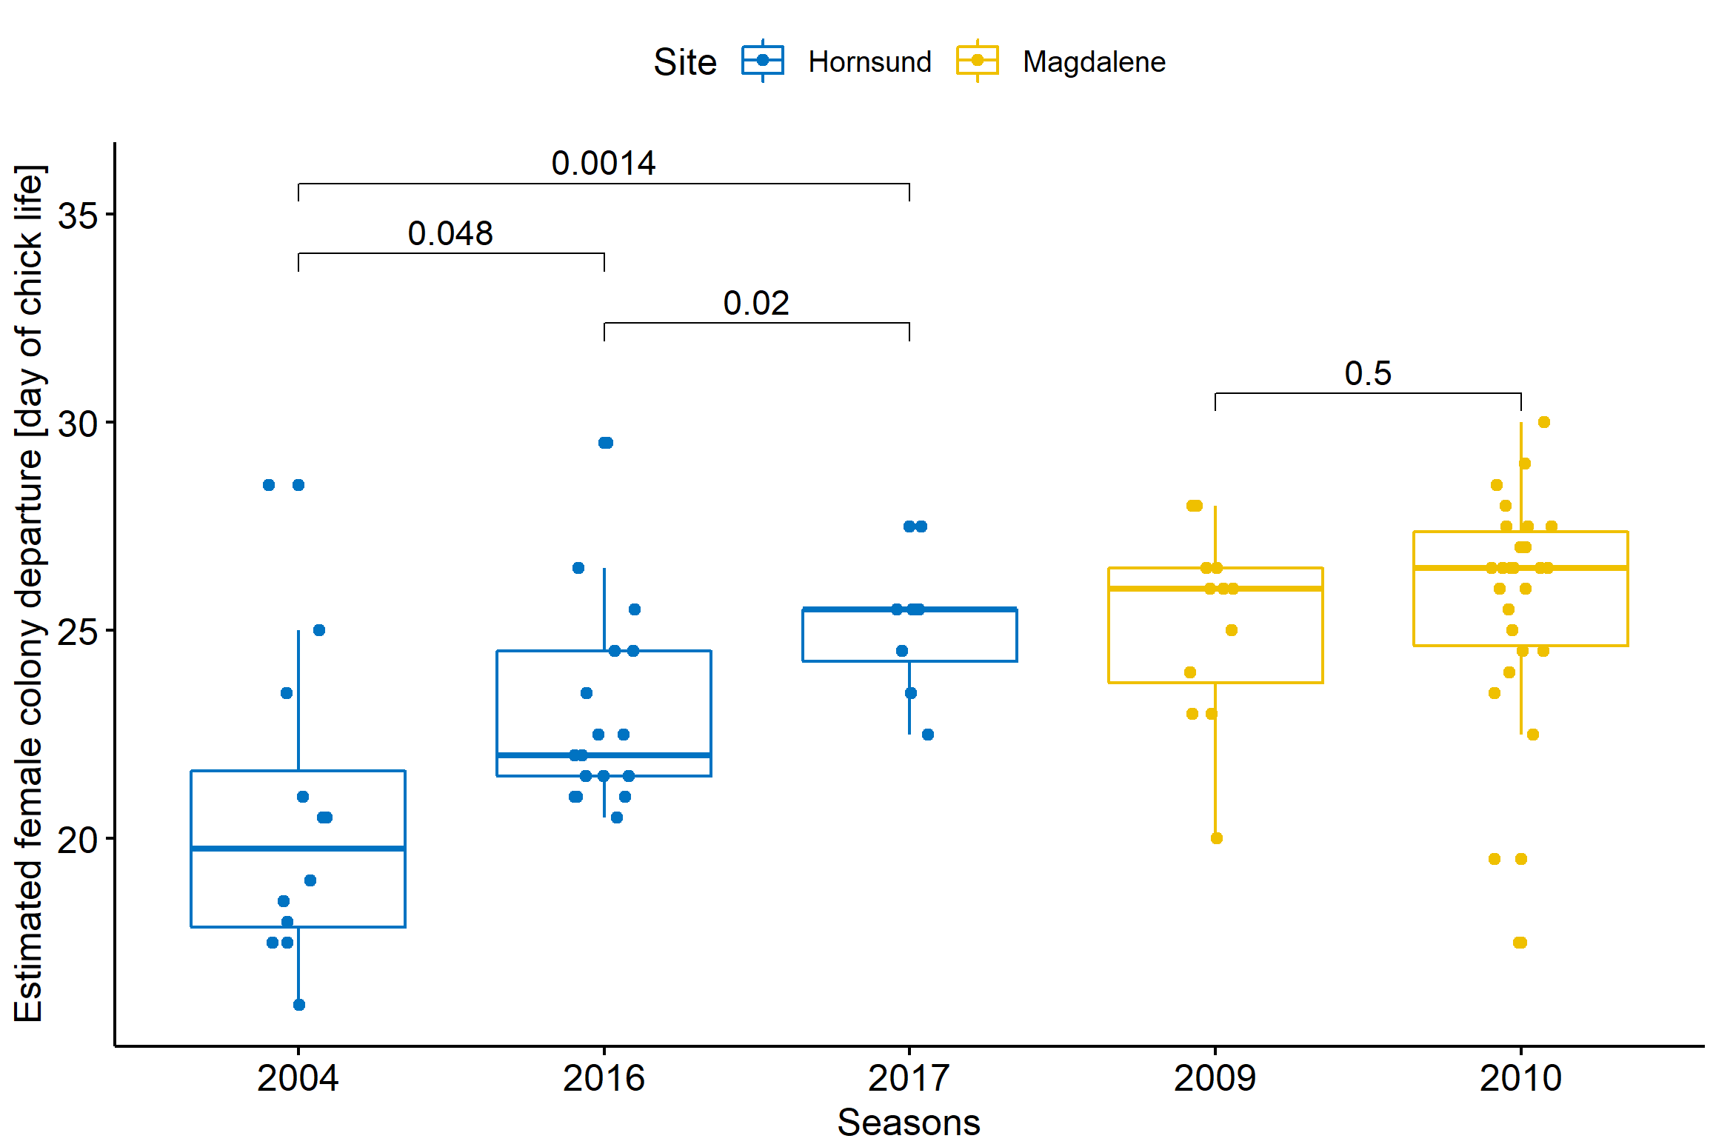
Figure S3 Inter-annual differences in duration of female parental care. Pair-wise comparisons performed with t tests (p-value < 0.05 considered significant). Boxplots show the median (band inside the box), the first (25%) and third (75%) quartile (box), the lowest and the highest values within 1.5 interquartile range (whiskers) and all data points (dots)

Fledging. The colonies did not differ considerably in chick’s age at fledging and this result being the core of the study is presented in the main text. However, some inter-annual significant differences or tendencies for differences were found (Fig. S4). They are likely to be driven by relatively small sample sizes.

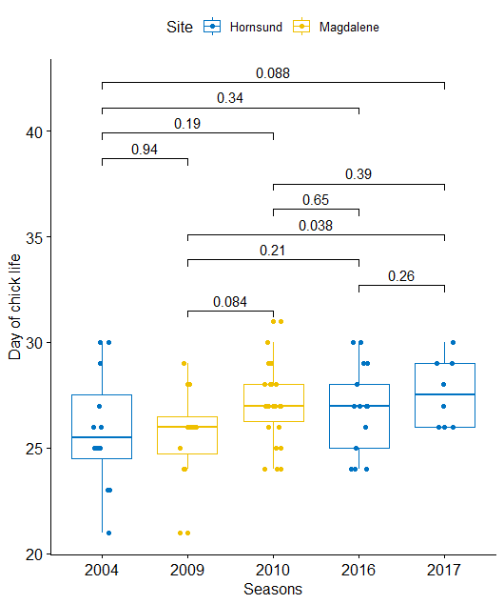
Figure S4 Inter-annual differences in chick’s age at fledging. Pair-wise comparisons performed with t tests (p-value < 0.05 considered significant). Boxplots show the median (band inside the box), the first (25%) and third (75%) quartile (box), the lowest and the highest values within 1.5 interquartile range (whiskers) and all data points (dots)

Number of chick feedings. Overall the number of feedings performed by little auk parents in Hornsund tended to be higher than in Magdalenefjorden (GLM, z = -1.77, P = 0.08), although this differences was mostly evident due to considerably higher number of feedings performed in Hornsund in 2017 (Fig. S5).

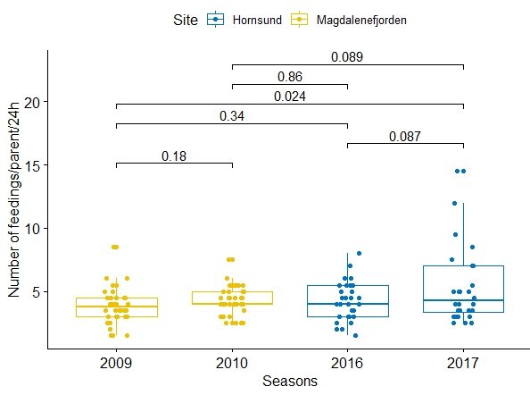

Figure S5 Number of chicks feedings per one little auk parent per 24h in four study years. Pair-wise comparisons performed with t tests (p-value < 0.05 considered significant). Boxplots show the median (band inside the box), the first (25%) and third (75%) quartile (box), the lowest and the highest values within 1.5 interquartile range (whiskers) and all data points (dots)

Duration of foraging trips. Duration of both short (ST) and long foraging trips (LT), were similar in both studied colonies (all years combined/pooled) (LMM, ST: t = 1.43, df = 141, P = 0.15; LT: t = -0.89, df = 84.2, P = 0.37), although there were some inter-annual differences both for ST and LT (Fig. S6).
Figure S6 Duration [h] of short (A) and long (B) foraging trips performed by little auk parents during 48 h continuous observations for four study years. Pair-wise comparisons performed with t tests (p-value < 0.05 considered significant). Note different y-axis scales for short and long trips. Boxplots show the median (band inside the box), the first (25%) and third (75%) quartile (box), the lowest and the highest values within 1.5 interquartile range (whiskers) and all data points (dots)

Chick diet. Comparison of energy content of food loads between the colonies (with pooled seasons) revealed that samples collected in Magdalenefjorden tended to had higher energy content than those from Hornsund (LM, t = 1.67, P = 0.09). This difference, however, was caused by high value recorded in a single year 2010 in Magdalenefjorden (Fig. S7), when birds regularly utilized distant foraging areas, at the sea ice edge, with easily available in energy-rich prey (Jakubas et al. 2011, 2013).

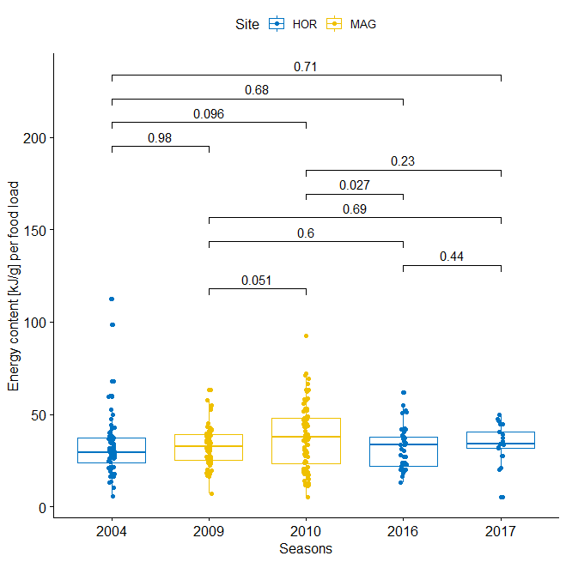

Figure S7 Energetic content [kJ/g] of food loads delivered to chicks by little auk parents in the five study years. Vertical lines indicate pair-wise comparisons performed with t tests (p-value < 0.05 considered significant). Boxplots show the median (band inside the box), the first (25%) and third (75%) quartile (box), the lowest and the highest values within 1.5 interquartile range (whiskers) and all data points (dots)

Literature
Loeng H, Drinkwater K (2007) An overview of the ecosystems of the Barents and Norwegian Seas and their response to climate variability. Deep Res Part II Top Stud Oceanogr 54:2478–2500.
Grissot A, Araya-Salas M, Jakubas D, et al (2019) Parental Coordination of Chick Provisioning in a Planktivorous Arctic Seabird Under Divergent Conditions on Foraging Grounds. Front Ecol Evol 7:. doi: 10.3389/fevo.2019.00349
Jakubas D, Głuchowska M, Wojczulanis-Jakubas K, et al (2011) Foraging effort does not influence body condition and stress level in little auks. Mar Ecol Prog Ser 432:277–290. doi: 10.3354/meps09082
Jakubas D, Trudnowska E, Wojczulanis-Jakubas K, et al (2013) Foraging closer to the colony leads to faster growth in little auks. Mar Ecol Prog Ser 489:263–278. doi: 10.3354/meps10414
Kidawa D, Jakubas D, Wojczulanis-Jakubas K, et al (2015) Parental efforts of an Arctic seabird, the little auk Alle alle under variable foraging conditions. Mar Biol Res 11:349–360. doi: 10.1080/17451000.2014.940974
Welcker J, Harding AMA, Karnovsky NJ, et al (2009) Flexibility in the bimodal foraging strategy of a high Arctic alcid, the little auk Alle alle. J Avian Biol 40:388–399. doi: 10.1111/j.1600-048X.2008.04620.x
Wojczulanis-Jakubas K, Jakubas D, Karnovsky NJ, Walkusz W (2010) Foraging strategy of little auks under divergent conditions on feeding grounds. Polar Res 29:22–29. doi: 10.1111/j.1751-8369.2009.00145.x
National Ice Center (NIC) and NSIDC. Multisensor Analyzed Sea Ice Extent – Northern Hemisphere. IMS Daily Northern Hemisphere Snow and Ice Analysis at 4 km Resolution data set. Developed by F. Fetterer, M. Savoie, S. Helfrich, and P. Clemente- Colón. Boulder, Colorado USA (2010).

