Break-down of the ideal free distribution under conditions of severe and low competition: Supplementary material

Authors
Sirovnik J.^{1,2*}, Voelkl B., Keeling L.J., Würbel H, M.J. Toscano

¹Center for Proper Housing: Poultry and Rabbits (ZTHZ), Division of Animal Welfare, VPH-Institute, University of Bern, Burgerweg 22, 3052 Zollikofen, Switzerland

²Current Address: Institute of Animal Welfare Science, University of Veterinary Medicine, Veterinaerplatz 1, 1210 Vienna, Austria. E-mail address: janja.sirovnik-koscica@vetmeduni.ac.at

Supplementary methods
Pens in our study were organized into two rows and the feeder ran first on one side of the pens through all pens in the row (orange arrows in Figure S 1). The feed trough then made two 90-degree-turns outside of the pens and ran on the other side within the pens in the same pen-row before it reached the engine that was positioned outside the pens. During the first six-weeks the feed engines ran for too short a time to supply all pens on both sides with fresh feed, i.e. fresh feed reached first four pens only on one side. Hence, in the affected pens the data during this period of unequal food supply was not used for the analysis.
To identify at what time after the lights were switched on (within the 30-min video recording), the majority of chickens fed simultaneously, a one-day recording from all 10 pens was analysed. The preliminary analysis was performed on the day that was not used for the final video analysis. The number of chickens simultaneously at the feeder was identified at each 30s-time step of the 5.5-minute time period starting 3.5 minutes after lights went on (this time was chosen as few birds were at the feeder prior to this).

Additional figures and tables
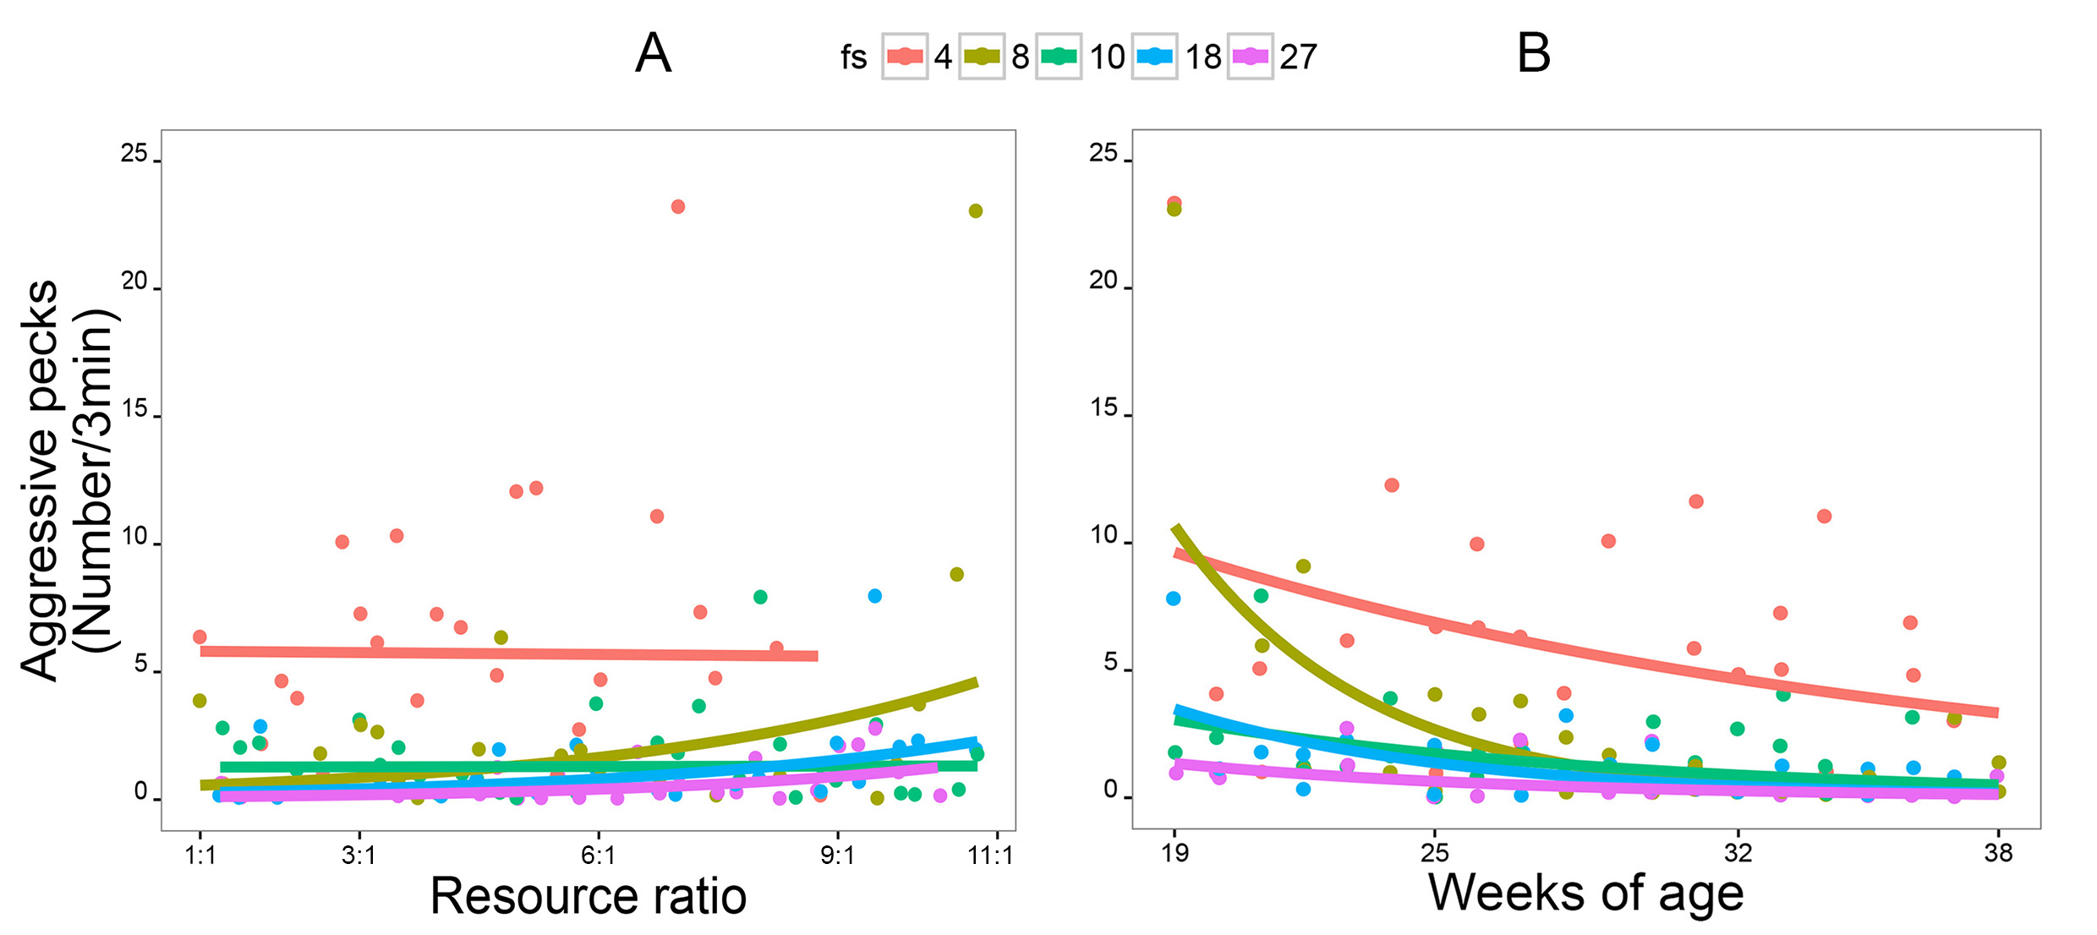

Figure S 1: a) Relationship between number of aggressive pecks per 3 min observation period (y-axis) and feeder space (fs; colours) and resource ratio (x-axis). b) Relationship between number of aggressive pecks per 3 min observation period (y-axis) and feeder space (fs; colours) and age (x-axis). The dots represent raw data points. Best fitted lines are based on the generalized linear model without random factors. Sample size: n=167 replicates.

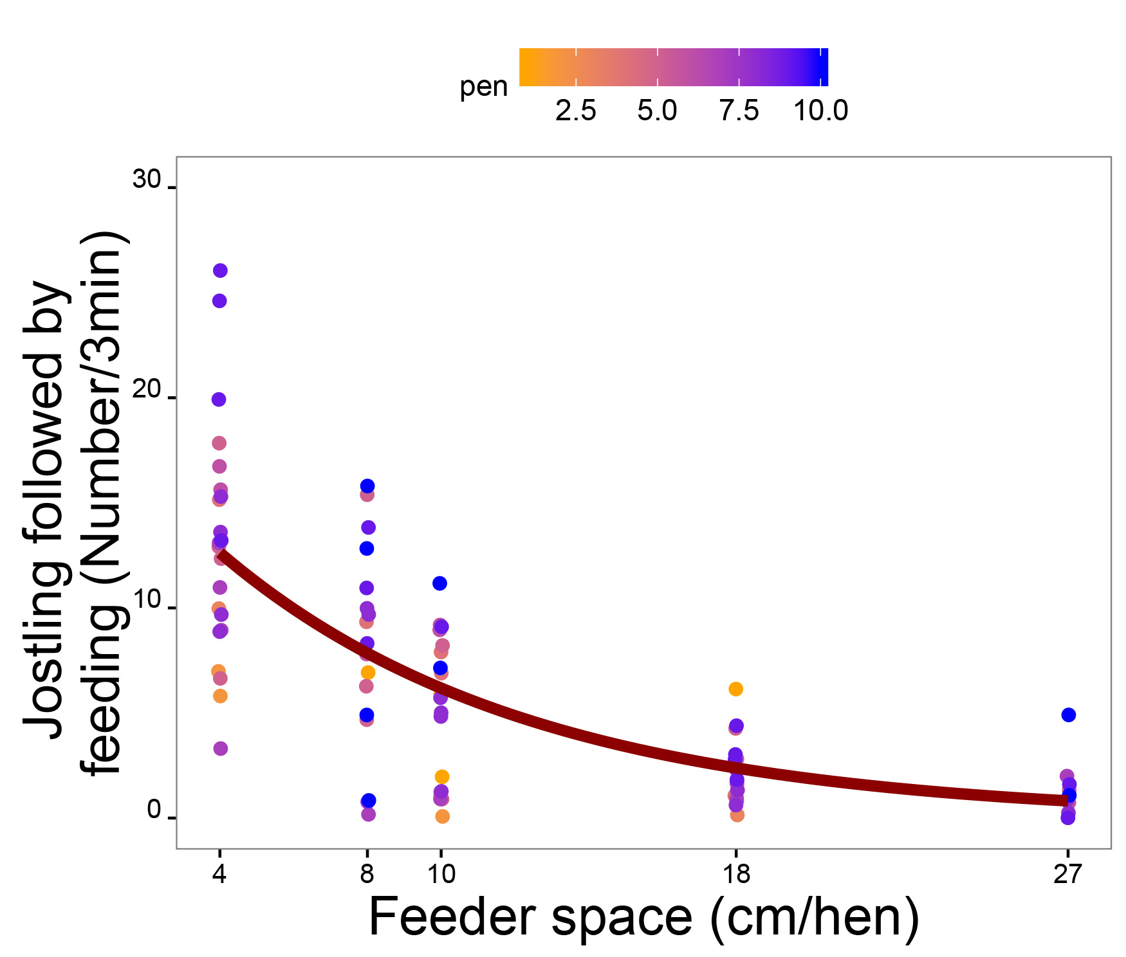
Figure S 2: Relationship between number of jostling events that were followed by feeding per 3 min observation period (y-axis) and feeder space (x-axis). The dots represent raw data points and colours pens. Best fitted line is based on the generalized linear model without random factors. Sample size: n=167 replicates.

Model outputs:
Table S 2: Model output for the number of competitors at the resources. Number of competitors at the resources. Results of GLMM model: No. of competitors at both resources (a)/No. of different competitors at both resources (b) ~ feeder space + age + resource ratio + pen side + feeder space × resource ratio + feeder space × age; Poisson distribution; pen = random factor. Sample size: n=167 replicates. *: p<α’, with α’=0.006 after Bonferroni correction.
Number of competitors at the resources
 |  |  | estimate |  | SE |  | z |  | pGLMM
 | a) Average No. of competitors at both resources
 | β |  | 1.794 |  | 0.063 |  | 28.588 |  | <2×10^{-16*}
 | feeder space |  | 0.01 |  | 0.003 |  | 2.74 |  | 0.006*
 | age |  | -0.213 |  | 0.06 |  | -3.53 |  | 0.0004*
 | resource ratio |  | -0.163 |  | 0.057 |  | -2.861 |  | 0.004*
 | side |  | 0.023 |  | 0.059 |  | 0.392 |  | 0.695
 | feeder space × resource ratio |  | 0.006 |  | 0.004 |  | 1.772 |  | 0.076
 | feeder space × age |  | 0.002 |  | 0.004 |  | 0.556 |  | 0.578
 | b) No. of different competitors at both resources
 | β |  | 2.693 |  | 0.041 |  | 65.32 |  | <2×10^{-16*}
 | feeder space |  | 0.0006 |  | 0.002 |  | 0.23 |  | 0.819
 | age |  | -0.144 |  | 0.042 |  | -346 |  | 0.001*
 | resource ratio |  | -0.0373 |  | 0.038 |  | -0.99 |  | 0.323
 | side |  | 0.032 |  | 0.040 |  | 0.8 |  | 0.426
 | feeder space × resource ratio |  | 0.0002 |  | 0.003 |  | 0.07 |  | 0.942
 | feeder space × age |  | 0.003 |  | 0.003 |  | 1.03 |  | 0.302
Table S 3: Model output for the number of switches and transitions. Number of switches and transitions. Results of GLMM models: Number of switches (a) /Number of transition (b) ~ feeder space + age + resource ratio + pen side; Binomial (a)/Poisson (b) distribution; pen = random factor. Sample size: n=167 replicates. *: p<α’, with α’=0.006 after Bonferroni correction.
Number of switches and transitions
 |  |  | estimate |  | SE |  | z |  |  |  | pGLMM
 | a) Number of switches
 | β |  | -1.361 |  | 0.153 |  | -8.873 |  |  |  | <2×10^{-16 *}
 | feeder space |  | 0.006 |  | 0.006 |  | 0.89 |  |  |  | 0.373
 | age |  | -0.261 |  | 0.058 |  | -4.522 |  |  |  | 6.13×10^{-6*}
 | resource ratio |  | -0.134 |  | 0.02 |  | -6.875 |  |  |  | 6.18×10^{-12*}
 | side |  | 0.083 |  | 0.105 |  | 0.784 |  |  |  | 0.433
 | b) Number of transitions
 | β |  | 0.741 |  | 0.034 |  | 21.482 |  |  | <2×10^{-16*}
 | feeder space |  | -0.0003 |  | 0.001 |  | -0.189 |  |  | 0.85
 | age |  | -0.113 |  | 0.013 |  | -8.773 |  |  | <2×10^{-16*}
 | resource ratio |  | -0.061 |  | 0.012 |  | -4.983 |  |  | 6.28×10^{-7*}
 | side |  | 0.009 |  | 0.024 |  | 0.373 |  |  | 0.709

Table S 4: Model output for the prevalence of aggression at the resources. Results of GLMM model: Prevalence of aggression at both resources (a) Does prevalence of aggression (binomial response) depend on the size of the resource? (b) ~ feeder space + age + resource ratio + pen side + feeder space × resource ratio + feeder space × age; Poisson (a)/ binomial (b) distribution; pen = random factor. Sample size: n=167 replicates. *: p<α’, with α’=0.006 after Bonferroni correction.
Prevalence of aggression at the resources
 |  |  | estimate |  | SE |  | z |  | pGLMM
 | a) Prevalence of aggression
 | β |  | 2.106 |  | 0.203 |  | 10.401 |  | <2×10^{-16*}
 | feeder space |  | -0.0166 |  | 0.016 |  | -10.51 |  | <2×10^{-16*}
 | age |  | -0.245 |  | 0.122 |  | -2.006 |  | 0.045
 | resource ratio |  | -0.147 |  | 0.123 |  | -1.196 |  | 0.232
 | side |  | 0.002 |  | 0.118 |  | 0.017 |  | 0.986
 | feeder space × resource ratio |  | 0.043 |  | 0.013 |  | 3.198 |  | 0.001*
 | feeder space × age |  | -0.038 |  | 0.014 |  | -2.719 |  | 0.007
 | b) Prevalence is aggression (binomial response)
 | β |  | 0.619 |  | 0.486 |  | 1.273 |  | 0.203
 | feeder space |  | -0.008 |  | 0.035 |  | -0.217 |  | 0.828
 | age |  | 0.212 |  | 0.453 |  | 0.467 |  | 0.64
 | resource ratio |  | 0.356 |  | 0.478 |  | 0.746 |  | 0.456
 | side |  | -0.512 |  | 0.478 |  | -1.07 |  | 0.284
 | feeder space x resource ratio |  | 0.002 |  | 0.035 |  | 0.07 |  | 0.944
 | feeder space x age |  | -0.0307 |  | 0.032 |  | -0.947 |  | 0.344
Table S 5: Model output for the prevalence of jostling and interrupted feeding. Results of GLMM model: Prevalence of jostling followed by feeding (a) / Prevalence of interrupted feeding (b) ~ feeder space + age + resource ratio + pen side + feeder space × resource ratio + feeder space × age; Poisson distribution; pen = random factor. Sample size: n=167 replicates. *: p<α’, with α’=0.006 after Bonferroni correction.
Prevalence of jostling and interrupted feeding
 |  |  | estimate |  | SE |  | z |  |  | pGLMM
 | a) Prevalence of jostling followed by feeding
 | β |  | 2.831 |  | 0.113 |  | 25.134 |  |  | <2×10^{-16*}
 | feeder space |  | -0.111 |  | 0.007 |  | -16.261 |  |  | <2×10^{-16*}
 | age |  | -0.223 |  | 0.069 |  | -3.216 |  |  | 0.0013*
 | resource ratio |  | -0.067 |  | 0.073 |  | -0.916 |  |  | 0.36
 | side |  | -0.077 |  | 0.07 |  | -1.097 |  |  | 0.273
 | feeder space × resource ratio |  | -0.003 |  | 0.007 |  | -0.376 |  |  | 0.703
 | feeder space × age |  | -0.004 |  | 0.007 |  | -0.558 |  |  | 0.577
 | c) Prevalence of interrupted feeding
 | β |  | 2.248 |  | 0.146 |  | 15.38 |  |  | <2×10^{-16*}
 | feeder space |  | -0.109 |  | 0.009 |  | -12.291 |  |  | <2×10^{-16*}
 | age |  | 0.033 |  | 0.091 |  | 0.365 |  |  | 0.715
 | resource ratio |  | -0.015 |  | 0.096 |  | -0.158 |  |  | 0.874
 | side |  | -0.071 |  | 0.093 |  | -0.767 |  |  | 0.443
 | feeder space × resource ratio |  | -0.007 |  | 0.009 |  | -0.801 |  |  | 0.423
 | feeder space × age |  | -0.016 |  | 0.008 |  | -1.883 |  |  | 0.06

