Supplementary materials

Mixture models as a method for comparative sociality: social networks and demographic change in resident killer whales

Authors

Samuel Ellis^{1,}* (ORCID: 0000-0001-9019-6040),
Daniel W. Franks² (ORCID: 0000-0002-4832-7470),
Michael N. Weiss^{1,3},
Michael. A. Cant⁴ (ORCID: 0000-0002-1530-3077),
Paolo Domenici⁵,
Kenneth C. Balcomb³,
David K. Ellifrit³
Darren P. Croft¹ (ORCID: 0000-0001-6869-5097)

Author affiliations

- Centre for Research in Animal Behaviour, Department of Psychology, University of Exeter, UK
- Department of Biology, University of York, UK
- Center for Whale Research, Friday Harbor, WA, USA
- Centre for Ecology and Conservation, University of Exeter, Penryn Campus, UK
- IAMC-CNR, Istituto per l’Ambiente Marino Costiero, Consiglio Nazionale delle Ricerche, Oristano, Italy

*s.ellis@exeter.ac.uk

Journal name:
Behavioural Ecology and Sociobiology
Supplementary 1: Classifying kinship pseudocode

Pseudocode showing how the relation from whale from.id to whale to.id is established (output fits the sentence: from id is to ids RELATION). Commands are sequential and are applied in the order presented. Note: all relationships are maternal relatedness only.

if
to.id is offspring of from.id
relation = MOTHER

if
to.id is from.id’s offsprings’ offspring
relation = GRANDMOTHER

if
from.id’s mother is UNKNOWN
relation = UNKNOWN

if
to.id’s is from.id’s mother:
& from.id’s sex is MALE
relation = SON
& from.id’s sex is FEMALE
Relation = DAUGHTER
& from.id’s sex is UNKNOWN
relation = OFFSPRING: UNKNOWN SEX

if
from.id’s mother’s mother is to.id
& from.id’s mother’s mother is not UNKNOWN
& from.id’s sex is MALE
Relation = GRANDSON
& from.id’s sex is FEMALE
Relation = GRANDAUGHTER
& from.id’s sex is UNKOWN
relation = GRANDOFFSPRING: UNKNOWN SEX

if
to.id’s mother is UNKNOWN
relation = UNKNOWN

if
to.id’s mother is the same as from.id’s mother
& from.id’s sex is MALE
relation = BROTHER
& from.id’s sex is FEMALE
relation = SISTER
& from.id’s sex is UNKNOWN
relation = SIBLING: UNKNOWN SEX

if
to.id’s mother is from.id’s sibling
& from.id’s sex is MALE
relation = UNCLE
& from.id’s sex is FEMALE
relation = AUNT
& from.id’s sex is UNKNOWN
relation = MATERNAL SIBLING: UNKNOWN SEX

if
from.id’s mother’s mother is UNKNOWN
relation = UNKNOWN

if
from.id’s mother’s mother to to.id’s mother
& from.id’s sex is FEMALE
relation = NIECE
& from.id’s sex is MALE
relation = NEPHEW
& from.id’s sex is UNKNOWN
relation = NIBBLING: UNKNOWN SEX

ELSE
from.id’s pod is the same as to.id’s pod relation = IN POD NON-RELATIVE

Supplementary 2: 4 component model reanalyses
In this section we present a partial reanalysis of our data applying a 4-componenet model to the data rather than the three-component model used in the main manuscript. Methods are described in the main text (methods).

Number of associations per component

Tables S2.1: c.f. Main text. Table 1

sex agecat mean.n.k2 sd.n.k2 mean.n.k3 sd.n.k3 mean.n.k4 sd.n.k4
F adult 9.85 6.12 2.35 1.55 1.35 0.581
F infant 7.25 5.64 2.12 1.48 1.32 0.564
F juvenile 9.05 6.30 2.47 1.40 1.31 0.564
F postreproductive 8.77 6.01 2.49 2.01 1.22 0.511
M adult 9.08 6.30 2.72 1.95 1.42 0.690
M infant 7.87 5.28 2.06 1.11 1.22 0.498
M juvenile 8.65 5.96 2.16 1.26 1.38 0.582

Average number of k2, k3 and k4 social connections in male and female killer whales in different age categories (see text for explanation of categories). Male and females of all age categories have comparable number of k2 associations in the four-component model presented here to the 3-component model presented in the text (table 1). In general, in the four-component model, males and females of all age categories have 1-2 k3 component associations and 1-1.5 k4 component associations. In the three-component model the mean number of k3 associations is approximately 2. The four-component model therefore appears to split the three-component model k3 component into two smaller components.

Relation by component

Figure S2.1: c.f. main text figure 1

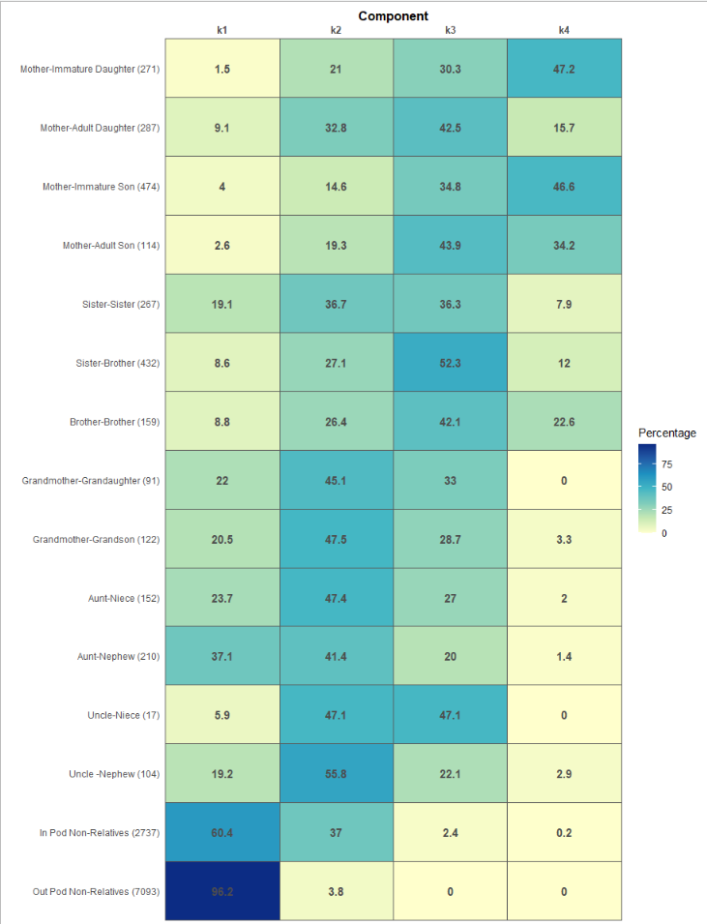

In the four-component model k1 and k2 are dominated by out and in-pod non-relatives and second-degree matrilineal relatives respectively. This is comparable to the three-component model (main text). In the four-component model, k3 contains mostly first-degree relative relationships other than mother-immature offspring relationships and some mother-adult son associations which are in k4. In the three-component model (main text) all of these associations are in k3. The four-component model appears to split k3 associations.

Social dynamics of mother offspring associations a) ontogeny

Figure S2.2: c.f Main text figure 2

- Predicted probability of mother-offspring association being in k4 of four-component model given offspring age and sex.
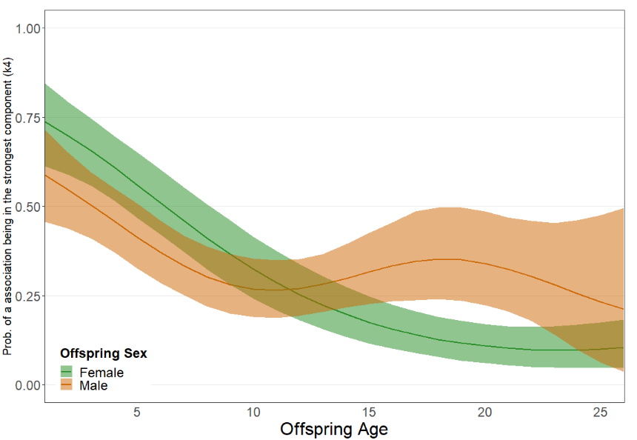
- Predicted probability of mother-offspring association being in 43 of a four-component model
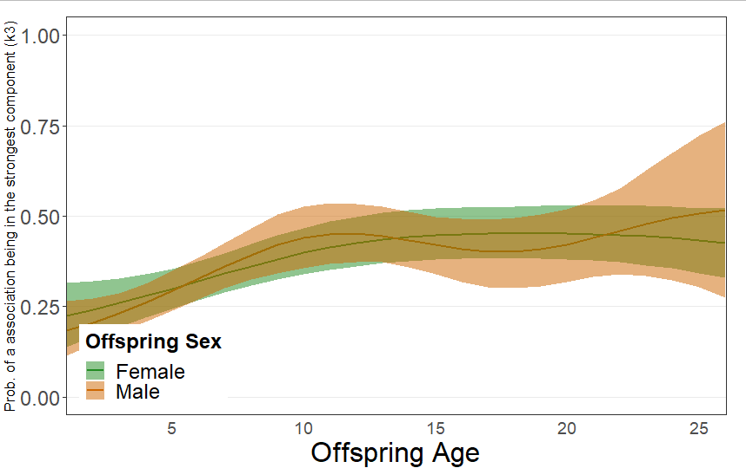

In a four-component model, mother-offspring associations begin in k4, and then move gradually into k3 between 1 and 10 years. Males then have a constant probability of approximately 25% of being in k4 throughout later development and into adulthood. Females on the other hand continue to drop out of k4. Mother-offspring associations of both sexes which drop out of k4 are maintained in k3, where the probability of a mother-offspring association being in k3 is low until 10 and then at around 50% for both sexes for the rest of their life.

Social dynamics of mother offspring associations b) mother-daughter associations

Figure S2.3: c.f. main text figure 3

i) Number of mother-daughter associations in k4 and not in k4 in the five years before and after the birth of a new offspring (n = 105). Left tile shows the five years before and after the birth of an offspring to the daughter, the right tile shows the five years either side of the birth of an offspring to the mother.
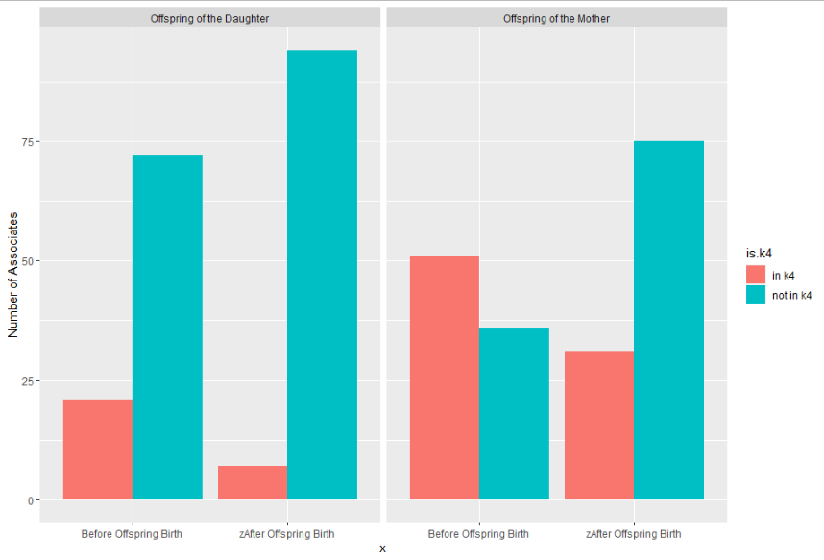

ii) Number of mother-daughter associations in k3 and not in k3 in the five years before and after the birth of a new offspring (n = 105). Left tile shows the five years before and after the birth of an offspring to the daughter, the right tile shows the five years either side of the birth of an offspring to the mother.
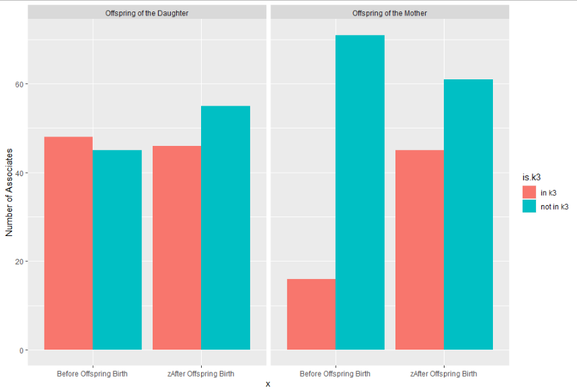
From section (a) it is clear that k4 associations are concentrated in mother-immature offspring associations. This unlike in the three-component model where k3 associations cover offspring for much longer (lifetime in the case of males). The interpretation of these section (b) results is therefore different. Whales are less likely to have a k4 association with their mother after their mother has given birth to a new offspring. This differs from the result presented from the three-component model. However, it should be interpreted with caution. Mothers are unlikely to give birth to a new calf while their offspring are still dependent. The correlation between sibling birth and loss of k4 associations in killer whale mother-offspring relationships may be an artefact of this ageing effect.

We do not repeat our impact of mother death analysis because of this differing interpretation of k4 associations.

Discussion

The four-component model can be interpreted in terms of the three-component model (and vice versa). In essence, the four-component model separates the three-component models strongest component into two. Under the three-component model the strongest k3 component is dominated by first order mother-offspring and sibling-sibling relationships. Combining components k3 and k4 from the four-component model covers, approximately, the same set of relationships, namely mother-offspring and sibling-sibling bonds. However, the four-component model separates relationships between mother and immature offspring (which are in k4) from the other first-order bonds (which are in k3). The four-component model introduces a new ‘extra-strong’ mother-immature offspring component.

The mother-offspring results reported here (figure S2.1) reflect this separation of three-component model k3 into two components. Under a four-component model 60-70% of mother-offspring bonds of both sexes are in the strongest k4 component in the offspring’s first year of life, but they drop of over the first 10 years few mother-offspring associations are in k3 of the offspring’s life to around 25% at age 10. In contrast, few mother-offspring associations are in four-component model k3 component when the offspring is 0 but this rises over the first 10 years of life reaching 50% by age 10. Mother-offspring associations, therefore, move from k4 to k3 as the offspring ages.

It is clear that the components in the four-component model represent different, but overlapping, aspects of killer whale biology. This highlights the importance of understanding what the components in a model represent, biologically, before interpreting results.

Supplementary 3. Raw Data and Components
Histograms illustrating the mapping of the three and four component models onto the raw association data. For each year, plot i shows the raw association data without components, ii) shows a histogram of the three-component model and iii) a histogram of the four-component model. It is important to note that the binomial mixture models do not model the association data as represented on the x axis, rather it models the numerator and denominators of the index. Please not the y axis represents the square root of the count of number of associations.
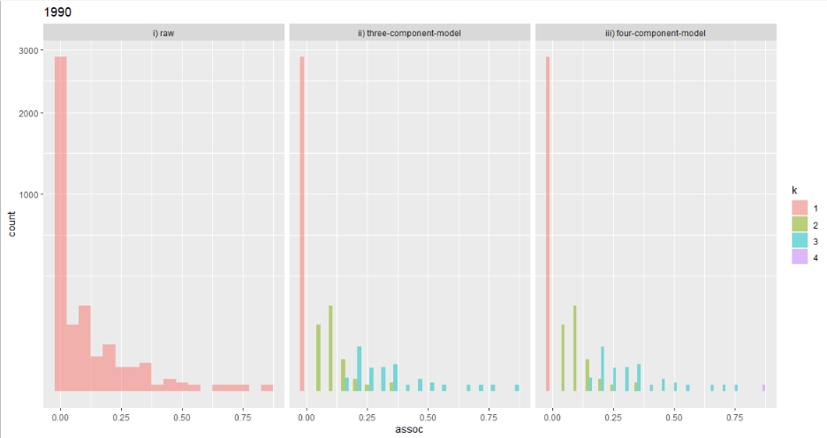
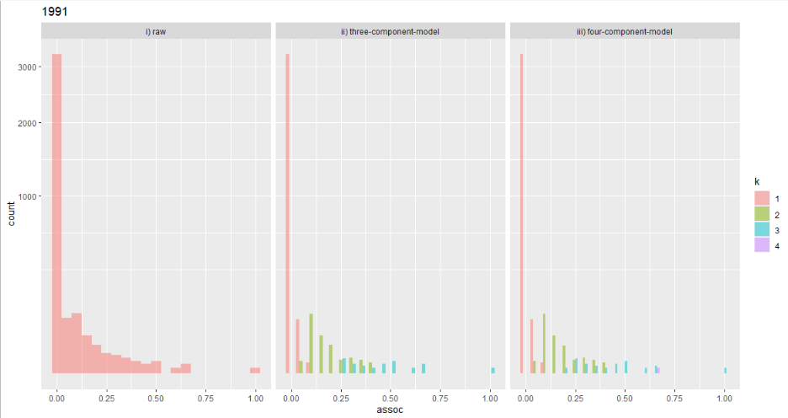
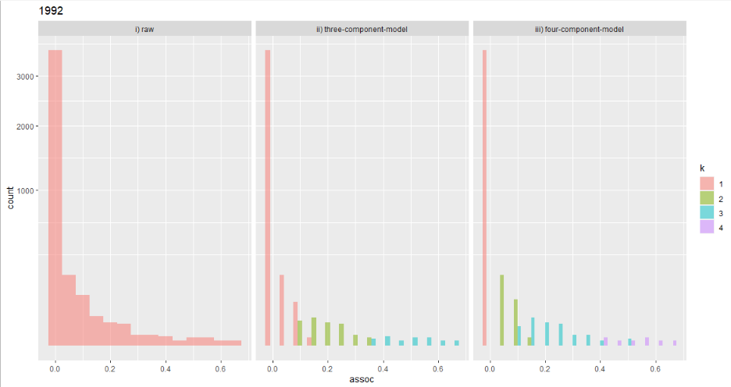
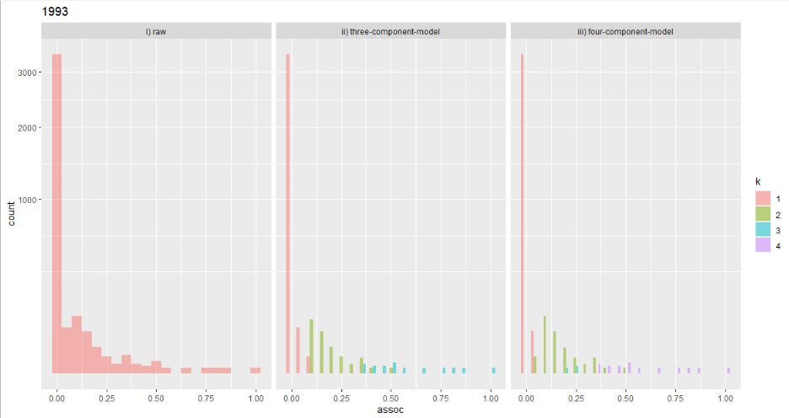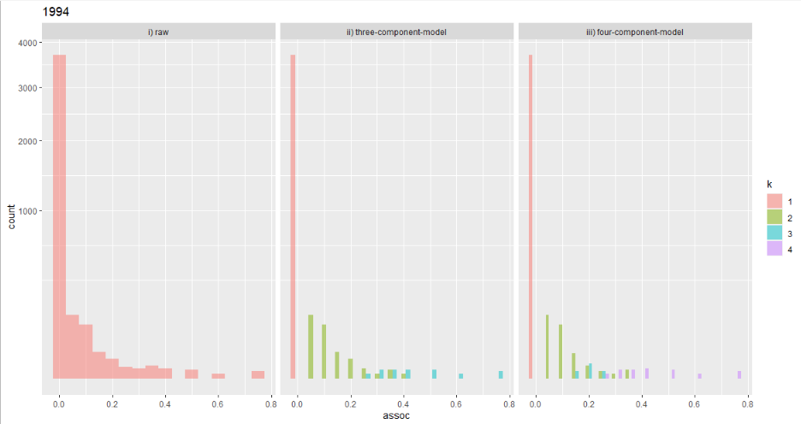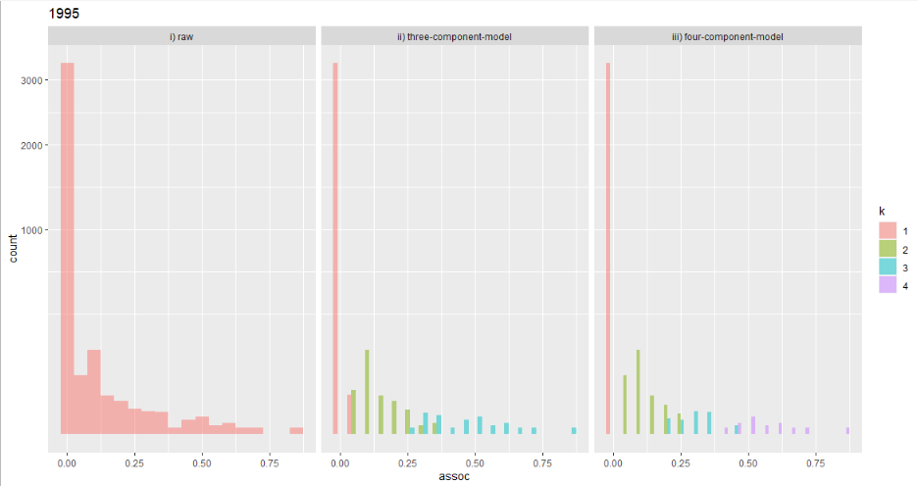
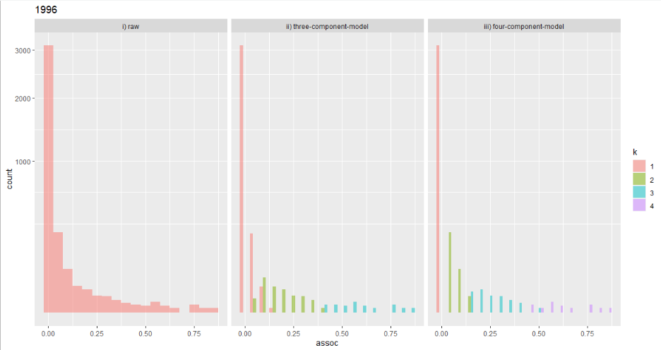
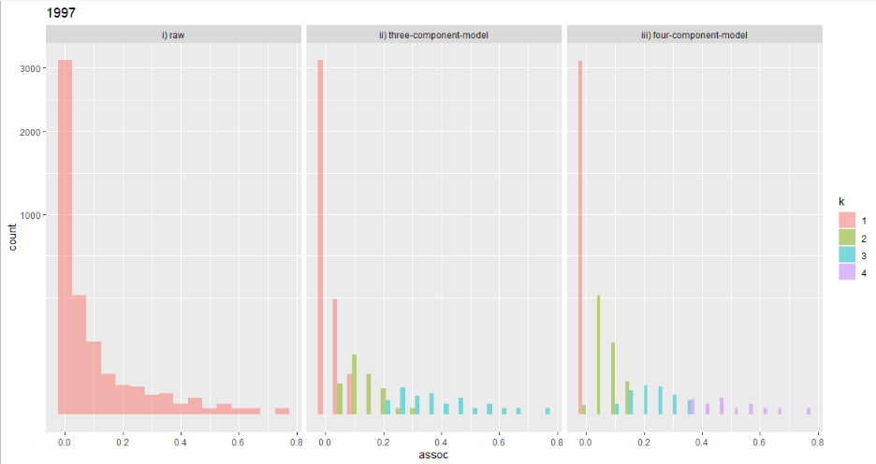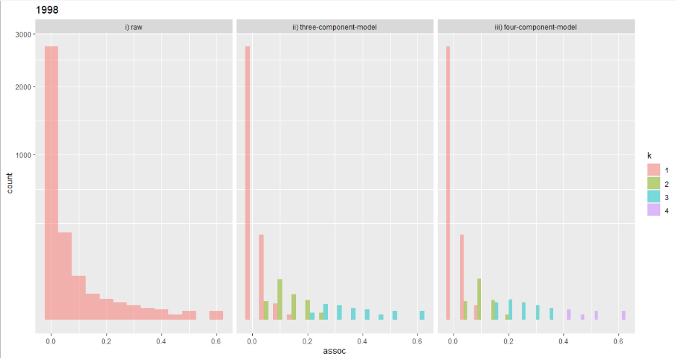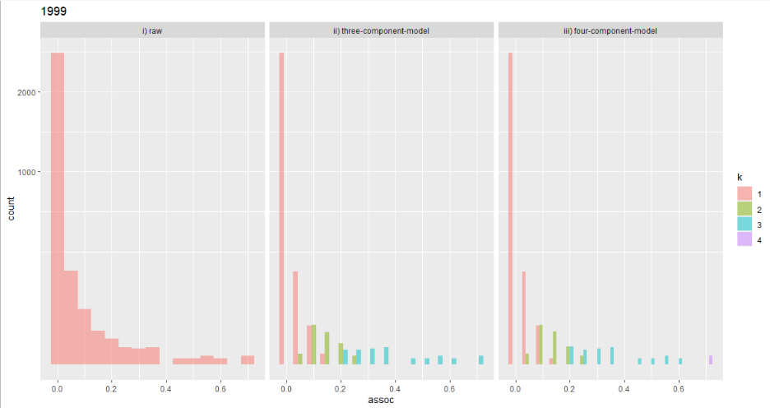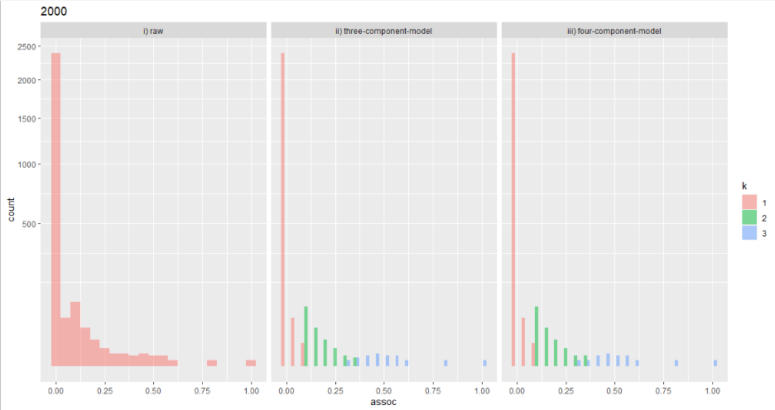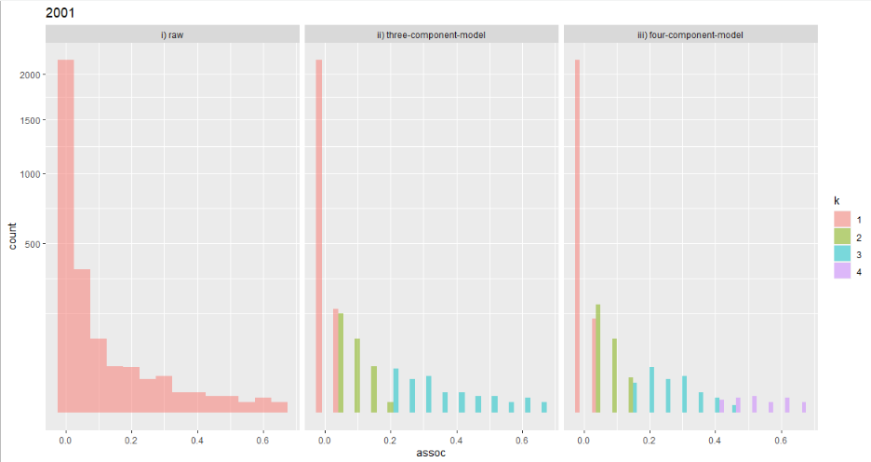
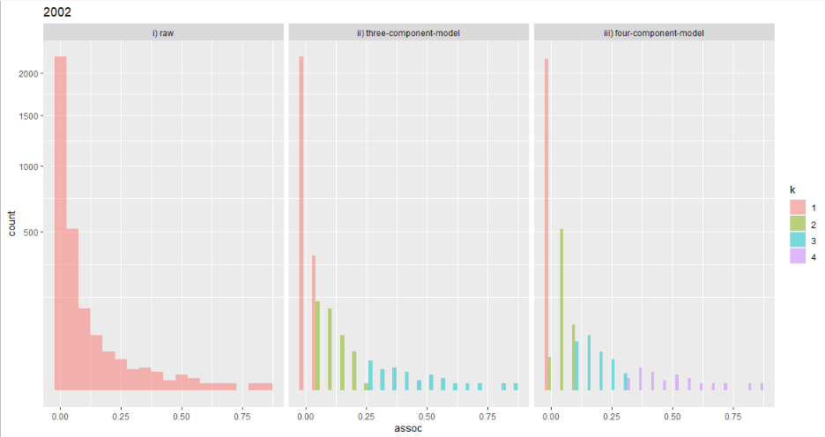
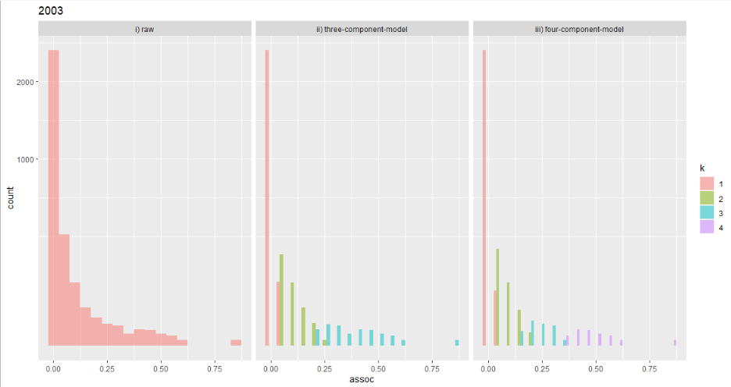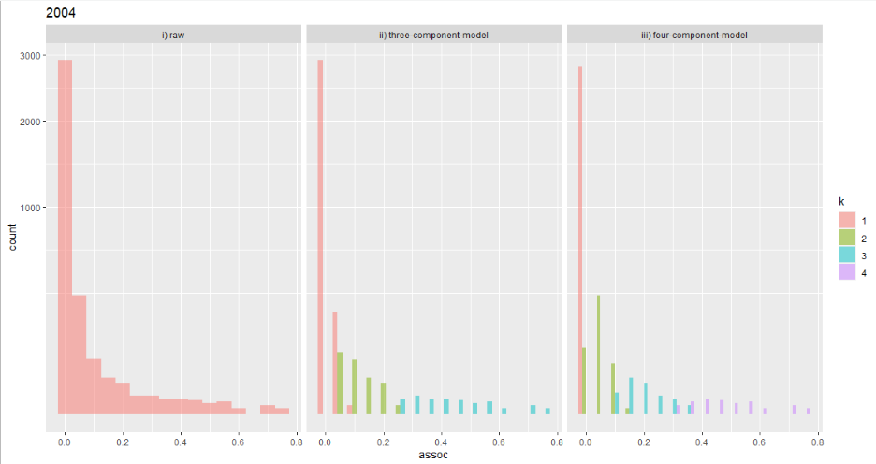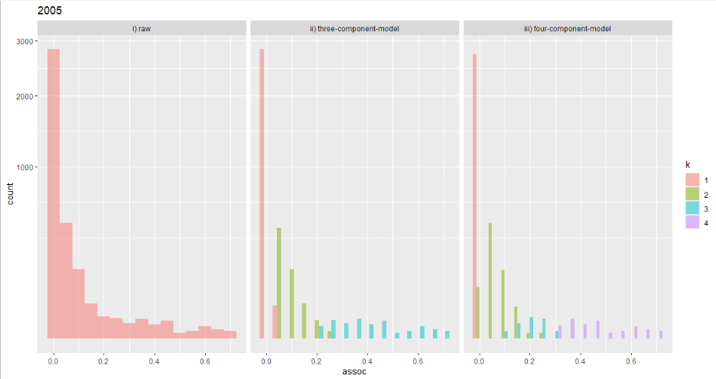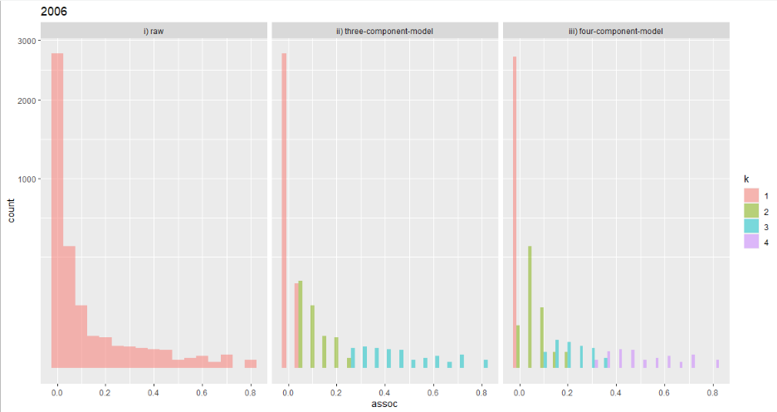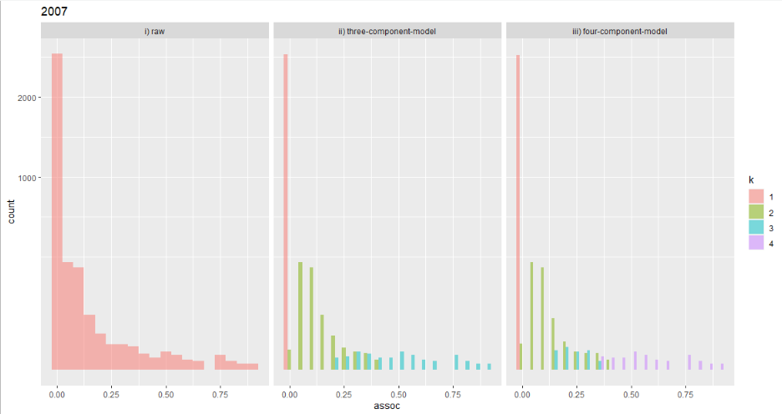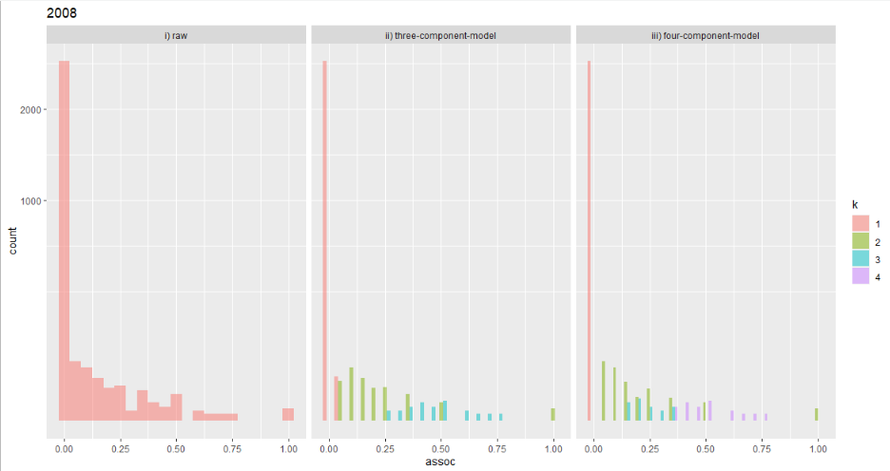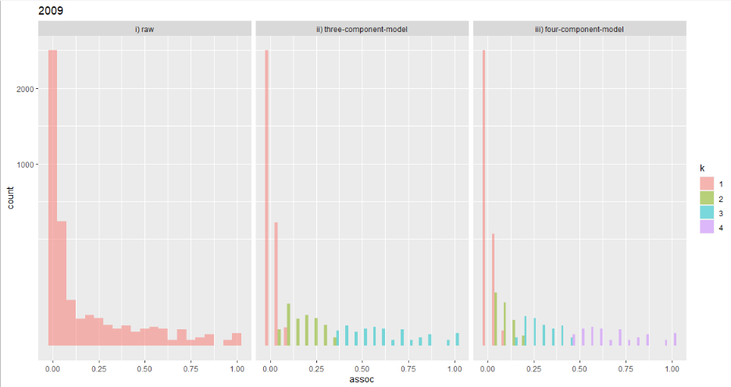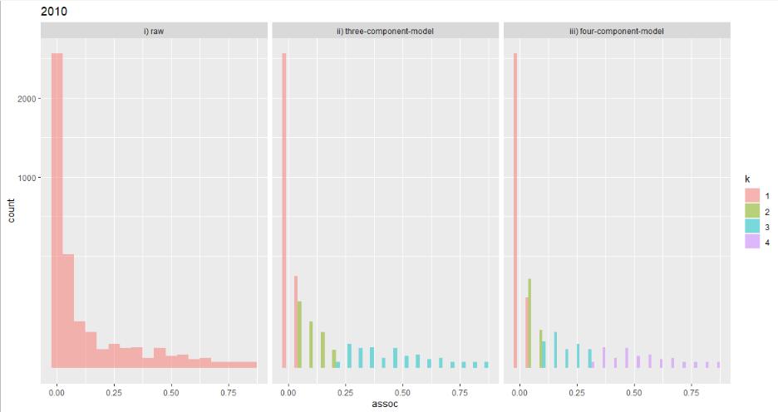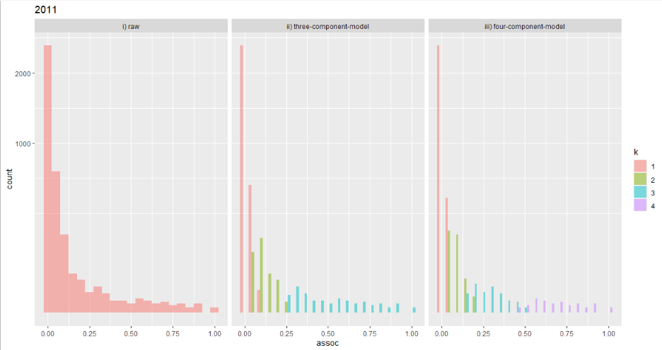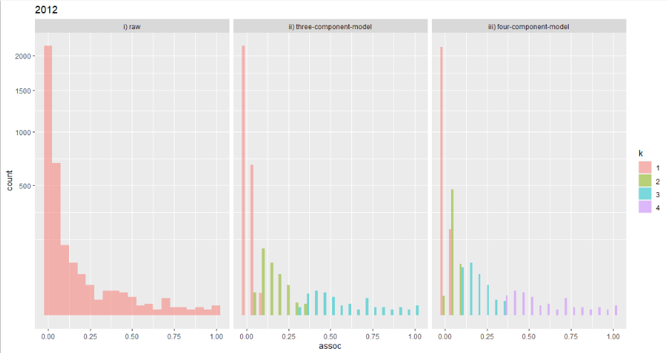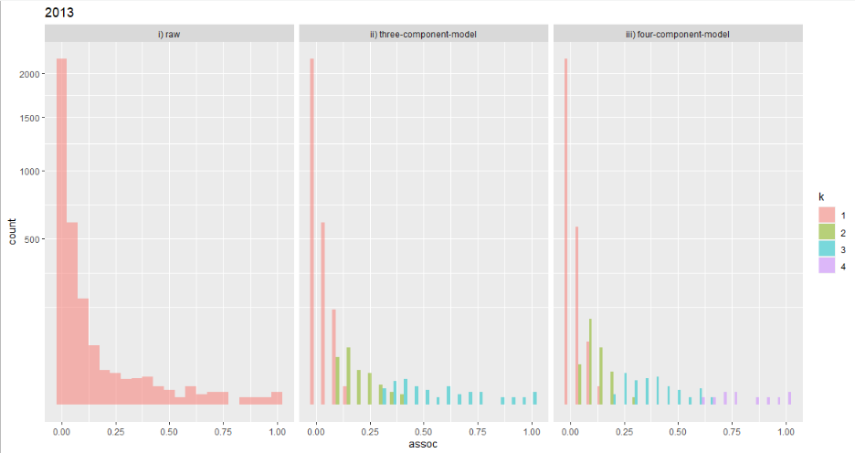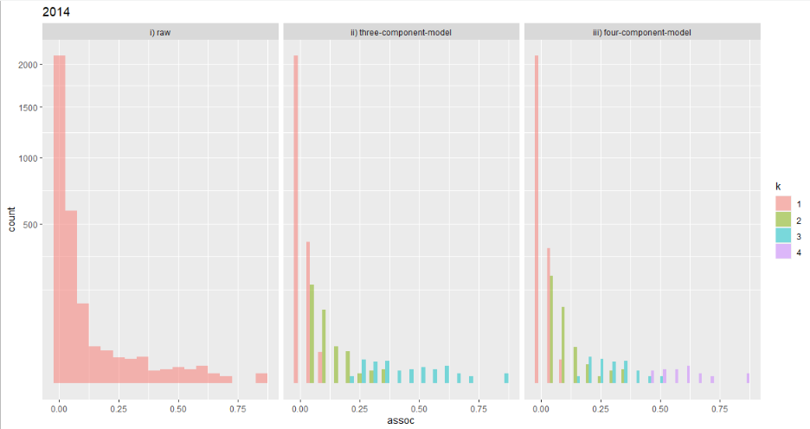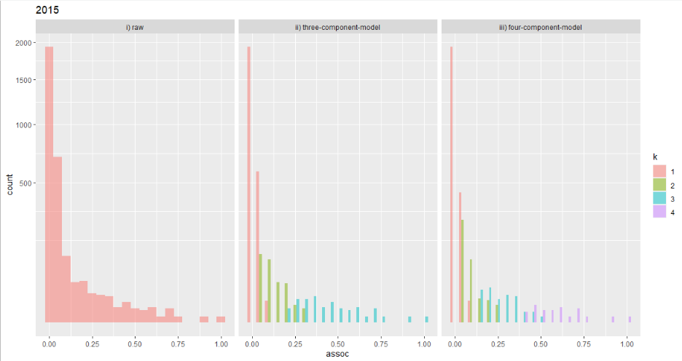

Supplementary Table 1. Choosing the best fitting number of components

k | ΔzBIC | # best fitting
1 | 81.20 | 0
2 | 6.54 | 1
3 | 0.74 | 11
4 | 1.2 | 10
5 | 2.54 | 3
6 | 4.00 | 1
7 | 5.4 | 0
8 | 6.98 | 0
9 | 8.48 | 0

Supplementary Table 2. Number of observations by relation, sex and mother status

Partner relation | N female | N male | N mother alive | N mother dead | N female & mother alive | N female & mother dead | N male & mother alive | N male & mother dead
aunt | 152 | 210 | 307 | 55 | 128 | 24 | 179 | 31
grandmother | 91 | 122 | 200 | 13 | 90 | 1 | 110 | 12
grandoffspring | 56 | 0 | 5 | 51 | 5 | 51 | 0 | 0
in.pod-non.relative | 2471 | 2997 | 4889 | 579 | 2224 | 247 | 2665 | 332
nibbling | 362 | 121 | 213 | 270 | 111 | 251 | 102 | 19
offspring | 607 | 0 | 204 | 403 | 204 | 403 | 0 | 0
out.pod-non.relative | 6487 | 7693 | 12848 | 1332 | 5954 | 533 | 6894 | 799
sibling.other.sex | 432 | 436 | 740 | 128 | 368 | 64 | 372 | 64
sibling.same.sex | 534 | 318 | 628 | 224 | 326 | 208 | 302 | 16
uncle | 17 | 104 | 115 | 6 | 16 | 1 | 99 | 5

Supplementary Table 3. Social complexity calculated for both the 3 component mixture models (used throughout the analysis) and for models based on the best fitting k for that year.

year | 3k model S | best fit model S
1990 | 0.69 | 0.70
1991 | 1.03 | 1.03
1992 | 1.01 | 0.68
1993 | 0.99 | 0.99
1994 | 0.81 | 0.82
1995 | 1.02 | 1.02
1996 | 1.07 | 1.07
1997 | 1.07 | 1.07
1998 | 1.09 | 1.09
1999 | 1.09 | 1.09
2000 | 1.05 | 1.05
2001 | 0.99 | 1.26
2002 | 0.98 | 1.08
2003 | 0.96 | 1.24
2004 | 1.06 | 1.27
2005 | 0.96 | 1.17
2006 | 1.02 | 1.17
2007 | 0.72 | 1.02
2008 | 1.02 | 1.02
2009 | 1.07 | 1.35
2010 | 1.07 | 1.52
2011 | 1.09 | 1.43
2012 | 1.10 | 1.53
2013 | 1.09 | 1.32
2014 | 1.08 | 1.32
2015 | 1.10 | 1.67

Table 4. Results of a Bayesian generalised linear mixed effect models exploring the difference between the number of social associations in a given component in each age category for females compared to males.

Age Category  (age in years for males M and females F) | k2  Posterior Mean (95% Credible Interval) | k3  Posterior Mean (95% Credible Interval)
Immature (F:0-11, M: 0-15) | 0.00 (-0.13 – 0.13) | -0.11 (-0.24 – 0.01)
Adult (F: 12-41, M: 15+) | 0.06 (-0.19 - 0.06) | 0.00 (-0.12 – 0.13)

Supplementary table 5. Results of a Bayesian generalised linear mixed effect models exploring the difference between the number of social associations in a given component in each age category compared to the number maintained by males of that sex. See table 3 for ages of individuals in different age categories.

Adults vs. | # k2 associations. Posterior mean (credible interval) | # k3 associations. Posterior mean (credible interval)
Males
Infants | -0. 21(-0.0.32 - -0.11) | -0.12 (-0.28 - 0.03)
Juveniles | -0.10 (-0.18 - -0.01) | -0.10 (-0.25 - 0.04)
Females
Infants | -0.38 (-0.48 - -0.28) | -0.05 (-0.21 – 0.10)
Juveniles | -0.23 (-0.31 - -0.15) | 0.02 (-0.13 – 0.16)
Post-Reproductive | -0.23 (-0.33 - -0.14) | -0.10 (- 0.23 – 0.03)

Supplementary Table 6. Average numbers of intermediate k2 and strong k3 social connections in male and female killer whales in different age categories. Ages categories are derived from the literature (Olesiuk et al. 2005). Female age at adulthood reflects the average age of first birth of the first offspring, whereas males represent the average age the physical maturity is attained (as opposed to sexual maturity which achieved several years earlier) (Olesiuk et al. 2005). Age of becoming post-reproductive is the age at which 95% of population female fecundity has been achieved (Ellis et al. 2018). Here (cf. table 3) we separate sexually mature males, those physiologically of reproducing, from physically mature males, those who have reached full adult size (Olesiuk et al. 2005).

Sex | Age Category  (age in years) | Mean # k2 connections | Std. dev. # k2 connections | Mean # k3 connections | Std. dev. # k3 connections
F | Infant (0-4) | 5.59 | 5.12 | 1.86 | 0.88
F | Juvenile (5-11) | 7.03 | 5.33 | 2.05 | 1.02
F | Adult (12-41) | 7.70 | 5.54 | 1.98 | 1.13
F | Post-reproductive (42+) | 6.99 | 5.07 | 1.80 | 1.24
M | Infant (0-4) | 6.21 | 4.80 | 1.72 | 0.91
M | Juvenile (5-15) | 6.75 | 5.22 | 1.78 | 0.95
M | Sexually mature (15-20) | 7.68 | 5.72 | 1.86 | 1.03
 | Physically mature (20+) | 7.31 | 5.40 | 2.13 | 1.43

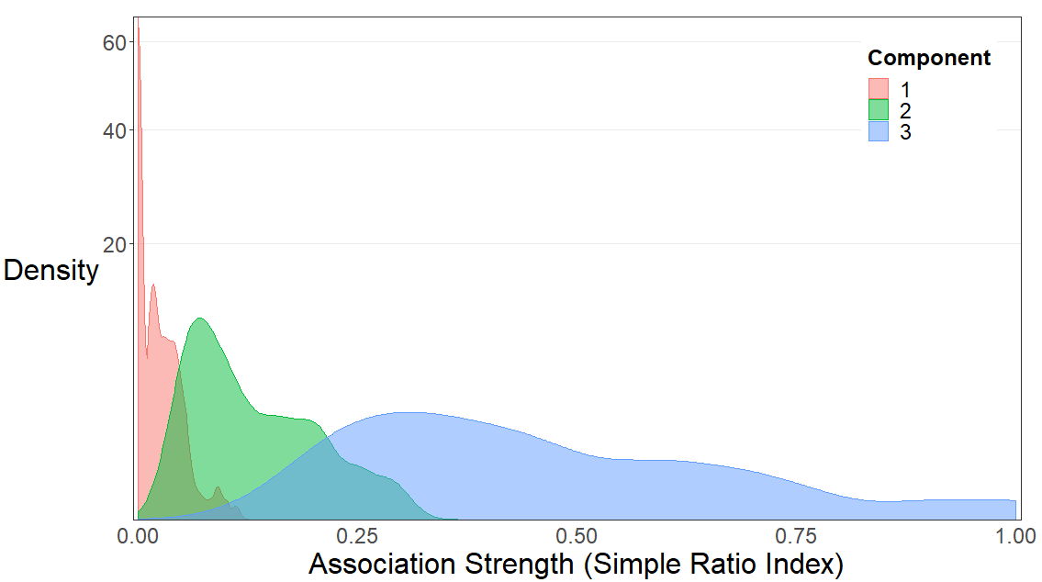

Supplementary figure 1. Example illustrating the simple ratio indices of k1, k2, and k3 components in 2015. Density shows the kernel density of each component at each strength. Kernel densities are a smoothed equivalent of a histogram. Overlap between components partially reflects the difference between the simple ratio index, which is a proportion and does not take account of sampling, and the binomial mixture models, which do take account of sampling.

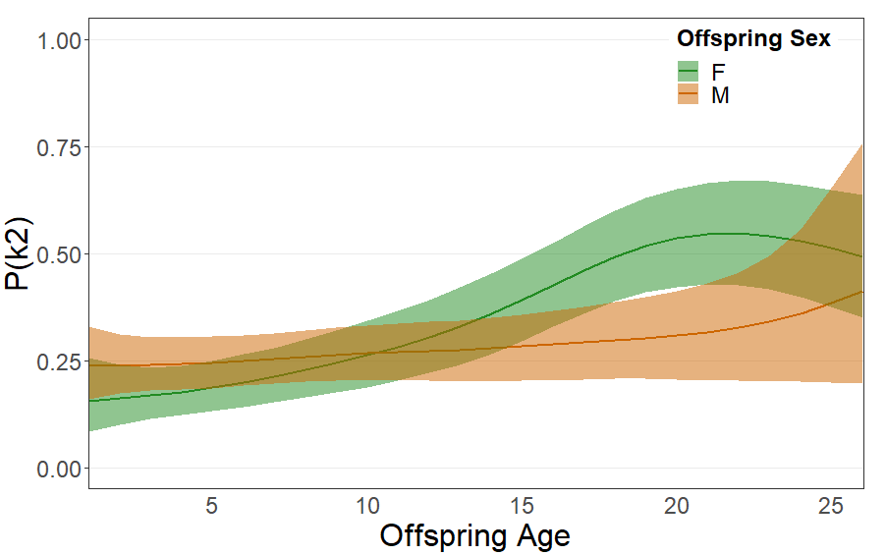

Supplementary figure 2. The predicted (± credible intervals) change in probability of a mother-offspring association being in component 2 with age for male and female offspring. Predictions are form a Bayesian generalised linear model with offspring age modelled as a four-knot spline. Lack of overlap in credible intervals between points suggests that the whales with those properties have different probabilities of their association being in k2. The pattern observed matches the expectation if associations not in k3 (figure 2) are in k2.

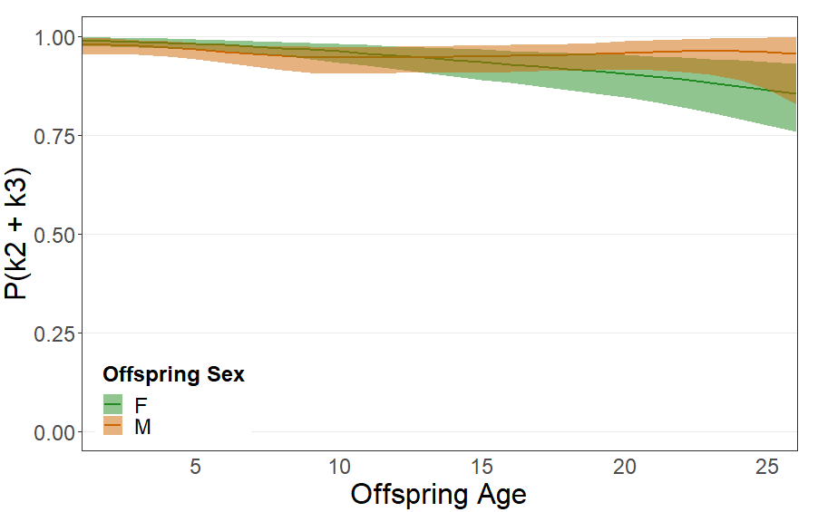
Supplementary figure 3. The predicted (± credible intervals) change in probability of a mother-offspring association being in component 2 or 3 with age for male and female offspring. Predictions are from a Bayesian generalised linear model with offspring age modelled as a four-knot spline. Lack of overlap in credible intervals between points suggests that the whales with those properties have different probabilities of their association being in k2 or 3. There is little change in the probability of a mother-offspring association being in either k3 or k2 over the lifetime.

