Electronic supplementary material for

Dear territory or dear partner? Causes and consequences of breeding dispersal in a highly territorial bird of prey with a strong pair bond
(Includes 2 figures, 1 table)
Behavioural Ecology and Sociobiology
Arianna Passarotto^{1,2,3*}, Chiara Morosinotto^{1,2,†}, Jon E. Brommer⁴, Esa Aaltonen⁵, Kari Ahola⁶, Teuvo Karstinen⁷, Patrik Karell^{1,2,‡}
¹ Bioeconomy Research Team, Novia University of Applied Sciences, Raseborgsvägen 9, FI-10600 Raseborg, Finland
² Evolutionary Ecology Unit, Department of Biology, Lund University, Sölvegatan 39 (Ecology Building), SE-223 62 Lund, Sweden
³ Universidad de Sevilla, P.º de las Delicias, s/n, 41013 Sevilla, Spain
⁴ Department of Biology, 20014 University of Turku, Turku, Finland
⁵ Vanhansahantie 13B 7, FI-08800 Lohja, Finland
⁶ Tornihaukantie 8D 72, FI-02620 Espoo, Finland
⁷ Juusinkuja 1, FI-02700 Kauniainen, Finland

† Present address: Department of Biology, University of Padova, Via U. Bassi 58/B, 35131 Padova, Italy; National Biodiversity Future Center (NBFC), 90133 Palermo, Italy

‡ Present address: Department of Ecology and Genetics, University of Uppsala, Norbyvägen 18D, SE-752 36 Uppsala

*Corresponding author
arianna.passarotto@biol.lu.se
ariannapassarotto84@gmail.com

Fig. S1. Histogram depicting the distribution of the dispersal distances observed in tawny owl population. The blue line indicates distances equal to 1km, the threshold considered in this study to determine a potential movement to another territory.
Table S1. Binomial GLMM analyzing effects of movement on breeding success (proportion of fledglings on clutch size, see main text for detailed explanation) in both sexes in adult tawny owls. Models include individual specific traits (color morph, sex, breeding experience and mate change as fixed terms). The contrast is given in the table in brackets. ‘Year’, ‘individual ID’ and ‘Nest box ID’ (both in the following breeding event) are entered as random factors. Bold font indicates statistically significant effects (α = 0.05)
 | Breeding success
 | (observations n = 645; individuals n = 305)
Predictors | Estimate | z | P
Intercept | 1.71 ± 0.22 | 7.62 | <0.0001
Colour morph (brown) | -0.11 ± 0.15 | -0.75 | 0.452
Sex (male) | 0.11 ± 0.13 | 0.86 | 0.392
Movement (yes) | 0.39 ± 0.29 | 1.34 | 0.179
Mate change (change) | -0.41 ± 0.16 | -2.59 | 0.010
Breeding experience (older breeder) | 0.12 ± 0.17 | 0.70 | 0.487
Sex*movement | -0.18 ± 0.26 | -0.71 | 0.477
Breeding experience*movement | -0.42 ± 0.31 | -1.35 | 0.176
Random factors | Year: Variance 0.32, SD 0.57
 | Individual ID: Variance <.0001
 | Nest box ID: Variance 1.48, SD 1.22

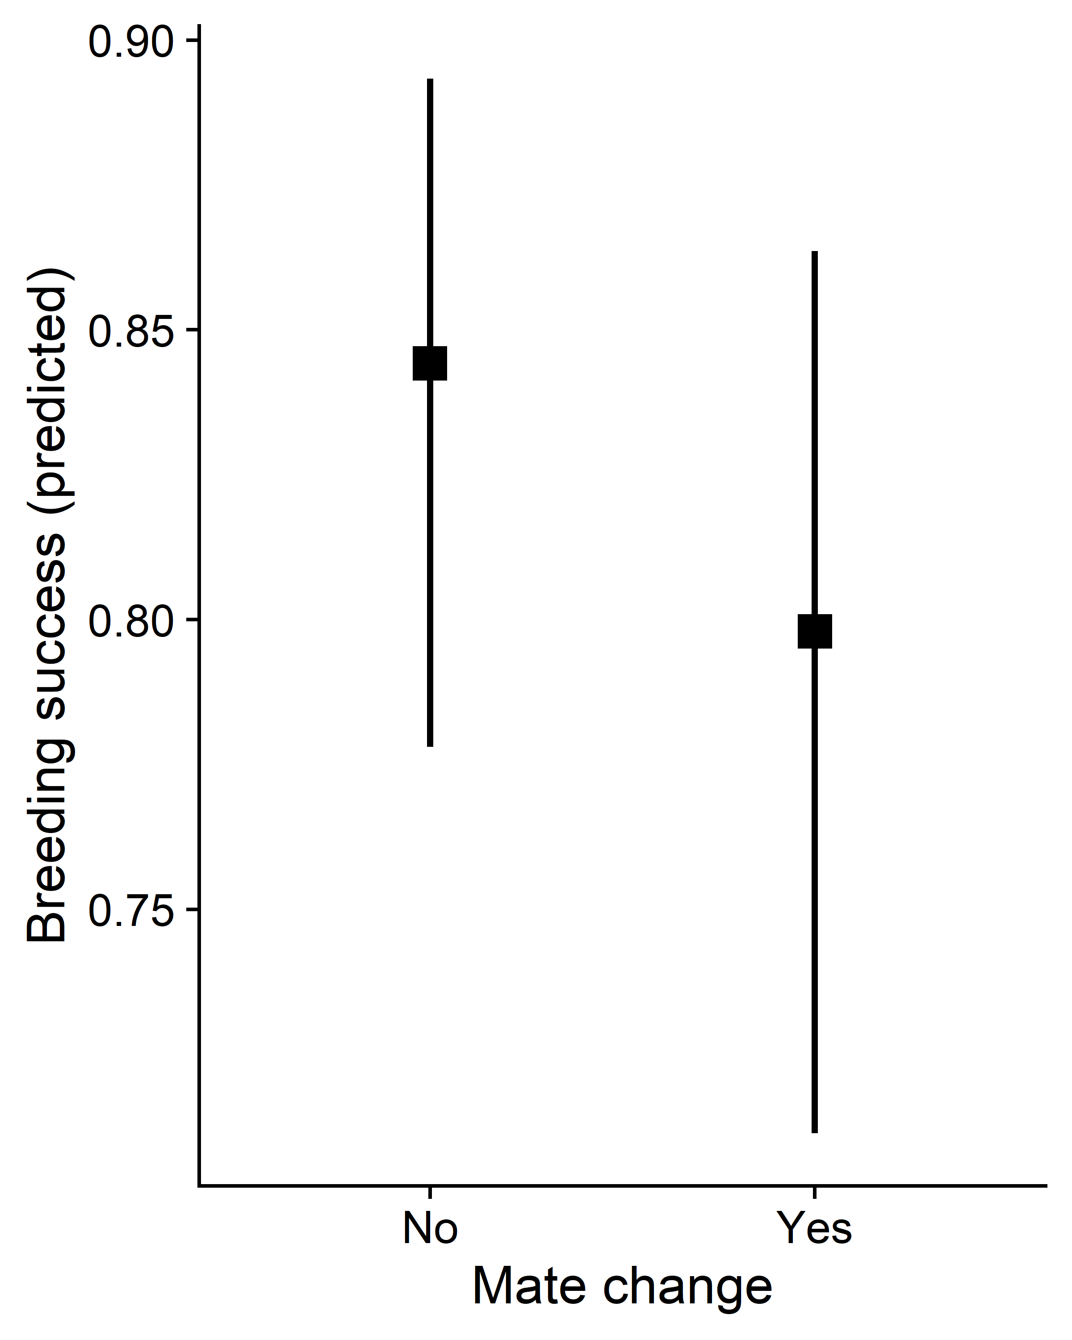

Fig. S2. Boxplot depicting predicted values of breeding success between consecutive breeding attempts in relation to mate change. Error bars indicate 95% CI.

