Online Resources
Testing presence of directionality information in female spider silk trails through male trail-following behavior

Michelle Beyer, Kardelen Özgün Uludag, Maylis Lailler, Jonas O. Wolff, Monika J. B. Eberhard, Tomer J. Czaczkes, Cristina Tuni

Experiment 1.
Do female silk trails convey directional information to males and is this chemically or structurally mediated?

Experiment 1d: Silk ultrastructure investigation after washing treatment
To investigate structural changes in silk lines upon washing them with solvents, we collected silk lines by letting a female P. mirabilis walk over a piece of black paper cardboard (5 cm width x 15 cm length) to leave a single silk line. We let each female produce three silk lines, one for each treatment (unwashed, pentane-washed, deionized-water-washed). Once all three silk lines were collected, they were placed in individual petri dishes (15 cm diameter) under a fume hood. For the washing treatment, approximately 5 mL of the respective solvent (n-pentane, deionized water) were dropped onto the silk line using a disposable pipette, and left to dry for one hour (pentane evaporated after few seconds).
After drying, the silk was prepared for scanning electron microscopy by mounting it on aluminum stubs following established protocols (Ramírez, Ravelo, and Lopardo 2013). Briefly, the silk was placed on a double-sided carbon adhesive disc mounted on an aluminium stub by carefully folding the paper cardboard and catching the now mid-air suspended silk with the stub. Samples were sputter-coated with gold for 5 min without further fixation and examined at 1400 and 4000 magnification in an EVO LS10 scanning electron microscope (Carl Zeiss GmbH). Silk surface was inspected by eye and silk line diameter was measured by using one random measurement per silk line, using ImageJ (version 1.52).

No structural changes were visible between silk line-treatments (Figure S1). Silk line diameters did not vary significantly between treatments (one-way ANOVA: F_{2,16} = 1.25, p = 0.31; mean silk line diameter in µm ± standard error: unwashed: 1.17 ± 0.05, n = 6; pentane: 1.68 ± 0.29, n = 8; deionized water: 1.44 ± 0.22, n = 5) (Figure S2, Table S1).

a)
b) | c)
Figure S1. Ultrastructural images (1500x) of single female silk lines that are untreated (a), washed with deionized water (b) or washed with pentane (c).

Table S1: Post-hoc analysis (pairwise comparisons) of the estimates for differences in silk line diameter between different treatments using Tuckey’s HSD-test.
Comparison between treatments | 95 % Confidence Intervals |  | p-value  adjusted
Comparison between treatments | Lower | Upper | p-value  adjusted
unwashed-pentane | -1.34 | 0.32 | 0.28
unwashed-water | -0.66 | 1.21 | 0.73
water-pentane | -1.11 | 0.64 | 0.77

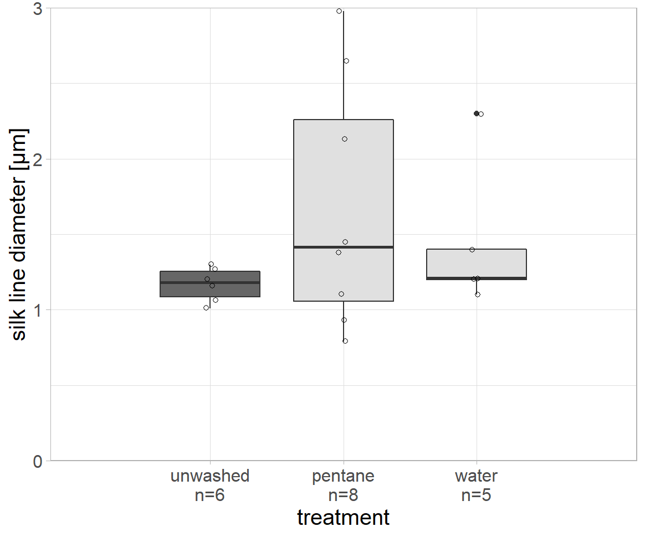
Figure S2. Silk line diameter in µm between treatments (unwashed: dark grey, washed: light grey). Open circles represent measurements for silk lines. No significant difference was found.

Experiment 1c: Details on tests for directional biases
We investigated within and between individual male directional bias both over the course of the experiment and on specific days by using binomial tests to compare i) the number of males always choosing the same vs. varying directions in their three control repetitions (within individual overall bias), ii) the number of males choosing the same or opposite direction as the female during the course of the experiment (between individual overall bias) and iii) the number of males choosing each direction during individual experimental days (between individual daily bias). As a single experimental day showed male directional bias (binomial test: p = 0.04, 83 %, 95 % CI: 52 % - 98 %, 10 out of 12), analyses were repeated with a dataset excluding this biased day. By repeating the model simulation excluding data from this specific day, the treatment effect was retained (Table S2).

Table S2: Estimated effect sizes and 95 % credible intervals (CIs) of the GLMM (binomial) testing for predictors of male likelihood of following trails in the same direction moved by females during trail deposition using a reduced dataset excluding the biased day, including treatment (washed and unwashed trails) and testing order (test number) in model (n = 54). Significance is shown in bold.
Directional trail-following
(reduced dataset)
Fixed effects | β (95 % CI)
Intercept* | 0.83 (-0.08, 1.91)
Treatment (washed)ª | -1.45 (-2.76, -0.28)
Test number^{b} | 0.02 (-0.60, 0.66)
Random effects | σ² (95% CI)
Male ID | 0.50 (0.00, 2.73)
Female ID | 0.33 (0.00, 2.00)
*Reference category; estimate for treatment (unwashed) and mean values of remaining fixed effects; ªDifference between reference category and treatment (washed); ^{b}Mean centered and standardized using the standard deviation within all trials

Exploratory models: i) testing the effect of male assessment behaviours
Here we tested whether males that spent more time assessing the environment and/or performing directional turns are more likely to follow trails correctly (i.e. in the direction deposited by the female). We investigated the effects of male trail assessment behaviors scored during the trials by adding i) total time spent in the device and ii) occurrence of turns, defined as a 180° directional change, as additional fixed effects to the model reported in the manuscript, resulting in the following model formula:
DirectionSameAsFemale ~ 1 + Treatment + Test + TimeInDevice + Turned +
(1|IdMale) + (1|IdFem).

In the unwashed treatment, 11 out of 31 males (35 %) undertook 180° directional changes, out of which 6 finally choose the same direction as the female that deposited the trail (54 %, 6/11) (Figure S3). Males did not significantly turn more often than expected by chance (binomial test: p = 0.15, 35 %, 95 % - CI: 19 % - 55 %, 11 out of 31). In the washed treatment, 4 out of 31 males (12 %) made directional changes, with 2 choosing the same direction the female deposited the trail (50 %, 2/4). Males did turn significantly less than expected by chance (binomial test: p < 0.001, 12 %, 95 % - CI: 3 % - 30 %, 4 out of 31).

Of all males that undertook directional turns, 9 turned more than once (60 %, 9/15), with a maximum of 16 turns for a single male in the washed treatment (Figure S4).

Neither the time spent in the testing device nor the occurrence of additional turns affected male likelihood of following female silk lines in the same direction as deposited. The treatment effect was retained (Table S3).

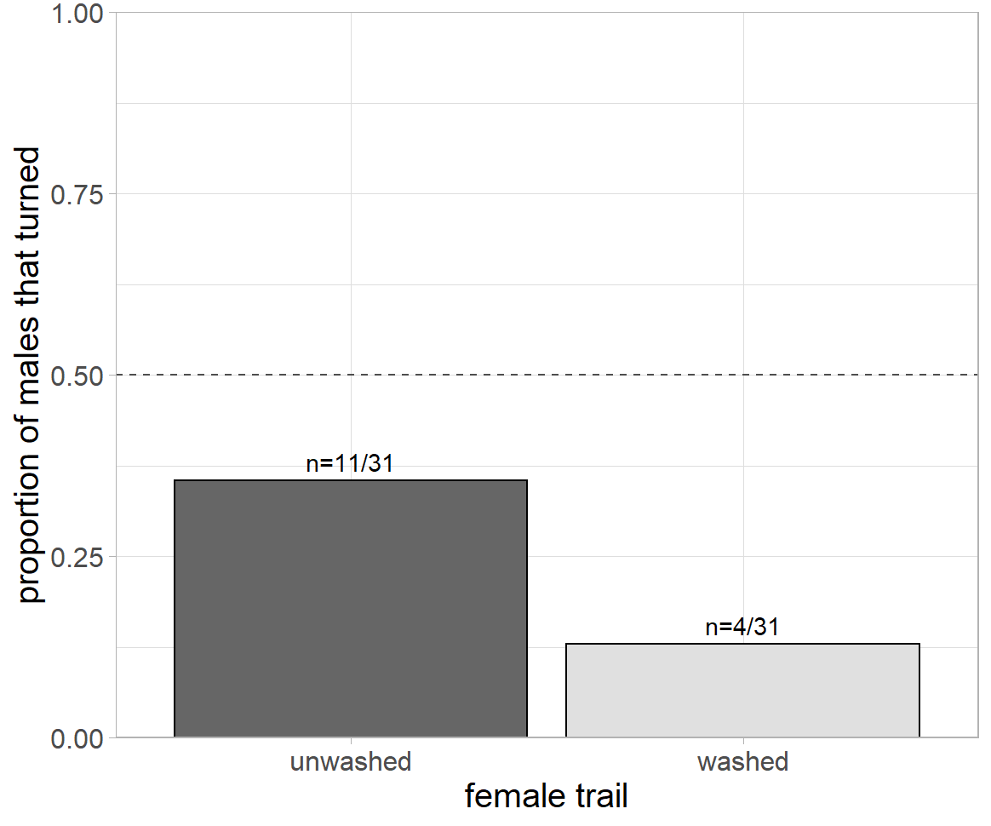
Figure S3. Proportion of males that undertook 180° directional turns for unwashed (dark grey) and washed (light grey) trail treatment. The dashed line indicates a proportion of turns of 0.5. Numbers above bars = number of turns per treatment.

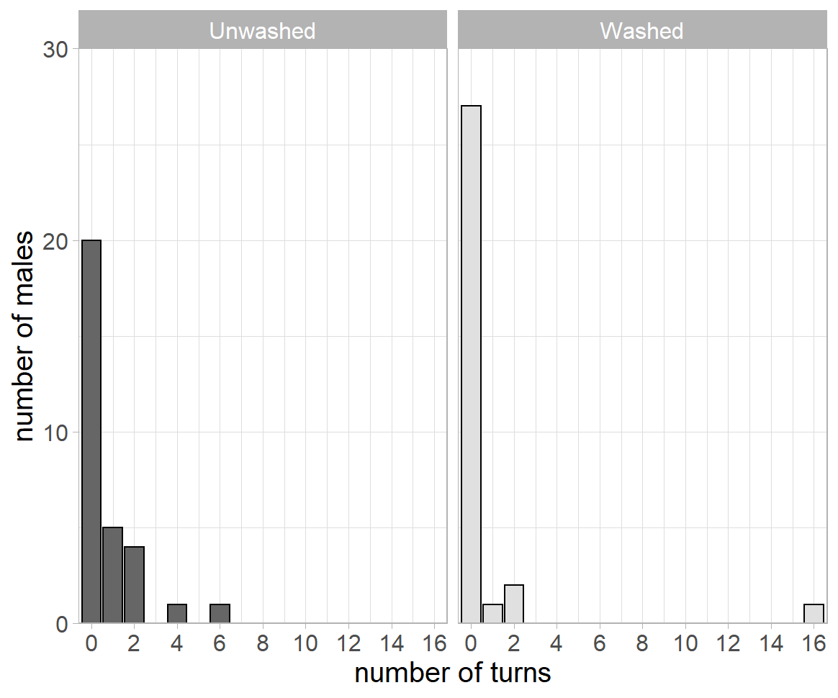
Figure S4. Number of turns with the frequencies of their occurrence for unwashed (dark grey) and washed (light grey) trails.

Table S3. Estimated effect sizes and 95 % credible intervals (CIs) of the GLMM (binomial) testing for predictors of male likelihood of following trails in the same direction moved by females during trail deposition, including treatment (washed and unwashed trails), testing order (test number) total time spent in the testing device, additional directional turns (n = 62). Significance is shown in bold.
 | Directional trail-following
Fixed effects | β (95 % CI)
Intercept* | 0.54 (-0.50, 1.64)
Treatment (washed)ª | -1.25 (-2.49, -0.09)
Test number^{b} | -0.09 (-0.52, 0.70)
Time spent in device^{b} | -0.08 (-0.83, 0.65)
Additional turns (yes)^{c} | 0.13 (-1.55, 1.87)
Random effects | σ² (95% CI)
Male ID | 0.52 (0.00, 2.78)
Female ID | 0.34 (0.00, 1.92)
*Reference category; estimate for treatment (unwashed), turned (no) and mean values of remaining fixed effects; ªDifference between reference category and treatment (washed); ^{b}Mean centered and standardized using the standard deviation within all trials; ^{c}Difference between reference category and turned more than once (yes); ^{d}Difference between treatments (unwashed, washed) in the difference between female body mass

Exploratory models: ii) testing for the effect of female individual phenotypic traits
Here we test if female phenotypic characteristics (body mass, condition and size) influence male directional trail-following (high trait-females preferred by males) with the prediction of effects being lower in the washed treatment due to removal of chemically encoded information on female phenotype,
We investigated the influence of female body mass, body condition (measured as a residual index), and size, measured as prosoma width, on the probability of males to follow trails in the direction they were deposited by the female by fitting three models, each with one female trait, including treatment (washed and unwashed trails) and testing order (to account for increasing male experience with the testing device) as fixed effects. Spider identities of each sex were added as random effects to account for repeated measurements (i.e. to avoid pseudo-replication).

We found that males were more likely to follow trails in the same direction as the female laid them when the female had higher body mass (model A in Table S4, Figure S5). The significant effect of the washing treatment was retained, yet the effect of female body mass was significantly smaller in the washed than the unwashed treatment. The effect of the residual index differed significantly between treatments, while the treatment effect itself is reduced to a non-significant but strong tendency of males to follow female trails in the unwashed treatment more often than in the washed treatment (model B in Table S4). Male probability to directionally follow female trails was not significantly affected by female body size (model C in Table S4).

Table S4: Estimated effect sizes and 95 % credible intervals (CIs) of the GLMMs (binomial) testing for predictors of male likelihood of following trails in the same direction moved by females during trail deposition, including treatment (washed and unwashed), testing order, and either female body mass (model A; n = 62), female residual body condition index (model B; n = 50) or female size (model C; n = 50), as well as the interaction between female trait and treatment. Significance is shown in bold.
 | Directional trail-following
 | Model A)  Body mass | Model B)  Body condition | Model C)  Body size
Fixed effects | β (95 % CI)
Intercept* | 0.78 (-0.20, 1.89) | 1.00 (-0.18, 2.37) | 0.93 (-0.24, 2.41)
Treatment (washed)ª | -1.49 (-2.80, -0.27) | -1.94 (-3.63, -0.41) | -2.01 (-3.96, -0.49)
Test number^{b} | 0.03 (-0.61, 0.66) | 0.08 (-0.74, 0.88) | 0.39 (-0.41, 1.25)
Female trait^{b} | 1.59 (0.43, 3.03) | 1.55 (0.33, 3.01) | 0.58 (-0.55, 1.90)
Treatment (washed):Female trait^{bc} | -1.83 (-3.48, -0.44) | -1.52 (-3.15, -0.01) | -1.48 (-3.35, 0.04)
Random effects | σ² (95% CI)
Male ID | 0.62 (0.00, 3.40) | 0.98 (0.00, 5.56) | 1.74 (0.00, 9.04)
Female ID | 0.38 (0.00, 2.15) | 0.47 (0.00, 2.90) | 0.79 (0.00, 4.85)
*Reference category; estimate for treatment (unwashed) and mean values of remaining fixed effects; ªDifference between reference category and treatment (washed); ^{b}Mean centered and standardized using the standard deviation within all trials; ^{c}Difference between treatments (unwashed, washed) in the difference between female body mass (A), residual body condition index (B) or body size (C)

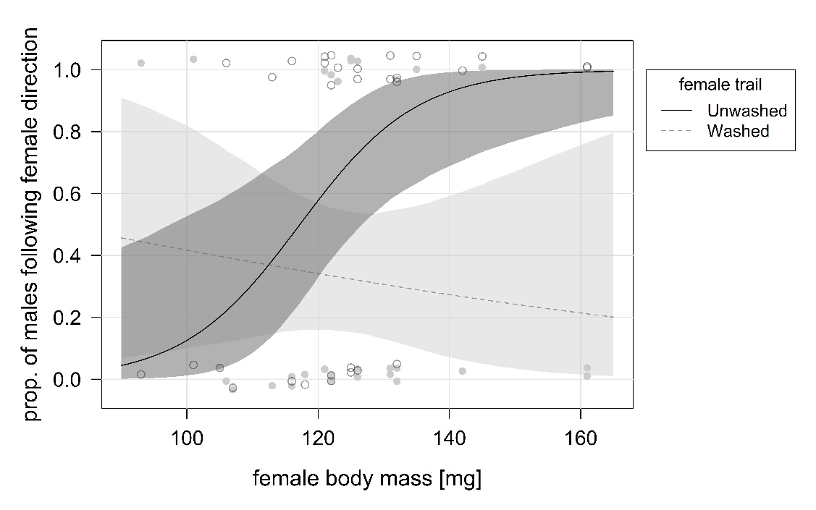
Figure S5. The effect of female body mass on the male’s probability to follow trails in the same direction laid by females in each treatment (unwashed trail: dark grey, washed trail: light grey) in study 1 (n = 31 for each treatment). Males were more likely to choose the same direction of females of high body mass, when female trails were unwashed. Continuous and dashed lines represent regression lines, grey areas 95 % credible intervals and circles the body mass of the individual females in the trials of each treatment (open circles: unwashed, closed: washed).

Due to the sigmoidal appearance of the relationship between female body mass and the probability of males to follow a female (Figure S5), data (body mass and corresponding direction chosen) was separated into three thirds, comprised of females with lowest (n = 11; mean body mass in mg ± standard error: 110.63 ± 2.70 mg), medium (n = 10; 123.90 ± 0.59 mg) and highest (n = 10; 140.20 ± 3.79 mg) body mass, and a binomial test was applied to each quartile. Interestingly, in the highest-mass quartile, males followed in female direction in 9 out of 10 trials (binomial test: p = 0.02, 90 %, 95 % - CI: 55 % - 100 %, 9 out of 10). In contrast, males did not follow females of low (binomial test: p = 1, 45 %, 95 % - CI: 17 % - 77 %, 5 out of 11) or medium (binomial test: p = 1, 50 %, 95 % - CI: 19 % - 81 %, 5 out of 10) body mass.

Exploratory models: iii) testing for the effect of male individual phenotypic traits
Here we test if male phenotypic characteristics (body mass, condition and size) influence male directional trail-following with the prediction of …..

We investigated the influence of male phenotype (body mass, size, condition) on the probability of males to follow trails in the direction they were deposited by the female fitting three additional variations of model a, adding male mass and subsequently replacing the variable for male size and condition. Male phenotype (i.e. body mass, size or condition) did not significantly influence male likelihood to follow trails in female direction. The treatment effect was retained (Table S5, models A-C).

Table S5: Estimated effect sizes and 95 % credible intervals (CIs) of the GLMMs (binomial) testing for predictors of male likelihood of following trails in the same direction moved by females during trail deposition, including treatment (washed and unwashed), testing order, and male body mass in model A) (n = 62), male residual body condition index B) (n = 52), and male body size in model C (n = 52). Significance is shown in bold.
 | Directional trail-following
 | Model A)  Body mass | Model B)  Body condition | Model C)  Body size
Fixed effects | β (95 % CI)
Intercept* | 0.57 (-0.27, 1.48) | 0.80 (-0.16, 1.89) | 0.82 (-0.17, 1.91)
Treatment (washed)ª | -1.26 (-2.46, -0.15) | -1.55 (-2.89, -0.30) | -1.58 (-3.00, -0.27)
Test number^{b} | 0.11 (-0.49, 0.70) | 0.06 (-0.62, 0.75) | 0.07 (-0.59, 0.75)
Male trait^{b} | -0.11 (-0.80, 0.55) | 0.22 (-0.54, 1.01) | -0.47 (-1.29, 0.26)
Random effects | σ² (95% CI)
Male ID | 0.51 (0.00, 2.95) | 0.49 (0.00, 2.82) | 0.47 (0.00, 2.67)
Female ID | 0.32 (0.00, 1.94) | 0.55 (0.00, 3.10) | 0.54 (0.00, 3.14)
*Reference category; estimate for treatment (unwashed) and mean values of remaining fixed effects; ªDifference between reference category and treatment (washed); ^{b}Mean centered and standardized using the standard deviation within all trials;

Exploratory models: iv) testing for the effects of relative differences in male-female individual phenotypic traits
Finally, we combined both phenotypic traits from the sexes by calculating relative body mass, condition and size estimates (female value divided by male value), and replaced absolute trait values in the previous models.

We investigated the influence of the relative difference in female and male body mass and size male phenotype (body mass, size) on the probability of males to follow trails in the direction they were deposited by the female fitting two additional variations of model a, subsequently adding relative difference of mass and of size (dividing female values by male values). As the effect of the female phenotype was depending on the treatment, but male phenotype was not, we additionally fitted the abovementioned exploratory models only using data for the unwashed treatment.

Relative difference in female and male mass or size did not significantly influence male likelihood to follow trails in female direction. There was a significant difference between treatments (Table S6, models A and B). No significant effect was found when using the data for the unwashed treatment only (Table S7, models A and B).

Table S6: Estimated effect sizes and 95 % credible intervals (CIs) of the GLMMs (binomial) testing for predictors of male likelihood of following trails in the same direction moved by females during trail deposition, including treatment (washed and unwashed), testing order, and relative difference in female and male body mass in model A) (n = 62) and relative difference in female and male body size in model B) (n = 42). Significance is shown in bold.
 | Directional trail-following
 | Model A)  Body mass | Model B)  Body size
Fixed effects | β (95 % CI) | β (95 % CI)
Intercept* | -0.87 (-3.92, 2.13) | -4.41 (-17.31, 6.86)
Treatment (washed)ª | -1.27 (-2.46, -0.14) | -1.73 (-3.37, -0.25)
Test number^{b} | 0.09 (-0.49, 0.68) | 0.27 (-0.53, 1.11)
Relative difference in phenotype^{c} | 1.01 (-0.99, 3.14) | 5.24 (-5.83, 18.15)
Random effects | σ² (95% CI) | σ² (95% CI)
Male ID | 0.49 (0.00, 2.65) | 0.66 (0.00, 3.82)
Female ID | 0.27 (0.00, 1.58) | 0.90 (0.00, 5.08)
*Reference category; estimate for treatment (unwashed) and mean values of remaining fixed effects; ªDifference between reference category and treatment (washed); ^{b}Mean centered and standardized using the standard deviation within all trials; ^{c}Calculated by dividing female by male value

Table S7: Estimated effect sizes and 95 % credible intervals (CIs) of the GLMMs (binomial) testing for predictors of male likelihood of following trails in the same direction moved by females during trail deposition using only data for the unwashed treatment, including testing order and relative difference in female and male body mass in model A) (n = 31) and relative difference in female and male body size in model B) (n = 21). Significance is shown in bold.
Directional trail-following
(reduced dataset)
 | Model A)  Body mass | Model B)  Body size
Fixed effects | β (95 % CI) | β (95 % CI)
Intercept* | 1.39 (-5.48, 9.53) | -9.36 (-36.04, 12.78)
Test numberª | 0.57 (-0.82, 2.34) | 1.47 (-0.11, 3.54)
Relative difference in phenotype^{b} | -0.35 (-5.53, 4.52) | 10.30 (-11.21, 36.88)
Random effects | σ² (95% CI) | σ² (95% CI)
Male ID | 7.71 (0.00, 39.49) | 3.86 (0.00, 22.89)
Female ID | 1.83 (0.00, 10.48) | 2.69 (0.00, 15.79)
*Reference category; estimate for mean values of fixed effects; ªMean centered and standardized using the standard deviation within all trials; ^{b}Calculated by dividing female by male variable value

Experiment 2
Do silk trails provide information on female phenotypic characteristics (body mass, size and condition) that affect directional trail following in males?

Experiment 2a: Effect of season
We explored the effect of season by adding the variable as random effect to our model.
Season did not explain variation in the model output (Table S8).

Table S8: Estimated effect sizes and 95 % credible intervals (CIs) of the GLMM (binomial) testing for predictors of male likelihood of following trails in the same direction moved by females during trail deposition in study 2, including testing order (test number) and female body mass in model as fixed effects and spider identity and season as random effects (n = 115). Significance is shown in bold.
 | Directional trail-following
Fixed effects | β (95 % CI)
Intercept* | -0.13 (-1.20, 1.01)
Test numberª | 0.44 (-0.05, 1.11)
Female massª | -0.08 (-0.58, 0.41)
Random effects | σ² (95% CI)
Male ID | 0.17 (0.00, 1.00)
Female ID | 1.28 (0.00, 7.99)
Season | 0.57 (0.00, 4.26)
*Reference category; estimate for mean values of fixed effects; ªMean centered and standardized using the standard deviation within all trials

Experiment 2a: Effects male body mass, size and condition
We investigated the influence of male traits (body mass, size and body condition) on the probability of males to follow trails in female direction by fitting two additional variations of our model presented in the manuscript.
Male likelihood to follow in female direction was not significantly influenced by either male body mass, size nor by male residual body condition index (Table S9, models a - c).

Table S9: Estimated effect sizes and 95 % credible intervals (CIs) of the GLMMs (binomial) testing for predictors of male likelihood of following trails in the same direction moved by females during trail deposition, including male body mass (model a), size (model b ) and residual body condition index (model c), accounting for testing order (n = 113). Significance is shown in bold.

 | Directional trail-following – male phenotype
 | Model a) body mass | Model b) body size | Model c) body condition
Fixed effects | β (95 % CI) | β (95 % CI) | β (95 % CI)
Intercept* | -0.14 (-0.61, 0.31) | -0.38 (-1.07, 0.21) | -0.18 (-0.69, 0.29)
Test numberª | 0.44 (-0.02, 1.04) | 0.42 (-0.03, 1.03) | 0.42 (-0.04, 1.09)
Male traitª | -0.21 (-0.70, 0.24) | 0.27 (-0.16, 0.75) | -0.03 (-0.54, 0.45)
Random effects | σ² (95% CI) | σ² (95% CI) | σ² (95% CI)
Male ID | 1.01 (0.00, 6.14) | 0.16 (0.00, 0.89) | 0.17 (0.00, 0.95)
Female ID | 0.15 (0.00, 0.81) | 0.98 (0.00, 6.19) | 1.30 (0.00, 8.35)
*Reference category; estimate for mean values of fixed effects
ªMean centered and standardized using the standard deviation within all trials

Experiment 2a: Effect of relative size difference depending on season
We investigated whether the influence of relative size difference between males and females occurred both for data collected in spring and autumn.
In spring, males were significantly more likely to follow females that were smaller than they were (Table S10, model A). This effect was not to be found in autumn (Table S10, model B).
Table S10: Estimated effect sizes and 95 % credible intervals (CIs) of the GLMMs (binomial) testing for predictors of male likelihood of following trails in the same direction moved by females during trail deposition in study 2, including testing order (test number) and relative size difference (F/M) in spring, model a) (n = 78) and autumn, model b) (n = 35). Significance is shown in bold.
 | Directional trail-following
 | Model A)  Spring | Model B)  Autumn
Fixed effects | β (95 % CI) | β (95 % CI)
Intercept* | -6.99 (-15.52, -0.53) | -5.61 (-18.69, 6.35)
Test numberª | 0.41 (-0.14, 1.12) | 0.65 (-0.37, 2.31)
Relative size difference^{b} | 6.40 (0.39, 14.33) | 5.05 (-6.01, 17.21)
Random effects | σ² (95% CI) | σ² (95% CI)
Male ID | 0.20 (0.00, 1.19) | 0.97 (0.00, 5.79)
Female ID | 1.51 (0.00, 9.80) | 2.92 (0.00, 19.06)
*Reference category; estimate for mean values of fixed effects; ªMean centered and standardized using the standard deviation within all trials; ^{b}Value calculated by dividing female size by male size

Experiment 2c: Effect of exclusion of biases on one day
Simulations of main models a and b were repeated excluding data collected on the biased day 24.05.2022.
Results in comparison to data not excluding the biased day were retained (Table S11).

Table S11: Estimated effect sizes and 95 % credible intervals (CIs) of the GLMMs (binomial) testing for predictors of male likelihood of following trails in the same direction moved by females during trail deposition in study 2 excluding the biased day, including testing order (test number) and female body mass in model A) (n = 100) and replacing female body mass with relative size difference between sexes in model B) (n = 98). Significance is shown in bold.
Directional trail-following
(reduced dataset, biased day)
 | Model A) | Model B)
Fixed effects | β (95 % CI) | β (95 % CI)
Intercept* | -0.18 (-0.69, 0.31) | -6.46 (-12.80, -1.20)
Test numberª | 0.32 (-0.15, 0.90) | 0.21 (-0.27, 0.75)
Female massª | 0.11 (-0.39, 0.64) | -
Relative size difference^{b} | - | 5.86 (0.90, 11.78)
Random effects | σ² (95% CI) | σ² (95% CI)
Male ID | 0.16 (0.00, 0.91) | 0.16 (0.00, 0.87)
Female ID | 0.97 (0.00, 6.22) | 0.68 (0.00, 4.30)
*Reference category; estimate for mean values of fixed effects
ªMean centered and standardized using the standard deviation within all trials
^{b}Value calculated by dividing female size by male size

