Electronic Supplementary material 1
Supplementary Figures and Tables

Reproductive success of Bornean orangutan males: spread out in time but clustered in space
Maria A. van Noordwijk*, Laura R. LaBarge, Julia A. Kunz, Anna M. Marzec, Brigitte Spillmann, Corinne Ackermann, Puji Rianti, Erin R. Vogel, S. Suci Utami Atmoko, Michael Kruetzen, Carel P. van Schaik Behavioral Ecology and Sociobiology
*Corresponding author: vnoord@ab.mpg.de

Figure S1
Total observed presence per 3 month periods (max N=60) of all recognized flanged males in the study area in relation to the number of assigned offspring sired during the study period. The size of the bubble indicates number of identical values

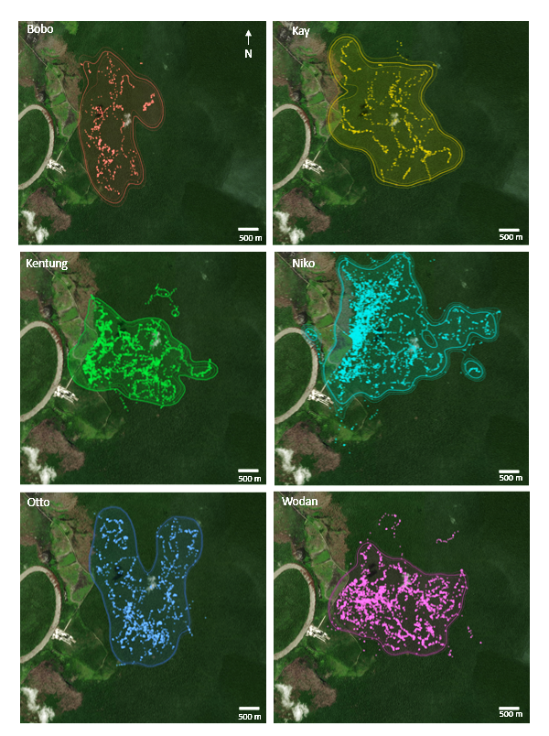

Figure S2
95% Autocorrelated kernel density Estimates (AKDE) for long-term space use by 6 sires

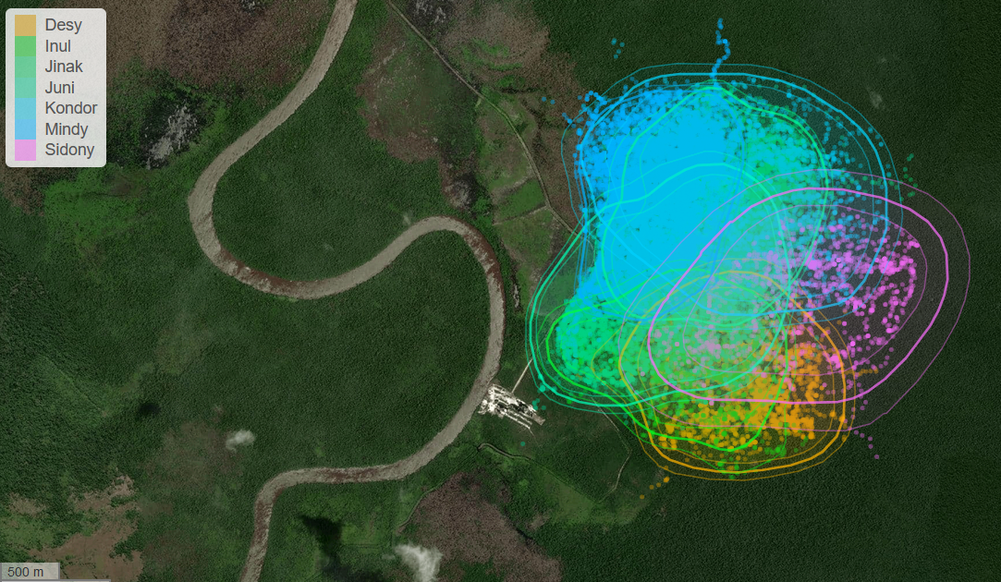

Figure S3
Overlapping ranges of the adult females (95% Autocorrelated kernel density Estimates (AKDE) for long-term space use), included in the analyses for female-sire analyses

Figure S4
Map of the Tuanan study area with, for each male, the location of the core of the natal ranges of his assigned offspring’s mother: e.g. N1 is first offspring of Niko (see figure 1) etc. (Note for Guapo 1 and Kentung 1 mother is unknown, most likely ranging outside the study area.). G4, born in 2008, paternity based on only 12 matched loci (but no mismatches), not included in high confidence paternities in the text

Figure S5
Overlap in AKDEs for sire-mother dyads for 3 year periods before and following a birth measured via the Bhattacharyya Coefficient estimates (see Table S7)

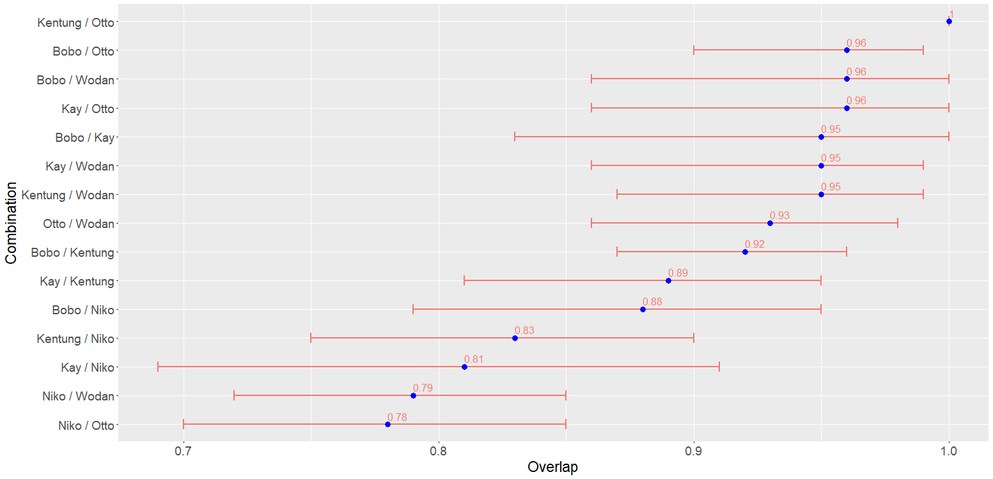

Figure S6
Long-term overlap of space use of known sires calculated via the Bhattacharyya Coefficient (BC): values are based on variation in intensity of use across the AKDE utilization distribution. These values do not account for the fact that males will use similar areas at different time, thus they do not reflect more fine-scale spatiotemporal avoidance strategies

Table S1
The number of focal follows (July2010-July2018) of identified adult females and males (flanged and unflanged) that were maintained until the focal made a night nest or were ‘lost’ because the focal left the study area, fled after encountering another orangutan, or moved fast on the ground without obvious social trigger, or ‘other’ reason (including weather, bee attack, observer decision).

SUMMARY TABLE Follows LOST or to NEST
 | to NEST | LOST | TOTAL | Out of area |  | ground | social | other
adult female | 1802 | 93 | 1895 | 26 |  | 11 | 9 | 47
flanged male | 1377 | 263 | 1640 | 57 |  | 66 | 69 | 71
unflanged male | 318 | 55 | 373 | 11 |  | 10 | 22 | 12
TOTAL | 3497 | 411 | 3908 | 94 |  | 87 | 100 | 130

Difference between adult classes in getting lost during focal follow

 |  | Chi SQ | P
lost: total
adf-flm |  | 119 | <0.0001 | ***
adf-ufm |  | 47.85 | <0.0001 | ***
flm-ufm |  | 0.29 | 0.59 | NS
lost: out of area
adf-flm |  | 16.06 | <0.0001 | ***
adf-ufm |  | 3.9 | 0.048 | *
flm-ufm |  | 0.12 | 0.729 | NS
females-males |  | 15.89 | <0.0001 | ***
lost: on ground
adf-flm |  | 47.33 | <0.0001 | ***
adf-ufm |  | 12.79 | 0.0003 | ***
flm-ufm |  | 1.16 | 0.28 | NS
lost: social lost
adf-flm |  | 55.04 | <0.0001 | ***
adf-ufm |  | 64.03 | <0.0001 | ***
flm-ufm |  | 1.64 | 0.2 | NS

Table S2
Comparison of the frequency of ‘encounters’ with females by flanged and unflanged males: the number of male focal follow days on which the male was within 50m of a female for any time (‘in association’). Only included are follows lasting at least 3 h for males who were followed on at least 10 different days

Male morph | Total N days with female encounter | # days without female encounter | # follow days | % days with female encounter
Flanged (N=31) | 380 | 1609 | 1989 | 19.1
Unflanged (N=18) | 383 | 371 | 754 | 50.8

Table S3
Male presence per individual and his morph at the time during the 6-months conception windows for 8 genotyped infants with assigned sires indicated in shading (Fla for flanged males and unfl for unflanged males). Conception windows are defined as 4 months before estimated conception and 2 months into pregnancy

Table S4
Long-term sampling schedule of ranging data (one point per half hour focal follow) for the 4 sires and 6 females they successfully mated with

Name | Sex | Date - First Follow | Date - Last Follow | Duration (months) | # Location Points
Jinak | Female | 2003-08-01 | 2017-02-17 | 168 | 11452
Mindy | Female | 2003-09-01 | 2018-05-12 | 182 | 14006
Juni | Female | 2006-02-10 | 2018-06-09 | 152 | 9442
Inul | Female | 2003-10-24 | 2017-05-06 | 167 | 2590
Desy | Female | 2003-12-01 | 2018-05-10 | 179 | 4164
Juni | Female | 2006-02-10 | 2018-06-09 | 152 | 9442
Kondor | Female | 2006-03-08 | 2018-02-14 | 148 | 3094
Niko | Male | 2003-09-10 | 2016-12-19 | 159 | 4510
Bobo | Male | 2004-02-14 | 2016-02-24 | 144 | 884
Kay | Male | 2005-03-10 | 2014-07-11 | 115 | 1025
Otto | Male | 2008-08-03 | 2016-09-25 | 101 | 2086

Table S5
Allele frequency analysis Cervus 3.0.7

Locus | k | N | HObs | HExp | PIC | NE-1P | NE-2P | NE-PP | NE-I | NE-SI | HW | F(Null)
D1S550 | 9 | 119 | 0.681 | 0.711 | 0.660 | 0.698 | 0.527 | 0.339 | 0.133 | 0.429 | NS | 0.0190
D2S1326 | 8 | 122 | 0.549 | 0.585 | 0.512 | 0.822 | 0.684 | 0.527 | 0.244 | 0.520 | NS | 0.0354
D3S2459 | 9 | 120 | 0.825 | 0.821 | 0.792 | 0.541 | 0.365 | 0.189 | 0.059 | 0.356 | NS | -0.0073
D4S2408 | 5 | 107 | 0.757 | 0.696 | 0.642 | 0.723 | 0.554 | 0.374 | 0.146 | 0.440 | NS | -0.0487
D5S1470 | 6 | 118 | 0.475 | 0.487 | 0.439 | 0.876 | 0.734 | 0.579 | 0.311 | 0.585 | NS | 0.0080
D13S321 | 6 | 125 | 0.560 | 0.647 | 0.585 | 0.775 | 0.617 | 0.446 | 0.186 | 0.474 | NS | 0.0763
D13S765 | 5 | 123 | 0.642 | 0.660 | 0.604 | 0.759 | 0.593 | 0.415 | 0.170 | 0.464 | NS | 0.0121
D16S420 | 7 | 122 | 0.566 | 0.544 | 0.487 | 0.845 | 0.699 | 0.539 | 0.265 | 0.545 | NS | -0.0222
D2S141 | 11 | 120 | 0.800 | 0.778 | 0.740 | 0.611 | 0.433 | 0.248 | 0.085 | 0.384 | NS | -0.0153
D5S1505 | 12 | 115 | 0.800 | 0.814 | 0.788 | 0.536 | 0.361 | 0.176 | 0.058 | 0.360 | NS | 0.0049
D6S501 | 9 | 121 | 0.702 | 0.700 | 0.657 | 0.706 | 0.529 | 0.336 | 0.132 | 0.435 | NS | 0.0017
D4S1627 | 7 | 106 | 0.689 | 0.663 | 0.613 | 0.753 | 0.582 | 0.399 | 0.163 | 0.461 | NS | -0.0253
O4A5 | 6 | 109 | 0.661 | 0.621 | 0.585 | 0.776 | 0.596 | 0.398 | 0.179 | 0.486 | NS | -0.0427
O4B5 | 8 | 107 | 0.720 | 0.705 | 0.655 | 0.709 | 0.536 | 0.351 | 0.136 | 0.433 | NS | -0.0137
O4_6 | 3 | 117 | 0.615 | 0.611 | 0.538 | 0.815 | 0.671 | 0.521 | 0.224 | 0.502 | NS | -0.0058
D5S1457 | 9 | 120 | 0.817 | 0.776 | 0.736 | 0.624 | 0.446 | 0.266 | 0.089 | 0.386 | NS | -0.0294
O4A1 | 5 | 111 | 0.802 | 0.752 | 0.703 | 0.669 | 0.493 | 0.318 | 0.109 | 0.403 | NS | -0.0353
O4B17 | 8 | 109 | 0.734 | 0.794 | 0.762 | 0.582 | 0.403 | 0.217 | 0.072 | 0.373 | NS | 0.0415
O4C13 | 6 | 93 | 0.591 | 0.591 | 0.502 | 0.820 | 0.697 | 0.549 | 0.256 | 0.520 | NS | -0.0015
O4C9 | 5 | 112 | 0.643 | 0.700 | 0.642 | 0.727 | 0.560 | 0.385 | 0.147 | 0.438 | NS | 0.0439

**** Summary statistics ****
Number of individuals: 131
Number of loci: 20
Mean number of alleles per locus: 7.200
Mean proportion of loci typed: 0.8763
Mean expected heterozygosity: 0.6829
Mean polymorphic information content (PIC): 0.6320
Combined non-exclusion probability (first parent): 0.00110415
Combined non-exclusion probability (second parent): 0.00000489
Combined non-exclusion probability (parent pair): 1.201E-0009
Combined non-exclusion probability (identity): 1.121E-0017
Combined non-exclusion probability (sib identity): 0.00000009

Table S6
Cervus 3.0.7 parentage analyses results, reporting only values with >95% confidence

Table S7
Pairwise distributional range overlap of female-male dyads, based on AKDEs (autocorrelated kernel density estimates) calculated via the Bhattacharyya Coefficient (BC), the expected overlap from female and male perspective based on the medians for all range-resident members of the opposite sex, and the percentage of each individual’s range covered by the area of overlap with the mate

Pair
Female | Male | Bhattacharyya Coefficient - Distribution Overlap (95% CIs) |  | Expected Overlap (female perspective) |  | Expected Overlap (male perspective) |  | % Range covered by area of overlap (female) |  | % Range covered by area of overlap (male)
Inul | Bobo | 0.76 (0.69 - 0.81) |  | 0.68 |  | 0.58 |  | 100 |  | 22
Desy | Otto | 0.73 (0.59 -0.85) |  | 0.55 |  | 0.49 |  | 100 |  | 27
Jinak | Otto | 0.61 (0.51 - 0.71) |  | 0.70 |  | 0.49 |  | 100 |  | 32
Kondor | Otto | 0.64 (0.52 - 0.78) |  | 0.81 |  | 0.49 |  | 92 |  | 53
Juni | Kay | 0.70 (0.61 - 0.78) |  | 0.79 |  | 0.49 |  | 93 |  | 33
Mindy | Niko | 0.83 (0.78 - 0.87) |  | 0.59 |  | 0.39 |  | 100 |  | 26
Jinak | Niko | 0.64 (0.58 - 0.70) |  | 0.70 |  | 0.39 |  | 91 |  | 32

Table S8
Overlap in AKDEs for sire-mother dyads for 3 year periods before and following a birth measured via the Bhattacharyya Coefficient estimates

 |  | Pre-Birth |  | Post-Birth
Infant | Dyad | Est. | CI. | Est. | CI.
Mawas | Mindy + Niko | 0.85 | (0.74, 0.93) | 0.77 | (0.69, 0.84)
Joya | Jinak + Otto | 0.49 | (0.11, 0.94) | 0.75 | (0.50, 0.94)
Kilmino | Kondor + Otto | 0.79 | (0.61, 0.93) | 0.51 | (0.36, 0.67)
Ivan | Inul + Bobo | 0.90 | (0.69, 0.99) | 0.71 | (0.38, 0.96)

