Behavioral Ecology and Sociobiology

Supplementary material for: The effect of repeated measurements and within-individual variance on the estimation of heritability: a simulation study
by: Jablonszky, Mónika¹; Garamszegi, László Zsolt¹

¹Evolutionary Ecology Research Group, Institute of Ecology and Botany, Centre for Ecological Research, Vácrátót, Hungary

Corresponding author
Mónika Jablonszky, jablonszky.monika@gmail.com

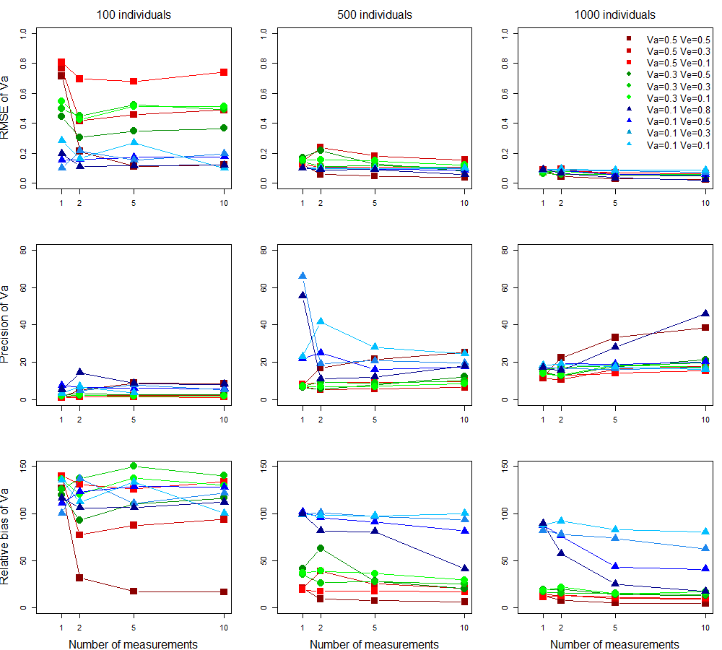
Fig. S1: Root Mean Square error (RMSE), accuracy and precision for the additive genetic variance (Va) estimates are displayed for all scenario, separately for the models with 100, 500 and 1000 between-individual sample size. The corresponding additive genetic variance (Va) values used in the simulations are depicted by colours and point types and within-individual variance (Ve) by shades of the respective Va value as can be seen in the legend. Vpe values were simulated in a way that the sum of all variance components became one

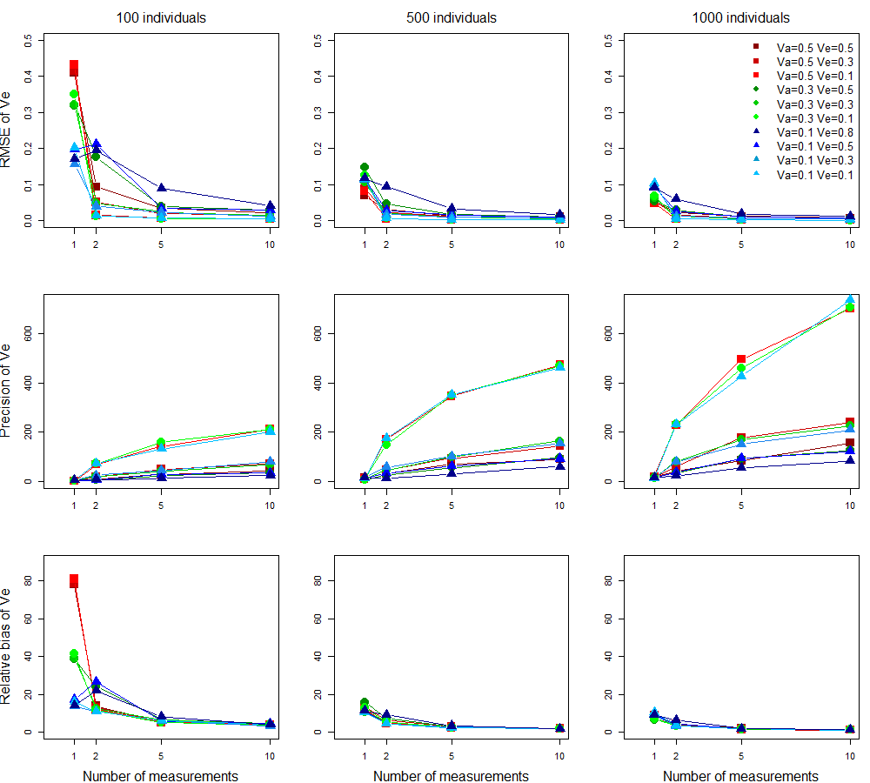
Fig. S2: Root Mean Square error (RMSE), accuracy and precision for the within-individual variance (Ve) estimates (in the case of one measurement models: residual variance) are displayed for all scenario, separately for the models with 100, 500 and 1000 between-individual sample size. The corresponding additive genetic variance (Va) values used in the simulations are depicted by colours and point types and within-individual variance (Ve) by shades of the respective Va value as can be seen in the legend. Vpe values were simulated in a way that the sum of all variance components became one

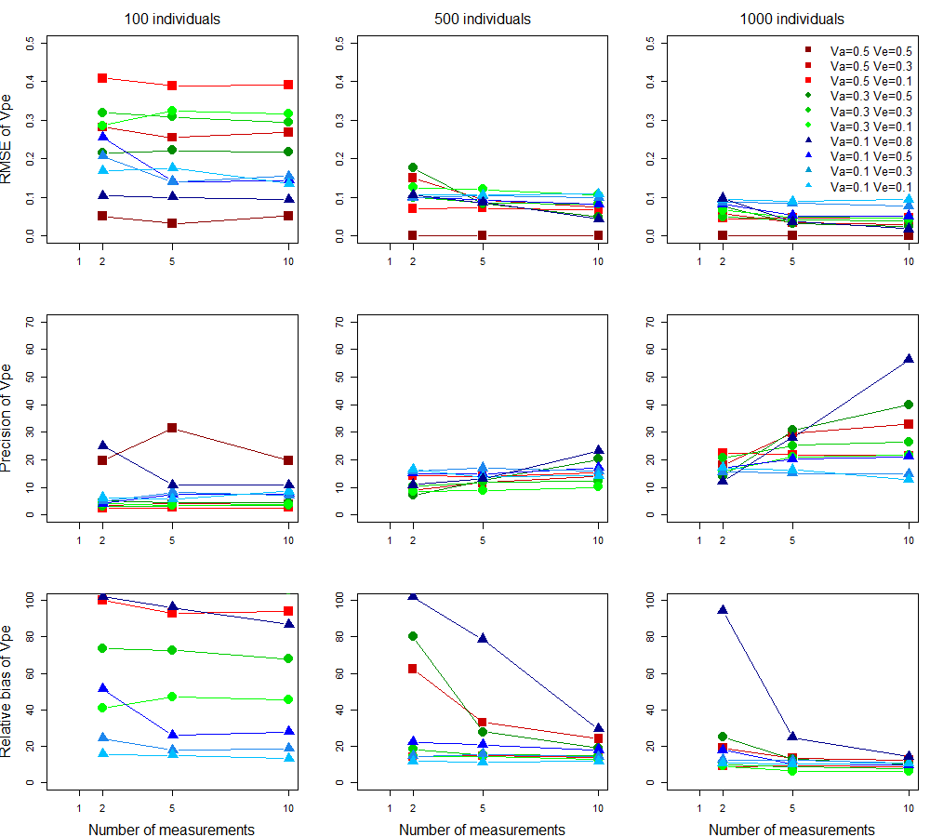
Fig. S3: Root Mean Square error (RMSE), accuracy and precision for the permanent environmental variance (Vpe) estimates are displayed for the scenarios with repeated measurements, separately for the models with 100, 500 and 1000 between-individual sample size. The corresponding additive genetic variance (Va) values used in the simulations are depicted by colours and point types and within-individual variance (Ve) by shades of the respective Va value as can be seen in the legend. Vpe values were simulated in a way that the sum of all variance components became one

Table S1: performance metrics for the 120 scenarios. The simulated value of h2 is equal to that of Va
NI | NR | Nall | Va | Vpe | Ve | RMSE(h2) | RMSE(Va) | RMSE(Vpe) | RMSE(Ve) | relbias(h2) | relbias(Va) | relbias(Vpe) | relbias(Ve) | precision(h2) | precision(Va) | precision(Vpe) | precision(Ve) | power(h2)
1000 | 1 | 1000 | 0.5 | 0 | 0.5 | 0.065 | 0.082 |  | 0.052 | 10.160 | 13.034 |  | 8.401 | 15.646 | 12.166 |  | 19.397 | 1.000
1000 | 1 | 1000 | 0.5 | 0.2 | 0.3 | 0.068 | 0.088 |  | 0.054 | 10.913 | 14.205 |  | 8.753 | 15.092 | 11.541 |  | 18.508 | 1.000
1000 | 1 | 1000 | 0.5 | 0.4 | 0.1 | 0.056 | 0.072 |  | 0.048 | 9.026 | 11.599 |  | 7.486 | 18.157 | 14.433 |  | 20.728 | 1.000
1000 | 1 | 1000 | 0.3 | 0.2 | 0.5 | 0.061 | 0.070 |  | 0.053 | 16.777 | 19.113 |  | 6.401 | 17.408 | 15.080 |  | 19.557 | 1.000
1000 | 1 | 1000 | 0.3 | 0.4 | 0.3 | 0.059 | 0.062 |  | 0.063 | 15.895 | 16.555 |  | 7.317 | 16.981 | 16.060 |  | 15.931 | 1.000
1000 | 1 | 1000 | 0.3 | 0.6 | 0.1 | 0.072 | 0.077 |  | 0.069 | 17.410 | 18.747 |  | 6.979 | 14.799 | 13.824 |  | 15.295 | 0.980
1000 | 1 | 1000 | 0.1 | 0.4 | 0.5 | 0.092 | 0.092 |  | 0.095 | 87.363 | 87.533 |  | 9.083 | 18.259 | 18.195 |  | 14.476 | 0.210
1000 | 1 | 1000 | 0.1 | 0.6 | 0.3 | 0.088 | 0.088 |  | 0.097 | 81.914 | 82.116 |  | 9.377 | 17.983 | 17.897 |  | 14.527 | 0.290
1000 | 1 | 1000 | 0.1 | 0.8 | 0.1 | 0.092 | 0.092 |  | 0.103 | 87.673 | 87.728 |  | 10.205 | 18.514 | 18.385 |  | 14.141 | 0.210
1000 | 1 | 1000 | 0.1 | 0.1 | 0.8 | 0.092 | 0.093 |  | 0.091 | 88.766 | 89.084 |  | 8.952 | 17.476 | 17.223 |  | 15.810 | 0.210
1000 | 2 | 2000 | 0.5 | 0 | 0.5 | 0.030 | 0.045 | 0.000 | 0.023 | 5.028 | 7.755 | * | 3.738 | 33.335 | 22.534 |  | 42.597 | 1.000
1000 | 2 | 2000 | 0.5 | 0.2 | 0.3 | 0.066 | 0.094 | 0.058 | 0.016 | 9.503 | 13.007 | 19.113 | 4.265 | 15.202 | 10.622 | 17.977 | 61.146 | 1.000
1000 | 2 | 2000 | 0.5 | 0.4 | 0.1 | 0.059 | 0.079 | 0.045 | 0.004 | 9.455 | 12.804 | 8.927 | 3.456 | 17.199 | 12.919 | 22.322 | 227.363 | 1.000
1000 | 2 | 2000 | 0.3 | 0.2 | 0.5 | 0.072 | 0.082 | 0.076 | 0.029 | 17.037 | 19.400 | 24.900 | 4.426 | 14.488 | 12.788 | 13.917 | 34.741 | 1.000
1000 | 2 | 2000 | 0.3 | 0.4 | 0.3 | 0.054 | 0.060 | 0.049 | 0.012 | 13.759 | 15.505 | 9.878 | 3.273 | 19.021 | 17.256 | 20.493 | 83.135 | 1.000
1000 | 2 | 2000 | 0.3 | 0.6 | 0.1 | 0.075 | 0.080 | 0.066 | 0.004 | 20.342 | 21.675 | 9.058 | 3.415 | 14.110 | 13.104 | 15.852 | 232.967 | 0.990
1000 | 2 | 2000 | 0.1 | 0.4 | 0.5 | 0.084 | 0.085 | 0.083 | 0.025 | 75.898 | 76.387 | 17.820 | 4.185 | 19.554 | 19.352 | 17.017 | 39.118 | 0.330
1000 | 2 | 2000 | 0.1 | 0.6 | 0.3 | 0.085 | 0.085 | 0.087 | 0.012 | 77.080 | 77.692 | 12.362 | 3.282 | 17.061 | 16.784 | 15.495 | 80.809 | 0.340
1000 | 2 | 2000 | 0.1 | 0.8 | 0.1 | 0.094 | 0.094 | 0.094 | 0.004 | 91.610 | 91.874 | 10.582 | 3.454 | 19.378 | 19.080 | 17.015 | 230.596 | 0.160
1000 | 2 | 2000 | 0.1 | 0.1 | 0.8 | 0.064 | 0.066 | 0.097 | 0.059 | 56.171 | 57.475 | 94.284 | 6.323 | 15.968 | 15.623 | 12.249 | 23.044 | 0.820
1000 | 5 | 5000 | 0.5 | 0 | 0.5 | 0.017 | 0.030 | 0.000 | 0.012 | 2.824 | 5.010 |  | 1.910 | 59.896 | 33.269 |  | 85.637 | 1.000
1000 | 5 | 5000 | 0.5 | 0.2 | 0.3 | 0.044 | 0.061 | 0.034 | 0.006 | 7.142 | 9.935 | 13.489 | 1.438 | 22.883 | 16.512 | 29.641 | 178.224 | 1.000
1000 | 5 | 5000 | 0.5 | 0.4 | 0.1 | 0.055 | 0.070 | 0.046 | 0.002 | 8.572 | 11.011 | 8.978 | 1.666 | 18.179 | 14.221 | 21.793 | 495.551 | 1.000
1000 | 5 | 5000 | 0.3 | 0.2 | 0.5 | 0.046 | 0.056 | 0.032 | 0.011 | 11.410 | 13.952 | 12.802 | 1.729 | 21.549 | 17.671 | 30.704 | 92.351 | 1.000
1000 | 5 | 5000 | 0.3 | 0.4 | 0.3 | 0.052 | 0.059 | 0.042 | 0.006 | 13.984 | 15.547 | 8.523 | 1.500 | 20.840 | 18.270 | 25.174 | 170.260 | 1.000
1000 | 5 | 5000 | 0.3 | 0.6 | 0.1 | 0.053 | 0.057 | 0.048 | 0.002 | 13.626 | 14.622 | 6.370 | 1.795 | 19.831 | 18.478 | 20.956 | 459.645 | 1.000
1000 | 5 | 5000 | 0.1 | 0.4 | 0.5 | 0.056 | 0.057 | 0.052 | 0.011 | 42.640 | 43.185 | 10.106 | 1.763 | 19.254 | 19.050 | 20.202 | 93.554 | 0.740
1000 | 5 | 5000 | 0.1 | 0.6 | 0.3 | 0.083 | 0.083 | 0.084 | 0.007 | 73.661 | 73.669 | 12.104 | 1.666 | 16.456 | 16.393 | 15.069 | 152.294 | 0.380
1000 | 5 | 5000 | 0.1 | 0.8 | 0.1 | 0.088 | 0.088 | 0.089 | 0.002 | 82.300 | 82.679 | 10.023 | 1.826 | 17.683 | 17.547 | 16.305 | 426.283 | 0.270
1000 | 5 | 5000 | 0.1 | 0.1 | 0.8 | 0.034 | 0.036 | 0.036 | 0.018 | 23.988 | 25.185 | 24.788 | 1.867 | 29.602 | 28.110 | 28.036 | 54.609 | 1.000
1000 | 10 | 10000 | 0.5 | 0 | 0.5 | 0.014 | 0.026 | 0.000 | 0.006 | 2.205 | 4.187 |  | 1.044 | 71.957 | 38.460 |  | 156.787 | 1.000
1000 | 10 | 10000 | 0.5 | 0.2 | 0.3 | 0.041 | 0.056 | 0.030 | 0.004 | 6.763 | 9.188 | 12.335 | 1.079 | 24.359 | 17.908 | 32.855 | 239.271 | 1.000
1000 | 10 | 10000 | 0.5 | 0.4 | 0.1 | 0.053 | 0.065 | 0.046 | 0.001 | 8.167 | 10.284 | 8.832 | 1.209 | 18.895 | 15.442 | 21.564 | 698.749 | 1.000
1000 | 10 | 10000 | 0.3 | 0.2 | 0.5 | 0.038 | 0.046 | 0.025 | 0.008 | 10.419 | 12.672 | 10.205 | 1.225 | 26.071 | 21.413 | 39.912 | 126.029 | 1.000
1000 | 10 | 10000 | 0.3 | 0.4 | 0.3 | 0.044 | 0.051 | 0.039 | 0.004 | 11.787 | 13.637 | 7.801 | 1.172 | 23.173 | 19.716 | 26.363 | 226.270 | 1.000
1000 | 10 | 10000 | 0.3 | 0.6 | 0.1 | 0.054 | 0.061 | 0.046 | 0.001 | 15.250 | 17.125 | 6.295 | 1.197 | 19.332 | 17.236 | 21.547 | 703.772 | 1.000
1000 | 10 | 10000 | 0.1 | 0.4 | 0.5 | 0.056 | 0.056 | 0.052 | 0.008 | 40.400 | 40.779 | 9.435 | 1.317 | 20.362 | 20.340 | 21.189 | 121.606 | 0.730
1000 | 10 | 10000 | 0.1 | 0.6 | 0.3 | 0.073 | 0.073 | 0.077 | 0.005 | 62.254 | 62.456 | 10.493 | 1.287 | 16.854 | 16.890 | 14.778 | 209.422 | 0.530
1000 | 10 | 10000 | 0.1 | 0.8 | 0.1 | 0.087 | 0.087 | 0.094 | 0.001 | 81.180 | 80.474 | 10.596 | 1.104 | 15.882 | 16.164 | 12.771 | 734.618 | 0.300
1000 | 10 | 10000 | 0.1 | 0.1 | 0.8 | 0.021 | 0.022 | 0.018 | 0.012 | 16.736 | 17.239 | 14.154 | 1.187 | 47.558 | 46.004 | 56.401 | 83.052 | 1.000
500 | 1 | 500 | 0.5 | 0 | 0.5 | 0.094 | 0.128 |  | 0.070 | 15.148 | 20.541 |  | 11.374 | 10.623 | 7.800 |  | 14.218 | 1.000
500 | 1 | 500 | 0.5 | 0.2 | 0.3 | 0.115 | 0.139 |  | 0.089 | 16.585 | 20.703 |  | 13.427 | 8.639 | 7.137 |  | 11.210 | 0.980
500 | 1 | 500 | 0.5 | 0.4 | 0.1 | 0.104 | 0.125 |  | 0.082 | 15.027 | 19.017 |  | 11.973 | 9.908 | 8.193 |  | 12.386 | 0.990
500 | 1 | 500 | 0.3 | 0.2 | 0.5 | 0.168 | 0.171 |  | 0.146 | 39.910 | 41.598 |  | 15.726 | 6.618 | 6.502 |  | 7.286 | 0.740
500 | 1 | 500 | 0.3 | 0.4 | 0.3 | 0.139 | 0.145 |  | 0.108 | 32.274 | 35.013 |  | 10.699 | 7.612 | 7.283 |  | 9.518 | 0.850
500 | 1 | 500 | 0.3 | 0.6 | 0.1 | 0.150 | 0.153 |  | 0.125 | 35.116 | 37.138 |  | 13.052 | 7.413 | 7.158 |  | 8.787 | 0.810
500 | 1 | 500 | 0.1 | 0.4 | 0.5 | 0.103 | 0.103 |  | 0.118 | 101.834 | 101.813 |  | 11.190 | 22.028 | 22.069 |  | 12.800 | 0.030
500 | 1 | 500 | 0.1 | 0.6 | 0.3 | 0.100 | 0.100 |  | 0.112 | 99.461 | 99.517 |  | 10.606 | 68.446 | 65.920 |  | 15.906 | 0.010
500 | 1 | 500 | 0.1 | 0.8 | 0.1 | 0.099 | 0.099 |  | 0.116 | 98.586 | 98.819 |  | 10.552 | 23.630 | 23.118 |  | 12.404 | 0.060
500 | 1 | 500 | 0.1 | 0.1 | 0.8 | 0.100 | 0.100 |  | 0.118 | 99.735 | 99.806 |  | 11.319 | 57.637 | 55.371 |  | 15.772 | 0.010
500 | 2 | 1000 | 0.5 | 0 | 0.5 | 0.037 | 0.058 | 0.000 | 0.031 | 5.925 | 9.273 |  | 5.067 | 26.728 | 17.098 |  | 32.183 | 1.000
500 | 2 | 1000 | 0.5 | 0.2 | 0.3 | 0.164 | 0.237 | 0.150 | 0.023 | 27.626 | 38.638 | 62.375 | 6.056 | 7.713 | 5.347 | 8.779 | 46.741 | 1.000
500 | 2 | 1000 | 0.5 | 0.4 | 0.1 | 0.084 | 0.108 | 0.070 | 0.006 | 13.219 | 17.266 | 14.054 | 4.643 | 11.910 | 9.207 | 14.289 | 172.228 | 1.000
500 | 2 | 1000 | 0.3 | 0.2 | 0.5 | 0.179 | 0.217 | 0.176 | 0.046 | 53.039 | 62.886 | 80.096 | 7.495 | 6.787 | 5.753 | 7.158 | 25.057 | 0.960
500 | 2 | 1000 | 0.3 | 0.4 | 0.3 | 0.106 | 0.111 | 0.100 | 0.021 | 24.198 | 26.430 | 18.227 | 5.455 | 9.896 | 9.449 | 10.363 | 46.474 | 0.930
500 | 2 | 1000 | 0.3 | 0.6 | 0.1 | 0.151 | 0.156 | 0.125 | 0.007 | 36.392 | 38.792 | 14.410 | 5.507 | 7.284 | 6.987 | 8.626 | 150.002 | 0.820
500 | 2 | 1000 | 0.1 | 0.4 | 0.5 | 0.097 | 0.097 | 0.101 | 0.029 | 95.859 | 95.491 | 22.313 | 4.408 | 24.327 | 24.995 | 15.025 | 34.867 | 0.090
500 | 2 | 1000 | 0.1 | 0.6 | 0.3 | 0.101 | 0.101 | 0.100 | 0.017 | 100.054 | 100.657 | 14.447 | 4.524 | 20.305 | 19.385 | 15.663 | 58.530 | 0.070
500 | 2 | 1000 | 0.1 | 0.8 | 0.1 | 0.099 | 0.099 | 0.106 | 0.006 | 98.454 | 98.189 | 11.701 | 4.543 | 39.007 | 41.433 | 16.519 | 173.955 | 0.030
500 | 2 | 1000 | 0.1 | 0.1 | 0.8 | 0.087 | 0.090 | 0.105 | 0.094 | 79.811 | 81.450 | 102.090 | 9.194 | 11.376 | 11.104 | 10.909 | 13.562 | 0.600
500 | 5 | 2500 | 0.5 | 0 | 0.5 | 0.025 | 0.046 | 0.000 | 0.014 | 3.824 | 7.397 |  | 2.271 | 39.914 | 21.595 |  | 71.452 | 1.000
500 | 5 | 2500 | 0.5 | 0.2 | 0.3 | 0.118 | 0.182 | 0.094 | 0.011 | 17.205 | 25.232 | 33.041 | 2.860 | 8.905 | 5.814 | 11.620 | 94.784 | 1.000
500 | 5 | 2500 | 0.5 | 0.4 | 0.1 | 0.086 | 0.108 | 0.072 | 0.003 | 14.034 | 17.638 | 14.621 | 2.198 | 11.585 | 9.262 | 13.871 | 344.815 | 1.000
500 | 5 | 2500 | 0.3 | 0.2 | 0.5 | 0.102 | 0.127 | 0.084 | 0.018 | 23.532 | 28.321 | 27.803 | 2.893 | 9.956 | 8.033 | 12.414 | 56.430 | 0.990
500 | 5 | 2500 | 0.3 | 0.4 | 0.3 | 0.108 | 0.116 | 0.085 | 0.010 | 24.652 | 27.671 | 15.177 | 2.571 | 9.465 | 8.760 | 11.800 | 100.610 | 0.920
500 | 5 | 2500 | 0.3 | 0.6 | 0.1 | 0.142 | 0.148 | 0.120 | 0.003 | 33.834 | 36.258 | 14.308 | 2.349 | 7.539 | 7.156 | 8.717 | 349.183 | 0.830
500 | 5 | 2500 | 0.1 | 0.4 | 0.5 | 0.094 | 0.095 | 0.094 | 0.016 | 90.716 | 90.969 | 20.720 | 2.514 | 16.488 | 16.192 | 14.941 | 62.784 | 0.200
500 | 5 | 2500 | 0.1 | 0.6 | 0.3 | 0.097 | 0.098 | 0.103 | 0.010 | 96.218 | 96.742 | 15.483 | 2.572 | 21.728 | 20.837 | 17.005 | 103.120 | 0.100
500 | 5 | 2500 | 0.1 | 0.8 | 0.1 | 0.099 | 0.099 | 0.107 | 0.003 | 97.765 | 97.588 | 11.261 | 2.231 | 27.415 | 28.006 | 13.782 | 350.912 | 0.050
500 | 5 | 2500 | 0.1 | 0.1 | 0.8 | 0.087 | 0.090 | 0.086 | 0.033 | 77.708 | 80.675 | 78.798 | 3.286 | 12.554 | 12.126 | 13.106 | 30.641 | 0.840
500 | 10 | 5000 | 0.5 | 0 | 0.5 | 0.020 | 0.039 | 0.000 | 0.011 | 3.271 | 6.256 |  | 1.791 | 48.979 | 25.329 |  | 90.202 | 1.000
500 | 10 | 5000 | 0.5 | 0.2 | 0.3 | 0.098 | 0.156 | 0.073 | 0.007 | 13.752 | 20.496 | 24.058 | 1.814 | 10.391 | 6.589 | 14.076 | 145.184 | 1.000
500 | 10 | 5000 | 0.5 | 0.4 | 0.1 | 0.079 | 0.106 | 0.068 | 0.002 | 12.875 | 16.683 | 13.594 | 1.696 | 12.969 | 9.711 | 15.291 | 472.578 | 1.000
500 | 10 | 5000 | 0.3 | 0.2 | 0.5 | 0.067 | 0.082 | 0.050 | 0.010 | 17.063 | 19.994 | 18.754 | 1.642 | 14.946 | 12.243 | 20.176 | 97.023 | 1.000
500 | 10 | 5000 | 0.3 | 0.4 | 0.3 | 0.096 | 0.103 | 0.083 | 0.006 | 22.747 | 24.920 | 14.547 | 1.663 | 10.710 | 10.037 | 12.185 | 164.079 | 0.950
500 | 10 | 5000 | 0.3 | 0.6 | 0.1 | 0.114 | 0.120 | 0.106 | 0.002 | 27.020 | 29.364 | 12.779 | 1.636 | 9.101 | 8.538 | 10.057 | 468.769 | 0.910
500 | 10 | 5000 | 0.1 | 0.4 | 0.5 | 0.088 | 0.088 | 0.082 | 0.011 | 80.952 | 81.254 | 17.978 | 1.807 | 17.656 | 17.531 | 17.208 | 92.803 | 0.270
500 | 10 | 5000 | 0.1 | 0.6 | 0.3 | 0.095 | 0.096 | 0.098 | 0.006 | 92.905 | 93.590 | 14.193 | 1.727 | 20.506 | 19.744 | 15.718 | 155.510 | 0.140
500 | 10 | 5000 | 0.1 | 0.8 | 0.1 | 0.100 | 0.101 | 0.108 | 0.002 | 100.171 | 100.053 | 11.773 | 1.773 | 24.471 | 24.516 | 14.122 | 461.402 | 0.040
500 | 10 | 5000 | 0.1 | 0.1 | 0.8 | 0.054 | 0.055 | 0.043 | 0.016 | 40.262 | 41.317 | 29.240 | 1.623 | 18.822 | 18.233 | 23.227 | 60.830 | 0.860
100 | 1 | 100 | 0.5 | 0 | 0.5 | 0.490 | 0.714 |  | 0.411 | 96.552 | 126.792 |  | 78.001 | 2.355 | 1.406 |  | 2.614 | 0.270
100 | 1 | 100 | 0.5 | 0.2 | 0.3 | 0.492 | 0.769 |  | 0.414 | 97.112 | 138.014 |  | 78.693 | 2.128 | 1.297 |  | 2.431 | 0.360
100 | 1 | 100 | 0.5 | 0.4 | 0.1 | 0.481 | 0.807 |  | 0.432 | 93.629 | 140.044 |  | 80.866 | 2.179 | 1.239 |  | 2.351 | 0.390
100 | 1 | 100 | 0.3 | 0.2 | 0.5 | 0.332 | 0.443 |  | 0.320 | 106.667 | 119.447 |  | 38.749 | 4.565 | 2.557 |  | 4.006 | 0.050
100 | 1 | 100 | 0.3 | 0.4 | 0.3 | 0.338 | 0.496 |  | 0.320 | 108.000 | 125.911 |  | 39.077 | 4.190 | 2.166 |  | 3.847 | 0.060
100 | 1 | 100 | 0.3 | 0.6 | 0.1 | 0.354 | 0.547 |  | 0.351 | 111.634 | 136.429 |  | 41.553 | 3.445 | 1.875 |  | 3.181 | 0.100
100 | 1 | 100 | 0.1 | 0.4 | 0.5 | 0.134 | 0.155 |  | 0.198 | 108.000 | 110.840 |  | 17.100 | 10.000 | 7.788 |  | 5.385 | 0.010
100 | 1 | 100 | 0.1 | 0.6 | 0.3 | 0.100 | 0.100 |  | 0.157 | 100.000 | 100.000 |  | 13.751 |  |  |  | 7.590 | 0.000
100 | 1 | 100 | 0.1 | 0.8 | 0.1 | 0.161 | 0.283 |  | 0.201 | 116.000 | 135.257 |  | 16.020 | 7.107 | 3.606 |  | 5.335 | 0.020
100 | 1 | 100 | 0.1 | 0.1 | 0.8 | 0.134 | 0.198 |  | 0.170 | 108.000 | 116.116 |  | 14.191 | 10.000 | 5.520 |  | 5.938 | 0.010
100 | 2 | 200 | 0.5 | 0 | 0.5 | 0.190 | 0.214 | 0.051 | 0.093 | 24.391 | 31.591 |  | 13.746 | 5.727 | 5.060 | 19.619 | 10.965 | 0.880
100 | 2 | 200 | 0.5 | 0.2 | 0.3 | 0.326 | 0.416 | 0.282 | 0.051 | 59.220 | 77.021 | 128.904 | 13.144 | 3.065 | 2.482 | 3.560 | 20.527 | 0.730
100 | 2 | 200 | 0.5 | 0.4 | 0.1 | 0.460 | 0.696 | 0.408 | 0.015 | 91.673 | 131.137 | 100.119 | 11.931 | 2.163 | 1.478 | 2.437 | 68.542 | 0.520
100 | 2 | 200 | 0.3 | 0.2 | 0.5 | 0.260 | 0.306 | 0.216 | 0.176 | 81.895 | 92.797 | 106.070 | 24.119 | 3.825 | 3.258 | 5.101 | 6.523 | 0.570
100 | 2 | 200 | 0.3 | 0.4 | 0.3 | 0.353 | 0.449 | 0.320 | 0.049 | 115.271 | 137.083 | 73.683 | 12.638 | 2.834 | 2.222 | 3.112 | 21.692 | 0.370
100 | 2 | 200 | 0.3 | 0.6 | 0.1 | 0.339 | 0.423 | 0.286 | 0.014 | 108.818 | 120.728 | 40.880 | 11.347 | 3.940 | 2.630 | 4.077 | 72.848 | 0.080
100 | 2 | 200 | 0.1 | 0.4 | 0.5 | 0.141 | 0.158 | 0.256 | 0.211 | 118.261 | 123.283 | 51.594 | 26.461 | 8.065 | 6.881 | 4.011 | 5.467 | 0.070
100 | 2 | 200 | 0.1 | 0.6 | 0.3 | 0.175 | 0.214 | 0.207 | 0.039 | 127.313 | 136.973 | 24.165 | 10.877 | 6.105 | 4.794 | 4.859 | 25.616 | 0.050
100 | 2 | 200 | 0.1 | 0.8 | 0.1 | 0.130 | 0.165 | 0.168 | 0.014 | 107.305 | 112.163 | 15.495 | 10.818 | 10.747 | 7.061 | 6.200 | 74.149 | 0.010
100 | 2 | 200 | 0.1 | 0.1 | 0.8 | 0.109 | 0.112 | 0.104 | 0.195 | 104.822 | 106.079 | 102.002 | 21.723 | 16.081 | 14.466 | 24.988 | 8.868 | 0.030
100 | 5 | 500 | 0.5 | 0 | 0.5 | 0.076 | 0.111 | 0.032 | 0.034 | 10.263 | 17.071 |  | 5.243 | 13.181 | 9.004 | 31.476 | 29.461 | 0.990
100 | 5 | 500 | 0.5 | 0.2 | 0.3 | 0.336 | 0.456 | 0.254 | 0.020 | 63.004 | 87.348 | 120.926 | 5.167 | 2.991 | 2.344 | 3.989 | 50.426 | 0.730
100 | 5 | 500 | 0.5 | 0.4 | 0.1 | 0.461 | 0.678 | 0.388 | 0.007 | 90.265 | 125.883 | 93.132 | 5.557 | 2.224 | 1.476 | 2.590 | 142.981 | 0.440
100 | 5 | 500 | 0.3 | 0.2 | 0.5 | 0.283 | 0.346 | 0.221 | 0.040 | 93.301 | 109.939 | 106.717 | 6.452 | 3.510 | 2.904 | 4.500 | 25.049 | 0.530
100 | 5 | 500 | 0.3 | 0.4 | 0.3 | 0.363 | 0.521 | 0.308 | 0.024 | 116.996 | 150.123 | 72.618 | 6.368 | 2.792 | 1.913 | 3.284 | 42.193 | 0.300
100 | 5 | 500 | 0.3 | 0.6 | 0.1 | 0.361 | 0.514 | 0.324 | 0.006 | 114.371 | 137.517 | 47.024 | 4.978 | 3.140 | 1.978 | 3.301 | 159.456 | 0.140
100 | 5 | 500 | 0.1 | 0.4 | 0.5 | 0.151 | 0.173 | 0.141 | 0.034 | 122.183 | 128.679 | 25.954 | 5.661 | 7.333 | 6.124 | 7.361 | 29.393 | 0.060
100 | 5 | 500 | 0.1 | 0.6 | 0.3 | 0.122 | 0.153 | 0.141 | 0.023 | 105.984 | 110.665 | 17.710 | 5.990 | 12.525 | 7.896 | 8.230 | 44.129 | 0.010
100 | 5 | 500 | 0.1 | 0.8 | 0.1 | 0.156 | 0.269 | 0.175 | 0.008 | 115.058 | 133.287 | 14.976 | 6.177 | 7.458 | 3.811 | 5.818 | 132.721 | 0.020
100 | 5 | 500 | 0.1 | 0.1 | 0.8 | 0.108 | 0.115 | 0.100 | 0.089 | 102.723 | 106.575 | 96.206 | 8.147 | 9.272 | 8.689 | 10.825 | 12.462 | 0.410
100 | 10 | 1000 | 0.5 | 0 | 0.5 | 0.099 | 0.121 | 0.051 | 0.022 | 10.566 | 16.550 |  | 3.632 | 10.402 | 8.543 | 19.638 | 45.404 | 0.970
100 | 10 | 1000 | 0.5 | 0.2 | 0.3 | 0.340 | 0.488 | 0.269 | 0.014 | 64.211 | 93.701 | 125.215 | 3.576 | 2.954 | 2.226 | 3.740 | 73.459 | 0.730
100 | 10 | 1000 | 0.5 | 0.4 | 0.1 | 0.460 | 0.740 | 0.392 | 0.005 | 90.032 | 133.498 | 94.109 | 3.680 | 2.196 | 1.369 | 2.552 | 212.080 | 0.470
100 | 10 | 1000 | 0.3 | 0.2 | 0.5 | 0.287 | 0.365 | 0.217 | 0.028 | 94.761 | 116.439 | 105.949 | 4.360 | 3.470 | 2.789 | 4.589 | 36.400 | 0.550
100 | 10 | 1000 | 0.3 | 0.4 | 0.3 | 0.349 | 0.492 | 0.294 | 0.015 | 112.324 | 140.093 | 67.726 | 3.938 | 3.032 | 2.027 | 3.581 | 68.231 | 0.240
100 | 10 | 1000 | 0.3 | 0.6 | 0.1 | 0.339 | 0.511 | 0.316 | 0.005 | 107.777 | 129.750 | 45.641 | 3.790 | 3.825 | 2.040 | 3.726 | 212.578 | 0.100
100 | 10 | 1000 | 0.1 | 0.4 | 0.5 | 0.148 | 0.177 | 0.144 | 0.029 | 119.932 | 127.780 | 27.721 | 4.599 | 7.624 | 6.018 | 7.597 | 34.669 | 0.050
100 | 10 | 1000 | 0.1 | 0.6 | 0.3 | 0.140 | 0.198 | 0.154 | 0.012 | 111.980 | 121.935 | 18.602 | 3.298 | 8.887 | 5.408 | 7.128 | 80.176 | 0.020
100 | 10 | 1000 | 0.1 | 0.8 | 0.1 | 0.100 | 0.100 | 0.135 | 0.005 | 100.000 | 100.000 | 12.936 | 3.841 |  |  | 8.548 | 201.755 | 0.000
100 | 10 | 1000 | 0.1 | 0.1 | 0.8 | 0.112 | 0.120 | 0.094 | 0.041 | 107.665 | 112.033 | 86.801 | 4.092 | 8.941 | 8.306 | 10.696 | 24.471 | 0.230
Footnote: NI: number of individuals, NR: number of measurements, Nall: overall sample size, Va: simulated value of additive genetic variance, Vpe: simulated value of permanent environmental variance, Ve: simulated value of within-individual variance, h2: heritability, RMSE: root mean square error, relbias: relative bias
*The missing values occurred because the simulated value of the parameter or its standard deviation was zero and this lead to division by zero during the calculation of relative bias and precision, respectively.

Table S2: performance metrics resulted from a simulation with different pedigree structure (5 generations, but Ni/2 dams and sires). These analyses were carried out for only a subset of scenarios due to logistic constraints. The simulated value of h2 is equal to that of Va
NI | NR | Nall | Va | Vpe | Ve | RMSE(h2) | RMSE(Va) | RMSE(Vpe) | RMSE(Ve) | relbias(h2) | relbias(Va) | relbias(Vpe) | relbias(Ve) | precision(h2) | precision(Va) |  | precision(Vpe) | precision(Ve) |  | power(h2)
100 | 1 | 100 | 0.5 | 0.2 | 0.3 | 0.213 | 0.310 |  | 0.169 | 33.721 | 47.060 |  | 27.335 | 4.777 | 3.208 |  |  |  | 5.951 | 0.800
100 | 2 | 200 | 0.5 | 0.2 | 0.3 | 0.125 | 0.171 | 0.102 | 0.045 | 20.957 | 27.812 | 42.946 | 12.027 | 7.979 | 5.817 | 9.983 |  |  | 22.302 | 1.000
100 | 2 | 200 | 0.1 | 0.1 | 0.8 | 0.055 | 0.062 | 0.061 | 0.102 | 47.152 | 50.224 | 48.562 | 9.651 | 18.794 | 16.505 | 16.594 |  |  | 9.814 | 0.040

Table S3: performance metrics resulted from a simulation with different pedigree structure (3 generations). These analyses were carried out for only a subset of scenarios due to logistic constraints. The simulated value of h2 is equal to that of Va
NI | NR | Nall | Va | Vpe | Ve | RMSE(h2) | RMSE(Va) | RMSE(Vpe) | RMSE(Ve) | relbias(h2) | relbias(Va) | relbias(Vpe) | relbias(Ve) | precision(h2) | precision(Va) | precision(Vpe) | precision(Ve) | power(h2)
100 | 1 | 100 | 0.5 | 0.2 | 0.3 | 0.223 | 0.259 |  | 0.204 | 37.355 | 43.727 |  | 34.122 | 4.507 | 3.850 |  | 4.891 | 0.810
100 | 2 | 200 | 0.5 | 0.2 | 0.3 | 0.144 | 0.179 | 0.140 | 0.041 | 22.515 | 29.056 | 57.226 | 10.756 | 6.920 | 5.575 | 7.088 | 24.552 | 0.950
100 | 2 | 200 | 0.1 | 0.1 | 0.8 | 0.054 | 0.056 | 0.067 | 0.107 | 47.012 | 47.783 | 55.315 | 10.408 | 19.781 | 18.993 | 14.960 | 9.397 | 0.090

Table S4: performance metrics resulted from a simulation with different pedigree structure (lower number of sires than dams). These analyses were carried out for only a subset of scenarios due to logistic constraints. The simulated value of h2 is equal to that of Va
NI | NR | Nall | Va | Vpe | Ve | RMSE(h2) | RMSE(Va) | RMSE(Vpe) | RMSE(Ve) | relbias(h2) | relbias(Va) | relbias(Vpe) | relbias(Ve) | precision(h2) | precision(Va) | precision(Vpe) | precision(Ve) | power(h2)
100 | 1 | 100 | 0.5 | 0.2 | 0.3 | 0.211 | 0.269 |  | 0.179 | 34.107 | 42.733 |  | 28.919 | 4.734 | 3.702 |  | 5.563 | 0.720
100 | 2 | 200 | 0.5 | 0.2 | 0.3 | 0.165 | 0.216 | 0.120 | 0.044 | 26.152 | 34.552 | 52.285 | 11.388 | 6.052 | 4.609 | 8.382 | 23.817 | 0.990
100 | 2 | 200 | 0.1 | 0.1 | 0.8 | 0.061 | 0.069 | 0.061 | 0.082 | 48.589 | 53.177 | 48.512 | 8.649 | 16.398 | 14.541 | 16.944 | 12.130 | 0.340

Table S5: mean, standard deviation (sd) and average width of the 95% credible interval (CI) of the heritability estimates and variance components estimates for the 120 scenarios. The simulated value of h2 is equal to that of Va
NI | NR | Nall | Va | Vpe | Ve | h2 mean | h2 sd | h2 CI | Va mean | Va sd | Va CI | Vpe mean | Vpe sd | Vpe CI | Ve mean | Ve sd | Ve CI
1000 | 1 | 1000 | 0.5 | 0 | 0.5 | 0.488663 | 0.063912 | 0.226167 | 0.489508 | 0.082198 | 0.293472 |  |  |  | 0.507619 | 0.051554 | 0.195829
1000 | 1 | 1000 | 0.5 | 0.2 | 0.3 | 0.484856 | 0.06626 | 0.227918 | 0.480041 | 0.086645 | 0.291171 |  |  |  | 0.505239 | 0.054031 | 0.19444
1000 | 1 | 1000 | 0.5 | 0.4 | 0.1 | 0.486666 | 0.055076 | 0.226299 | 0.480683 | 0.069284 | 0.289677 |  |  |  | 0.504204 | 0.048244 | 0.193341
1000 | 1 | 1000 | 0.3 | 0.2 | 0.5 | 0.278187 | 0.057446 | 0.219757 | 0.278113 | 0.066311 | 0.246001 |  |  |  | 0.716188 | 0.051133 | 0.214543
1000 | 1 | 1000 | 0.3 | 0.4 | 0.3 | 0.29834 | 0.058891 | 0.224222 | 0.296918 | 0.062268 | 0.253047 |  |  |  | 0.696975 | 0.06277 | 0.214727
1000 | 1 | 1000 | 0.3 | 0.6 | 0.1 | 0.27298 | 0.067572 | 0.218806 | 0.272593 | 0.072338 | 0.244593 |  |  |  | 0.722218 | 0.065382 | 0.21664
1000 | 1 | 1000 | 0.1 | 0.4 | 0.5 | 0.026485 | 0.054766 | 0.058177 | 0.026413 | 0.054959 | 0.059483 |  |  |  | 0.964909 | 0.069081 | 0.197999
1000 | 1 | 1000 | 0.1 | 0.6 | 0.3 | 0.031294 | 0.055607 | 0.071584 | 0.031424 | 0.055875 | 0.073817 |  |  |  | 0.968541 | 0.068838 | 0.205009
1000 | 1 | 1000 | 0.1 | 0.8 | 0.1 | 0.025651 | 0.054014 | 0.048329 | 0.02568 | 0.054392 | 0.049864 |  |  |  | 0.974595 | 0.070717 | 0.193261
1000 | 1 | 1000 | 0.1 | 0.1 | 0.8 | 0.027278 | 0.057221 | 0.050793 | 0.027608 | 0.058061 | 0.052823 |  |  |  | 0.965408 | 0.063252 | 0.192254
1000 | 2 | 2000 | 0.5 | 0 | 0.5 | 0.493738 | 0.029998 | 0.105018 | 0.49109 | 0.044377 | 0.164815 | 0 | 0 | 0.000017 | 0.502212 | 0.023476 | 0.083002
1000 | 2 | 2000 | 0.5 | 0.2 | 0.3 | 0.508456 | 0.06578 | 0.192266 | 0.508929 | 0.094142 | 0.261748 | 0.184191 | 0.055627 | 0.153021 | 0.301598 | 0.016354 | 0.053172
1000 | 2 | 2000 | 0.5 | 0.4 | 0.1 | 0.488324 | 0.058143 | 0.215012 | 0.483722 | 0.077405 | 0.278451 | 0.402476 | 0.044799 | 0.180356 | 0.10002 | 0.004398 | 0.017498
1000 | 2 | 2000 | 0.3 | 0.2 | 0.5 | 0.322026 | 0.069021 | 0.187959 | 0.324689 | 0.078197 | 0.222814 | 0.173728 | 0.071855 | 0.158708 | 0.503966 | 0.028784 | 0.090031
1000 | 2 | 2000 | 0.3 | 0.4 | 0.3 | 0.287041 | 0.052574 | 0.195931 | 0.284999 | 0.057951 | 0.221317 | 0.40452 | 0.048797 | 0.179773 | 0.299427 | 0.012029 | 0.052405
1000 | 2 | 2000 | 0.3 | 0.6 | 0.1 | 0.275641 | 0.070869 | 0.210827 | 0.276354 | 0.076314 | 0.237547 | 0.621352 | 0.063082 | 0.204248 | 0.099581 | 0.004292 | 0.017399
1000 | 2 | 2000 | 0.1 | 0.4 | 0.5 | 0.032552 | 0.051141 | 0.063239 | 0.032705 | 0.051675 | 0.065256 | 0.458262 | 0.058766 | 0.162434 | 0.501343 | 0.025564 | 0.08777
1000 | 2 | 2000 | 0.1 | 0.6 | 0.3 | 0.038428 | 0.058614 | 0.070884 | 0.038896 | 0.05958 | 0.073628 | 0.659226 | 0.064536 | 0.178883 | 0.2996 | 0.012375 | 0.052404
1000 | 2 | 2000 | 0.1 | 0.8 | 0.1 | 0.021008 | 0.051605 | 0.043479 | 0.021318 | 0.052411 | 0.045439 | 0.873861 | 0.058773 | 0.183008 | 0.10071 | 0.004337 | 0.017599
1000 | 2 | 2000 | 0.1 | 0.1 | 0.8 | 0.114801 | 0.062624 | 0.102022 | 0.115961 | 0.06401 | 0.109695 | 0.04664 | 0.081637 | 0.050921 | 0.84064 | 0.043395 | 0.139443
1000 | 5 | 5000 | 0.5 | 0 | 0.5 | 0.495797 | 0.016695 | 0.067336 | 0.494068 | 0.030058 | 0.120704 | 0 | 0 | 0.000341 | 0.501656 | 0.011677 | 0.043571
1000 | 5 | 5000 | 0.5 | 0.2 | 0.3 | 0.504882 | 0.0437 | 0.169681 | 0.505458 | 0.06056 | 0.236123 | 0.192959 | 0.033737 | 0.128296 | 0.299947 | 0.005611 | 0.026215
1000 | 5 | 5000 | 0.5 | 0.4 | 0.1 | 0.50166 | 0.055008 | 0.205468 | 0.504468 | 0.07032 | 0.275466 | 0.398196 | 0.045886 | 0.17227 | 0.099876 | 0.002018 | 0.00873
1000 | 5 | 5000 | 0.3 | 0.2 | 0.5 | 0.294761 | 0.046405 | 0.151857 | 0.295925 | 0.056591 | 0.178787 | 0.201991 | 0.032569 | 0.118524 | 0.500785 | 0.010828 | 0.043817
1000 | 5 | 5000 | 0.3 | 0.4 | 0.3 | 0.279141 | 0.047985 | 0.181341 | 0.277211 | 0.054735 | 0.205087 | 0.412846 | 0.039723 | 0.157934 | 0.299205 | 0.005873 | 0.026157
1000 | 5 | 5000 | 0.3 | 0.6 | 0.1 | 0.28382 | 0.050427 | 0.210124 | 0.281423 | 0.054119 | 0.235405 | 0.60768 | 0.047719 | 0.196049 | 0.099735 | 0.002176 | 0.0087
1000 | 5 | 5000 | 0.1 | 0.4 | 0.5 | 0.077382 | 0.051937 | 0.099225 | 0.077683 | 0.052492 | 0.103058 | 0.417268 | 0.0495 | 0.132284 | 0.501567 | 0.010689 | 0.043767
1000 | 5 | 5000 | 0.1 | 0.6 | 0.3 | 0.043745 | 0.060767 | 0.076878 | 0.043769 | 0.061001 | 0.07947 | 0.652076 | 0.066363 | 0.160963 | 0.299504 | 0.006566 | 0.026163
1000 | 5 | 5000 | 0.1 | 0.8 | 0.1 | 0.032518 | 0.056552 | 0.062646 | 0.032639 | 0.056989 | 0.064804 | 0.864338 | 0.061329 | 0.185417 | 0.099772 | 0.002346 | 0.008728
1000 | 5 | 5000 | 0.1 | 0.1 | 0.8 | 0.103516 | 0.033781 | 0.091632 | 0.103731 | 0.035574 | 0.095829 | 0.091872 | 0.035669 | 0.082125 | 0.801734 | 0.018312 | 0.070464
1000 | 10 | 10000 | 0.5 | 0 | 0.5 | 0.499507 | 0.013897 | 0.055671 | 0.499975 | 0.026001 | 0.106245 | 0 | 0 | 0.000009 | 0.500333 | 0.006378 | 0.029127
1000 | 10 | 10000 | 0.5 | 0.2 | 0.3 | 0.496405 | 0.041053 | 0.160919 | 0.495174 | 0.055841 | 0.223794 | 0.199887 | 0.030437 | 0.118872 | 0.300114 | 0.004179 | 0.017468
1000 | 10 | 10000 | 0.5 | 0.4 | 0.1 | 0.493486 | 0.052924 | 0.203859 | 0.490486 | 0.064757 | 0.268659 | 0.401088 | 0.046374 | 0.168556 | 0.100093 | 0.001431 | 0.005825
1000 | 10 | 10000 | 0.3 | 0.2 | 0.5 | 0.300513 | 0.038356 | 0.138901 | 0.300573 | 0.046701 | 0.165121 | 0.195099 | 0.025055 | 0.102745 | 0.500915 | 0.007935 | 0.029207
1000 | 10 | 10000 | 0.3 | 0.4 | 0.3 | 0.289281 | 0.043154 | 0.175846 | 0.291144 | 0.050721 | 0.203651 | 0.411215 | 0.037932 | 0.151639 | 0.300657 | 0.004419 | 0.01749
1000 | 10 | 10000 | 0.3 | 0.6 | 0.1 | 0.283844 | 0.051729 | 0.20592 | 0.280839 | 0.058018 | 0.230181 | 0.604897 | 0.04641 | 0.191213 | 0.099817 | 0.001421 | 0.005816
1000 | 10 | 10000 | 0.1 | 0.4 | 0.5 | 0.07269 | 0.049112 | 0.092473 | 0.072539 | 0.049163 | 0.095335 | 0.421217 | 0.047194 | 0.120388 | 0.498713 | 0.008223 | 0.02903
1000 | 10 | 10000 | 0.1 | 0.6 | 0.3 | 0.056424 | 0.059333 | 0.091419 | 0.05609 | 0.059206 | 0.094105 | 0.636791 | 0.067668 | 0.158592 | 0.300132 | 0.004775 | 0.017487
1000 | 10 | 10000 | 0.1 | 0.8 | 0.1 | 0.03985 | 0.062965 | 0.066708 | 0.039132 | 0.061865 | 0.068456 | 0.853477 | 0.0783 | 0.180121 | 0.099882 | 0.001361 | 0.005828
1000 | 10 | 10000 | 0.1 | 0.1 | 0.8 | 0.099552 | 0.021027 | 0.072848 | 0.099503 | 0.021737 | 0.076298 | 0.098512 | 0.01773 | 0.05979 | 0.799817 | 0.012041 | 0.046596
500 | 1 | 500 | 0.5 | 0 | 0.5 | 0.497376 | 0.094135 | 0.319814 | 0.502164 | 0.128203 | 0.424287 |  |  |  | 0.495597 | 0.070333 | 0.277667
500 | 1 | 500 | 0.5 | 0.2 | 0.3 | 0.494616 | 0.115749 | 0.315522 | 0.502002 | 0.140122 | 0.424347 |  |  |  | 0.500922 | 0.089206 | 0.280411
500 | 1 | 500 | 0.5 | 0.4 | 0.1 | 0.473784 | 0.100929 | 0.320563 | 0.471362 | 0.12206 | 0.412015 |  |  |  | 0.514005 | 0.080737 | 0.279391
500 | 1 | 500 | 0.3 | 0.2 | 0.5 | 0.225844 | 0.1511 | 0.270328 | 0.224003 | 0.153808 | 0.30242 |  |  |  | 0.752792 | 0.137246 | 0.316055
500 | 1 | 500 | 0.3 | 0.4 | 0.3 | 0.251777 | 0.131371 | 0.282781 | 0.25159 | 0.137307 | 0.319215 |  |  |  | 0.725512 | 0.105063 | 0.30603
500 | 1 | 500 | 0.3 | 0.6 | 0.1 | 0.233251 | 0.13489 | 0.27607 | 0.235112 | 0.139706 | 0.313013 |  |  |  | 0.752589 | 0.113805 | 0.311365
500 | 1 | 500 | 0.1 | 0.4 | 0.5 | 0.007834 | 0.045396 | 0.014976 | 0.007813 | 0.045312 | 0.016445 |  |  |  | 0.98857 | 0.078123 | 0.253997
500 | 1 | 500 | 0.1 | 0.6 | 0.3 | 0.001461 | 0.01461 | 0.0153 | 0.001517 | 0.01517 | 0.01577 |  |  |  | 0.992959 | 0.062868 | 0.25678
500 | 1 | 500 | 0.1 | 0.8 | 0.1 | 0.010586 | 0.042319 | 0.023863 | 0.010819 | 0.043257 | 0.025586 |  |  |  | 0.983486 | 0.080618 | 0.25706
500 | 1 | 500 | 0.1 | 0.1 | 0.8 | 0.001735 | 0.01735 | 0.011031 | 0.001806 | 0.01806 | 0.011652 |  |  |  | 0.999406 | 0.063404 | 0.254857
500 | 2 | 1000 | 0.5 | 0 | 0.5 | 0.49838 | 0.037414 | 0.147762 | 0.499183 | 0.058487 | 0.236219 | 0 | 0 | 0.000001 | 0.500141 | 0.031072 | 0.116921
500 | 2 | 1000 | 0.5 | 0.2 | 0.3 | 0.600767 | 0.12966 | 0.228972 | 0.64613 | 0.187031 | 0.386187 | 0.101114 | 0.113903 | 0.149943 | 0.309737 | 0.021394 | 0.078546
500 | 2 | 1000 | 0.5 | 0.4 | 0.1 | 0.498239 | 0.083966 | 0.301947 | 0.495767 | 0.108608 | 0.400268 | 0.391983 | 0.069986 | 0.255498 | 0.099783 | 0.005806 | 0.024684
500 | 2 | 1000 | 0.3 | 0.2 | 0.5 | 0.403269 | 0.147334 | 0.230384 | 0.431787 | 0.173826 | 0.323767 | 0.091765 | 0.139697 | 0.13658 | 0.523985 | 0.039908 | 0.133413
500 | 2 | 1000 | 0.3 | 0.4 | 0.3 | 0.265436 | 0.101052 | 0.273751 | 0.265185 | 0.105826 | 0.312338 | 0.426704 | 0.096493 | 0.271224 | 0.29891 | 0.021517 | 0.074273
500 | 2 | 1000 | 0.3 | 0.6 | 0.1 | 0.235844 | 0.137295 | 0.269451 | 0.236525 | 0.143122 | 0.305064 | 0.647234 | 0.115929 | 0.300021 | 0.098907 | 0.006667 | 0.024453
500 | 2 | 1000 | 0.1 | 0.4 | 0.5 | 0.011859 | 0.041107 | 0.037149 | 0.011491 | 0.040007 | 0.037658 | 0.475906 | 0.066555 | 0.21254 | 0.501074 | 0.028681 | 0.124571
500 | 2 | 1000 | 0.1 | 0.6 | 0.3 | 0.012054 | 0.049249 | 0.032945 | 0.012657 | 0.051588 | 0.03617 | 0.676797 | 0.063845 | 0.22763 | 0.30251 | 0.017085 | 0.075025
500 | 2 | 1000 | 0.1 | 0.8 | 0.1 | 0.004454 | 0.025637 | 0.014634 | 0.004189 | 0.024135 | 0.014911 | 0.886746 | 0.060538 | 0.242088 | 0.098853 | 0.005749 | 0.024481
500 | 2 | 1000 | 0.1 | 0.1 | 0.8 | 0.097849 | 0.087902 | 0.105949 | 0.09939 | 0.090054 | 0.116985 | 0.047944 | 0.091667 | 0.049516 | 0.857979 | 0.073736 | 0.199732
500 | 5 | 2500 | 0.5 | 0 | 0.5 | 0.50132 | 0.025054 | 0.094426 | 0.504101 | 0.046308 | 0.173356 | 0 | 0 | 0.000006 | 0.499558 | 0.013995 | 0.06134
500 | 5 | 2500 | 0.5 | 0.2 | 0.3 | 0.538634 | 0.112296 | 0.242997 | 0.563204 | 0.172 | 0.374126 | 0.161932 | 0.086061 | 0.176533 | 0.301832 | 0.01055 | 0.037439
500 | 5 | 2500 | 0.5 | 0.4 | 0.1 | 0.491808 | 0.086318 | 0.297524 | 0.492502 | 0.107965 | 0.39659 | 0.402146 | 0.072095 | 0.249339 | 0.09975 | 0.0029 | 0.012314
500 | 5 | 2500 | 0.3 | 0.2 | 0.5 | 0.319987 | 0.100442 | 0.219909 | 0.328309 | 0.124493 | 0.273226 | 0.176205 | 0.080552 | 0.164651 | 0.504084 | 0.017721 | 0.062504
500 | 5 | 2500 | 0.3 | 0.4 | 0.3 | 0.275867 | 0.105652 | 0.246026 | 0.277341 | 0.114159 | 0.287054 | 0.412646 | 0.084746 | 0.22785 | 0.301353 | 0.009939 | 0.03728
500 | 5 | 2500 | 0.3 | 0.6 | 0.1 | 0.248075 | 0.132647 | 0.264077 | 0.249255 | 0.139752 | 0.302796 | 0.637597 | 0.114716 | 0.282966 | 0.099547 | 0.002864 | 0.012285
500 | 5 | 2500 | 0.1 | 0.4 | 0.5 | 0.027674 | 0.060651 | 0.048902 | 0.028013 | 0.061759 | 0.052098 | 0.465957 | 0.066928 | 0.165348 | 0.500186 | 0.015928 | 0.06189
500 | 5 | 2500 | 0.1 | 0.6 | 0.3 | 0.014218 | 0.046024 | 0.034008 | 0.014742 | 0.047992 | 0.036212 | 0.685275 | 0.058805 | 0.202208 | 0.298722 | 0.009697 | 0.036929
500 | 5 | 2500 | 0.1 | 0.8 | 0.1 | 0.007765 | 0.036476 | 0.0306 | 0.007588 | 0.035707 | 0.031259 | 0.878466 | 0.07256 | 0.241435 | 0.099985 | 0.00285 | 0.012335
500 | 5 | 2500 | 0.1 | 0.1 | 0.8 | 0.134682 | 0.079656 | 0.110376 | 0.137401 | 0.082465 | 0.123582 | 0.059178 | 0.076304 | 0.069629 | 0.807502 | 0.032636 | 0.100955
500 | 10 | 5000 | 0.5 | 0 | 0.5 | 0.497906 | 0.020417 | 0.078686 | 0.49627 | 0.039481 | 0.149268 | 0 | 0 | 0.000004 | 0.499013 | 0.011086 | 0.041094
500 | 10 | 5000 | 0.5 | 0.2 | 0.3 | 0.519803 | 0.096238 | 0.21858 | 0.537746 | 0.151777 | 0.327704 | 0.181268 | 0.071045 | 0.158867 | 0.300595 | 0.006888 | 0.024793
500 | 10 | 5000 | 0.5 | 0.4 | 0.1 | 0.519705 | 0.077107 | 0.291465 | 0.526091 | 0.102975 | 0.404627 | 0.38044 | 0.065398 | 0.244133 | 0.099836 | 0.002116 | 0.00822
500 | 10 | 5000 | 0.3 | 0.2 | 0.5 | 0.304188 | 0.066907 | 0.201689 | 0.306289 | 0.08168 | 0.243766 | 0.193472 | 0.049564 | 0.148787 | 0.49863 | 0.010307 | 0.041056
500 | 10 | 5000 | 0.3 | 0.4 | 0.3 | 0.274689 | 0.093369 | 0.240671 | 0.273356 | 0.099628 | 0.278056 | 0.412907 | 0.082066 | 0.214362 | 0.300587 | 0.006095 | 0.024778
500 | 10 | 5000 | 0.3 | 0.6 | 0.1 | 0.266452 | 0.109879 | 0.278001 | 0.271665 | 0.117126 | 0.324115 | 0.637464 | 0.099432 | 0.287169 | 0.099966 | 0.002133 | 0.008231
500 | 10 | 5000 | 0.1 | 0.4 | 0.5 | 0.032878 | 0.056639 | 0.055093 | 0.03297 | 0.057041 | 0.057922 | 0.458562 | 0.058113 | 0.152725 | 0.498399 | 0.010776 | 0.041114
500 | 10 | 5000 | 0.1 | 0.6 | 0.3 | 0.018115 | 0.048766 | 0.039956 | 0.018608 | 0.050648 | 0.042501 | 0.675179 | 0.063622 | 0.196896 | 0.299636 | 0.00643 | 0.024674
500 | 10 | 5000 | 0.1 | 0.8 | 0.1 | 0.008171 | 0.040865 | 0.02142 | 0.008053 | 0.04079 | 0.02244 | 0.881806 | 0.070812 | 0.23338 | 0.100043 | 0.002167 | 0.008258
500 | 10 | 5000 | 0.1 | 0.1 | 0.8 | 0.090332 | 0.053128 | 0.0996 | 0.090835 | 0.054844 | 0.105625 | 0.104426 | 0.043053 | 0.08699 | 0.800686 | 0.016439 | 0.066077
100 | 1 | 100 | 0.5 | 0 | 0.5 | 0.25155 | 0.424655 | 0.046711 | 0.403806 | 0.711341 | 0.293292 |  |  |  | 0.654506 | 0.382513 | 0.401603
100 | 1 | 100 | 0.5 | 0.2 | 0.3 | 0.345506 | 0.469966 | 0.04439 | 0.548972 | 0.771054 | 0.363875 |  |  |  | 0.561053 | 0.411278 | 0.346917
100 | 1 | 100 | 0.5 | 0.4 | 0.1 | 0.348851 | 0.458951 | 0.09474 | 0.575092 | 0.807089 | 0.450102 |  |  |  | 0.585544 | 0.425379 | 0.392119
100 | 1 | 100 | 0.3 | 0.2 | 0.5 | 0.05 | 0.219043 | 0.002241 | 0.088341 | 0.391148 | 0.050812 |  |  |  | 0.901244 | 0.24963 | 0.504738
100 | 1 | 100 | 0.3 | 0.4 | 0.3 | 0.06 | 0.238683 | 0.013935 | 0.113733 | 0.461669 | 0.090511 |  |  |  | 0.888803 | 0.259917 | 0.510635
100 | 1 | 100 | 0.3 | 0.6 | 0.1 | 0.094902 | 0.290239 | 0.008496 | 0.169287 | 0.533458 | 0.101766 |  |  |  | 0.859176 | 0.314343 | 0.484976
100 | 1 | 100 | 0.1 | 0.4 | 0.5 | 0.01 | 0.1 | 0 | 0.01284 | 0.1284 | 0.007147 |  |  |  | 0.971522 | 0.185702 | 0.540553
100 | 1 | 100 | 0.1 | 0.6 | 0.3 | 0 | 0 | 0 | 0 | 0 | 0 |  |  |  | 0.985986 | 0.131744 | 0.549126
100 | 1 | 100 | 0.1 | 0.8 | 0.1 | 0.02 | 0.140705 | 0.004725 | 0.039257 | 0.277293 | 0.026091 |  |  |  | 0.975885 | 0.187429 | 0.547025
100 | 1 | 100 | 0.1 | 0.1 | 0.8 | 0.01 | 0.1 | 0 | 0.018116 | 0.18116 | 0.010308 |  |  |  | 0.927133 | 0.168393 | 0.516504
100 | 2 | 200 | 0.5 | 0 | 0.5 | 0.422443 | 0.1746 | 0.316484 | 0.416509 | 0.197628 | 0.481622 | 0.005097 | 0.05097 | 0.008141 | 0.522466 | 0.091203 | 0.283179
100 | 2 | 200 | 0.5 | 0.2 | 0.3 | 0.524113 | 0.326302 | 0.182489 | 0.610656 | 0.402882 | 0.531305 | 0.165807 | 0.280886 | 0.130309 | 0.31417 | 0.048716 | 0.178444
100 | 2 | 200 | 0.5 | 0.4 | 0.1 | 0.478364 | 0.462271 | 0.044484 | 0.675687 | 0.676711 | 0.450765 | 0.387238 | 0.410349 | 0.238357 | 0.102457 | 0.01459 | 0.057922
100 | 2 | 200 | 0.3 | 0.2 | 0.5 | 0.286431 | 0.261407 | 0.222237 | 0.31794 | 0.306916 | 0.386805 | 0.108139 | 0.196046 | 0.117598 | 0.587585 | 0.153311 | 0.317114
100 | 2 | 200 | 0.3 | 0.4 | 0.3 | 0.267814 | 0.352849 | 0.092806 | 0.333248 | 0.449975 | 0.295513 | 0.39746 | 0.321286 | 0.292882 | 0.316511 | 0.0461 | 0.180364
100 | 2 | 200 | 0.3 | 0.6 | 0.1 | 0.074453 | 0.253793 | 0.014479 | 0.110183 | 0.380159 | 0.079029 | 0.748493 | 0.245284 | 0.450562 | 0.100121 | 0.013727 | 0.055807
100 | 2 | 200 | 0.1 | 0.4 | 0.5 | 0.032261 | 0.123996 | 0.028548 | 0.037283 | 0.145318 | 0.050665 | 0.337785 | 0.249309 | 0.348644 | 0.606673 | 0.182921 | 0.339701
100 | 2 | 200 | 0.1 | 0.6 | 0.3 | 0.037313 | 0.163788 | 0.01074 | 0.046973 | 0.208594 | 0.039205 | 0.628959 | 0.205796 | 0.444361 | 0.306609 | 0.039038 | 0.172704
100 | 2 | 200 | 0.1 | 0.8 | 0.1 | 0.009305 | 0.09305 | 0.000596 | 0.014163 | 0.14163 | 0.009024 | 0.848784 | 0.161295 | 0.500814 | 0.096526 | 0.013486 | 0.053677
100 | 2 | 200 | 0.1 | 0.1 | 0.8 | 0.010822 | 0.062185 | 0.021593 | 0.012079 | 0.069128 | 0.028953 | 0.004002 | 0.04002 | 0.010494 | 0.959102 | 0.112765 | 0.393605
100 | 5 | 500 | 0.5 | 0 | 0.5 | 0.489054 | 0.075866 | 0.20968 | 0.488314 | 0.111068 | 0.383582 | 0.003177 | 0.03177 | 0.002272 | 0.495887 | 0.033943 | 0.136574
100 | 5 | 500 | 0.5 | 0.2 | 0.3 | 0.545022 | 0.334323 | 0.112754 | 0.66674 | 0.426688 | 0.455745 | 0.149851 | 0.250694 | 0.101809 | 0.303419 | 0.019831 | 0.084441
100 | 5 | 500 | 0.5 | 0.4 | 0.1 | 0.388029 | 0.449623 | 0.05795 | 0.566928 | 0.677612 | 0.384988 | 0.457348 | 0.386136 | 0.286662 | 0.099287 | 0.006994 | 0.027518
100 | 5 | 500 | 0.3 | 0.2 | 0.5 | 0.297902 | 0.284868 | 0.115082 | 0.347816 | 0.34434 | 0.274481 | 0.201433 | 0.222206 | 0.145887 | 0.503314 | 0.039922 | 0.140141
100 | 5 | 500 | 0.3 | 0.4 | 0.3 | 0.23078 | 0.358149 | 0.048679 | 0.329569 | 0.522704 | 0.22848 | 0.457159 | 0.304482 | 0.289102 | 0.302685 | 0.023701 | 0.084097
100 | 5 | 500 | 0.3 | 0.6 | 0.1 | 0.127114 | 0.318475 | 0.021173 | 0.196552 | 0.505665 | 0.142564 | 0.719184 | 0.302951 | 0.42386 | 0.100472 | 0.006271 | 0.027802
100 | 5 | 500 | 0.1 | 0.4 | 0.5 | 0.034183 | 0.136372 | 0.017626 | 0.040679 | 0.163296 | 0.037145 | 0.440063 | 0.13585 | 0.30235 | 0.498769 | 0.034022 | 0.138231
100 | 5 | 500 | 0.1 | 0.6 | 0.3 | 0.007984 | 0.07984 | 0.00119 | 0.012665 | 0.12665 | 0.008336 | 0.671919 | 0.121511 | 0.408018 | 0.298767 | 0.022661 | 0.082627
100 | 5 | 500 | 0.1 | 0.8 | 0.1 | 0.019058 | 0.134079 | 0.000583 | 0.037287 | 0.262408 | 0.021606 | 0.837269 | 0.171876 | 0.477024 | 0.101065 | 0.007535 | 0.027944
100 | 5 | 500 | 0.1 | 0.1 | 0.8 | 0.084723 | 0.107854 | 0.105952 | 0.088305 | 0.115092 | 0.12929 | 0.061112 | 0.092382 | 0.077353 | 0.839473 | 0.080241 | 0.240054
100 | 10 | 1000 | 0.5 | 0 | 0.5 | 0.473085 | 0.096138 | 0.170679 | 0.46866 | 0.117055 | 0.320854 | 0.008779 | 0.050923 | 0.005704 | 0.499826 | 0.022024 | 0.092077
100 | 10 | 1000 | 0.5 | 0.2 | 0.3 | 0.549005 | 0.338536 | 0.101864 | 0.696334 | 0.44932 | 0.449259 | 0.162429 | 0.267362 | 0.104835 | 0.302683 | 0.013613 | 0.055836
100 | 10 | 1000 | 0.5 | 0.4 | 0.1 | 0.420161 | 0.455447 | 0.07197 | 0.636874 | 0.730567 | 0.426997 | 0.436638 | 0.391844 | 0.284998 | 0.10017 | 0.004715 | 0.018469
100 | 10 | 1000 | 0.3 | 0.2 | 0.5 | 0.314284 | 0.288226 | 0.1069 | 0.379316 | 0.358524 | 0.272332 | 0.191898 | 0.217909 | 0.131814 | 0.503872 | 0.027472 | 0.093116
100 | 10 | 1000 | 0.3 | 0.4 | 0.3 | 0.179863 | 0.329796 | 0.040062 | 0.26262 | 0.493382 | 0.176873 | 0.494904 | 0.279247 | 0.300684 | 0.296734 | 0.014656 | 0.05465
100 | 10 | 1000 | 0.3 | 0.6 | 0.1 | 0.08333 | 0.261466 | 0.01732 | 0.148371 | 0.490291 | 0.100104 | 0.768253 | 0.268376 | 0.443606 | 0.099394 | 0.004704 | 0.018324
100 | 10 | 1000 | 0.1 | 0.4 | 0.5 | 0.029932 | 0.131163 | 0.008327 | 0.03778 | 0.166181 | 0.02509 | 0.460009 | 0.131624 | 0.283403 | 0.502515 | 0.028844 | 0.09247
100 | 10 | 1000 | 0.1 | 0.6 | 0.3 | 0.01598 | 0.11252 | 0.010113 | 0.025935 | 0.184897 | 0.027903 | 0.66611 | 0.140289 | 0.392142 | 0.299605 | 0.012473 | 0.055254
100 | 10 | 1000 | 0.1 | 0.8 | 0.1 | 0 | 0 | 0 | 0 | 0 | 0 | 0.86801 | 0.116982 | 0.489703 | 0.099409 | 0.004956 | 0.018309
100 | 10 | 1000 | 0.1 | 0.1 | 0.8 | 0.083665 | 0.111841 | 0.066895 | 0.088033 | 0.120394 | 0.087596 | 0.110801 | 0.093489 | 0.091188 | 0.799388 | 0.040864 | 0.147839

Footnote: NI: number of individuals, NR: number of measurements, Nall: overall sample size, Va: simulated value of additive genetic variance, Vpe: simulated value of permanent environmental variance, Ve: simulated value of within-individual variance, h2: heritability

