Electronic Supplementary Material
Figure S1
Title: Rapid facial mimicry as a regulator of play in a despotic macaque species
Journal: Behavioral Ecology and Sociobiology
Authors: Giulia Facondini^{1,*}, Luca Pedruzzi^{1,2,*}, Simone Aere¹, Martin Böye³, Alban Lemasson^{2,4,**} Elisabetta Palagi^{1,5,**}
1. Unit of Ethology, Department of Biology, University of Pisa, 56126 Pisa, Italy
2. Université de Rennes, Université de Normandie, CNRS, EthoS (Ethologie animale et humaine) - U.M.R 6552, F-35000 Rennes, France
3. Centre de Recherche et d'Etude pour l'Animal Sauvage, Planète Sauvage, 44710 Port Saint Pere, France
4. Institut Universitaire de France 1 rue Descartes, Cedex 05, 75231 Paris, France
5. Natural History Museum, University of Pisa, 56017 Calci, Pisa, Italy

*first authorship shared
**senior authorship shared

Corresponding authors: Elisabetta Palagi (elisabetta.palagi@unipi,it) and Alban Lemasson (alban.lemasson@univ-rennes.fr)

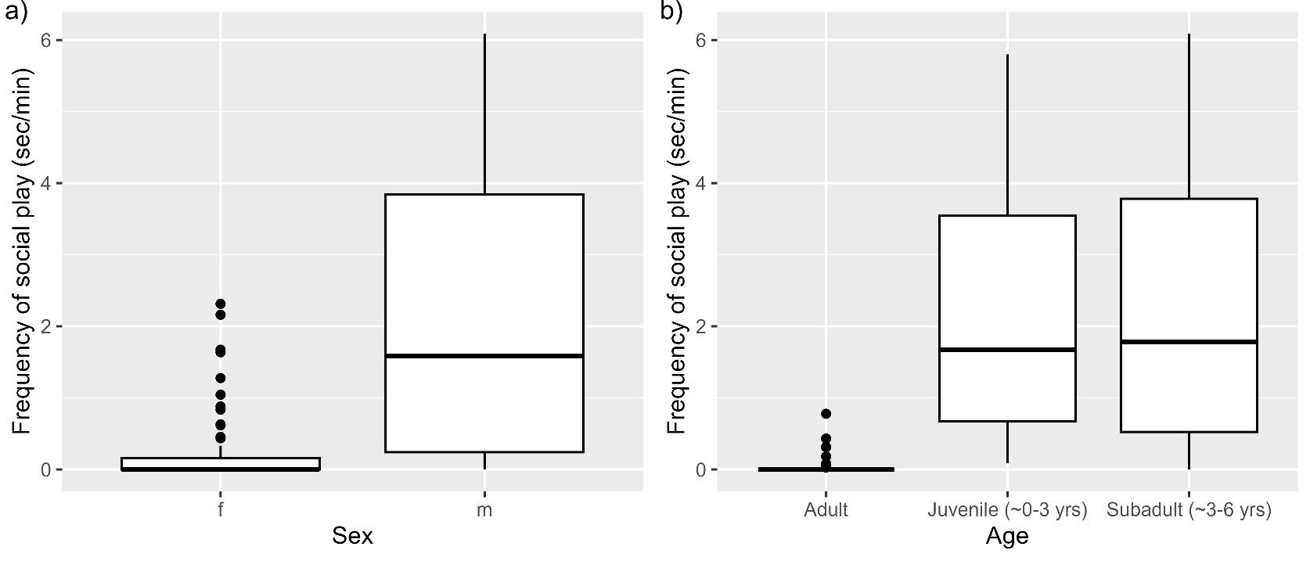
Figure S1. Boxplots comparing the Frequency of social play according to a) sex (males vs females), and b) age category (juveniles vs subadults vs adults). The boxplots show the medians, the interquartile range (IQR), and the extent of data to ±1.5×IQR; dots represent outliers

