  - Electronic Supplementary Material
Behavioral Ecology and Sociobiology

The effect of formation swimming on tailbeat and breathing frequencies in killer whales
  - Authors
Federica Spina^{1*}, Michael N. Weiss^{2,3}, Darren P. Croft^{2,3}, Paolo Luschi¹, Alessandro Massolo^{1,4,5}, Paolo Domenici^{6,7}
  - Affiliations
¹Ethology Unit, Department of Biology, University of Pisa, Pisa 56126, Italy
²Center for Whale Research, Friday Harbor, WA 98250, USA
³Centre for Research in Animal Behaviour, University of Exeter, Exeter EX4 4QG, UK
⁴Faculty of Veterinary Medicine, University of Calgary, Calgary, AB, Canada
⁵UMR CNRS 6249 Chrono-Environnement, Université Franche-Comté, Besançon, France
⁶IBF-CNR, Consiglio Nazionale delle Ricerche, area di ricerca San Cataldo, Via G. Moruzzi 1, Pisa 56124, Italy
⁷IAS-CNR, Località Sa Mardini, Torregrande, Oristano 09170, Italy
*Corresponding author. Email for correspondence: federica.spina@phd.unipi.it
  - Swimming speed data extraction
Whale xy-coordinates (digitized in pixels from each captured frame shot) were adjusted to balance the shooting image distortion (Supplementary Fig. 2a): the difference in position between the whale and the drone in the vertical dimension (d_{y}, Eq. 1b) was calculated taking into account camera vertical field of view (F_{y}), whale’s y-position within the frame (y), the framing angle relative to the vertical (C), and the flight altitude in meters (H)
$θ_{y}=F_{y}y+C$ (1a)
$d_{y}=\tan\left(θ_{y}\right) H$ (1b)
The difference in position in the horizontal dimension (d_{x}, Eq. 2b) was derived through camera horizontal field of view (F_{x}) and whale’s x-position within the frame (x)
$θ_{x}= F_{x} x$(2a)
$d_{x}= tan⁡(θ_{x})\sqrt{H^{2}+d_{y}^{2}}$ (2b)
Hence, the distance between the whale and the drone (D) was estimated with
$D = \sqrt{d_{x}^{2}+d_{y}^{2}}$ (3)
For each sequence we calculated the total bearing relative to north (δ_{total}) by combining camera’s bearing (δ_{camera}) with the angle from the drone to the whale
$δ_{total}=atan2\left(d_{x},d_{y}\right)+δ_{camera}$ (4)
Thus, knowing both the distance of each whale from the drone, whales bearing, and the GPS position of the drone, it was possible to estimate whales longitude (Lon_{whale}, Eq. 5a) and latitude (Lat_{whale}, Eq. 5b) as shown in Supplementary Fig. 2b
${Lon}_{whale}= \frac{D ∙ sin⁡(δ_{total})}{111320 ∙ cos⁡({Lat}_{drone})} + {Lon}_{drone}$ (5a)
${Lat}_{whale}= \frac{D ∙ cos⁡(δ_{total})}{110540}+{Lat}_{drone}$(5b)
Through the distance elapsed between consecutive GPS positions of each whale, we estimated the distance travelled by each orca every 10 seconds and calculated its swimming speed in m/s. The speed values in m/s obtained for each whale were converted into body-lengths-per-second (BL/s) according to the estimated individual size (i.e., individual average estimated size in each sequence).
Supplementary Table 1 Measurements of the diameter of a disc of known size at different known depths along the water column (in meters), obtained from aerial drone-based images collected in the wild. By knowing the real diameter of the disc (Disc real) all the measurements have been conducted observing the images on a 1920 x 1080 resolution screen through the software Kinovea (Charmant 2004). The diameter size is reported in centimeters also for the estimation performed with Kinovea (Disc Kinovea). Both the ratio of the Kinovea-based size to the real one and the estimated error (Est. Err.) of the diameter measurement are presented

Image ID | Depth | Disc real | Disc Kinovea | Kinovea/Real ratio | Est. Err.
DJI0194 | 0.559 | 95 | 92.30 | 0.972 | 0.028
DJI0227 | 1.635 | 95 | 86.56 | 0.922 | 0.078
DJI0246 | 2.635 | 95 | 76.53 | 0.806 | 0.194
DJI0270 | 3.635 | 95 | 72.00 | 0.758 | 0.242

Supplementary Table 2 Effects of multiple predictors estimated by mixed-effects Cox models for the likelihood of duration of Southern Resident killer whale underwater intervals, between consecutive emersions, during swimming in formation. Variables reported: whale sex, average swimming speed (in body-lengths-per-second), formation size, lateral and longitudinal distance from nearest neighbor in meters (La. Dist., Lo. Dist, respectively), relative positioning within the formation (follower, F, or middle-group whale, MG), individual length; also, interaction between positioning effect and individual length (F:Length and MG:Length). The size of effects resulting from the models is not affected by lateral and longitudinal distance from the nearest neighbor. Full model (A); interactive effect of lateral and longitudinal distance (La.D:Lo.D; B); final model with distances excluded from the set of variables (C)

Model type | Predictor | Coef | exp(coef) | SE(coef) | p
A | Sex | -0.204010373 | 0.81545391 | 0.16191577 | 0.21
A | BL speed | -2.554539446 | 0.07772802 | 0.33391649 | < 0.001
A | Group size | -0.026637916 | 0.97371374 | 0.03163048 | 0.40
A | La. Dist. | 0.002402351 | 1.00240524 | 0.02669363 | 0.93
A | Lo. Dist. | -0.015050062 | 0.98506262 | 0.02535485 | 0.55
A | F | -1.507785139 | 0.22139981 | 1.00535272 | 0.13
A | MG | -0.885809884 | 0.41238006 | 0.99434165 | 0.37
A | Length | -0.548997778 | 0.57752833 | 0.19927161 | 0.006
A | F:Length | 0.288018328 | 1.33378175 | 0.19638663 | 0.14
A | MG:Length | 0.153937784 | 1.16641832 | 0.19084257 | 0.42
B | Sex | -0.2041354829 | 0.81535190 | 0.16195638 | 0.21
B | BL speed | -2.5555895084 | 0.07764645 | 0.33436794 | < 0.001
B | Group size | -0.0266446252 | 0.97370721 | 0.03164023 | 0.40
B | La. Dist. | 0.0032584330 | 1.00326375 | 0.03182566 | 0.92
B | Lo. Dist. | -0.0137853731 | 0.98630921 | 0.03606553 | 0.70
B | F | -1.5085744212 | 0.22122513 | 1.00542435 | 0.13
B | MG | -0.8851337847 | 0.41265896 | 0.99452880 | 0.37
B | Length | -0.5494380986 | 0.57727409 | 0.19943613 | 0.006
B | La.D:Lo.D | -0.0001486194 | 0.99985139 | 0.00302320 | 0.96
B | F:Length | 0.2882020023 | 1.33402675 | 0.19640957 | 0.14
B | MG:Length | 0.1538886347 | 1.16636099 | 0.19085458 | 0.42
C | Sex | -0.20275979 | 0.8164743 | 0.16183151 | 0.21
C | BL speed | -2.57006724 | 0.0765304 | 0.33366933 | < 0.001
C | Group size | -0.02722385 | 0.9731434 | 0.03175056 | 0.39
C | F | -1.46334254 | 0.2314613 | 1.00518651 | 0.15
C | MG | -0.83080308 | 0.4356992 | 0.99318347 | 0.40
C | Length | -0.54532285 | 0.5796546 | 0.19921688 | 0.006
C | F:Length | 0.27992002 | 1.3230240 | 0.19636326 | 0.15
C | MG:Length | 0.14544223 | 1.1565509 | 0.19086280 | 0.45

Supplementary Table 3 Effects of multiple predictors on the breathing frequency of Southern Resident killer whales during swimming in formation, estimated by Bayesian Gaussian model performed with four Monte Carlo Markov Chains (10000 iterations per chain). Variables reported: whale sex, average swimming speed (estimated in body-lengths-per-second), modal relative positioning within the formation (follower, Mod. F, or middle-group whale, Mod. MG), individual length, formation size; also, interaction between positioning effect and individual length (Mod F:Length, Mod MG:Length)

Predictor | Estimate | Est. Error | l-95% CI | u-95% CI
Intercept | 1.71 | 0.55 | 0.64 | 2.79
Sex | -0.02 | 0.07 | -0.16 | 0.12
BL Speed | -0.47 | 0.20 | -0.86 | -0.08
Group size | -0.01 | 0.01 | -0.03 | 0.02
Mod. F | 0.20 | 0.52 | -0.98 | 1.03
Mod. MG | 0.14 | 0.52 | -0.88 | 1.16
Length | -0.12 | 0.10 | -0.31 | 0.08
Mod F:Length | -0.00 | 0.10 | -0.20 | 0.20
Mod MG:Length | -0.02 | 0.10 | -0.22 | 0.18

Supplementary Table 4 Effects of multiple predictors on the tail beat frequency of Southern Resident killer whales during swimming in formation, estimated by Bayesian Gaussian model performed with four Monte Carlo Markov Chains (10000 iterations per chain). Variables reported: whale sex, average swimming speed (estimated in body-lengths-per-second), formation size, lateral and longitudinal distance to nearest neighbor (La. Dist., Lo. Dist, respectively), relative positioning within the formation (follower, F, or middle-group whale, MG), individual length; also, interaction between positioning effect and individual length (F:Length and MG:Length). Full model (A); interactive effect of lateral and longitudinal distance (La.D:Lo.D; B); final model with distances excluded from the set of variables (C)

Model type | Predictor | Estimate | Est. Error | l-95% CI | u-95% CI
A | Intercept | -0.16 | 0.16 | -0.48 | 0.16
A | Sex | -0.08 | 0.02 | -0.12 | -0.04
A | BL speed | 0.15 | 0.06 | 0.04 | 0.27
A | Group size | -0.01 | 0.01 | -0.03 | 0.00
A | La. Dist. | -0.00 | 0.01 | -0.02 | 0.01
A | Lo. Dist. | 0.00 | 0.01 | -0.01 | 0.02
A | F | 0.13 | 0.16 | -0.19 | 0.44
A | MG | 0.29 | 0.16 | -0.02 | 0.61
A | Length | -0.10 | 0.03 | -0.16 | -0.04
A | F:Length | -0.02 | 0.03 | -0.09 | 0.04
A | MG:Length | -0.06 | 0.03 | -0.12 | -0.00
B | Intercept | -0.16 | 0.16 | -0.49 | 0.16
B | Sex | -0.08 | 0.02 | -0.12 | -0.03
B | BL speed | 0.15 | 0.06 | 0.04 | 0.27
B | Group size | -0.01 | 0.01 | -0.03 | 0.00
B | La. Dist. | -0.00 | 0.01 | -0.02 | 0.02
B | Lo. Dist. | 0.01 | 0.01 | -0.01 | 0.03
B | F | 0.11 | 0.16 | -0.21 | 0.44
B | MG | 0.29 | 0.16 | -0.03 | 0.60
B | Length | -0.10 | 0.03 | -0.16 | -0.04
B | La.D:Lo.D | -0.00 | 0.00 | -0.00 | 0.00
B | F:Length | -0.02 | 0.03 | -0.09 | 0.04
B | MG:Length | -0.06 | 0.03 | -0.12 | 0.00
C | Intercept | -0.16 | 0.16 | -0.48 | 0.16
C | Sex | -0.08 | 0.02 | -0.12 | -0.04
C | BL speed | 0.15 | 0.06 | 0.04 | 0.27
C | Group size | -0.01 | 0.01 | -0.03 | 0.00
C | F | 0.13 | 0.16 | -0.19 | 0.44
C | MG | 0.29 | 0.16 | -0.02 | 0.60
C | Length | -0.10 | 0.03 | -0.16 | -0.04
C | F:Length | -0.03 | 0.03 | -0.09 | 0.04
C | MG:Length | -0.06 | 0.03 | -0.12 | 0.00
Supplementary Table 5 Individuals sighted during drone-based observations of the population of the Southern Resident killer whales, conducted in 2019 and 2021, between June and September. Data reported from video sequences in which killer whales demonstrated directional and regular swimming behavior. For each individual the whale ID, matriline, sex (0 females, 1 males), year of birth (YoB), number of recorded sequences, and number of sighting days per year are given

Whale | Matriline | Sex | YoB | Tot. sequences | Days 2019 | Days 2021
J27 | J11s | 1 | 1991 | 14 | 4 | 0
J31 | J11s | 0 | 1995 | 21 | 7 | 0
J39 | J11s | 1 | 2003 | 8 | 4 | 0
J56 | J11s | 0 | 2019 | 20 | 7 | 0
J37 | J14s | 0 | 2001 | 9 | 5 | 0
J40 | J14s | 0 | 2004 | 21 | 7 | 0
J45 | J14s | 1 | 2009 | 15 | 4 | 0
J49 | J14s | 1 | 2012 | 12 | 5 | 0
J16 | J16s | 0 | 1972 | 2 | 1 | 0
J26 | J16s | 1 | 1991 | 1 | 1 | 0
J36 | J16s | 0 | 1999 | 3 | 2 | 0
J42 | J16s | 0 | 2007 | 3 | 2 | 0
J35 | J17s | 0 | 1998 | 16 | 5 | 0
J44 | J17s | 1 | 2009 | 13 | 6 | 0
J53 | J17s | 0 | 2015 | 12 | 5 | 0
J46 | J17s | 0 | 2009 | 19 | 7 | 0
J47 | J17s | 1 | 2010 | 13 | 4 | 0
J19 | J19s | 0 | 1979 | 12 | 5 | 1
J41 | J19s | 0 | 2005 | 14 | 6 | 1
J51 | J19s | 1 | 2015 | 17 | 8 | 1
J58 | J19s | 0 | 2020 | 1 | 0 | 1
J22 | J22s | 0 | 1985 | 10 | 6 | 0
J38 | J22s | 1 | 2003 | 7 | 4 | 0
L54 | L54s | 0 | 1977 | 12 | 0 | 1
L108 | L54s | 1 | 2006 | 12 | 0 | 1
L117 | L54s | 1 | 2010 | 12 | 0 | 1
L88 | / | 1 | 1993 | 1 | 0 | 1

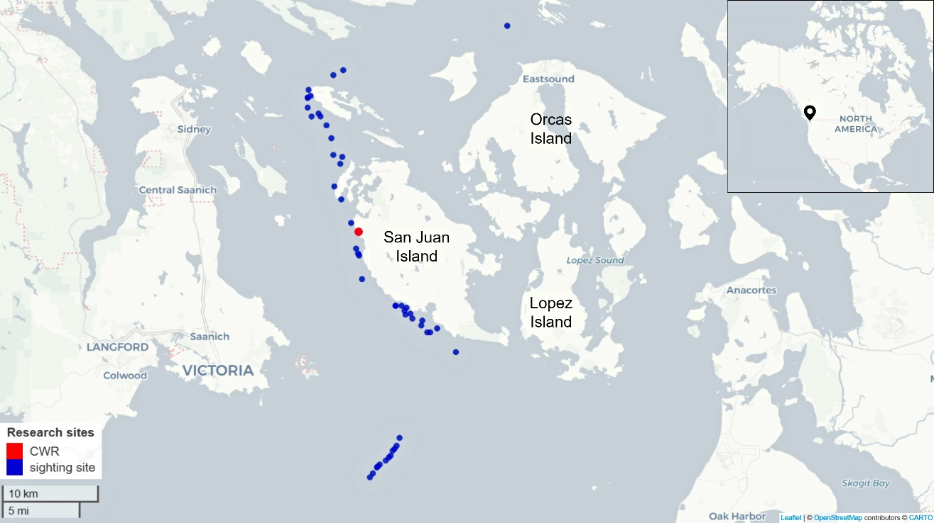
Supplementary Fig. 1 Map of sighting sites (blue dots) of the Southern Resident killer whale (Orcinus orca) population around the San Juan Islands archipelago (WA, USA). Observations carried out through drone-based surveys by the Center for Whale Research (CWR, red dot location in San Juan Island) under National Marine Fisheries Service federal permit, between June and September in 2019 and 2021. The reported sighting locations have been recorded through the aircraft GPS system during the flights

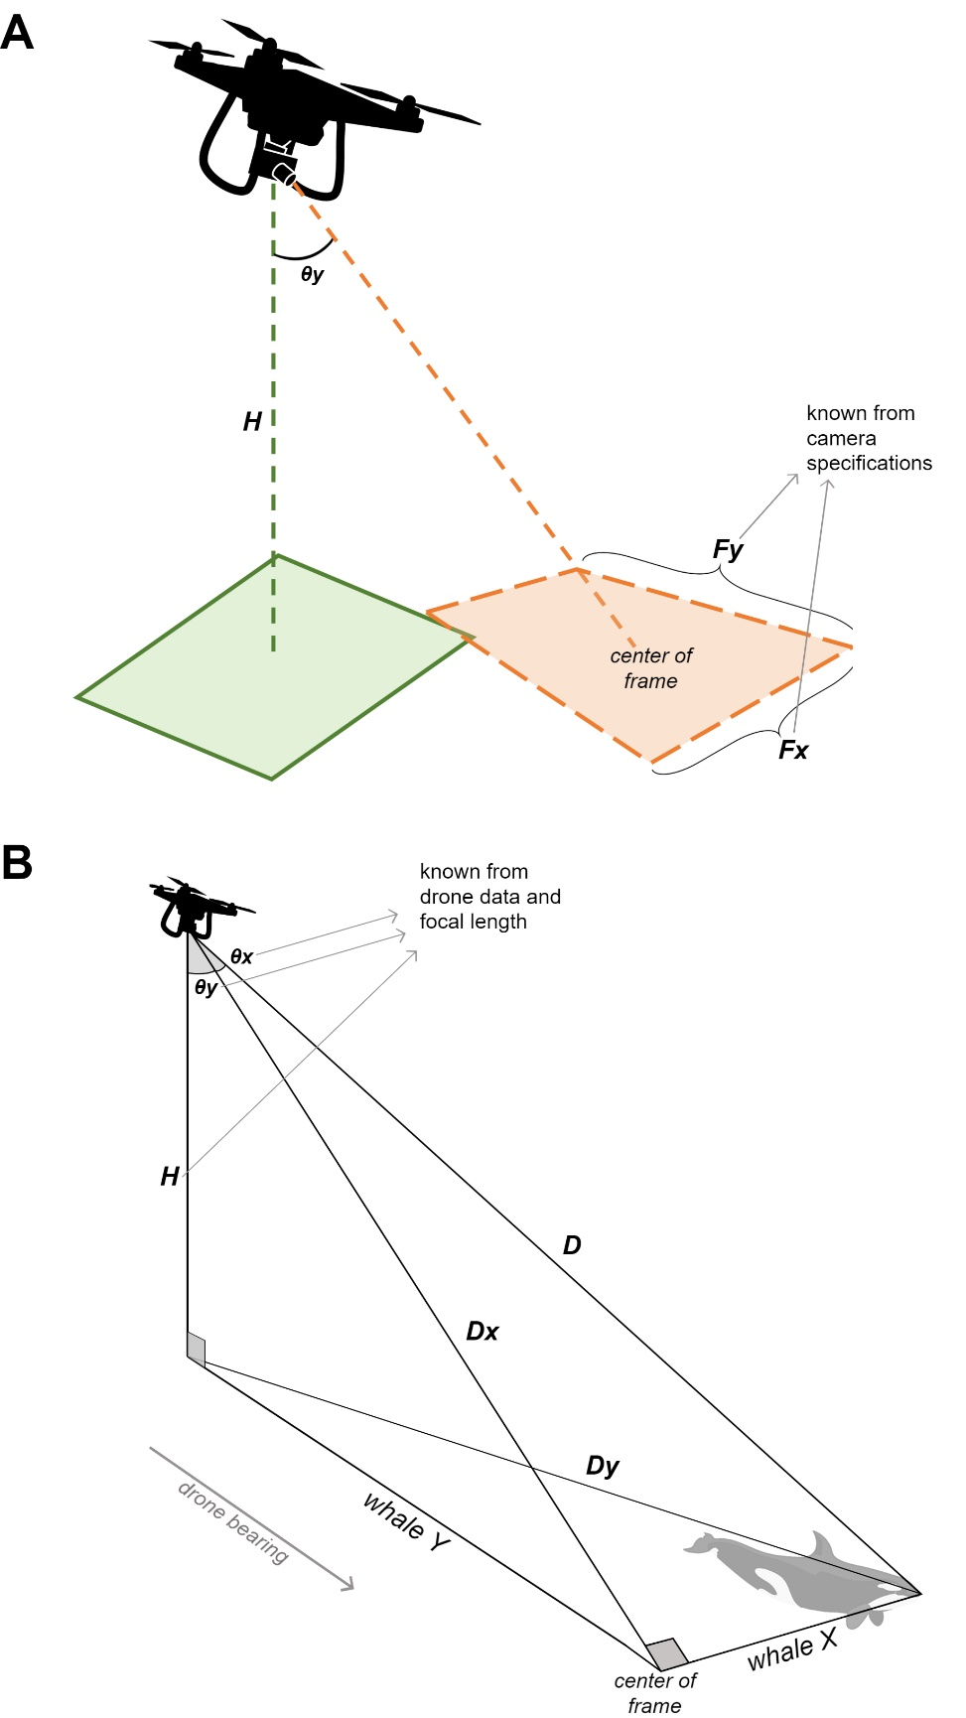
Supplementary Fig. 2 Scheme of the tridimensional trigonometry applied to estimate the GPS location of free ranging whales by observing through a drone overflight. During cetacean aerial monitoring it is possible to obtain an estimation of whale location, knowing their xy-position within the shooting frame (whale X and whale Y), the exact GPS location of the drone, and the aircraft’s flight logs (i.e., focal angle of the camera in both dimensions, F_{x} and F_{y}, and flight altitude, H).
(A) Calibration of the image distortion due to the shooting angle of the drone during the overflight.
(B) Trigonometry scheme between the drone and a sighted whale; the distances in the two dimensions (D_{x} and D_{y}) and the reported angles (θ_{x} and θ_{y}) allow to estimate the drone-whale distance and derive the GPS position of the latter

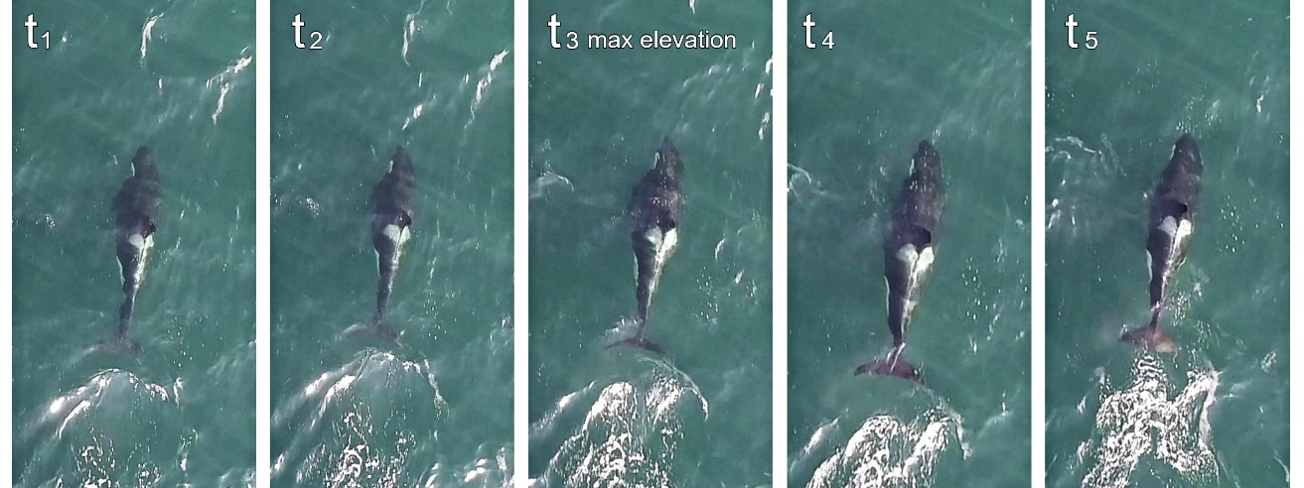
Supplementary Fig. 3 observation of the dorsoventral swimming cycle of the flukes of a killer whale in the wild via frame shots captured from a drone recorded video (aerial observation of the Southern Resident killer whale population, Orcinus orca). Images collected from a sequence in which whales displayed directional swimming behavior while in formation. By observing the swimming cycle from the video in slow motion, it was possible to identify the time of maximum elevation of the caudal fin, based on the apparent change in shape of the flukes, i.e. when the flukes showed the highest apparent aspect ratio (panel t₃). The time of maximum elevation of the caudal flukes is considered as the starting/ending point of each tailbeat, allowing for the timing of each stroke and for the estimation of tailbeat frequency

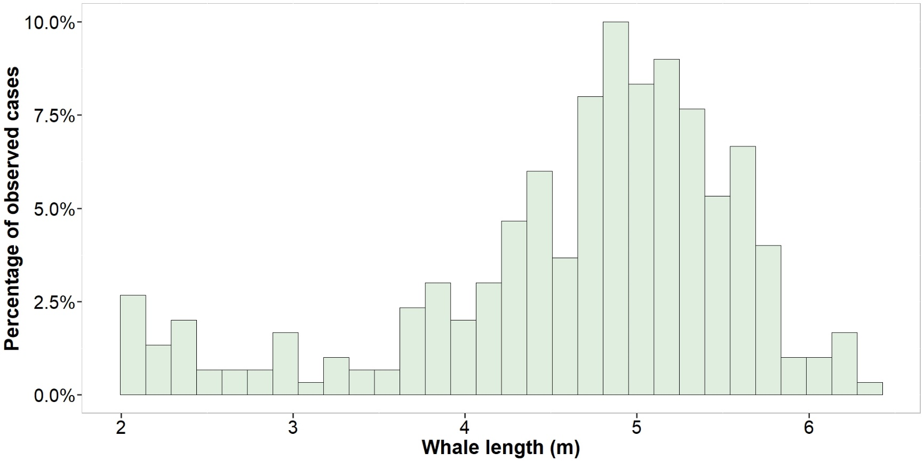
Supplementary Fig. 4 distribution of estimated lengths in meters calculated for swimming individuals of the Southern Resident killer whale population (Orcinus orca). Whale length estimated by observing the individuals from above using drone-based videos. Whales have been measured using the head-to-tail distance by digitizing the rostrum tip and middle tip of caudal flukes in xy-coordinates on the screen during video analysis

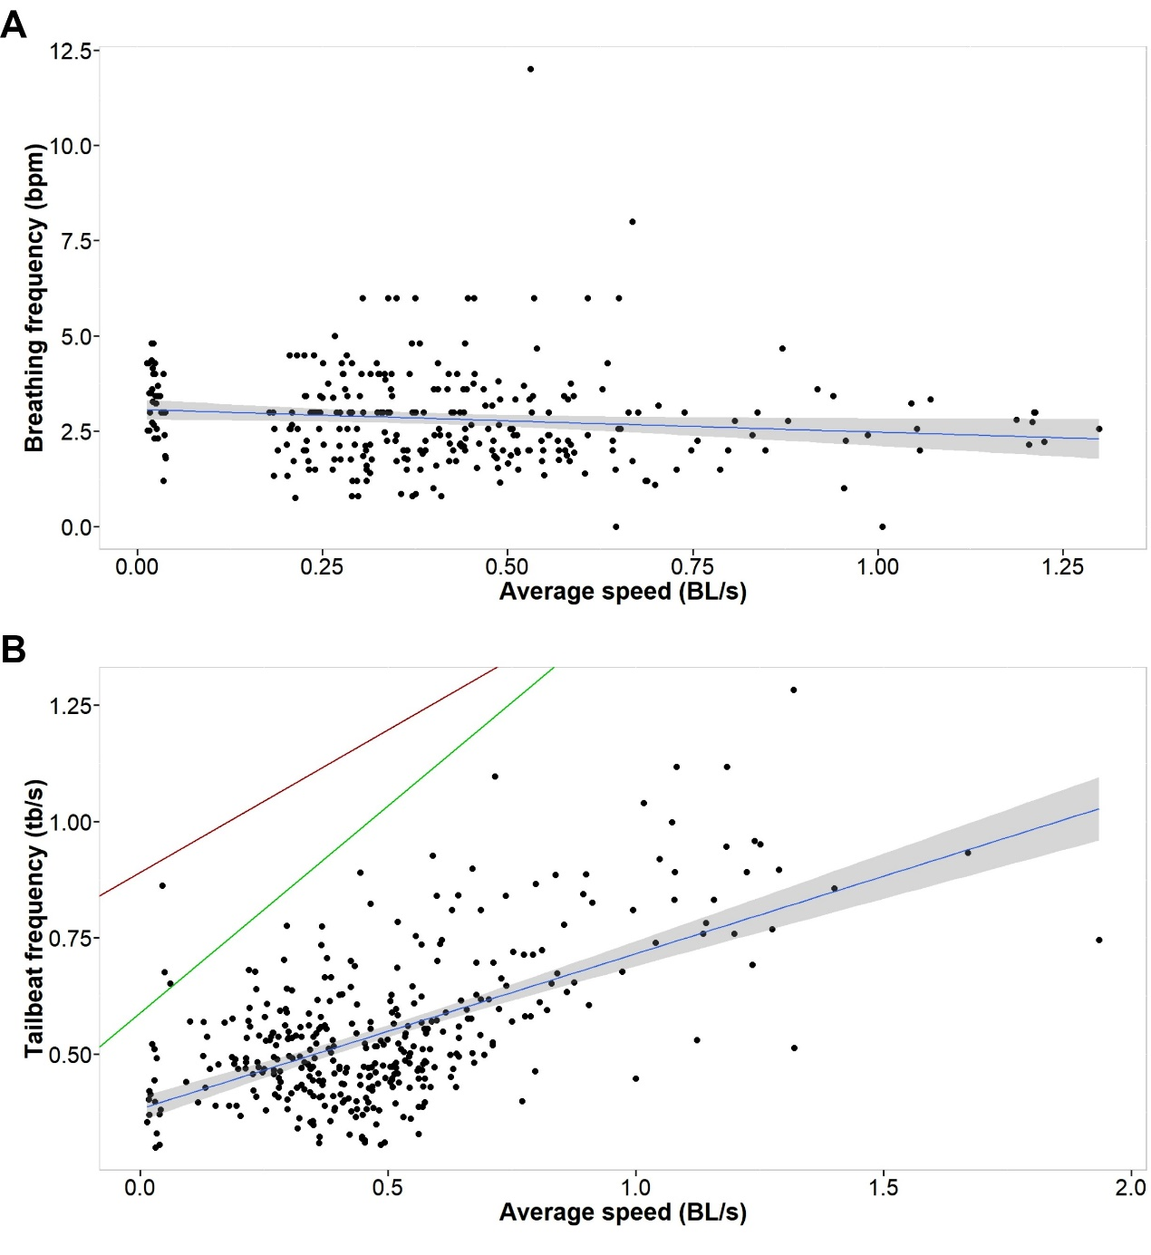
Supplementary Fig. 5 observed breathing frequency calculated in breath-per-minute (A) and tailbeat frequency calculated in tail-beats-per-second (B), in relation to the swimming speed (in body-lengths-per-second, BL/s), of free ranging Southern Resident killer whales (Orcinus orca). Data collected by observing swimming formations of killer whales through drone-based surveys. The linear regression of the observed data is reported in blue for both variables: y = -0.593 x + 3.071 (R² = 0.01, N = 300) for the breathing frequency, and y = 0.333x + 0.383 (R² = 0.35, N = 367) for the tailbeat frequency. Tailbeats are also compared with previous data collected from whales in captivity: linear relationship between tailbeats and peed is reported in red from Fish (1998) for killer whales, and in green from Rohr and Fish (2004) for seven species of odontocetes

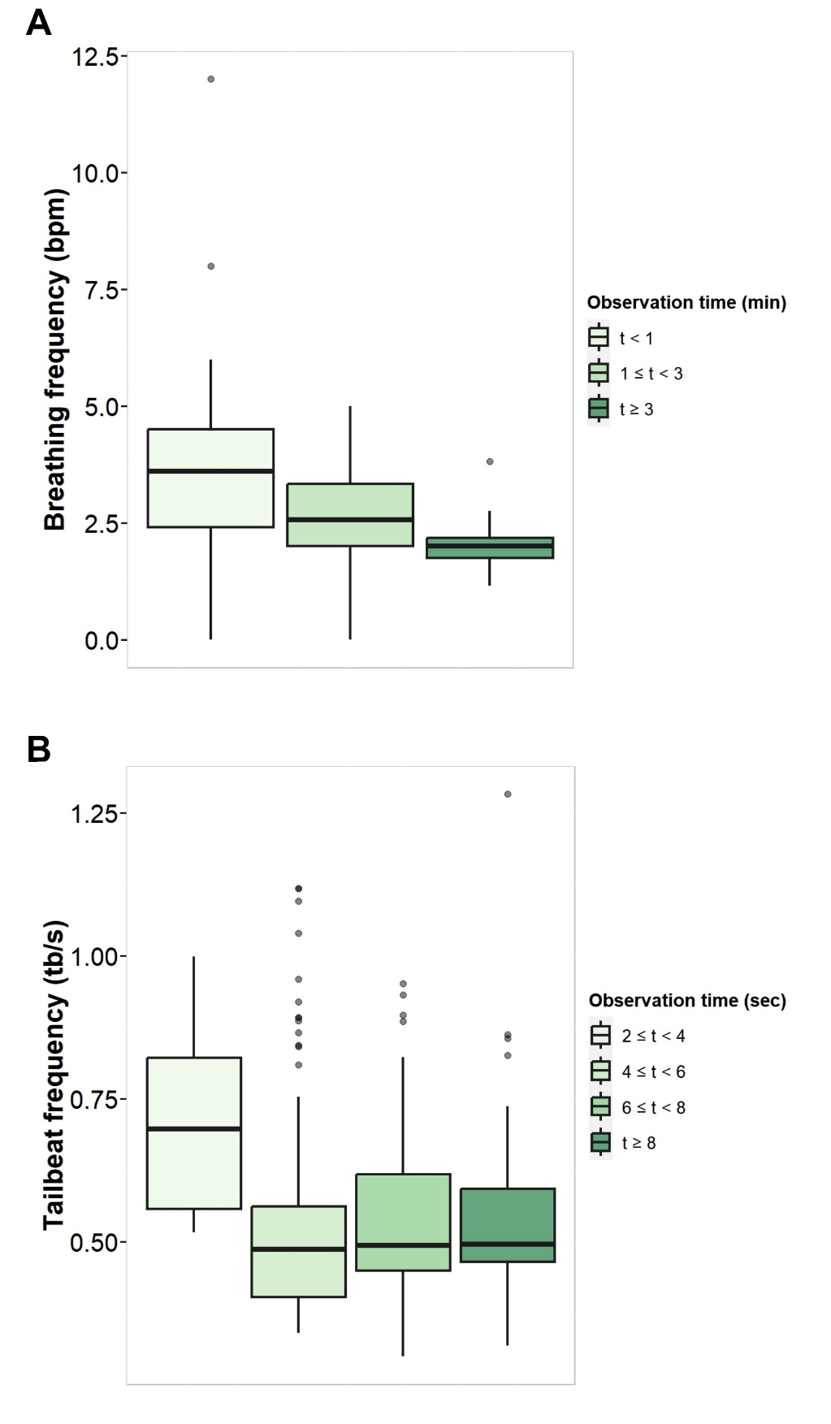
Supplementary Fig. 6 range of data obtained about the breathing frequency calculated in breath-per-minute (A) and tailbeat frequency calculated in tailbeats-per-second (B) of free ranging Southern Resident killer whales (Orcinus orca) swimming formations observed with drone-based surveys. Data grouped according to the duration of the observations, opportunistically conducted depending on visibility in water. The variability of the collected data is greater for shorter observation time

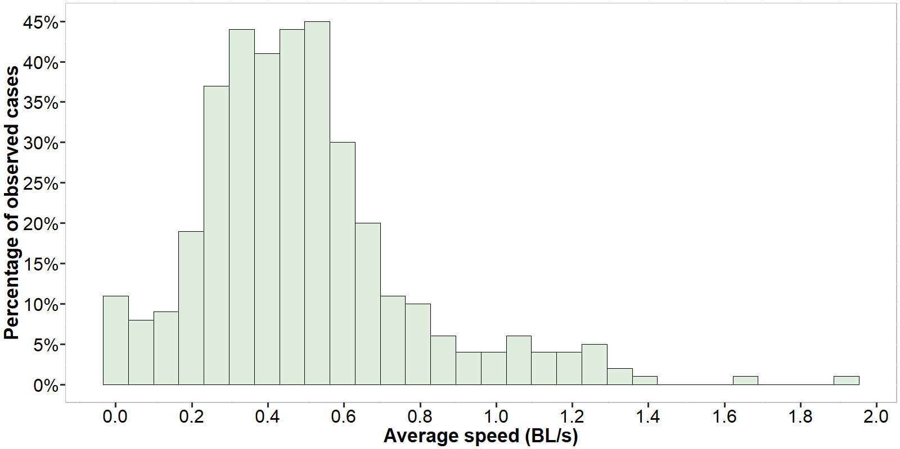
Supplementary Fig. 7 distribution of observed swimming speed (in body lengths-per-second, BL/s) during recording of the tailbeat frequency of free ranging Southern Resident killer whales (Orcinus orca) while swimming in formation. Whales observed through aerial drone-based video recorded in the wild. Swimming speed estimated by taking into account the estimation of whale length (head-to-tail distance) in meters

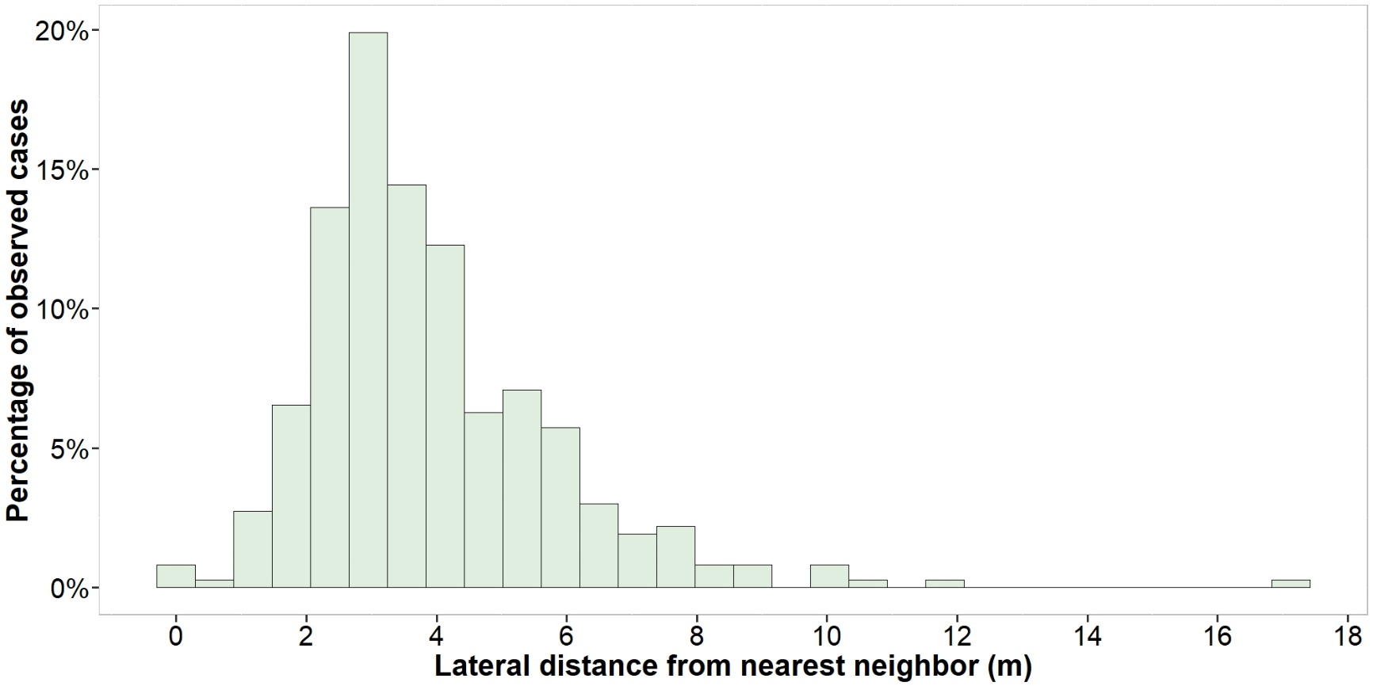
Supplementary Fig. 8 distribution of observed lateral distances, estimated in meters, between individuals of the Southern Resident killer whale population (Orcinus orca) while swimming in formation. Distances estimated between nearest neighbors within formations from aerial drone-based video recorded in the wild. By digitizing the rostrum tip of the whales in xy-coordinates on the screen during video processing it is possible to calculate the distance between two xy-point along the horizontal axis

Supplementary Video 1 observation of the dorsoventral swimming cycle of the flukes of a killer whale in the wild via a drone recorded video, reproduced in slow motion at 5% of the real speed, 30 frames-per-second (aerial observation of the Southern Resident killer whale population, Orcinus orca). The reported video is cropped from a sequence in which whales displayed directional swimming behavior while in formation. By observing the swimming cycle from the video in slow motion, it is possible to identify the time of maximum elevation of the caudal fin, based on the apparent change in shape of the flukes (indicated by the arrow in the video). The time of maximum elevation of the caudal flukes is considered as the starting/ending point of each tailbeat, allowing for the timing of each stroke and for the estimation of tailbeat frequency

References
Charmant J (2004) Kinovea, http://www.kinovea.org
Fish FE (1998) Comparative kinematics and hydrodynamics of odontocete cetaceans: Morphological and ecological correlates with swimming performance. J Exp Biol 201:2867–2877
Rohr JJ, Fish FE (2004) Strouhal numbers and optimization of swimming by odontocete cetaceans. J Exp Biol 207:1633–1642. https://doi.org/10.1242/jeb.00948

