Supporting Information for the paper:
Patterns of oviposition site selection of four sympatric species of amphibians in ephemeral streams

Dogeun Oh, Jaehoon Lee, Uhram Song, JeongYoon Ahn, Changku Kang

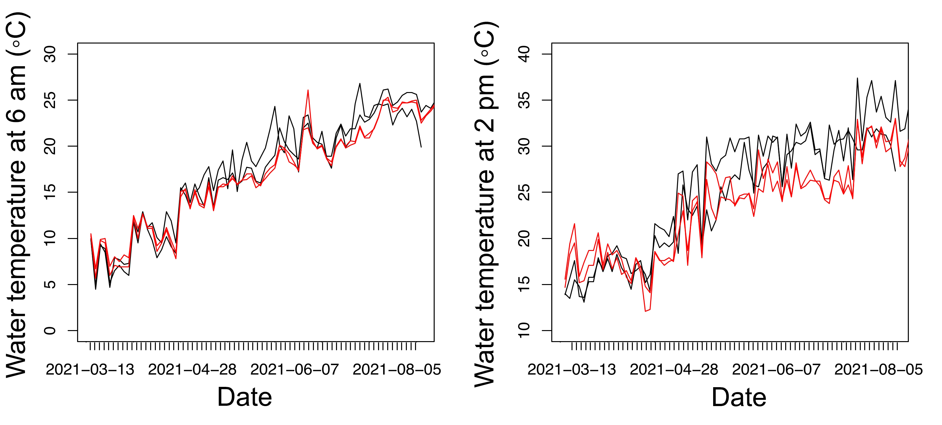
Figure S1. Plots showing the water temperature changes throughout the study period, measured for two small-sized (black lines) and large-sized (red lines) pools. The temperature was measured twice daily at 6 am and 2 pm, representing the (roughly) minimum and maximum temperatures of each day, respectively. The difference between small and large pools was not apparent in the minimum temperature. However, during the breeding seasons of B. orientalis and D. japonicus (from May to August), large pools were consistently cooler than smaller pools at 2 pm.

Figure S2. The results when we used a subset of data from dates on which most pools were available for oviposition (when more than 95% of available pools were filled with water) and conducted the same abiotic analyses. The effect of the factor 'Dry' was mostly insignificant, most likely due to (i) reduced sample size and (ii) the trend that most pools in the subset data remained water-filled on most of the dates we filtered, which biased the distribution of the probability of each pool being found dry towards lower values, as evidenced by the number and position of each datapoint in the scatterplots.

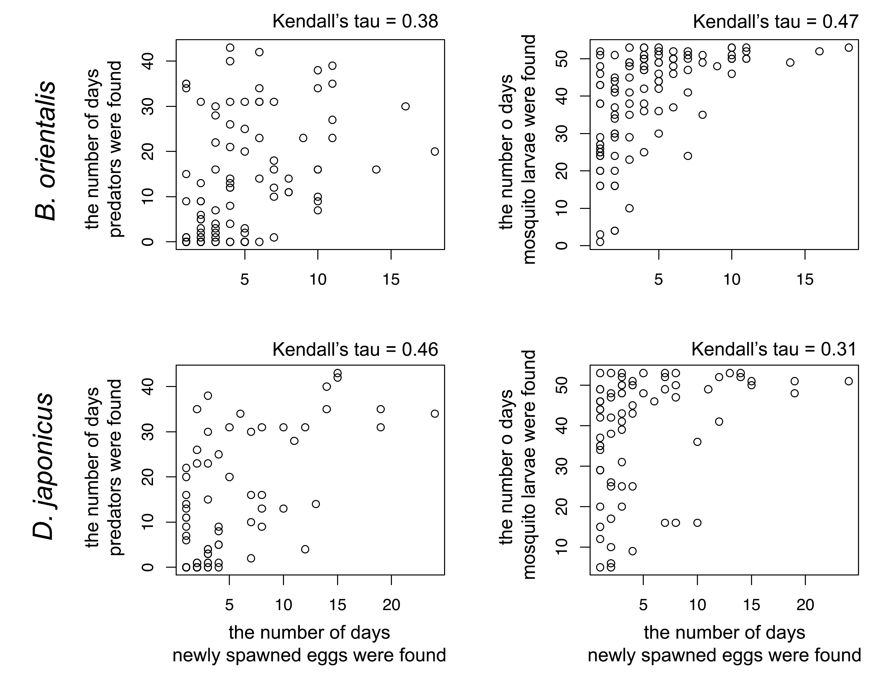
Figure S3. The correlation patterns of oviposition choice between amphibians and aquatic predators (left panels), and between amphibians and mosquito larvae (right panels), are shown. The points represent the number of days predators, mosquito larvae, or newly spawned eggs were observed in each pool.

