Behavioral Ecology and Sociobiology
Color variation and mate choice in a lacertid lizard
Supplementary Information

Wan-Xin Jian wanxin586@gmail.com
1. School of Life Science, National Taiwan Normal University, Taipei 116059, Taiwan
2. Raptor Research Group of Taiwan, Taipei 111095, Taiwan
Tsui-Wen Li x_kishuarashi@hotmail.com
1. School of Life Science, National Taiwan Normal University, Taipei 116059, Taiwan
Fitra Arya Dwi Nugraha fitraaryadn@fmipa.unp.ac.id
3. Department of Biology, Universitas Negeri Padang, Sumatera Barat 25171, Indonesia
Chen-Pan Liao apanliao@nmns.edu.tw
4. Department of Biology, National Museum of Natural Science, Taichung 404023, Taiwan
Tsung-Chen Lee lemaplestory@gmail.com
1. School of Life Science, National Taiwan Normal University, Taipei 116059, Taiwan
5. Walk for Wildlife Association, Taipei 116059, Taiwan
Ko-Huan Lee (*: corresponding author) kohuanlee@gmail.com
Orcid ID: https://orcid.org/0000-0001-5577-8619
6. Commonwealth Scientific and Industrial Research Organisation, Canberra 3169, ACT, Australia
Si-Min Lin (*: corresponding author) lizard.dna@gmail.com
Orcid ID: https://orcid.org/0000-0001-7080-706X
1. School of Life Science, National Taiwan Normal University, Taipei 116059, Taiwan
2. Raptor Research Group of Taiwan, Taipei 111095, Taiwan
5. Walk for Wildlife Association, Taipei 116059, Taiwan
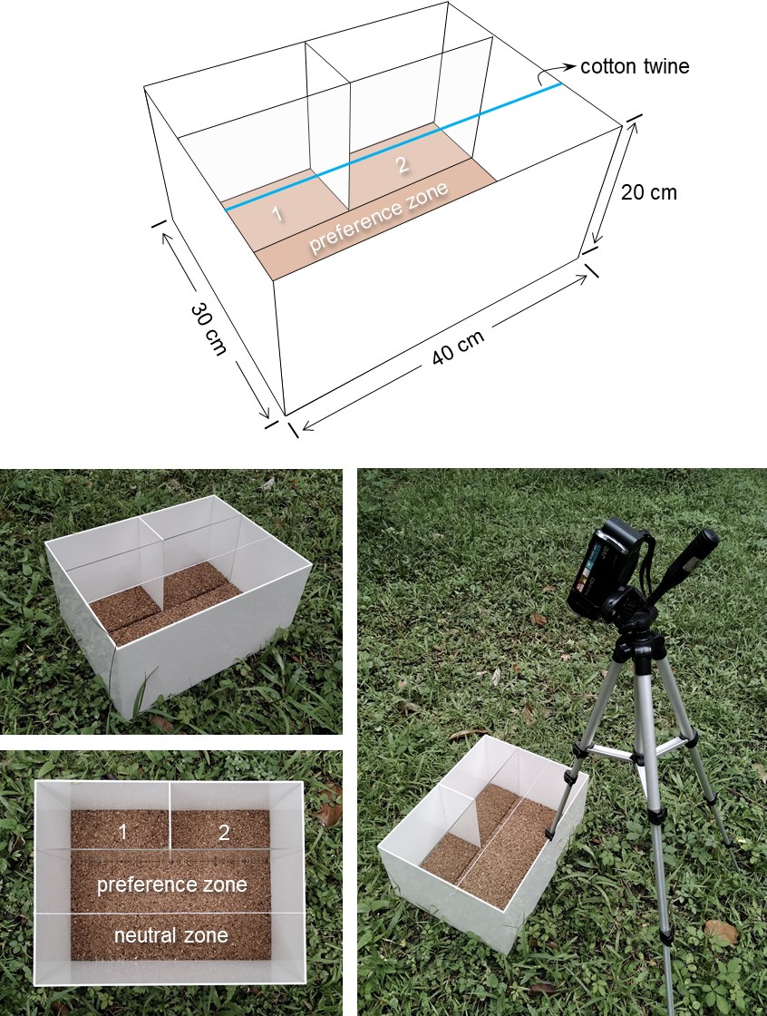
Figure S1. The acrylic arena for mate choice experiments. Two small compartments (1 and 2) and a big compartment were separated by transparent plexi-glasses. We sticked a cotton twine above the big compartment to designate two segments, preference zone and neutral zone.

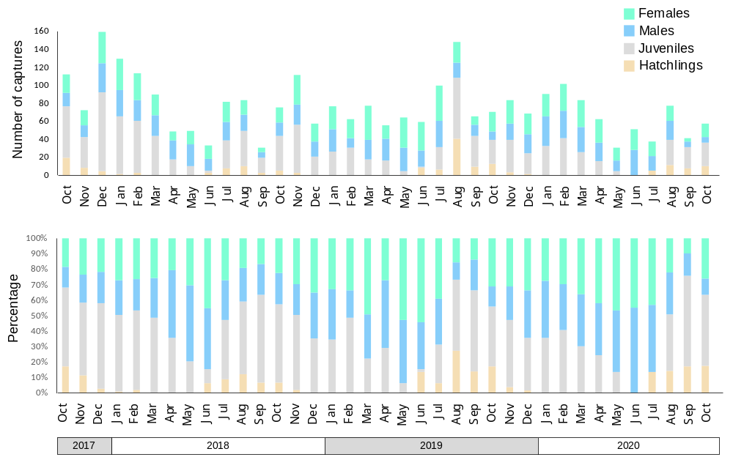
Figure S2. Capture records of Takydromus stejnegeri from October 2017 to October 2020.

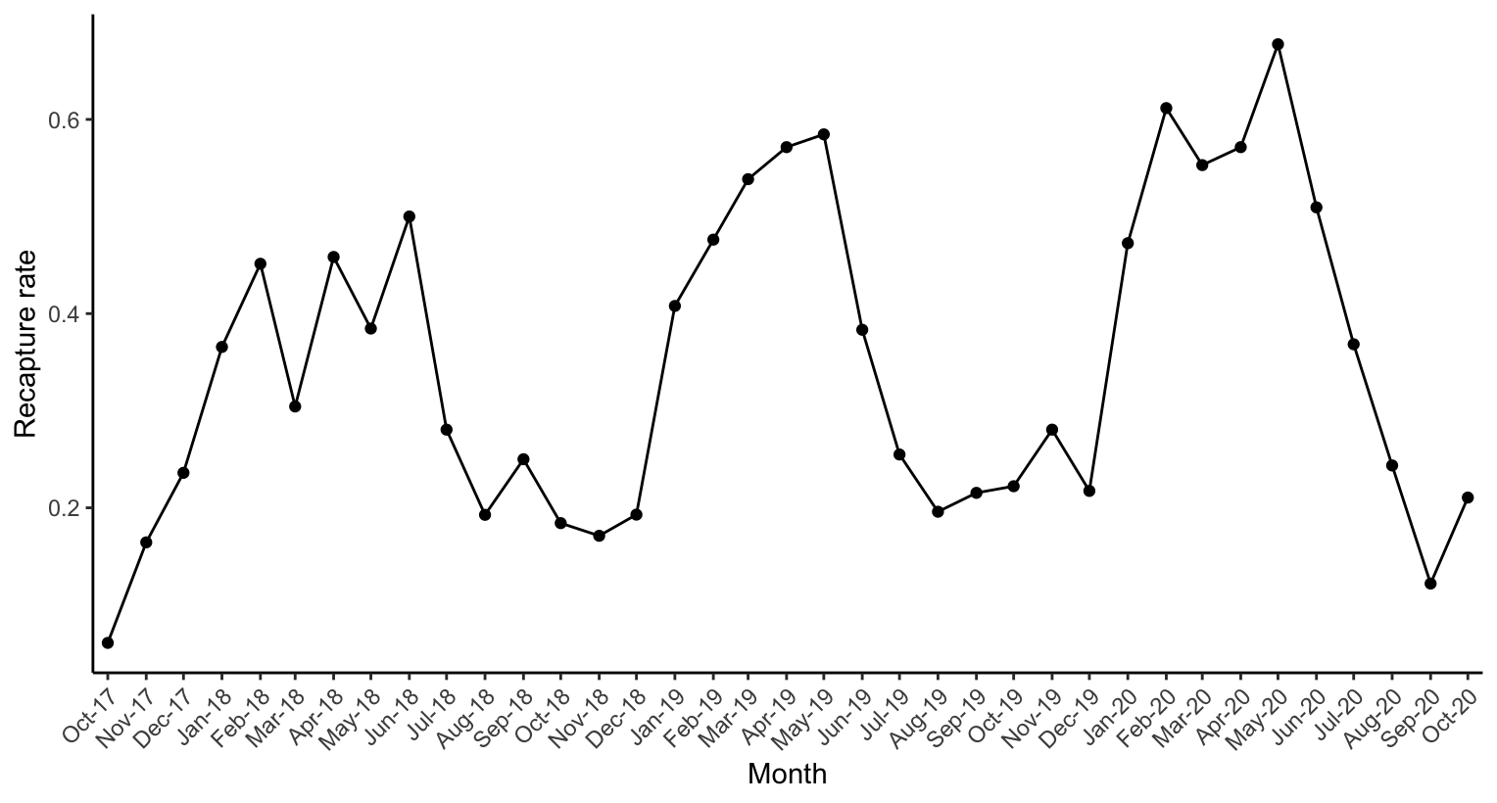
Figure S3. Monthly recapture rate of Takydromus stejnegeri from Oct. 2017 to Oct. 2020.

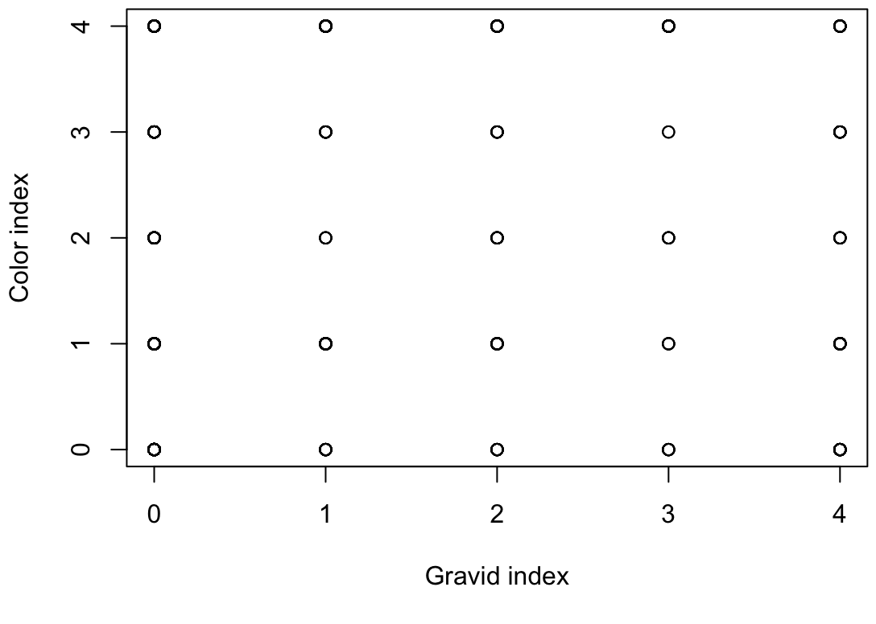
Figure S4. The scatter plot shows no correlation between the color index and the gravid index in females. The X-axis represents the reproductive stage, ranging from no eggs (0) to nearing oviposition (3) and post-oviposition (4). The Y-axis represents the level of green coloration on the lateral side, ranging from completely absent (0) to fully covered in green (4).

Text S1. Do green color and white strips correlate with the body condition measured by residual scores?
We found the full linear mixed model was singular fit because the variance of the random effect (lizard ID) was close to zero. Therefore, we removed the random effect and performed a linear model, where residual scores were the response variable. We included the interaction of sex, color, stripe, and season as the fixed variables. We removed the four-way interactions from the final model as it was not significant (|β| = -0.011, S.E. = 0.049, p = 0.810), and the model was better fitted according to the AIC value comparison (AIC = -3263). The results showed that the residual score was not significantly associated with the interaction of coloration, sex, and season (|β| = 0.021, S.E. = 0.021, p = 0.319, AIC = -3318) or the interaction of stripe, sex, and season (|β| = 0.035, S.E. = 0.019, p = 0.06, AIC = -3339).

Table S1. Summary of linear mixed model of body condition measured by scale mass index (SMI), where the three-way interaction of sex, color and season was included as a fixed effect.
Variables | Estimate | S.E. | T value | p value
Intercept | 1.549 | 0.019 | 81.763 | < 0.001
Sex (male) | 0.085 | 0.022 | 3.854 | < 0.001
Color (green) | 0.018 | 0.023 | 0.807 | 0.420
Season (non-breeding) | -0.014 | 0.023 | -0.632 | 0.528
Sex * Color | 0.011 | 0.032 | 0.346 | 0.730
Sex * Season | 0.084 | 0.027 | 3.087 | 0.002
Color * Season | -0.017 | 0.031 | -0.530 | 0.597
Sex * Color * Season | -0.059 | 0.051 | -1.161 | 0.246

Table S2. Summary of linear mixed model of body condition measured by scale mass index (SMI), where the three-way interaction of sex, stripe and season was included as a fixed effect.
Variables | Estimate | S.E. | T value | p value
Intercept | 1.566 | 0.014 | 114.802 | < 0.001
Sex (male) | 0.001 | 0.026 | 0.038 | 0.970
Stripe (white) | -0.015 | 0.024 | -0.633 | 0.527
Season (non-breeding) | -0.013 | 0.017 | -0.775 | 0.439
Sex * Stripe | 0.103 | 0.033 | 3.091 | 0.002
Sex * Season | 0.151 | 0.029 | 5.122 | < 0.001
Stripe * Season | -0.054 | 0.035 | -1.525 | 0.128
Sex * Stripe * Season | -0.056 | 0.047 | -1.184 | 0.237

