Tables and Supplementary
Table S1: Land use compositions at each site based on QGIS data (Online_Resource_1.xlsx).

Table S2: Raw colony weight data for each site and calculations to show how cumulative weight change (CWC). Raw weights taken at 12:00PM. Attached as Supplementary Excel File (Online_Resource_1.xlsx).

Table S3: LMEs used to test the relationships between treatments, honey bee egg size, worker size and foraging behaviour and lifespan. Both egg size and treatment are used as predictors of bee size and behaviour. T-values are presented with significant test statistics italicised and underlined (Online_Resource_1.xlsx).

Table S4: Colony averages (means) for egg size and bee size during experimental colony splitting treatment and non-split control conditions. Colonies presented twice in a pair-wise design with each colony measured under treatment and control conditions (Online_Resource_1.xlsx).
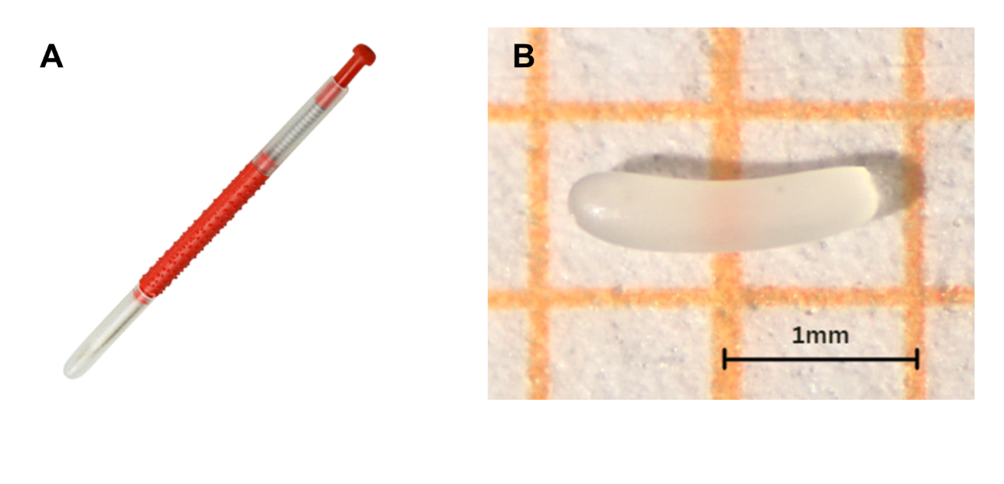
Fig. S1: (A) Retractable grafting tool used to extract eggs; (B) Photographed Apis mellifera egg as viewed through ZEISS Axiocam 208 colour lab scope with scale inlaid.

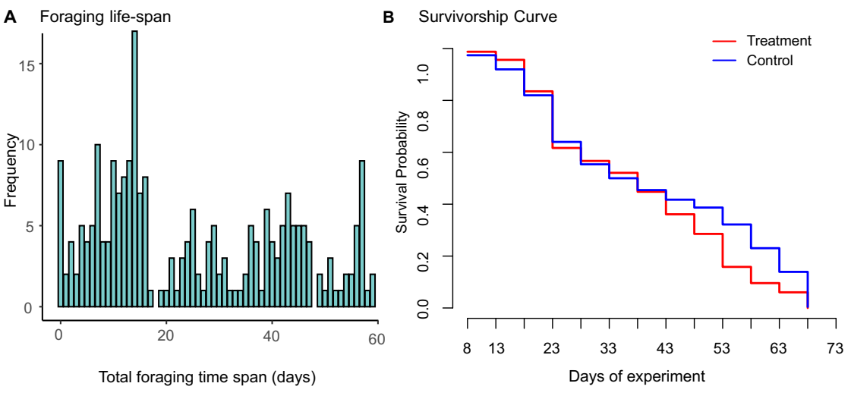
Fig. S2: (A) Foraging lifespan frequency distribution and (B) Survivorship curve to show the most frequent forager lifespan was 15 days (N=17) and there was no significant difference between survival rates of treatment groups (t= -1.014, p =0.691).
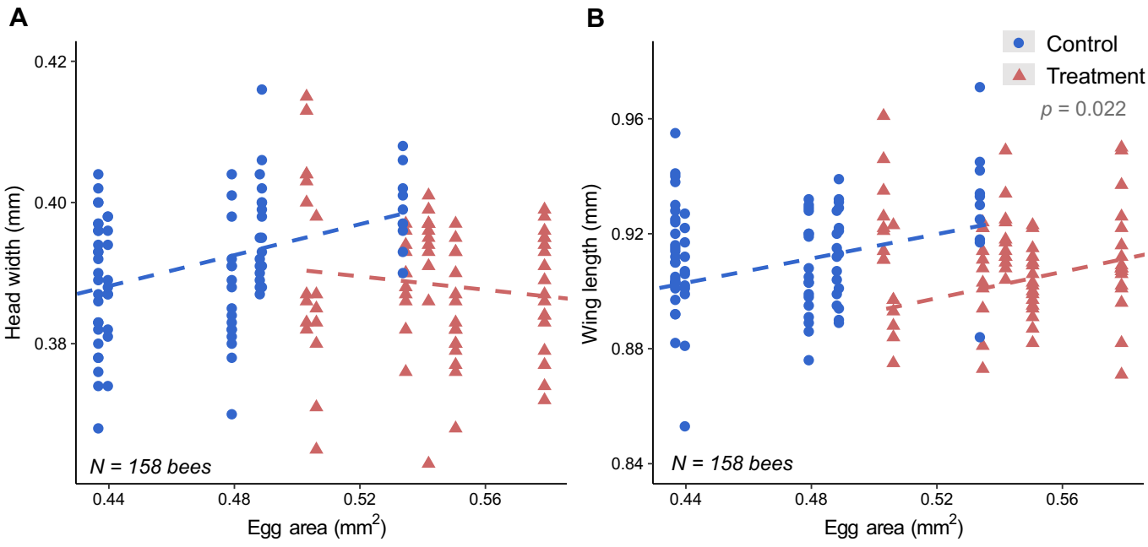
Fig. S3: The effect of egg area (mm²) on worker bee (A) head width and (B) wing length . Blue circles indicate control conditions/ non-split colonies, red triangles indicate treatment conditions/colony splitting event. Egg area did not significantly predict head widths in control (p = 0.093) and treatment groups (p = 0.648). However, there was an interaction between treatment and egg area on head width (LRT = 4.87, p = 0.027). Treatment condition was a significant predictor of bee wing lengths (p = 0.022). Full model specification can be found in Table S3.

