TITLE: Trust myself or trust my friends? Exploring the effect of sex on social information use in Poecilia wingei
JOURNAL: Behavioral Ecology and Sociobiology
AUTHORS:
Justine Rionach McCarthy*¹, Michelle E. St. John¹, Laura R. Stein¹
* Corresponding author
* e-mail: mrij@ou.edu
* Mailing address: School of Biological Sciences, University of Oklahoma, Norman, OK, USA 73019
- School of Biological Sciences, University of Oklahoma, Norman, OK, USA 73019

Supplemental Table. S1. Post-hoc tests for acute response. Marginal estimated means generated via emmeans package in R with standard error estimate, degrees of freedom, t-ratio and p-value..
Model | Contrast | Estimate | SE | Df | t-ratio | p-value
Proportion Time in Upper Tank | Females  Alone vs. Social | 0.08 | 0.05 | 42.70 | 1.76 | 0.09
Proportion Time in Upper Tank | Males  Alone vs. Social | 0.07 | 0.04 | 47.30 | 1.50 | 0.14
Activity in BL | Baseline vs. Acute | 71.30 | 11.60 | 48.40 | 6.16 | <1e⁻⁴
Proportion of Time on Floor | Baseline vs. Acute | 0.41 | 0.05 | 58.00 | 8.98 | <1e⁻⁴

Suppl. Table. 2. Post-hoc tests for total stress response. Marginal estimated means generated via emmeans package in R with standard error estimate, degrees of freedom, t-ratio and p-value.
Model | Contrast | Estimate | SE | Df | t-ratio | p-value
Proportion Time in Upper Tank | Females  Alone vs. Social | 0.05 | 0.05 | 42.60 | 1.07 | 0.29
Proportion Time in Upper Tank | Males  Alone vs. Social | -0.06 | 0.05 | 47.00 | -1.08 | 0.29
Activity in BL | Alone Females 0 seconds vs 2100 Seconds | 155.60 | 18.10 | 357.10 | 8.60 | <1e⁻⁴
Activity in BL | Social Females 0 Seconds vs 2100 Seconds | 81.87 | 15.30 | 357.01 | 5.36 | <1e⁻⁴
Activity in BL | Alone Males 0 seconds vs 2100 Seconds | 105.92 | 16.40 | 357.00 | 6.45 | <1e⁻⁴
Activity in BL | Alone Males 0 Seconds vs 2100 Seconds | 111.81 | 16.70 | 358.70 | 6.68 | <1e⁻⁴
Cortisol Release Rate Before Risk Cues | Males vs Females | 0.10 | 0.03 | 15.10 | 3.21 | 5.80e⁻³
Cortisol Release Rate Before Risk Cues | Males vs Females | 0.08 | 0.03 | 15.00 | 2.35 | 3.28e⁻²

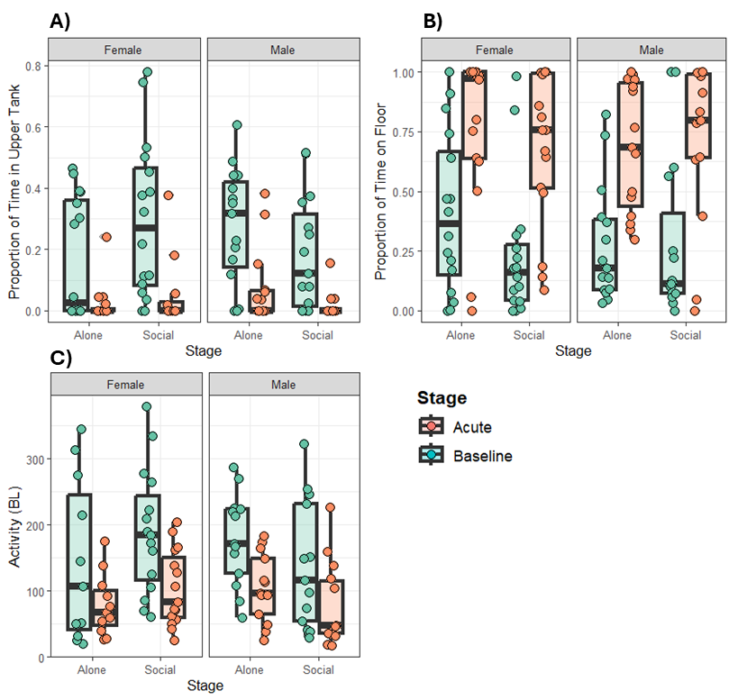
Supplemental Figure S1. Immediate (acute) behavioural responses across all fixed effects (sex, treatment, and stage). Baseline (teal) indicates the five minutes prior to the addition of predator cue; acute (orange) indicates the first five minutes where alarm cues were received. Addition of predator cue led to A) reduced proportion of time in the upper water column; B) increased proportion of time on the floor, and C) reduced activity, measured in distance moved in body lengths.

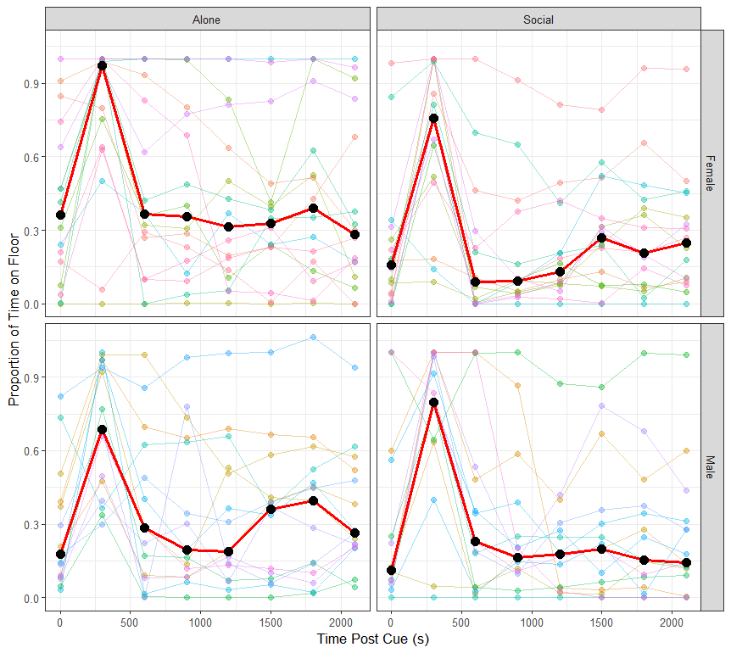
Supplemental Figure. S2. Floor usage across the total time of the trial (0 – 35 minutes). Risk cues were added at time 0, and fish were either able to see a social group (Social) or an empty tank (Alone). Red lines and black dots show the mean of each group at 300 second intervals, lighter lines indicate individuals.

