Supplementary Information
Hormonal modulation of brood allocation underlying evolutionary conflicts in the supercolonial ant Tapinoma darioi
Daniel Altair Saureu Velasco, Patricia González-Lleida & Ricardo Caliari Oliveira*
Departament de Biologia Animal, Biologia Vegetal i Ecologia, Universitat Autònoma de Barcelona, Barcelona, Spain
*Corresponding author: Ricardo.oliveira@uab.cat
Contrast | ratio | SE | z ratio | p value
Control / Methoprene [10] | 0.797 | 0.364 | -0.496 | 1.0000
Control / Methoprene [25] | 0.357 | 0.143 | -2.573 | 0.2119
Control / Methoprene [50] | 0.208 | 0.079 | -4.147 | 0.0007 | ***
Control / Precocene [1] | 1.304 | 0.694 | 0.498 | 1.0000
Control / Precocene [25] | 1.266 | 0.674 | 0.443 | 1.0000
Control / Precocene [50] | 1.057 | 0.528 | 0.110 | 1.0000
Methoprene [10] / Methoprene [25] | 0.447 | 0.201 | -1.789 | 1.0000
Methoprene [10] / Methoprene [50] | 0.261 | 0.112 | -3.125 | 0.0374 | *
Methoprene [10] / Precocene [1] | 1.635 | 0.932 | 0.862 | 1.0000
Methoprene [10] / Precocene [25] | 1.588 | 0.905 | 0.811 | 1.0000
Methoprene [10] / Precocene [50] | 1.325 | 0.716 | 0.521 | 1.0000
Methoprene [25] / Methoprene [50] | 0.583 | 0.215 | -1.463 | 1.0000
Methoprene [25] / Precocene [1] | 3.657 | 1.926 | 2.462 | 0.2903
Methoprene [25] / Precocene [25] | 3.551 | 1.871 | 2.406 | 0.3385
Methoprene [25] / Precocene [50] | 2.964 | 1.464 | 2.199 | 0.5858
Methoprene [50] / Precocene [1] | 6.275 | 3.202 | 3.599 | 0.0067 | **
Methoprene [50] / Precocene [25] | 6.094 | 3.109 | 3.542 | 0.0083 | **
Methoprene [50] / Precocene [50] | 5.085 | 2.423 | 3.413 | 0.0135 | *
Precocene [1] / Precocene [25] | 0.971 | 0.614 | -0.046 | 1.0000
Precocene [1] / Precocene [50] | 0.810 | 0.491 | -0.347 | 1.0000
Precocene [25] / Precocene [50] | 0.835 | 0.505 | -0.299 | 1.0000

Table S1. Pairwise contrasts the different treatments in relation to brood production and treatment concentrations in Tapinoma darioi. Significance levels generated through a Tukey post hoc test. Significant p values are highlighted in bold. *p < 0.05; **p<0.01; ***p<0.001. Df = 29. Queens treated with the highest concentration of methoprene showcase significantly reduced brood production when compared to the control (methoprene [50] - control, t = -3.388, p < 0.05), most likely due to the physiological toxicity high doses of this molecule can have in insects. Interestingly, probability of larvae cannibalization is significantly higher in this group when compared to the control (methoprene [50] - control, z = 5.437, p < 0.001; Table S2) despite the lower amount of brood present in its colonies.
Contrast | estimate | SE | z ratio | p value
Methoprene [10] - Methoprene [25] | -0.033 | 0.006 | -5.204 | <0.0001 | ***
Methoprene [10] - Methoprene [50] | -0.080 | 0.012 | -6.431 | <0.0001 | ***
Methoprene [10] - Precocene [1] | 0.012 | 0.007 | 1.798 | 0.5490
Methoprene [10] - Precocene [25] | -0.012 | 0.006 | -1.954 | 0.4446
Methoprene [10] - Precocene [50] | -0.004 | 0.006 | -0.575 | 0.9975
Methoprene [10] - Control | -0.012 | 0.005 | -2.532 | 0.1479
Methoprene [25] - Methoprene [50] | -0.047 | 0.013 | -3.616 | 0.0056 | **
Methoprene [25] - Precocene [1] | 0.045 | 0.008 | 5.702 | <0.0001 | ***
Methoprene [25] - Precocene [25] | 0.021 | 0.007 | 2.872 | 0.0621
Methoprene [25] - Precocene [50] | 0.029 | 0.007 | 3.991 | 0.0013 | **
Methoprene [25] - Control | 0.021 | 0.006 | 3.254 | 0.0195 | *
Methoprene [50] - Precocene [1] | 0.092 | 0.013 | 6.943 | <0.0001 | ***
Methoprene [50] - Precocene [25] | 0.068 | 0.013 | 5.275 | <0.0001 | ***
Methoprene [50] - Precocene [50] | 0.077 | 0.013 | 5.918 | <0.0001 | ***
Methoprene [50] - Control | 0.068 | 0.012 | 5.473 | <0.0001 | ***
Precocene [1] - Precocene [25] | -0.024 | 0.008 | -3.105 | 0.0313 | *
Precocene [1] - Precocene [50] | -0.016 | 0.008 | -2.023 | 0.3999
Precocene [1] - Control | -0.025 | 0.007 | -3.604 | 0.0058 | **
Precocene [25] - Precocene [50] | 0.008 | 0.007 | 1.160 | 0.9089
Precocene [25] - Control | -0.001 | 0.006 | -0.090 | 1.0000
Precocene [50] - Control | -0.009 | 0.006 | -1.448 | 0.7753

Table S2. Pairwise contrasts among the different treatments related to the probability of larvae cannibalization in Tapinoma darioi. Significance levels generated through a Tukey post hoc test. Significant p values are highlighted in bold. *p < 0.05; **p < 0.01; ***p<0.001

Contrast | ratio | SE | z ratio | p value
Control / Methoprene [10] | 0.797 | 0.364 | -0.496 | 1.0000
Control / Methoprene [25] | 0.357 | 0.143 | -2.573 | 0.2119
Control / Methoprene [50] | 0.208 | 0.079 | -4.147 | 0.0007 | ***
Control / Precocene [1] | 1.304 | 0.694 | 0.498 | 1.0000
Control / Precocene [25] | 1.266 | 0.674 | 0.443 | 1.0000
Control / Precocene [50] | 1.057 | 0.528 | 0.110 | 1.0000
Methoprene [10] / Methoprene [25] | 0.447 | 0.201 | -1.789 | 1.0000
Methoprene [10] / Methoprene [50] | 0.261 | 0.112 | -3.125 | 0.0374 | *
Methoprene [10] / Precocene [1] | 1.635 | 0.932 | 0.862 | 1.0000
Methoprene [10] / Precocene [25] | 1.588 | 0.905 | 0.811 | 1.0000
Methoprene [10] / Precocene [50] | 1.325 | 0.716 | 0.521 | 1.0000
Methoprene [25] / Methoprene [50] | 0.583 | 0.215 | -1.463 | 1.0000
Methoprene [25] / Precocene [1] | 3.657 | 1.926 | 2.462 | 0.2903
Methoprene [25] / Precocene [25] | 3.551 | 1.871 | 2.406 | 0.3385
Methoprene [25] / Precocene [50] | 2.964 | 1.464 | 2.199 | 0.5858
Methoprene [50] / Precocene [1] | 6.275 | 3.202 | 3.599 | 0.0067 | **
Methoprene [50] / Precocene [25] | 6.094 | 3.109 | 3.542 | 0.0083 | **
Methoprene [50] / Precocene [50] | 5.085 | 2.423 | 3.413 | 0.0135 | *
Precocene [1] / Precocene [25] | 0.971 | 0.614 | -0.046 | 1.0000
Precocene [1] / Precocene [50] | 0.810 | 0.491 | -0.347 | 1.0000
Precocene [25] / Precocene [50] | 0.835 | 0.505 | -0.299 | 1.0000

Table S3. Pairwise contrasts among the different treatment’s dilutions and queen survivorship in Tapinoma darioi. Significance levels generated through a Tukey post hoc test. Significant p values are highlighted in bold. *p < 0.05; **p < 0.01; ***p<0.001
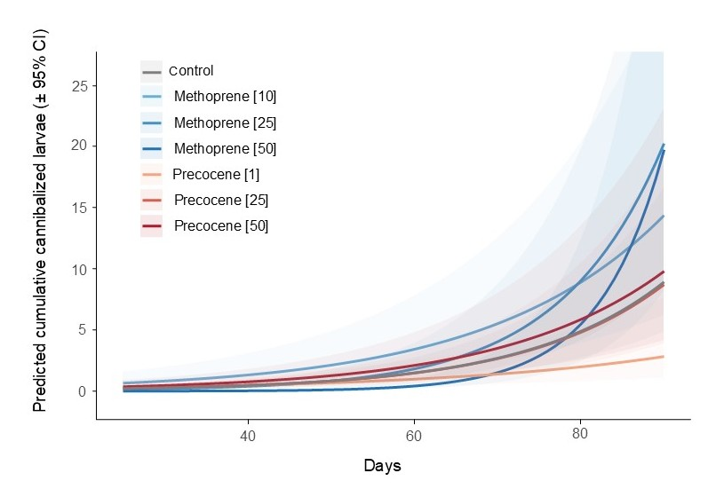
Fig. S1 Treatment of Tapinoma darioi queens with methoprene increases the likelihood of larvae being cannibalized. The figure shows the probability of larvae being cannibalized by workers throughout the experiment, with 95% confidence intervals derived from a negative binomial GLMM. Different shades of blue represent the 10 μg/μl, 25 μg/μl and 50 μg/μl methoprene treatments, shades of red the 1 μg/μl, 25 μg/μl and 50 μg/μl precocene groups, and grey for the control.
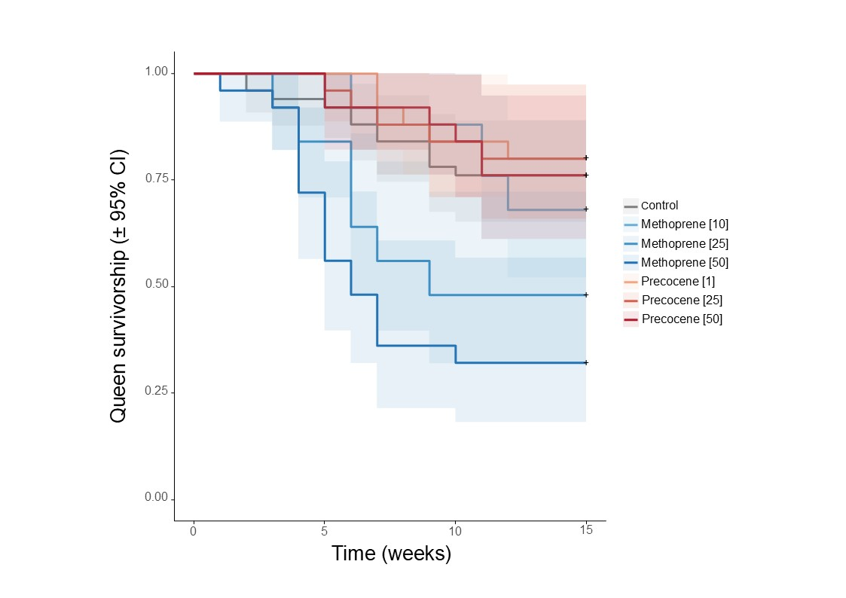
Fig. S2 Treatment effect on queen lifespan during our experiment in the ant Tapinoma darioi. Probability of queen survivorship is depicted throughout the entire experiment (0-15 weeks) based on a Cox proportional hazards model. Different lines represent each treatment studied during the bioassay, with shades of blue indicating the 10 μg/μl, 25 μg/μl and 50 μg/μl methoprene concentrations, shades of red representing the 1 μg/μl, 25 μg/μl and 50 μg/μl precocene concentrations, and grey for the control.

