Predatory crows use behavioural flexibility to overcome a novel, toxic prey
Behavioural Ecology and Sociobiology
Stephanie Deering¹, Martin J. Whiting², J. Sean Doody³, Richard P. Duncan¹, Harry Fryer, Simon Clulow¹
- Centre for Conservation Ecology and Genomics, Institute for Applied Ecology, University of Canberra, Bruce, ACT, Australia
- School of Natural Sciences, Macquarie University, Sydney, NSW, Australia
- Department of Integrative Biology, University of South Florida, St. Petersburg, United States

Corresponding author:
Stephanie Deering: Steph.Deering@canberra.edu.au
Supplementary material
Table S1: Raw data of all trials deployed in the East Kimberley including estimated year of cane toad invasion at each site, the treatments deployed, the number of trials per site (per treatment), the number of days at a site, the number of crow interactions and the number of trials that had known outcomes of the prey item.

Site | Estimated year of cane toad invasion | Treatment | No. of trials at site per treatment | No. of days of repeats at site | No. of crow interactions with prey item | No. of known end point of prey remains
Chamberlain jetty | 2012 | Excised | 1 | 1 | 0 | 1
Chamberlain jetty | 2012 | Intact | 2 | 2 | 0 | 0
Doon doon station | 2012 | Excised | 1 | 1 | 1 | 1
Doon doon station | 2012 | Intact | 1 | 1 | 1 | 1
Doon doon station | 2012 | Native | 2 | 1 | 2 | 1
Doon doon station | 2012 | Painted | 2 | 1 | 2 | 2
El questro camp | 2012 | Excised | 4 | 4 | 2 | 2
El questro camp | 2012 | Intact | 8 | 7 | 4 | 3
El questro camp | 2012 | Native | 2 | 2 | 2 | 0
El questro camp | 2012 | Painted | 3 | 3 | 2 | 0
El questro tip | 2012 | Excised | 4 | 2 | 4 | 0
El questro tip | 2012 | Intact | 4 | 2 | 4 | 0
El questro tip | 2012 | Native | 4 | 2 | 4 | 0
El questro tip | 2012 | Painted | 4 | 2 | 4 | 1
Emma gorge tip | 2012 | Excised | 4 | 3 | 4 | 2
Emma gorge tip | 2012 | Intact | 4 | 3 | 4 | 2
Emma gorge tip | 2012 | Native | 2 | 2 | 2 | 1
Emma gorge tip | 2012 | Painted | 2 | 2 | 2 | 1
Fitzroy crossing tip | 2019 | Excised | 2 | 1 | 1 | 2
Fitzroy crossing tip | 2019 | Intact | 2 | 1 | 2 | 1
Fitzroy crossing tip | 2019 | Native | 1 | 1 | 0 | 1
Fitzroy crossing tip | 2019 | Painted | 1 | 1 | 1 | 1
Gibb river road information stop | 2012 | Painted | 1 | 1 | 0 | 0
Halls creek campsite | 2014 | Excised | 1 | 1 | 1 | 1
Halls creek campsite | 2014 | Intact | 2 | 1 | 1 | 1
Halls creek campsite | 2014 | Native | 1 | 1 | 1 | 0
Halls creek campsite | 2014 | Painted | 2 | 1 | 1 | 2
Halls creek tip | 2014 | Excised | 2 | 1 | 2 | 2
Halls creek tip | 2014 | Intact | 1 | 1 | 0 | 0
Halls creek tip | 2014 | Native | 1 | 1 | 0 | 0
Halls creek tip | 2014 | Painted | 2 | 1 | 0 | 0
Hoochery distillery | 2010 | Excised | 2 | 2 | 1 | 0
Hoochery distillery | 2010 | Intact | 1 | 1 | 0 | 0
Hoochery distillery | 2010 | Native | 1 | 1 | 0 | 0
Hoochery distillery | 2010 | Painted | 1 | 1 | 0 | 0
Information stop | 2010 | Painted | 2 | 1 | 0 | 0
Ivanhoe campsite | 2010 | Painted | 3 | 2 | 0 | 0
Ivanhoe sewage | 2010 | Painted | 2 | 2 | 0 | 0
Kununurra community | 2010 | Excised | 1 | 1 | 1 | 1
Kununurra community | 2010 | Intact | 2 | 1 | 2 | 2
Kununurra community | 2010 | Painted | 1 | 1 | 1 | 1
Kununurra tip | 2010 | Excised | 7 | 4 | 2 | 0
Kununurra tip | 2010 | Intact | 7 | 4 | 6 | 3
Kununurra tip | 2010 | Native | 7 | 4 | 5 | 2
Kununurra tip | 2010 | Painted | 7 | 4 | 3 | 2
Mary's pool campsite | 2016 | Excised | 1 | 1 | 1 | 1
Mary's pool campsite | 2016 | Intact | 2 | 1 | 2 | 2
Mary's pool campsite | 2016 | Native | 1 | 1 | 1 | 0
Mary's pool campsite | 2016 | Painted | 1 | 1 | 0 | 0
Middle springs | 2010 | Intact | 2 | 1 | 1 | 2
Molly springs | 2010 | Native | 1 | 1 | 1 | 0
Parry's farm | 2011 | Excised | 3 | 2 | 0 | 0
Parry's farm | 2011 | Intact | 3 | 2 | 0 | 0
Parry's farm | 2011 | Native | 2 | 2 | 0 | 0
Parry's farm | 2011 | Painted | 2 | 2 | 0 | 0
Road site el questro | 2012 | Excised | 1 | 1 | 0 | 0
Tarunda campsite | 2019 | Excised | 1 | 1 | 1 | 1
Tarunda campsite | 2019 | Intact | 2 | 1 | 2 | 1
Tarunda campsite | 2019 | Native | 2 | 1 | 2 | 2
Tarunda campsite | 2019 | Painted | 1 | 1 | 1 | 1
Warmun roadhouse station | 2012 | Excised | 1 | 1 | 1 | 0
Warmun roadhouse station | 2012 | Intact | 1 | 1 | 1 | 0
Warmun roadhouse station | 2012 | Native | 1 | 1 | 1 | 0
Warmun roadhouse station | 2012 | Painted | 1 | 1 | 1 | 1
Wyndham abandoned lot | 2012 | Excised | 2 | 1 | 2 | 1
Wyndham abandoned lot | 2012 | Intact | 1 | 1 | 1 | 1
Wyndham abandoned lot | 2012 | Native | 1 | 1 | 1 | 0
Wyndham abandoned lot | 2012 | Painted | 1 | 1 | 1 | 1
Wyndham tip | 2012 | Excised | 1 | 1 | 0 | 0
Wyndham tip | 2012 | Painted | 1 | 1 | 1 | 1

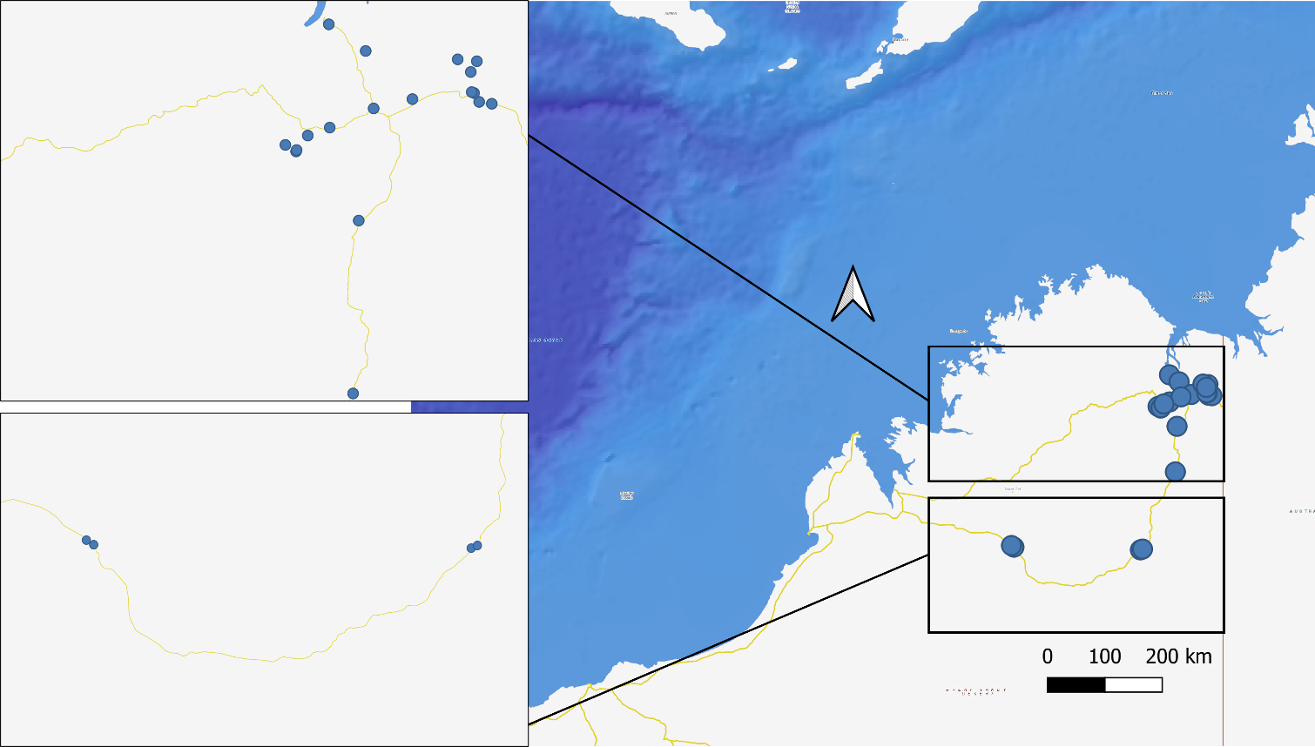

Fig. S1: Area map of feeding station locations within the East Kimberley region of Western Australia

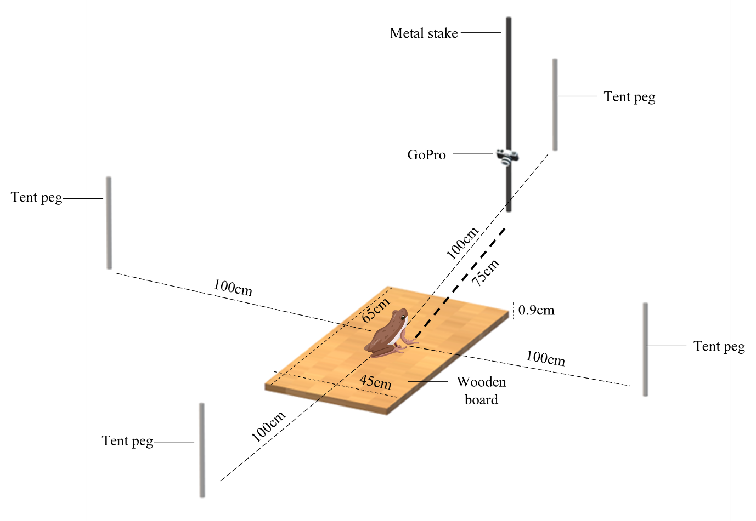

Fig. S2: Feeding stations consisted of a wooden board (650 x 450 x 9 mm) placed on the ground with a 9 mm eyelet attached to its centre. We drove a metal stake into the ground 75 cm from the short edge of the board and attached a GoPro Hero 7 to the stake 25 cm above the ground to record crow feeding behaviour. We placed four metal tent pegs in the ground, located directly outward from each edge of the wooden board at 1 m from the board’s centre. We used the tent pegs as a visual boundary when reviewing camera footage to identify when a crow had entered the feeding station.
S1: Methods: Data analysis
Crows did not interact with the prey item at 56 of the 153 (37%) feeding stations, so we eliminated these from our analysis, which removed seven sites. At the remaining 97 sites where crows interacted with the prey item, we aimed to collect data on the outcome of prey consumption. This required that there were either remnants of the prey item left unconsumed at the feeding station, or that we were able to observe via video that the entire prey item had been consumed. We eliminated a further 48 feeding station trials where crows removed the prey item from the board and had left the video camera view before we could determine the outcome. Because feeding stations were presented in the wild, there were often several crows attempting to grab the prey item, precluding us from scoring behaviours objectively. Also, we could not individually identify crows as they moved in and out of frame, again constraining video scoring. Consequently, we focused instead on scoring how much of the prey item was consumed and which parts were avoided—the video footage was useful for this.

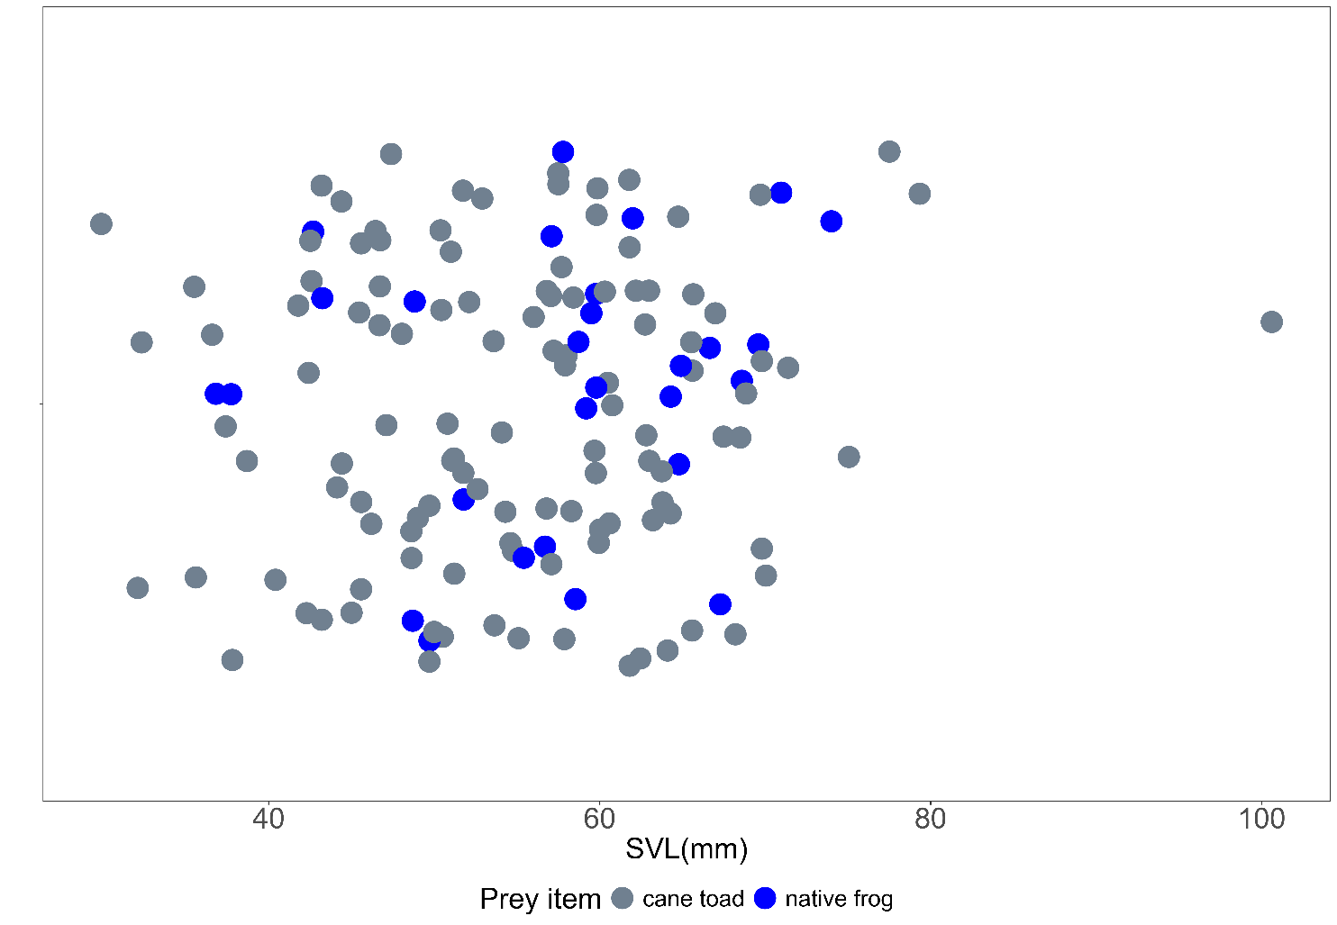
Fig, S3: Snout-vent-length (SVL) measurements (mm) between prey items (native frog, cane toad) of all trials.
Table S2: Posterior estimates generated in bayesian analysis between each treatment (‘native’, ‘intact cane toad’, ‘toad with glands excised’ and ‘toad with glands excised and toxin smeared back into the area’) and the probability of consuming toxic regions of the prey item. All probabilities were transformed from the logit scale.

Treatment | Estimate (Logit) | SE | Lower 95% CI (logit) | Upper 95% CI (Logit)
Native frog | 2.5 | 1.28 | 0.27 | 5.17
Intact cane toad | -2.26 | 0.81 | 4.02 | -0.85
Toad no glands | 3.31 | 1.16 | 1.32 | 5.88
Toad no glands, toxin smeared | 0.25 | 0.69 | 1.16 | 1.60

Table S3: Output of Bayesian model (±95% credible intervals) comparing differences in outcomes (the likelihood of consuming the toxic regions of the prey (head, glands, dorsal skin) between treatment groups of cane toads (intact, excised and painted) to native frogs as the reference.
Treatment | Estimate | Estimated error | Lower 95% CI (logit) | Upper 95% CI (Logit)
Native frog | 1.87 | 0.96 | 0 | 3.88
Intact cane toad | -3.90 | 1.08 | -6.12 | -1.88
Toad no glands | 2.11 | 1.40 | -0.43 | 4.96
Toad no glands, toxin smeared | -1.41 | 1.06 | -3.60 | 0.64

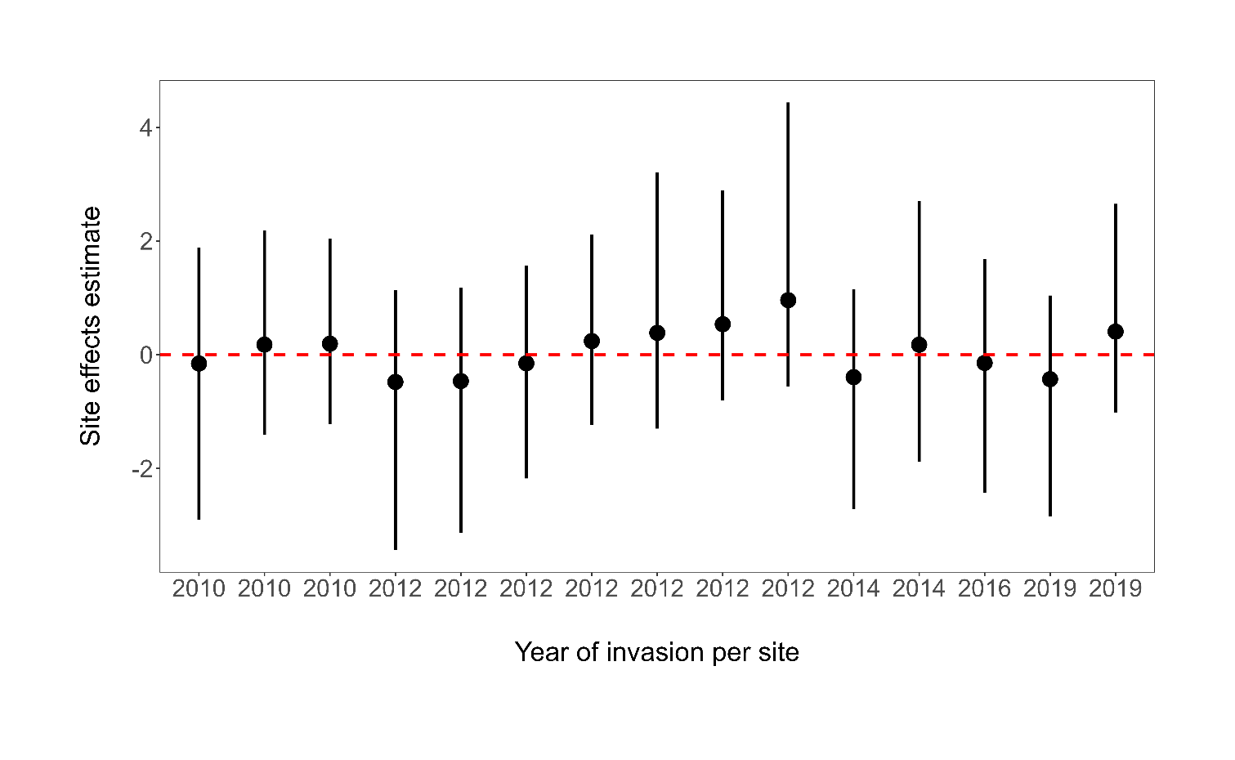
Fig. S4: Site effects estimate over time from 2010 to 2019 using a Bayesian regression model. Each black dot represents an estimate for a given year, with vertical error bars indicating the uncertainty around each estimate. A red dashed line at zero is included for reference. Overlap with the red dashed line is indicative of no difference between the reference and therefore no change.

