Title: Consistent behavioural variation in Asellus aquaticus does not correlate with individual metabolism.

Supplementary materials
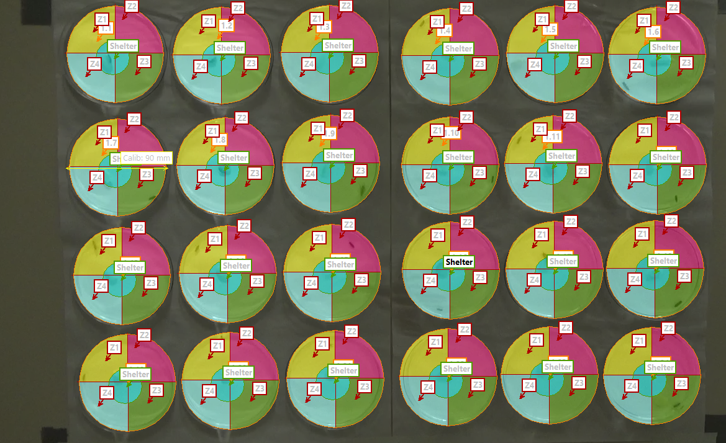
Supplemental figure S1: Image showing the virtual set-up to measure exploration (number of zone visited excluding shelter x sum of zones entries excluding shelter (exploration score)) during 5 minutes with Ethovision in the Petri dishes.
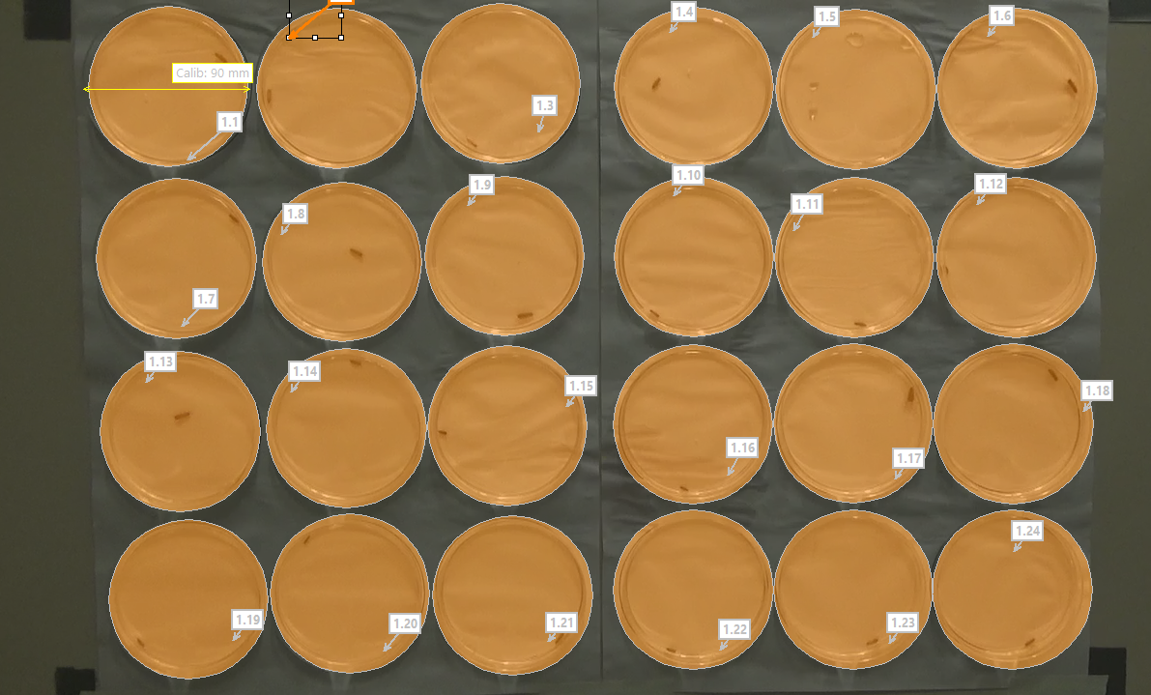
Supplemental figure S2: Image showing the virtual set-up to measure activity (distance moved in mm) during 5 minutes with Ethovision in the Petri dishes.
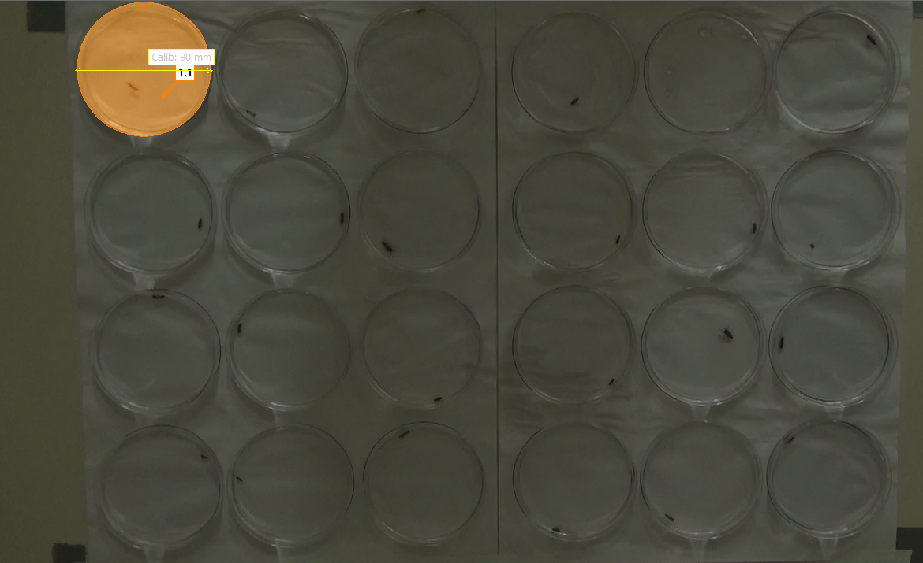
Supplemental figure S3: Image showing the virtual set-up to measure escape behaviour (time spent moving (seconds) after attack simulation) during 5 minutes with Ethovision in the Petri dish.

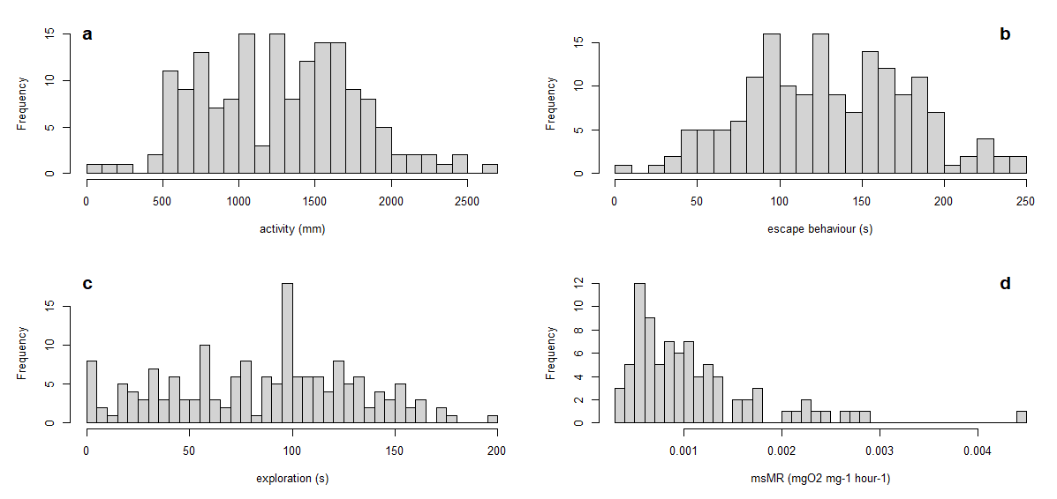
Supplemental figure S4: Frequency distributions (#) of the tested endpoints: (a) activity (mm), (b) escape behaviour (s), (c) exploration (score), and (d) routine mass-specific metabolic rate msMR (mgO₂ mg⁻¹ hour⁻¹) (n = 42x4 for a, b and c and n = 42x2 for d).
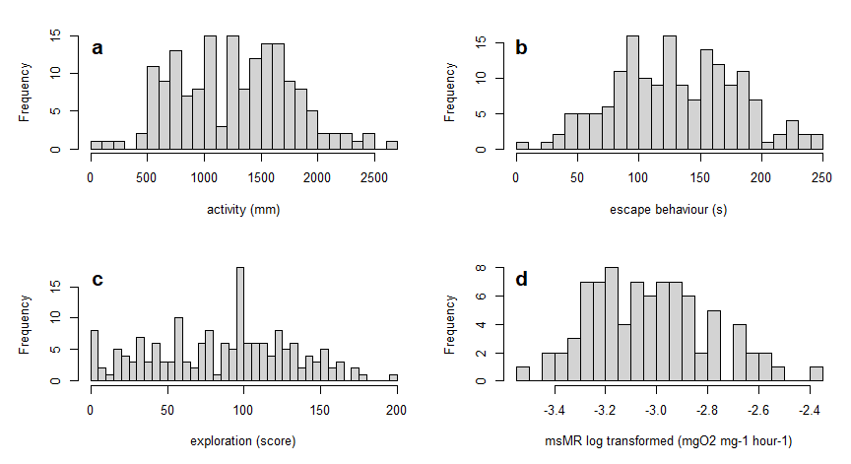
Supplemental figure S5: Frequency distributions (#) of endpoints tested (n = 42x4 for a, b and c and n = 42x2 for d) after transformation to fit normality for statistical analysis. Activity (a), escape behaviour (b) and exploration (c) were not transformed. Mass specific metabolic rate msMR (d) was log-transformed.

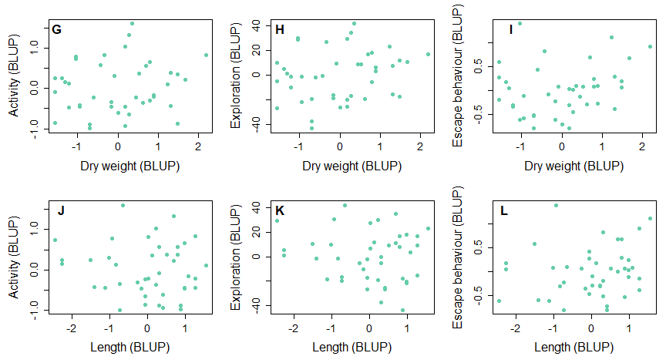
Supplemental figure S6: Correlations between dry weight or length (proxy for age) and all tested behaviours. Pearson correlation coefficients: (G) r = 0.16, p = 0.31 df: 40, (H) r = 0.21, p = 0.19, df: 40, (I) r = 0.23, p = 0.14, df: 40 (J) r = -0.11, p = 0.47, df: 40 (K) r = -0.13, p = 0.42, df: 40, and (L) r = 0.18, p = 0.26, df: 40.
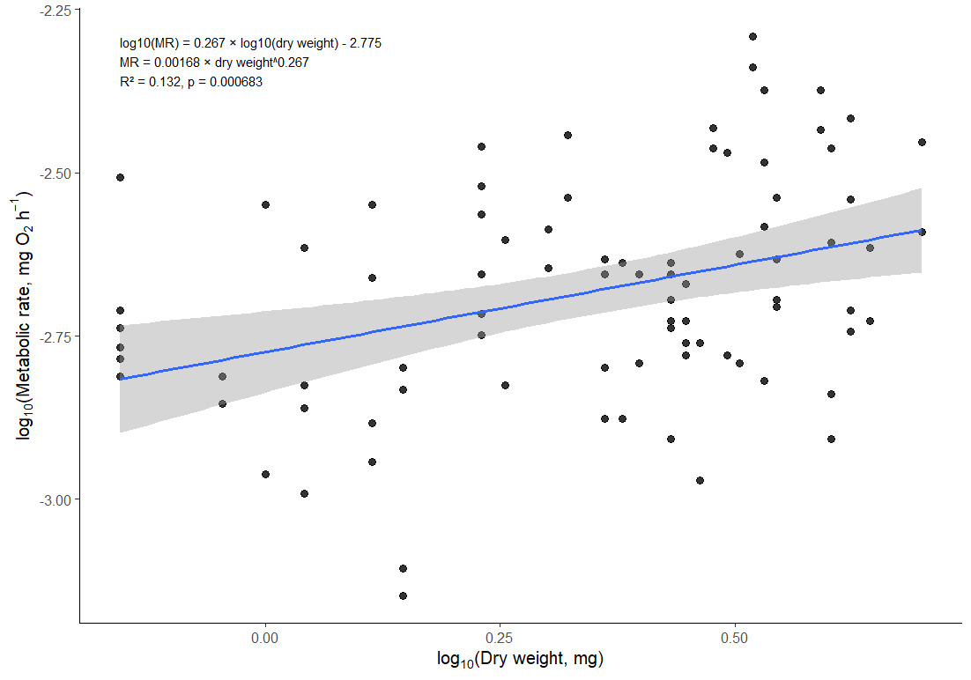
Supplementary Figure S7: Relationship between dry weight (mg) and whole-body metabolic rate (mgO₂/hour) in the 42 Asellus aquaticus individuals included in the experiment. Each point represents one metabolic measurement (two measurements per individual; n=84 observations total). Variables were log10-transformed prior to analysis. The fitted linear regression showed a significant positive relationship between dry weight and metabolic rate (R²=0.132, p < 0.001). The estimated metabolic scaling exponent was b=0.267, and the corresponding scaling coefficient was a=0.00168, yielding the relationship: MR=0.00168 x dry weight^{0.267}.
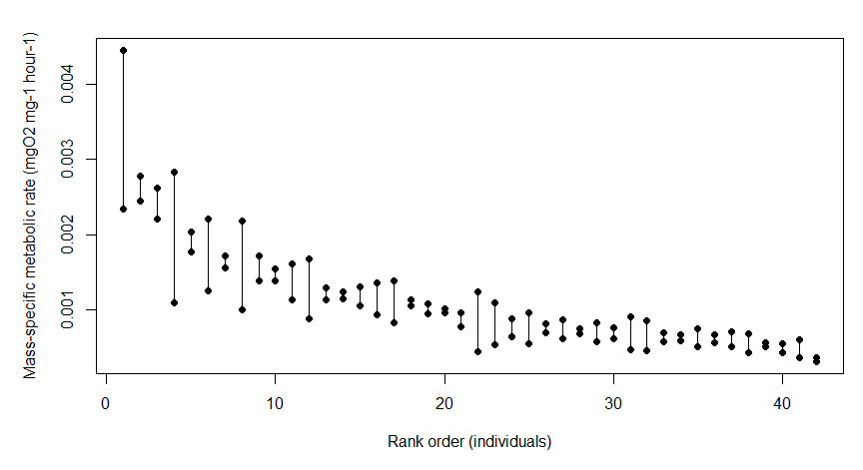
Supplemental info S8: Variation between the two routine metabolic rate measurements (mgO₂ mg⁻¹ hour⁻¹) of the tested Asellus ranked from highest to lowest mean value.

Supplemental table S9: Comparison of coefficients of variation for metabolic rates in different taxonomic groups or species and the Asellus population tested in this study.
Taxonomic group or species | N number or organisms | Inter-individual  Coefficient of Variation % | References
Asellus from our study | 42 | 58 | NA
Gammarus sp. | 10 | 24 | in Becker et al., 2016
Prokaryotes | 173 | 368 | in Makarieva et al., 2008
Protozoa | 52 | 264 | in Makarieva et al., 2008
Insects | 402 | 230 | in Makarieva et al., 2008
Aquatic invertebrates | 376 | 499 | in Makarieva et al., 2008
Crustacea: copepods and krill | 138 | 323 | in Makarieva et al., 2008
Crustacea: peracarids | 86 | 517 | in Makarieva et al., 2008
Crustacea: decapods | 80 | 266 | in Makarieva et al., 2008
Mollusca: cephalopods | 38 | 673 | in Makarieva et al., 2008
Gelatinous invertebrates | 34 | 106 | in Makarieva et al., 2008
Ectothermic vertebrates | 580 | 156 | in Makarieva et al., 2008
Amphibians | 158 | 97 | in Makarieva et al., 2008
Fish | 266 | 208 | in Makarieva et al., 2008
Reptiles | 156 | 130 | in Makarieva et al., 2008
Endothermic vertebrates | 946 | 132 | in Makarieva et al., 2008
Birds | 321 | 101 | in Makarieva et al., 2008
Mammals | 625 | 120 | in Makarieva et al., 2008
Cyanobacteria | 25 | 390 | in Makarieva et al., 2008
Eukaryotic microalgae | 47 | 161 | in Makarieva et al., 2008
Eukaryotic macroalgae | 88 | 426 | in Makarieva et al., 2008
Vascular plants: green leaves | 271 | 89 | in Makarieva et al., 2008
Vascular plants: tree saplings | 4 | 59 | in Makarieva et al., 2008
Vascular plants: seedlings | 42 | 47 | in Makarieva et al., 2008

