8. Supplementary Materials

8.1 Interview Guide and Questionnaire
Student Investigator: Nathanael Bergbusch
Study Title: Integrating Environmental and Cultural Flows within Impact Assessment through Dialogue with Experts and Practitioners in Canada to Inform Sustainable Decision-Making
Study Duration: June to August 2022 (Phase One) and September to November 2022 (Phase Two)
Interview Durations: 45 min to an hour and 15 min
Interview Location: Zoom
Phase One: Script for Interviews with E-flows Experts, Researchers, and Practitioners
Thank you for joining me for this interview to discuss perceptions around environmental and cultural flows and impact assessment in Canada. I have sent you a document about impact assessment prior to this interview to provide background information. First, I will begin with some demographic and preliminary inquiries.
Demographic/Preliminary inquiries:
- Where, geographically, are you currently based?
- What is your current occupation (e.g., professor, environmental consultant)? Please do not indicate the organization that you work for you.
- What is your experience with environmental or cultural flows in Canada?
- What is your experience with impact assessment in Canada?
Main inquiries:
Today’s interview and this study are intended to discuss how environmental and cultural flows approaches are currently integrated within impact assessment and how they might be integrated so that planning and implementation of developments are better informed about the interests of downstream or regional communities and ecosystems.
Topic I: Regional impacts to communities and ecosystems
- Do you believe that Canada (and/or particular sub-national jurisdictions) adequately include(s) attention to regional or downstream communities and ecosystems in industrial development decisions? Why or why not?
- Do you have any concerns with how Canada (and/or particular sub-national jurisdictions) currently evaluates (predicts in impact assessments and/or monitors/manages post-approval) development impacts on regional or downstream communities and ecosystems? Please describe.
- What do you perceive as needed additions to how Canada deals with regional impacts, especially on waterways?
Topic II: Environmental and cultural flows
- Please describe what environmental flows and cultural flows mean to you.
- How are environmental and cultural flows related to downstream or regional communities and ecosystems? Please describe.
Topic III: Integrating E-Flows and impact assessment
- How have you seen eflows considered in environmental impact assessment? Or how have you used eflows in environmental impact assessment in the past? What about cultural flows?
- How would you define cumulative impacts in the context of environmental impact assessment?
- Do you think eflows or cultural flows and cumulative impacts are related?
- There are 200+ environmental flows methods and many cultural flows approaches that are currently in development. Which approaches do you think have the greatest potential to be used in impact assessment? This includes consideration of valued ecosystem components, streamlining assessments, impact predictions and monitoring/management, cumulative effects, existing EIA models, as well as social and biophysical considerations.
- How might certain environmental and cultural flows approaches be used to identify and inform indicators for EIA practitioners examining downstream impacts and cumulative effects?
- For what kinds of projects subject to impact assessment requirements are environmental and cultural flows analyses most likely to be useful?
- Are you aware of ELOHA and SUMHA environmental flow frameworks or other similar frameworks?
- If you are aware of eflows frameworks [and more holistic approaches that engage communities like ELOHA or SUMHA], how might we adapt existing eflows frameworks for impact assessment?
Topic IV: Higher-level decision making
- What use are environmental and cultural flows for decision making?
- What is your understanding of regional and strategic assessment? What do you think of situating project-level assessment in regional and strategic assessment?
- How might environmental flows and cultural flows fit into higher-level assessment (especially regional and strategic level assessments of policy, plan and program matters)?
- Does the consideration of eflows have a place in environmental impact assessment legislation or other related acts and regulations?
- What future directions do you see for eflows or cultural flows implementation in Canada?
Topic V: Rights, consent, and water justice considerations
- How familiar are you with the United Nations Declaration on the Rights of Indigenous People and its implementation in Canada? What about Bill C-15: An Act respecting the United Nations Declaration on the Rights of Indigenous Peoples (commonly known as UNDRIPA)?
- Do you perceive environmental and cultural flows analyses as possible contributions in addressing UNDRIP (especially its provisions requiring free, prior and informed consent) and Indigenous rights in impact assessment? Please elaborate.
Thank you for your responses and time. We appreciate your answers and will send you transcripts of the recordings to verify that we have accurately represented your responses. I will send you a copy of my dissertation or a summary once this it is completed.
Phase Two: Script for Interviews with Environmental Impact Assessment Experts, Researchers, and Practitioners
Thank you for joining me for this interview to discuss perceptions around environmental and cultural flows and impact assessment in Canada. I have sent you a document about environmental and cultural flows prior to this interview to provide background information and potential applications for impact assessment. First, I will begin with some demographic and preliminary inquiries.
Demographic/Preliminary inquiries:
- Where, geographically, are you currently based?
- What is your current occupation (e.g., professor, environmental consultant)? Please do not indicate the organization that you work for you.
- In what capacity have you been involved with impact assessment in Canada?
- How familiar are you with environmental and cultural flows concepts and approaches?
Main inquiries:
Today’s interview and this study are intended to discuss how environmental flows and cultural flows approaches are currently integrated within impact assessment and how they might be integrated so that developments are more inclusive of downstream or regional communities and ecosystems. A previous interview series was completed with environmental flows experts and practitioners to identify how eflows concepts can be applied in impact assessment. This is the second interview series to ask for feedback on these applications and identify gaps in impact assessment practice related to regional or downstream communities and ecosystems. You should have received a document outlining the application of environmental and cultural flows concepts for impact assessment.
Topic I: Regional impacts to communities and ecosystems in impact assessment
- Do you think the current impact assessment process [either federal, provincial, territorial, or Indigenous] addresses downstream or regional impacts well? How does this process address those impacts?
- What gaps do you perceive in project-level, regional, and strategic assessment related to downstream communities and ecosystems?
- What do you perceive as needed additions to how Canada deals with regional impacts, especially on waterways?
Topic II: Impact assessment and environmental and cultural flows
- Were you aware of environmental and cultural flows concepts before this interview?
- How common do you think use of environmental and cultural flows concepts is in impact assessment in Canada? Please describe.
- Which of the identified environmental and cultural flows applications do you think would be most useful in impact assessment to address regional concerns?
- How might environmental and cultural flows address uncertainty in assessment?
- How would you define cumulative impacts in the context of environmental impact assessment?
- What are the challenges with doing good cumulative impacts/effects assessment in Canada?
- Do environmental and cultural flows approaches have the potential to address impact prediction and monitoring difficulties with cumulative impact assessment?
- What are the limitations to applying environmental and cultural flows approaches to impact assessment?
Topic III: Higher-level assessment
- What role, if any, do you think environmental or cultural flows could play in regional or strategic level assessment (on policy, plan and program matters)?
Topic IV: Rights, consent, and water justice considerations
- How familiar are you with the United Nations Declaration on the Rights of Indigenous People and its implementation in Canada? What about Bill C-15: An Act respecting the United Nations Declaration on the Rights of Indigenous Peoples (commonly known as UNDRIPA)?
- How are UNDRIP and Indigenous rights currently addressed in impact assessment?
- Do you perceive environmental and cultural flows analyses as possible contributions in addressing UNDRIP (especially its provisions requiring free, prior and informed consent) and Indigenous rights in impact assessment? Please elaborate.
Thank you for your responses and time. We appreciate your answers and will send you transcripts of the recordings to verify that we have accurately represented your responses. I will send you a copy of my dissertation or a summary once it is completed.

8.2 Supplementary Figures and Tables
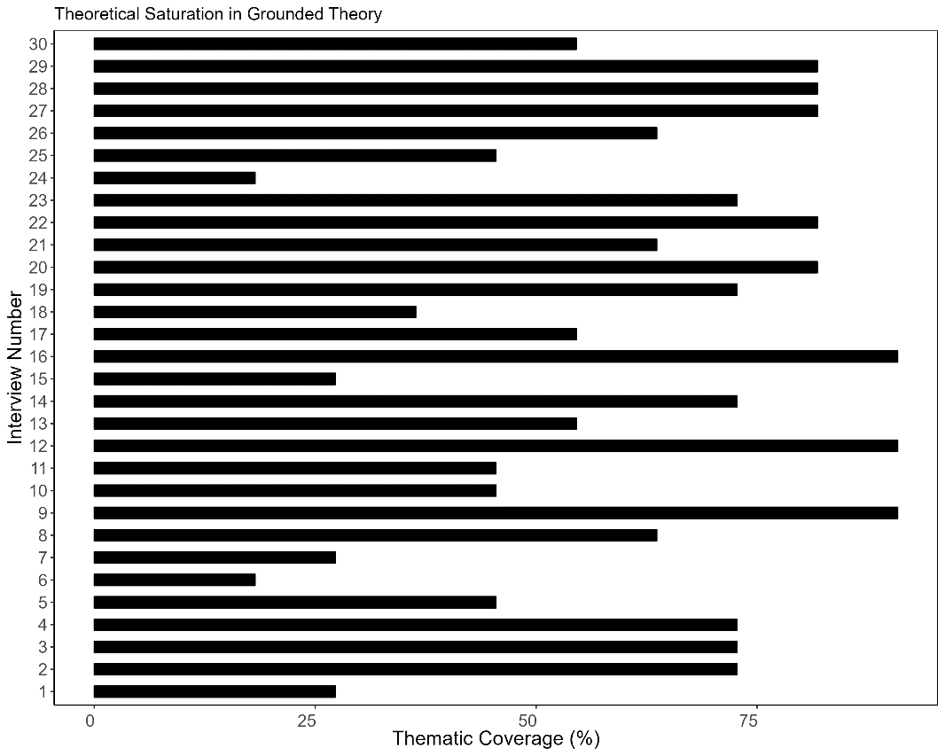
Supplementary Fig. 1 The thematic coverage (%) of grounded theory open codes by interview number. Interviews with greater than 80% coverage are key contributors. This process reached theoretical saturation in that, over the course of 30 interviews, 91% of themes were mentioned in three key contributor interviews and 81% of themes were mentioned in six additional key contributor interviews (Supplementary Figure 1). In addition, greater than 90% of total major themes emerged within the first six to nine interviews

Supplementary Table. 1 Acts, policies, program initiatives and impact assessments included in the scoping review
Federal Acts | Provincial and Territorial Acts | Regulations | Policies and Program Initiatives | Impact Assessments (Completed)
1. Canadian Environmental Protection Act  2. Canadian Navigable Waters Act  3. Canada Water Act  4. Federal Sustainable Development Act  5. Fisheries Act  6. Migratory Birds Convention Act  7. Species at Risk Act  8. Impact Assessment Act | 1. Alberta - Water Act  2. British Columbia - Water Sustainability Act  3. Manitoba - The Water Protection Act  4. New Brunswick - Clean Water Act  5. Newfoundland - Water Resources Act  6. Northwest Territories - Waters Act  7. Nova Scotia - Water Act  8. Nova Scotia - Water Resources Protection Act  9. Nunavut - Nunavut Waters and Nunavut Surface Rights Tribunal Act  10. Ontario - Water Resource Act  11. Prince Edward Island - Water Act  12. Québec - Act respecting compensation measures for the carrying out of projects affecting  wetlands or bodies of water  13. Québec - Act to affirm the collective nature of water resources and to promote better  governance of water and associated environments  14. Québec - Gas, Water and Electricity Companies Act  15. Québec - Water Resources Preservation Act  16. Québec – Dam Safety Act  17. Québec – Watercourses Act  18. Saskatchewan - The Water Security Agency Act  19. Yukon - Waters Act | 1. British Columbia – Water Sustainability Regulation  2. British Columbia – Groundwater Protection Regulation  3. British Columbia - Water Sustainability Fees, Rentals and Charges Tariff Regulation  4. British Columbia - Dam Safety Regulation  5. Prince Edward Island – Water Withdrawal Regulation  6. Prince Edward Island – Water Supply System and Wastewater Treatment System Regulation  7. Prince Edward Island – Well Construction Regulation  8. Prince Edward Island – Sewage Disposal System Regulations | 1. Alberta - Environmental Flows Program  2. Alberta - Environmental Flows Projects  3. Alberta - Future Flows  4. Alberta - Surface water allocation directive-2019  5. British Columbia - Application of Water Allocation Notations to Water Authorizations  6. British Columbia - Beneficial Use Declaration  7. British Columbia - Environmental Flow Needs Policy  8. British Columbia - Refusal of Applications on Over-subscribed Sources  9. British Columbia - Water Authorization Application Assessment and Processing  10. Environmental Flows Guidelines for Resource Development in New Brunswick.  11. New Brunswick - Water Strategy  12. Nova Scotia - Guide to Surface Water Withdrawal Approvals  13. Nunavut - Ayookxw Responding to Climate Change  14. Ontario - Aquatic Ecosystem Assessments for Rivers  15. PEI - Environmental Stream Flow Study  16. PEI - Water Resources Allocation Canada  17. Prairie Water Directive  18. Québec – Water Policy  19. Québec – La Politique de Débits Réservés Ecologiques pour la Protection du Poisson et de ses Habitats  20. Saskatchewan - Water Allocations  21. Saskatchewan – Agriculture Water Management Strategy  22. Saskatchewan – Aquatic Habitat Protection  23. Saskatchewan – Flood Damage Reduction Program  24. Yukon - Yukon Waters: An Assessment of Climate Change Vulnerabilities | 1. Ajax Mine Project  2. All Season Road to Wollaston Lake  3. Blackwater Gold Project  4. Grassy Mountain Coal Project  5. Highwood Storage and Diversion Plan for Little Bow Project  6. Horizon Oil Sands Project  7. Jackpine Mine Expansion Project  8. Joslyn North Mine Project  9. Kemess Underground Project  10. Lower Churchill Hydroelectric Generation Project  11. Marathon Platinum Group Metals and Copper Mine Project  12. Milton Logistics Hub Project  13. Mount Milligan Gold Copper Mine  14. New Prosperity Gold-Copper Mine  15. Rainy River Project  16. Site C Dam  17. Springback Off-Stream Reservoir  18. Tazi Twe Hydroelectric Project  19. Valentine Gold Project

Supplementary Table. 2 Summary of joint panel review assessment reports led by the panel and Agency from 2000-2022 that consider environmental and cultural flows to some degree
Number of Joint Panel Reviews by Jurisdiction | Project Type | Water Body | Water Flow Term and Method | Valued Components Related to Flows | Spatial Extent | Collaboration  and  Regional Plans | Actions
- Initial search (n = 39)  - After exclusion (n = 19)  Jurisdiction:  - BC (6)  - AB (6)  - ON (3)  - NFLD (2)  - SK (2) | - Mines (11)  - Dams (6)  - Oil/Gas (1)  - Road (1)  - Logistics hub (1)  Examples:  - Horizon Oil Sands Project  - Lower Churchill Hydroelectric Project  - Grassy Mountain Project | - Rivers (19)  - Lakes (8)  Examples:  - Elbow River  - Peace River  - Lower Churchill River  - Joslyn Lake and Creek  - Wollaston and Hatchet Lakes | Term  - Instream flow needs (5)  - Base flow (4)  - Ecological flow (1)  - Environmental flow (6)  - Water flow with some relation to ecosystem (4)  - Aboriginal base and extreme flows (1)  Method  - Hydrologic (5)  - Hydraulic and Habitat Simulation (3)  - Tessman method (1)  - Flood Scenarios (1)  - Mean Annual Flow (1)  - Not specified (9) | - Fish and fish habitat (14)  - Surface water quality and quantity (5)  - Groundwater quality and quantity (3)  - Riparian area (2)  - Sediment transport (3)  - Navigation and access (6)  - Traditional use (6)  - Rights (3)  - Heritage (2)  - Water licence holders (1) | - Localized to project area (15)  - Sub-watersheds (1)  - Greater than 10 km (4) | - Collaborations with Indigenous Nations (5)  - Referenced regional plans (3)  Examples:  - Athabasca River Management Plan (2)  - Yinka Dene Water Management Policy (1) | - Create management plan or strategy (3)  - Adjustment to management plan (1)  - Create adaptive management plan (1)  - Follow-up monitoring program and studies (9)  - Ongoing consultation (4)  - Limit withdrawal to < 10% (1)  - Fisheries offsetting or riparian compensation plan (4)  - Manage water depth to maintain fish passage (1)  - Develop low flow trigger (1)  - Update report in the context of the importance of water to Indigenous governance (1)  - Future flow scenarios (1)  - Ensure adequate sediment control structures (1)

8.3 Codebooks
Codebook. 1 Descriptions of demographic indicators for contributors’ positionality
Demographic Indicator | Definition
Background
Environmental or Cultural Flow/Water | Experience working in the field of environmental and cultural flow/water as a practitioner, policy-maker, or researcher.
Impact Assessment | Experience as a practitioner, regulator, policy-maker, or researcher within water-related impact assessment.
Expertise
Hydrogeomorphological | Engineers and modellers working on water allocation and hydrology and the relationships to geology and river/lake morphology.
Biophysical | Freshwater and estuarine biologists working on fish, habitat, contaminant transport, invertebrates, and algae and cyanobacteria and relationships to water allocation and hydrology.
Socio-Cultural-Economic | Social scientists with experience in qualitative investigation of people’s experiences with water allocation and hydrology.
Social-Ecological | Natural and social scientists offering systems perspectives on water quantity, quality, and socio-economic perspectives.
Rights-Based | Experts in rights-based analysis and forms of assessment related to how water allocation and hydrology affect the practice of Inherent and Treaty Rights.
Assessment Experience
Project-level | Those involved in project-level assessments for individual developments.
Regional-Strategic | Those involved in or who have experience in evaluating regional-strategic assessments.
Policy and Reviewer | Those designing policies or reviewing policies and projects for their organization.
Law and Regulatory | Legal experts or regulators for governmental organizations.
Researcher on Theory and Practice | Scholars researching impact assessment, environmental and cultural flows, or water sustainability more broadly.
Practitioner | Consultants carrying out part of a water-related impact assessment.
Supporting or Representing Communities | Individuals that are part of or are supporting Indigenous Nations in assessment or water management matters.
Part of Land Management Board | Individuals who sit on Land Management Boards in the Territories

Codebook. 2 Descriptions of emergent thematic codes corresponding to figure 1 – issues in impact assessment that require positive action. Themes emerged from conversations with contributors but were also inspired, in part, by impact assessment literature in the references section (e.g., Blakley et al. 2020)
Inductive thematic code | Description
Capacity and funding | Not enough monetary support or a lack of process in impact assessment and engagement to include regional and downstream Rights holders and stakeholders.
Data gaps | Lacking regional watershed information and data or a process to collate and synthesize natural and social science information and data.
Disciplinary siloes | Compartmentalization of impact assessment disciplines (physical, biophysical, socio-economic) with effort to coordinate but difficulties in practice.
Governance negotiation | The need to negotiate governance goals for watersheds ahead of impact assessments to identify if projects interfere with the ability to govern by rightsholders.
Scoping disagreements | Contention over chosen spatial, temporal, and contextual (institutions/organizations to include) scales to determine impacts on valued components.
Limited regulatory oversight | No legislation to protect environmental and cultural flows and water or broader water goals in impact assessment.
Political bias | Regional political agendas and economic motivations interfering with proper assessment of proposed projects or dictating which projects require assessments.
Screening projects | Determining which projects require assessments based on their perceived risk.
Unclear jurisdictional authority | Multiple jurisdictions with overlapping authority to trigger assessment, regulate assessment components (the Fisheries Act, the Navigable Water Acts, etc.), or influence decisions that are independent of assessments but influence cumulative stressors.
No existing thresholds | No consensus on limits for water levels, flow, withdrawal, or quality within a region.
Unclear assessment triggers | Criteria that trigger assessments allow projects to move ahead if they are able to circumvent requirements.
Unsatisfactory engagement | Engagement processes that inform communities rather than create mutually beneficial partnerships.
Inattention to cumulative effects | Minimal consideration of broader cumulative effects of multiple project developments within a region.

Codebook. 3 A description of emergent thematic codes related to the application of environmental-cultural flows planning in impact assessments. Themes emerged from conversations with contributors, but the generation of themes was also informed by existing literature
Thematic code | Description | Inspiration Source
Knowledge sharing | The ability to exchange knowledge about water in a generative way through proactive sharing spaces ahead of assessment. | E.g., Jimmy et al. 2019
Water standards | Developing water standards based on evaluating the sensitivity, importance, and sacredness of water bodies. | E.g., WWF-Canada 2017
Cumulative effects | Examining the cumulative effects of water abstraction, drainage, and pollution for assessment of designated and undesignated projects ahead of new development. | E.g., Blakley and Russell 2021
Early collaboration | Building up the pre-planning phase of impact assessments for greater appreciation of sustainability, strategic, and regional considerations. | E.g., Gibson et al. 2020
Baseline | Understanding hydro-social-ecological information needed to centre a project development within the watershed. | E.g., Douglas et al. 2019
Inclusive scoping | Broadening the temporal, spatial, and contextual/institutional scales of impacts assessments based on water cycles and transboundary relationships. | E.g., Sultana 2018
Rights and culture | Appreciating impacts to rights and culture for those downstream of development decisions. | E.g., Morgan 2012
Screening projects | Determining what projects should undergo assessments and be approved based on the creation of a water development space. | E.g., King and Brown 2018
Systems thinking | Including greater appreciation of social-ecological systems and related frameworks in assessments in watersheds. | E.g., Ostrom 2009
Tiering | Setting goals at the regional/watershed level, using that information to inform plans, programs, policies, and projects, and then testing success on the ground and informing water supply and allocation strategies at a higher level. | E.g., Arts et al. 2011
Water Relationships | Understanding how communities relate to and steward water systems, both through tangible and intangible expressions. | E.g., Craft and King 2021

