From Coalfields to Carbon Sinks: Examining the Dynamics of Ecosystem Services in the Watersheds of Eastern Kentucky, USA, and their Policy Implications
Shreesha Pandeya¹*, Buddhi Gyawali¹, Suraj Upadhaya¹, Maheteme Gebremedhin¹, Demetrio Zourarakis²
¹College of Agriculture, Health and Natural Resources, Kentucky State University, Frankfort, KY, 40601, USA
²Martin-Gatton College of Agriculture, Food and Environment, University of Kentucky, Lexington, KY, 40546, USA

*Corresponding Author:
Shreesha Pandeya
School of Agriculture and Natural Resources
College of Agriculture, Health and Natural Resources
Kentucky State University, Frankfort, KY 40601
Email : shreesha.pandeya1@kysu.edu

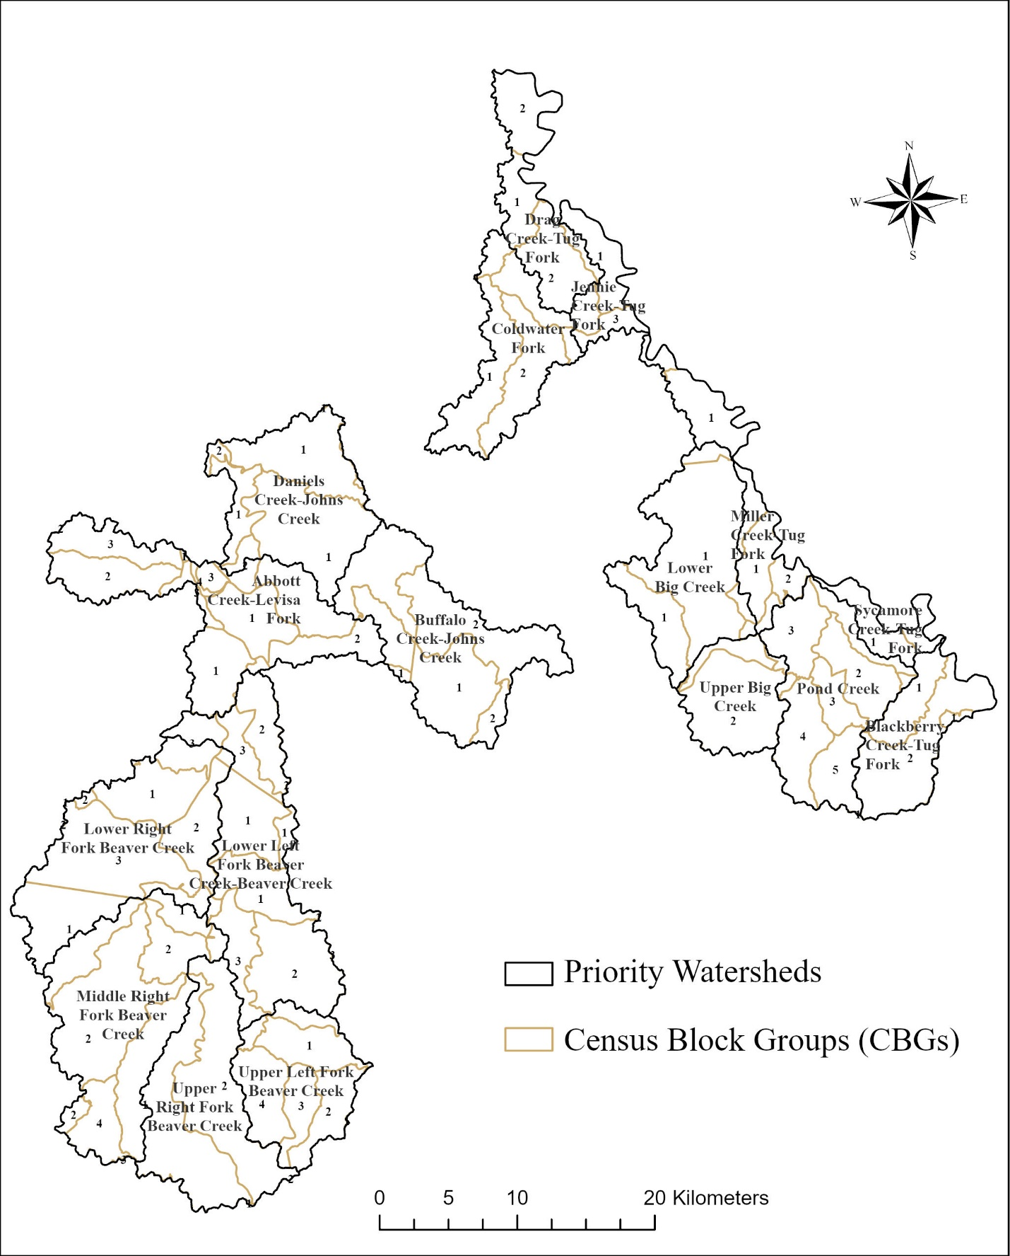
Figure S1. Priority watersheds at HUC-12 of the Big Sandy River Basin.
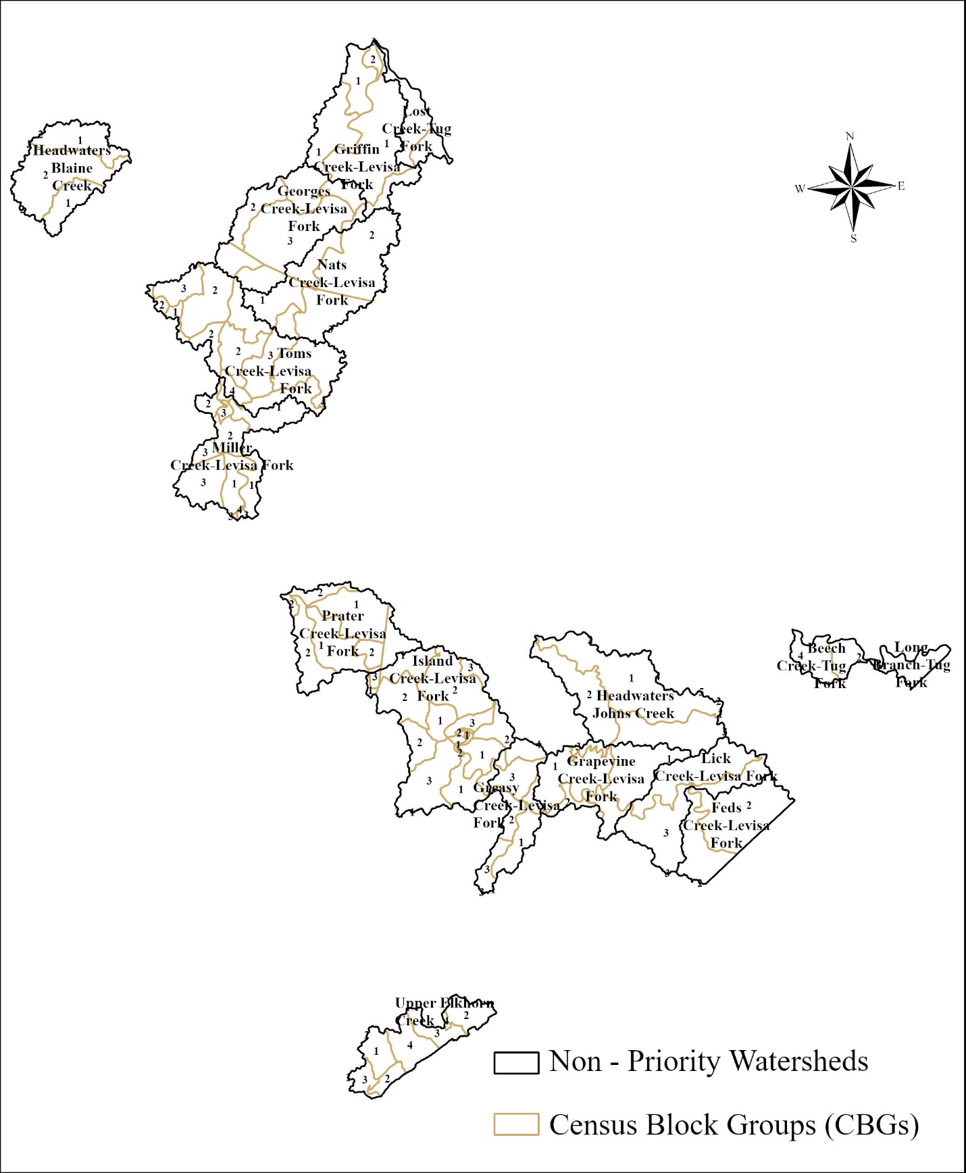
Figure S2: Non-priority watersheds at HUC-12 of the Big Sandy River Basin.

Table S1: Carbon pool coefficients used for the InVEST model.
LULC | Aboveground Carbon (Mg C/ ha) | Belowground (Mg C/ ha) | Soil OM | Dead OM
Water | 0.00 | 0.00 | 0.00 | 0.00
Developed | 5.06 | 2.10 | 31.13 | 1.50
Barren | 0.00 | 0.00 | 2.50 | 0.00
Forest | 118.51 | 57.00 | 72.39 | 22.18
Shrubland | 20.42 | 12.52 | 69.58 | 7.92
Herbaceous(grassland) | 21.64 | 13.38 | 64.58 | 8.21
Pasture and cultivated | 28.96 | 15.74 | 57.14 | 10.21
Wetlands | 117.40 | 25.72 | 168.74 | 25.00
(Abbasnezhad et al., 2024; Amichev et al., 2008; Bai et al., 2021, 2024; Benez-Secanho et al., 2022; Benez-Secanho & Dwivedi, 2020; Brown et al., 1999; Geneletti et al., 2018; Gurung et al., 2018; Heath et al., 2011; IPCC, 2006; Jerath et al., 2016; X. Li et al., 2018; Olson et al., 1985; Qiu & Turner, 2013; Sharp et al., 2014; Silver et al., 2010; Timilsina et al., 2013; Waleed et al., 2024).

Table S2: Total Carbon Storage values (Mg C) from 2001 to 2021 in PWs and NPWs as derived from the InVEST model
Year | Total Stored Carbon (Mg C) in PWs | Total Economic Value in PWs (million USD) | Total Carbon Stored (Mg C) in NPWs | Total Economic Value in NPWs (million USD)
2001 | 37.25 × 10⁶ | 968.58 | 33.94 × 10⁶ | 882.41
2006 | 36.81 × 10⁶ | 956.94 | 33.48 × 10⁶ | 870.38
2011 | 36.73 × 10⁶ | 954.86 | 33.40 × 10⁶ | 868.38
2016 | 36.97 × 10⁶ | 961.14 | 33.54 × 10⁶ | 871.95
2021 | 37.60 × 10⁶ | 977.62 | 33.99 × 10⁶ | 883.81

Table S3: Relative Change in carbon storage (Mg C/ha) in PWs and NPWs from 2001 to 2021.
Year | PWs (%) | NPWs (%)
2001-2006 | -1.20 | -1.36
2006-2011 | -0.22 | -0.23
2011-2016 | 0.66 | 0.41
2016-2021 | 1.71 | 1.36
2001-2021 | 0.93 | 0.16

Table S4: Mann-Whitney U test results comparing watershed-level carbon storage (Mg C/ha) between PWs (N=17) and NPWs (N=17).
Year | Median Carbon Storage in PWs (Mg C/ha) | Median Carbon Storage in NPWs (Mg C/ha) | U-value | p-value
2001 | 239.84 | 230.19 | 157.0 | 0.67
2006 | 236.42 | 227.42 | 158.0 | 0.65
2011 | 234.71 | 225.64 | 157.0 | 0.67
2016 | 236.47 | 227.55 | 166.0 | 0.46
2021 | 239.22 | 236.14 | 178.0 | 0.25

Table S5. Parameter-range uncertainty analysis in total carbon storage (2001 and 2021).
Watershed Type | Year | Low  (Mg C) | Mean  (Mg C) | High  (Mg C) | Error Margin  (Mg C)
PWs | 2001 | 8.53×10⁶ | 42.68×10⁶ | 76.84×10⁶ | 34.15×10⁶
PWs | 2021 | 8.67×10⁶ | 43.03×10⁶ | 77.39×10⁶ | 34.36×10⁶
NPWs | 2001 | 7.80×10⁶ | 38.93×10⁶ | 70.04×10⁶ | 31.13×10⁶
NPWs | 2021 | 7.87×10⁶ | 38.395×10⁶ | 70.04×10⁶ | 31.08×10⁶

Table S6: Total Carbon Sequestration values (Mg C) from 2001 to 2021 in PWs and NPWs
Year | Total Sequestered Carbon (Mg C) in PWs | Economic Value in PWs (million USD) | Total Sequestered Carbon (Mg C) in NPWs | Economic Value in PWs (million USD)
2001-2021 | 0.35 × 10⁶ | 5.49 | 0.05 × 10⁶ | 0.85
2001-2006 | -0.45 × 10⁶ | -10.38 | -0.46 × 10⁶ | -10.73
2006-2011 | -0.08 × 10⁶ | -1.86 | -0.07 × 10⁶ | -1.78
2011-2016 | 0.24 × 10⁶ | 5.61 | 0.13 × 10⁶ | 3.18
2016-2021 | 0.63 × 10⁶ | 14.71 | 0.45 × 10⁶ | 10.60

Table S7: Mann-Whitney U test results comparing watershed-level carbon sequestration (Mg C/ha) between PWs (N=17) and NPWs (N=17).
Year Interval | Median Carbon Sequestration in PWs (Mg C/ha) | Median Carbon Sequestration in NPWs (Mg C/ha) | U-value | p-value
2001-2006 | -1.34 | -2.66 | 160.0 | 0.60
2006-2011 | -0.07 | -0.39 | 162.0 | 0.55
2011-2016 | 1.18 | 0.35 | 182.0 | 0.20
2016-2021 | 2.43 | 2.75 | 161.0 | 0.58
2001-2021 | 0.36 | -0.64 | 185.0 | 0.16

Table S8: Global Moran’s I values of Carbon Storage (Mg/ha) for PWs and NPWs in the BSRB.
Watershed Type | Year | Morans I index | z | p
NPWs | 2001 | 0.207 | 2.77 | 0.005
 | 2006 | 0.22 | 2.94 | 0.003
 | 2011 | 0.21 | 2.92 | 0.003
 | 2016 | 0.22 | 2.91 | 0.003
 | 2021 | 0.19 | 2.70 | 0.006
PWs | 2001 | 0.19 | 0.71 | 0.006
 | 2006 | 0.19 | 2.62 | 0.008
 | 2011 | 0.18 | 2.55 | 0.01
 | 2016 | 0.18 | 2.59 | 0.009
 | 2021 | 0.19 | 2.70 | 0.006

Table S9: Global Moran’s I values of Carbon sequestration (Mg/ha) for PWs and NPWs in the BSRB
Watershed Type | Year | Moran’s I index | z | p
NPWs | 2001 - 2021 | 0.11 | 1.78 | 0.07
 | 2001 - 2006 | 0.18 | 2.63 | 0.008
 | 2006 - 2011 | 0.01 | 0.33 | 0.74
 | 2011 - 2016 | 0.05 | 1.33 | 0.18
 | 2016 - 2021 | 0.08 | 1.47 | 0.15
PWs | 2001 - 2021 | 0.04 | 1.28 | 0.197
 | 2001 - 2006 | 0.09 | 2.47 | 0.013
 | 2006 - 2011 | -0.02 | -0.149 | 0.88
 | 2011 - 2016 | 0.05 | 1.66 | 0.096
 | 2016 - 2021 | 0.08 | 1.42 | 0.15

Table S10: Local Moran’s I values of Carbon sequestration (Mg/ha) for PWs and NPWs in the BSRB
Watershed Type | Year | Local Moran’s I index
NPWs | 2001 - 2021 | 0.11
 | 2001 - 2006 | 0.18
 | 2006 - 2011 | 0.013
 | 2011 - 2016 | 0.051
 | 2016 - 2021 | 0.087
PWs | 2001 - 2021 | 0.12
 | 2001 - 2006 | 0.14
 | 2006 - 2011 | -0.06
 | 2011 - 2016 | 0.13
 | 2016 - 2021 | 0.18

Table S 11: Integrated summary of CS, CSE, EV, and Local Moran’s I results in PWs and NPWs
Watershed Type | CS Trend | CSE Trend | Economic value (USD/ha/yr) | Local Moran’s I
PWs | Increasing (2016-2021) | Recovery after 2011 | Higher | More H-H dominance
NPWs | Slower rate | More variable | Lower | More L-L dominance

