Annex 1.
Waste treatment according to an existing management system of waste with crucial points indicated that need to be considered in terms of radiation protection in Poland fig. 2-4).
- Yellow boxes indicate that external dose evaluation, based on an exposure scenario defined by specific disposal options, is required. This may result in decisions regarding the need for additional cover, barriers, or mitigation measures.
- Red boxes specify that, initially, an exposure scenario should be developed for each case, applying a conservative approach to rule out options that do not meet radiation protection requirements. Then to define the scope of any necessary additional testing or establish specific clearance levels reaming ones. New, tailored processes may need to be designed for each type of waste.
- To optimise resource use, radioactivity measurement or dose evaluation should only proceed after verifying other criteria relevant to contaminants present in the waste and confirming the solution's applicability.
In comparison, Figure 5 provides a NORM waste management scheme as defined by Czech legislation.
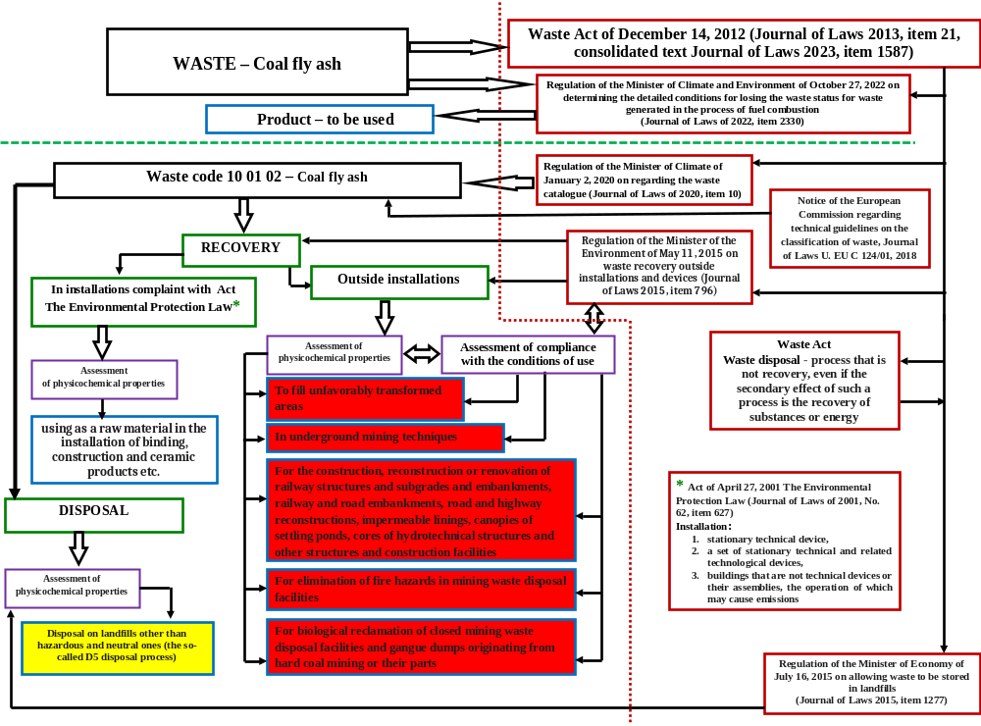
Fig. 2 Waste treatment options for coal fly ash applied in Poland based on EU Directive on waste, natural radioactivity not included yet.
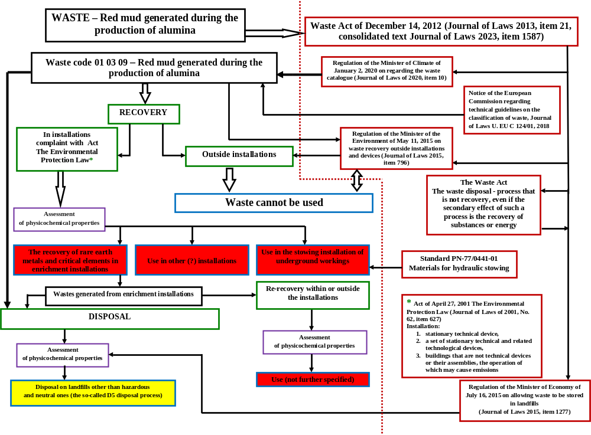
Fig. 3 Waste treatment options for red mud applied in Poland based on EU Directive on waste, natural radioactivity not included yet.

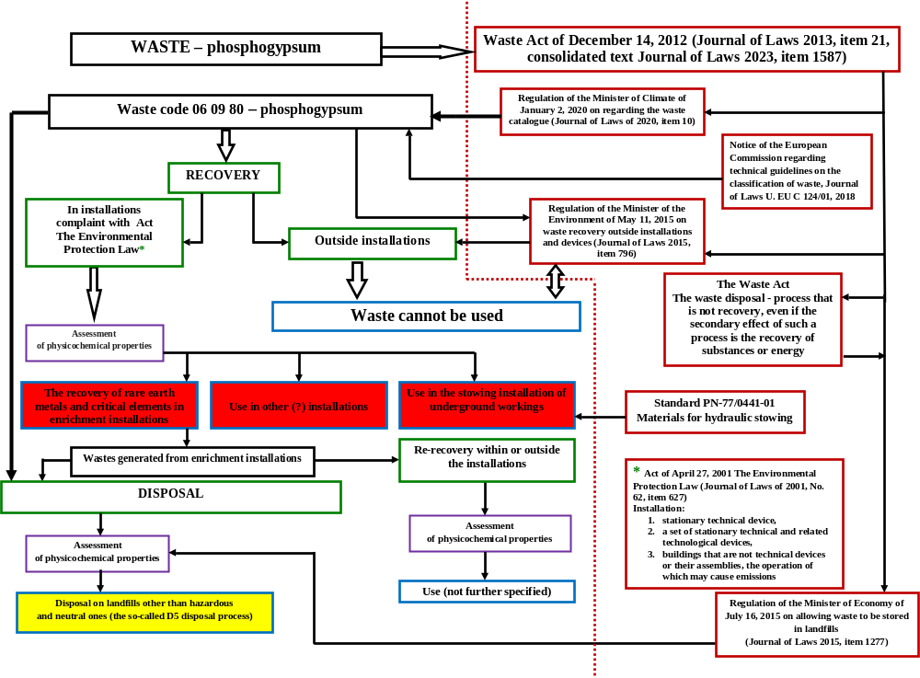
Fig. 4 Waste treatment options for phosphogypsum applied in Poland based on EU Directive on waste, natural radioactivity not included yet.

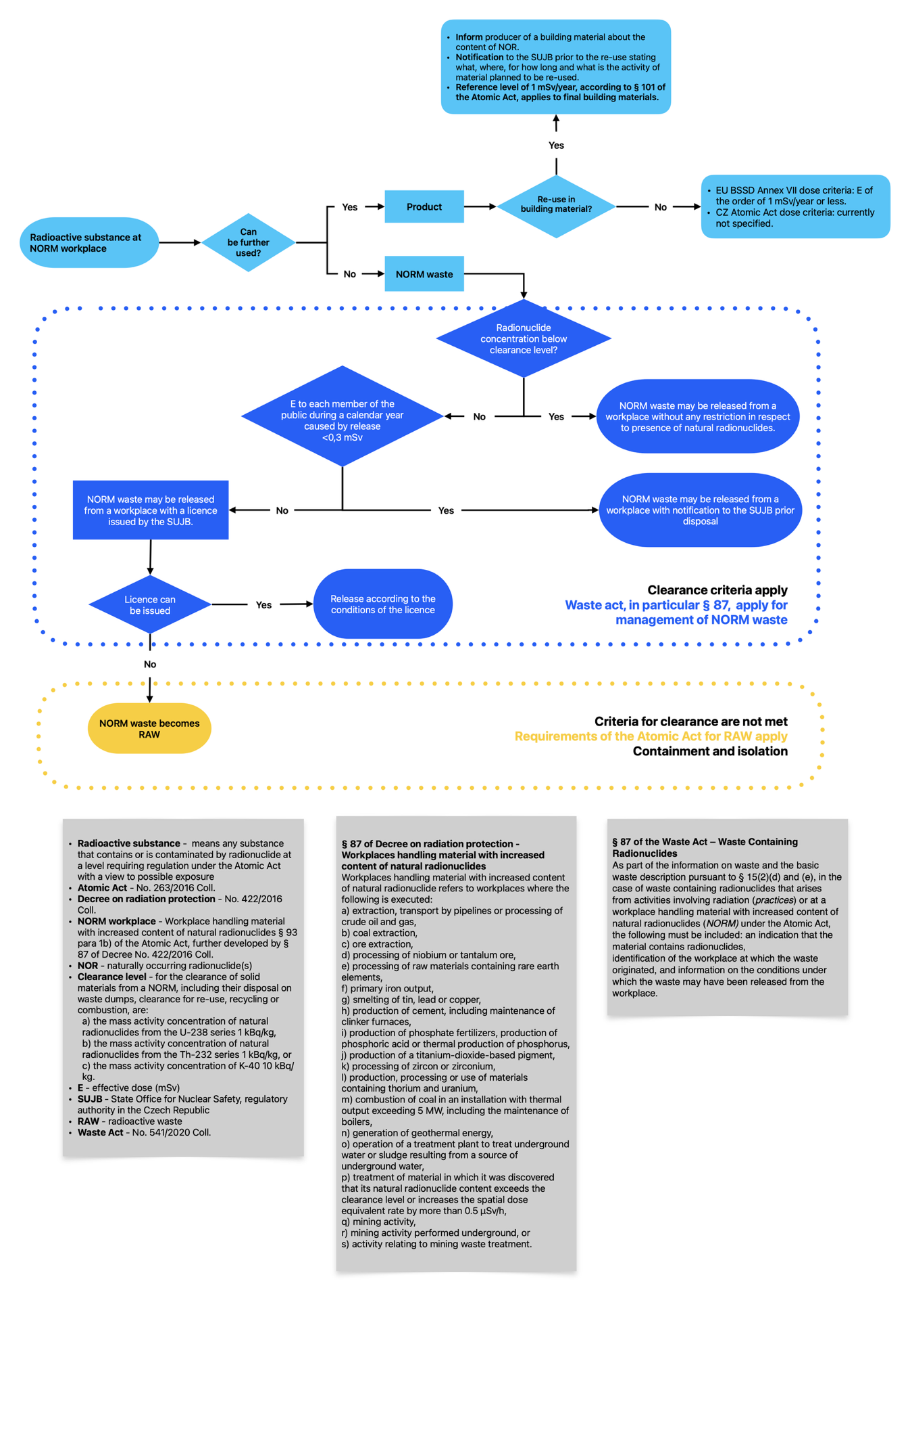
Fig. 5 Management scheme for NORM waste as defined by the Czech legislation.

