Supplementary table 1. Institutions with the highest number of papers in the top 100
Institution | Number of articles in top 100 | Total number of citations
Memorial Sloan-Kettering Cancer | 4 | 3307
Washington University | 4 | 2434
University of Zurich | 3 | 7644
University of Texas | 3 | 2356
University of Toronto | 3 | 2065
John Hopkins University | 3 | 1400
Orebro University | 2 | 1879
University of Virginia | 2 | 1486
Hospital Paul Brousse | 2 | 1371
University of Pittsburgh | 2 | 1359
University of California Los Angeles | 2 | 1222
Baylor College of Medicine | 2 | 1202
Cleveland Clinic Foundation | 2 | 1170

Supplementery table 2. General issues
Specialty | Number of articles
HPB | 15
Trauma & Orthopaedic | 13
Cardiothoracic | 11
Colorectal | 10
Neurosurgery | 10
Vascular | 8
Bariatric | 6
General Surgery | 6
ENT | 4
Multiple | 5
Breast | 2
Teaching | 2
Ophthalmology | 1
Plastics | 1
Urology | 1

HPB, Hepatico-pancreato-biliary; ENT, Ear Nose and Throat.

Supplementery table 3. Specific fields
Subject | Number of articles
Management  Surgical treatment  Randomised Control Trial  Surgical technique | 53  46  14  7
Surgical Complications | 16
Pathology | 8
Prognosis | 5
Training Methods | 5
Guidelines | 4
Epidemiology | 3
Quality of Life | 3
Reporting Methods | 2
Nutrition | 1

Supplementary figure 1. The distribution of the number of citations between studies relating to clinical trials in surgery

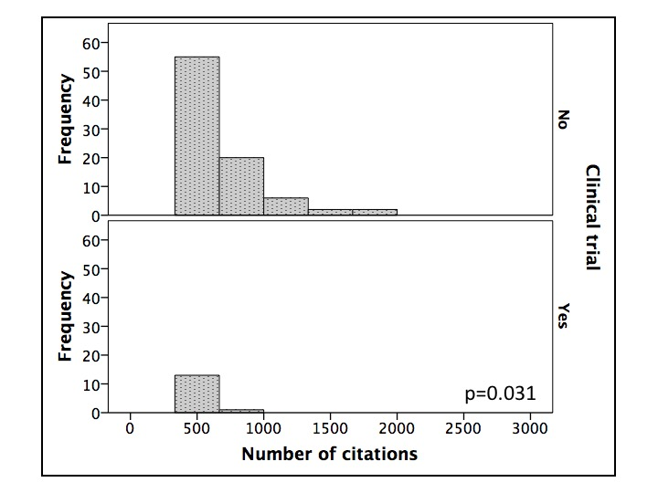
* The highest cited manuscript by Dindo et al was an outlier with a citation of 6336. This was removed for graphical representation to make the distribution of citations clearer.

Supplementery figure 2. The relationship between number of citations and Sacket score

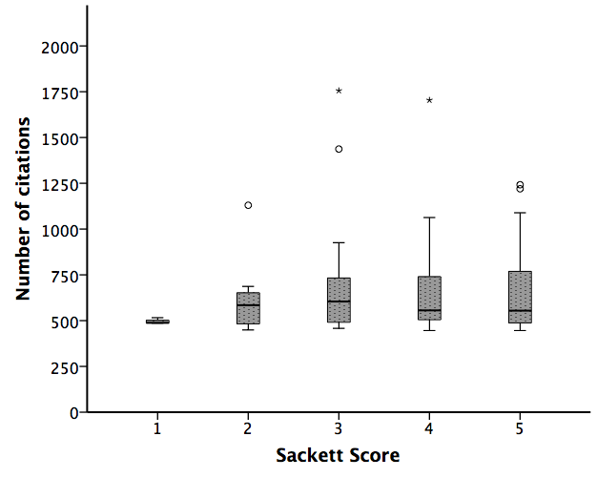

* p=0.674, Kruskal-Wallis Test

