Supplementary information
Equations of state of α-SiC (6H) and β’-Mg2Si1.1 from single-crystal X-ray diffraction data and novel high pressure magnesium silicide Mg₂Si₇
Iuliia Koemets^{1*} (ORC ID 0000-0002-0292-7382), Takayuki Ishii² (ORC ID 0000-0002-1494-2141), Michael Hanfland³ (ORC ID 0000-0002-8904-5461), Leonid Dubrovinsky¹ (ORC ID 0000-0002-3717-7585)
1. Bayerisches Geoinstitut (BGI), University of Bayreuth, Bayreuth, Germany
2. Center for High Pressure Science and Technology Advanced Research (HPSTAR), Shanghai, China
3. European Synchrotron Radiation Facility (ESRF), Grenoble, France
*Corresponding author. E-mail: koemets.j@gmail.com

Supplementary figure 1 A generalized diamond anvil cell assembly. Tungsten carbide seats and steel body of the cell block diffracted X-rays, therefore cell opening angle is important experimental parameter for single crystal diffraction at HP.
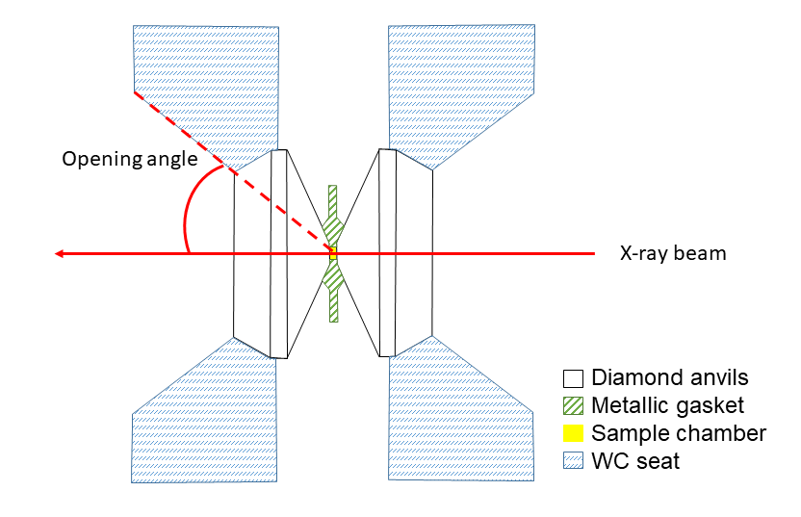

Supplementary figure 2 Equations of state of α-SiC(6H) and β’=Mg₂Si_{1.1}. As could be observed from f-F plots in inset, EoS for α-SiC(6H) can be fitted with 2nd order BM equation of state, while data from β’=Mg₂Si_{1.1} requires the use of 3rd order BM EoS.

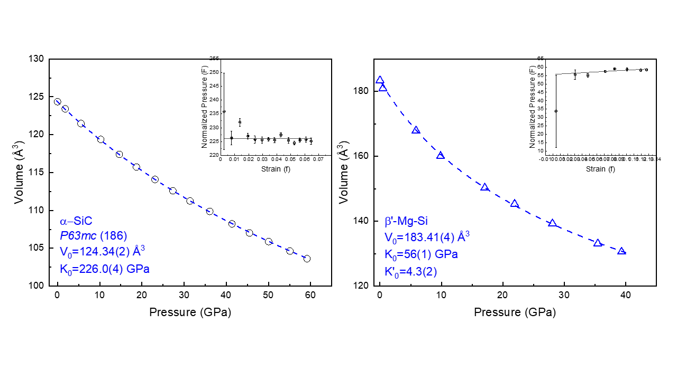

Supplementary table 1 List of experiments. In case of β’-Mg₂Si_{1.1, r}efinement of the atomic coordinates was not feasible.
Sample | P (GPa) | a (Å) | b (Å) | c (Å) | V (Å3) | Refl indexed | Rint (%) | Refl used | Rall (%)
β’-Mg₂Si_{1.1} | 0.0001 | 7.1555(7) |  | 4.1362(7) | 183.41(4) | 399 | - | - | -
β’-Mg₂Si_{1.1} | 0.5(3) | 7.1253(4) |  | 4.1153(5) | 180.94(3) | 174 | - | - | -
β’-Mg₂Si_{1.1} | 5.9(3) | 6.9576(3) |  | 4.0051(3) | 167.90(2) | 370 | - | - | -
β’-Mg₂Si_{1.1} | 9.9(2) | 6.8432(9) |  | 3.9465(9) | 160.05(5) | 450 | - | - | -
β’-Mg₂Si_{1.1} | 17.1(1) | 6.701(2) |  | 3.864(3) | 150.3(1) | 242 | - | - | -
β’-Mg₂Si_{1.1} | 21.9(2) | 6.625(2) |  | 3.824(2) | 145.3(1) | 427 | - | - | -
β’-Mg₂Si_{1.1} | 28.1(4) | 6.527(3) |  | 3.774(3) | 139.3(1) | 646 | - | - | -
β’-Mg₂Si_{1.1} | 35.5(3) | 6.425(5) |  | 3.724(5) | 133.1(2) | 377 | - | - | -
β’-Mg₂Si_{1.1} | 39.3(3) | 6.382(5) |  | 3.701(6) | 130.5(3) | 670 | - | - | -
Mg₂Si₇ | 46.6(2) | 7.16(1) | 12.490(3) | 2.6545(3) | 237.5(3) | 354 | 6.2 | 96 | 8.0
SiC | 0.0001 | 3.0814(1) |  | 15.122(2) | 124.35(2) | 253 | 2.8 | 162 | 4.9
SiC | 1.8(1) | 3.0740(1) |  | 15.0809(5) | 123.42(1) | 183 | 2.7 | 131 | 4.9
SiC | 5.55(5) | 3.0578(1) |  | 15.0013(5) | 121.47(1) | 175 | 1.5 | 123 | 3.4
SiC | 10.25(5) | 3.0405(1) |  | 14.9121(4) | 119.38(1) | 163 | 1.8 | 117 | 5.8
SiC | 14.65(5) | 3.0237(1) |  | 14.8268(5) | 117.40(1) | 149 | 0.9 | 120 | 3.0
SiC | 18.7(1) | 3.0093(1) |  | 14.7578(6) | 115.74(1) | 149 | 1.1 | 97 | 3.4
SiC | 23.1(1) | 2.9950(2) |  | 14.685(2) | 114.08(2) | 147 | 1.3 | 92 | 2.9
SiC | 27.35(5) | 2.9825(2) |  | 14.6157(8) | 112.59(1) | 149 | 1.0 | 112 | 3.0
SiC | 31.4(1) | 2.9706(4) |  | 14.556(2) | 111.24(2) | 141 | 1.3 | 100 | 3.2
SiC | 36.1(1) | 2.9578(2) |  | 14.450(1) | 109.86(1) | 133 | 1.0 | 89 | 3.9
SiC | 41.4(1) | 2.9435(4) |  | 14.423(2) | 108.22(3) | 195 | 2.2 | 137 | 5.8
SiC | 45.5(1) | 2.9320(3) |  | 14.374(2) | 107.02(2) | 128 | 1.9 | 75 | 7.0
SiC | 50.05(5) | 2.9220(7) |  | 14.318(2) | 105.87(4) | 129 | 2.6 | 78 | 6.5
SiC | 55.1(2) | 2.9106(3) |  | 14.261(2) | 104.62(2) | 122 | 2.2 | 69 | 7.7
SiC | 59.2(3) | 2.9024(6) |  | 14.203(3) | 103.62(4) | 131 | 4.4 | 71 | 9.3

