Physics and Chemistry of Minerals
Supporting Information for
Electrical conductivity of siderite and the effect of the spin transition of iron
Izumi Mashino^{1*}, Takashi Yoshino¹, Takaya Mitsui², Kosuke Fujiwara², Máté Garai³, and Shigeru Yamashita¹
¹Institute for Planetary Materials, Okayama University, 827 Yamada, Misasa, Tottori, Japan
²Synchrotron Radiation Research Center, Kansai Photon Science Institute, Quantum Beam Science Research Directorate, National Institutes for Quantum Science and Technology, Sayo, Hyogo, Japan
³The University of the South, 735 University Avenue Sewanee, TN, USA

*Corresponding author: Izumi Mashino (izumi.mashino@okayama-u.ac.jp), ORCID: 0000-0001-9719-593X,

Contents of this file

Text S1
Figures S1 to S5
Tables S1

Text S1. Estimation of sample thickness.
Considering the current paths in the samples of our cell assembly, the thickness of the sample volume for which the electrical conductivity was measured should be the same as the sample thickness. To estimate the thickness of the sample, we adopted the thickness estimation methods proposed by Li et al. (2007). In the thickness estimation methods, the effects of the gasket plastic deformation and the diamond elastic deformation have been considered. We measured the distance between the back facets of the two diamond anvils mechanically using a micrometer along with both increasing (compression: T_{C}) and decreasing (decompression: T_{D}) pressures. Because the gasket deformation is completely plastic, the sample thickness should be invariable in decomposition processes. Therefore, the total anvil deformation at each pressure (D_{P}) can be obtained by

$D_{P}=H_{0}-\left[T_{D}\left(P\right)-L_{M}\right]$ (1)

where H₀ is the sum of the initial thickness of the two anvils and L_{M} is the sample thickness at the maximum pressure. T_{C} (P) and T_{D} (P) are the total thicknesses at each pressure point in compression and decompression processes, respectively.
The sample thickness (t) can be expressed as

$t=T_{C}\left(P\right)-(H_{0}-D_{P})$ (2)

L_{M} can be obtained by

$L_{M}=T_{D}\left(0\right)-H_{0}$ (3)

T_{D}(0) is the sample thickness after full decompression. In this study, H₀ is 4.062 (mm) and T_{D}(0) is 4.076 (mm). Thus, L_{M} is 0.014 (mm).

Fig. S2 shows the pressure dependence of the distance between the back facets of the two diamond anvils along with both increasing (compression: T_{C}) and decreasing (decompression: T_{D}) pressures.
Fig. S3 shows the pressure dependence of diamond deformation (D_{P}). We can obtain a parabola of fit as follows:

$D_{P}=-2.8799×{10}^{-6}P^{2}+7.1052×{10}^{-4}P$ (4)

Thus, the sample thickness at each pressure (T(P)) can be obtained by

$t=T\left(P\right)-\left(4.062-D_{P}\right)$ (5)

Fig. S4 shows the pressure evolution of the sample thickness.

Text S2. Estimation of pressure uncertainty.
To estimate the uncertainty in pressure, we measured the pressure in a distribution of ruby grains putting around the central area of the sample in the same cell assembly for the electrical conductivity measurements. The sample powder and small ruby crystals were loaded into a DAC with 300 μm culets. The pressure was determined by the ruby fluorescence method (Dewaele et al. 2008). Fig. S5 shows the pressure uncertainty as a function of pressure estimated in this procedure. The uncertainty estimated from the standard deviation increases with increasing pressure up to 80 GPa which covers the entire pressure range of our measurements. All the uncertainties are within 4 GPa. Therefore, we provided relatively large pressure uncertainties of 4 GPa for all the pressure points.

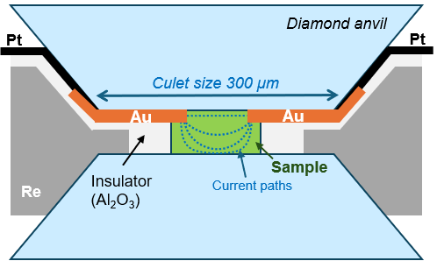

Figure S1. Schematic cross section of the experimental setup in a DAC for electrical conductivity measurements. The dotted curves in the sample show the current paths.

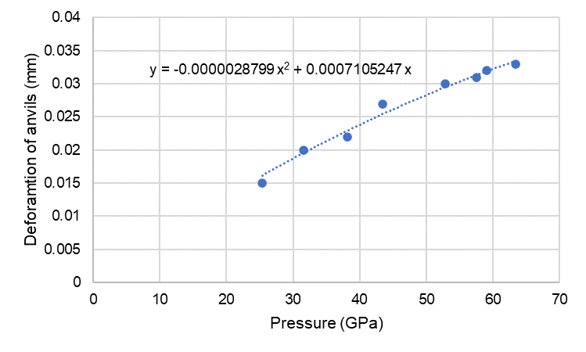

Figure S2. The deformation of anvils as a function of pressure.

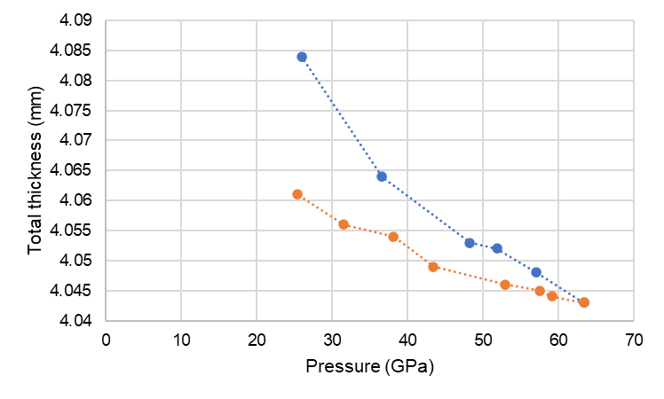

Figure S3. The total thickness, including the thicknesses of the two anvils and the sample as a function of pressure. Blue circles, T_{C}; orange circles, T_{D}.

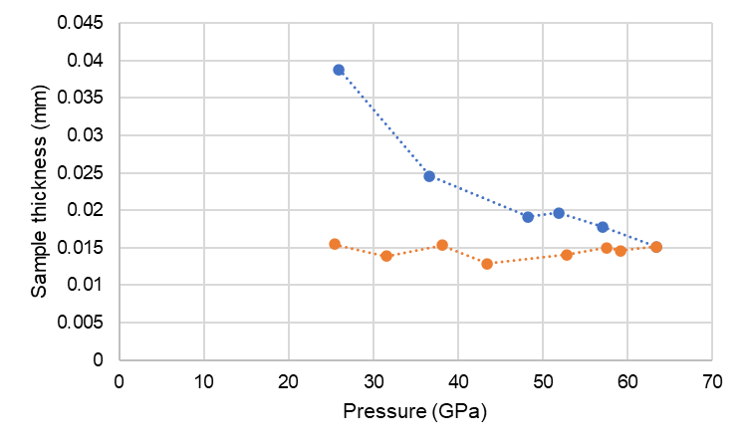

Figure S4. The estimated sample thickness as a function of pressure. Blue circles, T_{C}; orange circles, T_{D}.

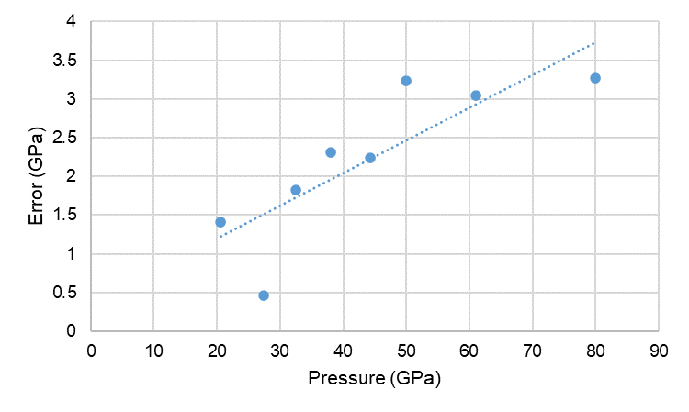

Figure S5. The pressure uncertainty as a function of pressure

Table S1. Electrical conductivity of siderite at room temperature.

