Supporting Information for
High-pressure spectroscopic investigation of ε-FeOOH: toward a better understanding of pressure-induced hydrogen-bond symmetrization
Izumi Mashino¹*, Shigeru Yamashita¹, and Takashi Yoshino¹
¹Institute for Planetary Materials, Okayama University, 827 Yamada, Misasa, Tottori, Japan

Text S1. Synchrotron XRD and Mössbauer spectroscopic measurements
To confirm the spin transition, high-pressure XRD measurements were conducted during decompression of the Raman measurements at BL10XU, SPring-8. The X-ray beam size was approximately 5 μm and the wavelength of x-ray was 0.414255(9) Å. The XRD Debye rings were collected on the Perkin Elmer digital x-ray flat panel detector. The diffraction patterns were integrated to provide 2θ profile using IPAnalyzer (https://yseto.net/soft/ipanalyzer) and the lattice parameters were calculated using PDIndexter (https://yseto.net/soft/pdi). The pressure was determined from the observed unit cell volume of KCl using the equation of state of Dewaele et al. (2012). Fig. S7 shows representative high-pressure XRD patterns collected at 29 (HS state) and 63 GPa (LS state).
Fig. S8 shows the pressure dependence of the unit cell volume of ε-FeOOH together with previous studies (Gleason et al., 2013; Thompson et al., 2020). There is a sudden reduction of the volume at around 45 GPa, indicating the HS-LS transition. The unit cell volumes obtained in this study are generally consistent with previous reports for both the HS and LS states, although the LS-state volume is slightly smaller than that reported by Gleason et al. (2013) and larger than that reported by Thompson et al. (2020). The differences in volume may arise from the presence or absence of a pressure medium, as well as differences in the pressure medium and pressure scale. Because our dataset is limited, we did not attempt to derive a new equation of state. Importantly, no obvious volume anomaly is observed across 18 GPa, which also supports that hydrogen bond symmetrization has only a subtle effect on the unit cell volume, consistent with the previous studies (Gleason et al., 2013; Thompson et al., 2020; Insixiengmay and Stixrude, 2023). In addition to the IR measurements, our XRD data collected during decompression did not support any density decrease, indicating that there is no dehydrogenation in ε-FeOOH as reported in previous studies (Gleason et al., 2011; Gleason et al., 2013; Suzuki, 2010; 2016; Ikeda et al., 2019; Thompson et al., 2020).
The LS state is supported by the Mössbauer measurement. To confirm the LS state, we also conducted high-pressure energy-domain synchrotron ⁵⁷Fe Mössbauer source (SMS) spectroscopic measurement at BL11XU of SPring-8 (Mitsui et al. 2009). SMS is based on a pure ⁵⁷FeBO₃ (111) monochromator, which via nuclear Bragg reflections provides neV energy resolution allowing the study of the Mössbauer effect on small specimen in a DAC. The Doppler velocity scales were calibrated using a 2 μm thick piece of α-⁵⁷Fe foil under ambient conditions. The Mössbauer spectrum at 53 GPa was collected from the same sample in the diamond anvil cell as used for the Raman and XRD measurements. The obtained spectrum was fitted using the MossA software package (Prescher et al. 2012).
The HS and LS states of ε-FeOOH are characterized by a sextet and doublet (Ikeda et al., 2025a). The Mössbauer spectrum at 53 GPa can be fitted with one doublet (Fig. S9), indicating the LS state.

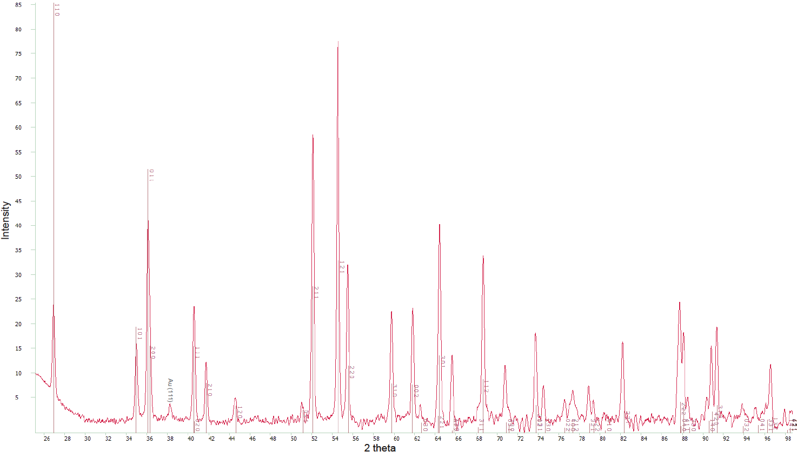Figure S1. Ambient X-ray powder diffraction pattern of ε-FeOOH used as the starting materials in this study.

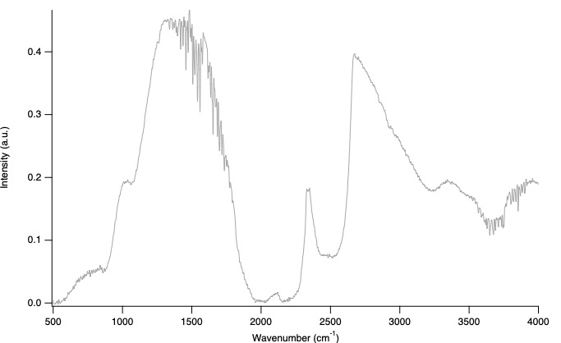
Figure S2. Intensity of the IR light passed through a pair of the type IIa diamond anvils used in this study.

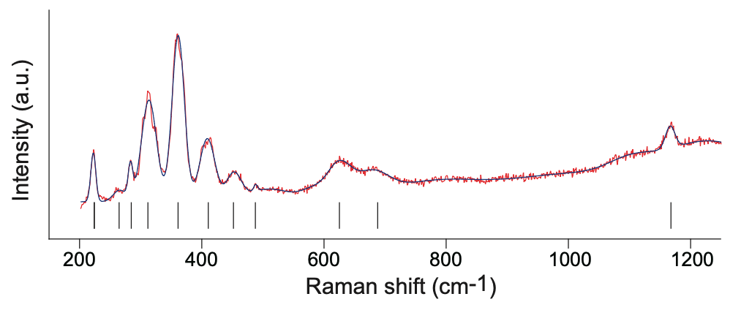
Figure S3. Ambient Raman spectrum of ε-FeOOH. Vertical tick marks indicate the positions of the observed Raman peaks.

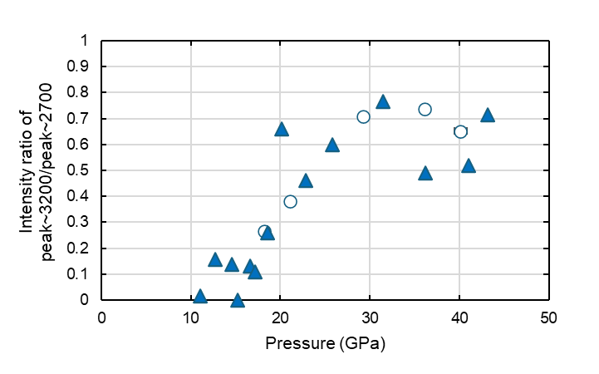
Figure S4. Pressure dependence of the intensity ratio of the IR band at ~2700 cm⁻¹ (ν₁₆) over the band at 3200 cm⁻¹ (ν₁₇). Open circles and solid triangles represent the data in the first and third experimental runs, respectively.

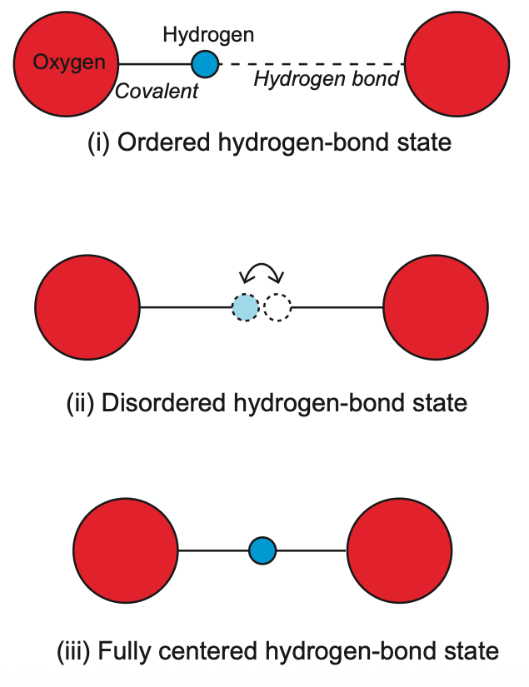
Figure S5. Schematic illustration of proton distributions in hydrogen bond symmetrization.

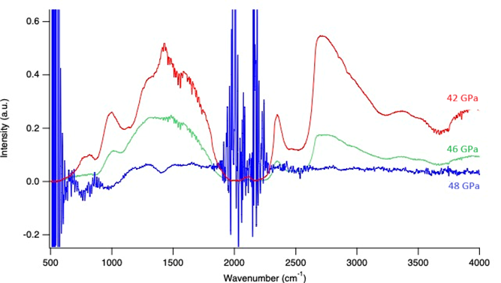
Figure S6. Intensities of the IR light passing through the sample collected at different pressures during 3rd experimental run (42, 46, and 48 GPa). A progressive decrease in signal intensity with increasing pressure indicates a reduction in optical transparency.

Figure S7. Representative high-pressure XRD patterns collected at 29 (HS state) and 63 GPa (LS state). Diffraction peaks from ε-FeOOH and reflections from the KCl pressure medium are labeled.

Figure S8. Unit-cell volume of ε‑FeOOH at room temperature as a function of pressure. The data illustrate the high-spin (HS) to low-spin (LS) transition, with the HS and LS regimes indicated by blue and orange symbols, respectively. All XRD data were collected during decompression. Previous results are also shown for comparison (Gleason et al., 2013; Thompson et al., 2020).

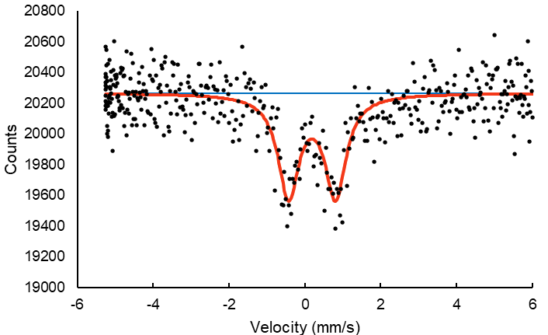
Figure S9. Mössbauer spectrum of ε-FeOOH at 53 GPa.

