SUPPLEMENTARY INFORMATION
TABLE OF CONTENTS
SEARCH STRATEGY 2
META-REGRESSION 3
A. Technical success 3
B. Clinical success 6
C Oncological efficacy 9
D. IPSS after treatment 12
EGGER’S TEST 15
A. Technical success 15
B. Clinical success 16
C Oncological efficacy 17
D. IPSS after treatment 18
SENSITIVITY ANALYSIS 19
A. Technical success 19
B. Clinical success 20
C. Oncological efficacy 21
D. IPSS after treatment 22

SEARCH STRATEGY
- PUBMED
(((((((((prostat* artery embolization[Title/Abstract]) OR (prostat* artery embolisation[Title/Abstract])) OR (PAE[Title/Abstract])) OR (prostat* artery chemoembolization[Title/Abstract])) OR (prostat* artery chemoembolisation[Title/Abstract])) OR (transarterial chemoembolization[Title/Abstract])) OR (transarterial chemoembolisation[Title/Abstract])) OR (TACE[Title/Abstract])) OR (PACE[Title/Abstract])) AND (prostate cancer[Title/Abstract])
- WEB OF SCIENCE/SCOPUS
(TS=("prostat* artery embolization" OR "prostat* artery embolisation" OR "prostat* artery chemobolization" OR "prostat* artery chemobolisation" OR "transarterial chemoembolization" OR "PAE" OR "PACE" OR "TACE")) AND TS=(prostate cancer)

META-REGRESSION

Technical success
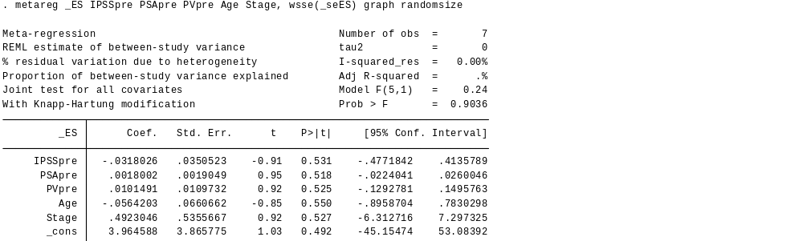

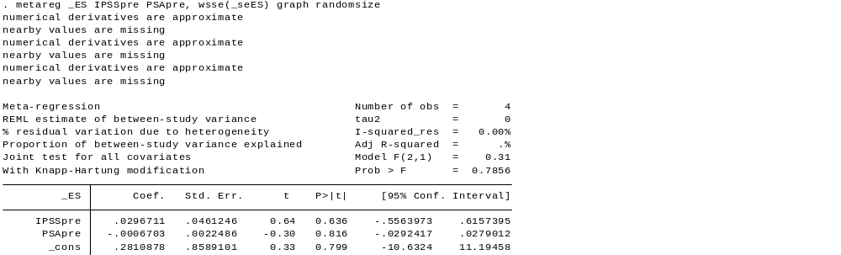
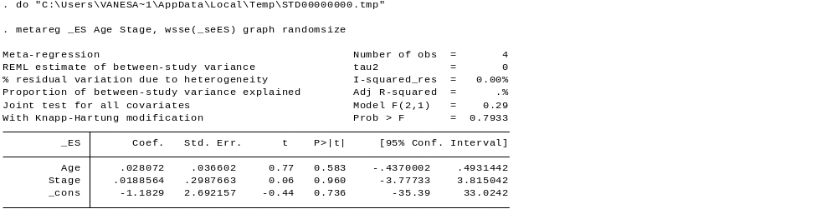
- Clinical success

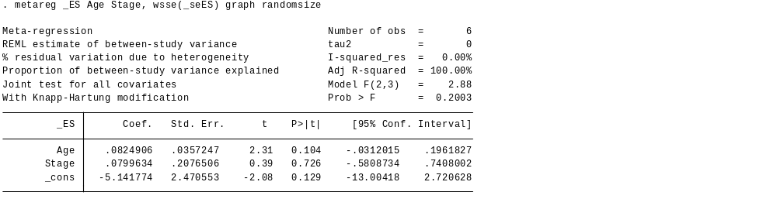
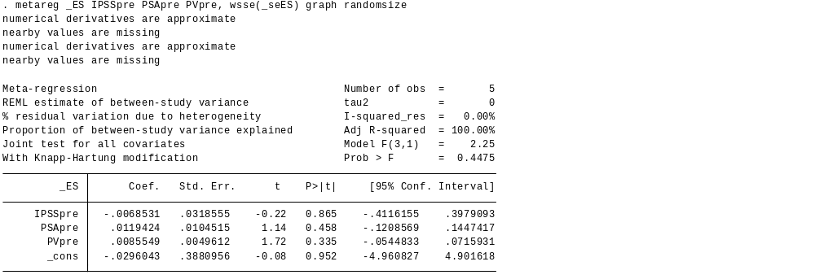
C Oncological efficacy

IPSS after treatment
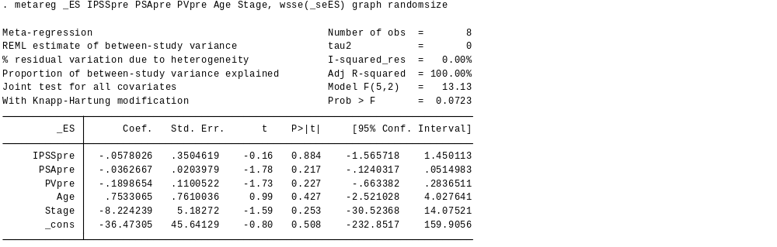

EGGER’S TEST

Technical success
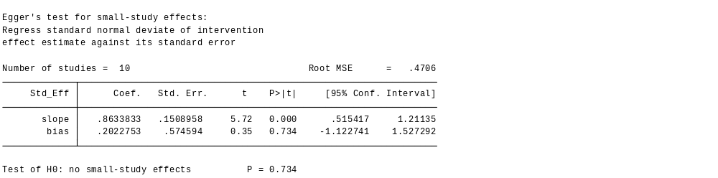

- Clinical success
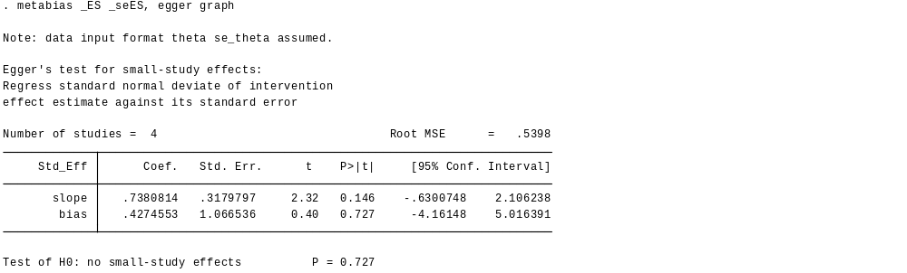

C Oncological efficacy
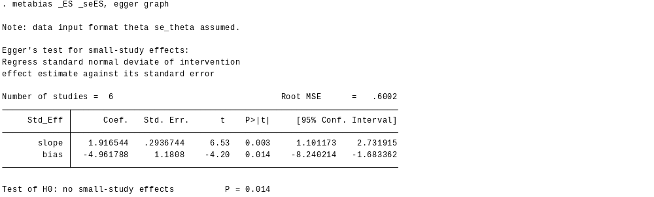

IPSS after treatment
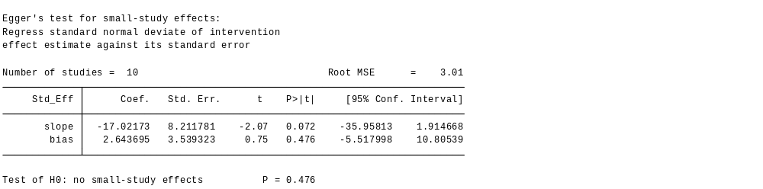

SENSITIVITY ANALYSIS

- Technical success
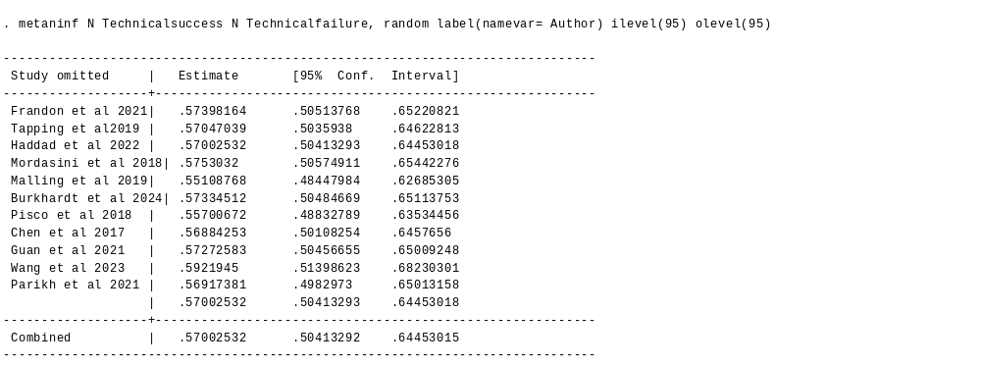

- Clinical success

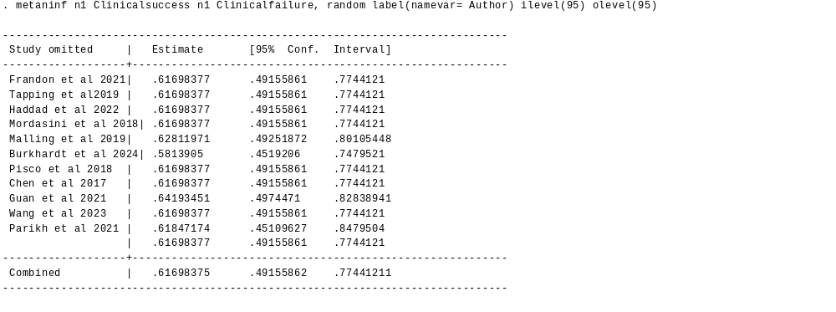

- Oncological efficacy

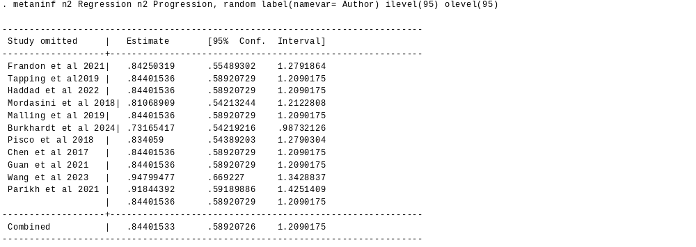

- IPSS after treatment

