Supplementary Material
Supplementary Table 1: Field Completeness of the registry form
Analytic cohort N = 2,335 procedures. "Answered" is the number of procedures with any entry for that item; for the grouped checkbox blocks it is the number with at least one tick. Proportions throughout the manuscript are reported against 2,335, with the missing fraction stated alongside the result.
Plausibility rules: age excluded when the birth year implied an age below 18 years; dose-area product excluded when absent, non-positive, above 100,000 cGy cm2, or carrying a unit multiplier of one million; fluoroscopy time excluded when absent, non-positive or above 200 minutes.
Block | Item | Status | Answered, n (%) | Distribution
Patient | Sex | mandatory | 2335 (100) | female 1328, male 1007
Patient | Date of birth | mandatory | 2335 (100) | 75 implausible, 2260 evaluable
Intervention | Treatment date | mandatory | 2335 (100) | Jan 2024 to 30 Dec 2025
Intervention | Outpatient setting | mandatory | 2335 (100) | yes 102, no 2233
Intervention | Outside routine day shift | mandatory | 2335 (100) | yes 3, no 2332
Intervention | Multiple intervention | facultative | 13 (0.6) | yes 13
Intervention | Side | facultative | 0 (0) | empty in all records
Preinterventional | Quick / INR | mandatory | 2335 (100) | normal 2161, path. 33, n.a. 141
Preinterventional | PTT | mandatory | 2335 (100) | normal 2150, path. 34, n.a. 151
Preinterventional | Thrombocyte count | mandatory | 2335 (100) | normal 2172, path. 29, n.a. 134
Preinterventional | Creatinine / GFR | mandatory | 2335 (100) | normal 2082, path. 117, n.a. 136
Preinterventional | Alkaline phosphatase | mandatory | 2335 (100) | normal 753, path. 23, n.a. 1559
Preinterventional | Total bilirubin | mandatory | 2335 (100) | normal 848, path. 10, n.a. 1477
Preinterventional | Cholinesterase | mandatory | 2335 (100) | normal 668, path. 9, n.a. 1658
Preinterventional | LDH | mandatory | 2335 (100) | normal 679, path. 19, n.a. 1637
Preinterventional | Knee endoprosthesis | mandatory | 2335 (100) | yes 300, no 2035
Preinterventional | Imaging block (at least one tick) | mandatory group | 2325 (99.6) | MRI 1240, radiography 1256, ultrasound 241, CT 106, DSA 110, scintigraphy 11, not done 134
Preinterventional | Interdisciplinary conference (at least one tick) | mandatory group | 2317 (99.2) | radiology 1461, surgery 1062, internal medicine 105, other 464, not done 283
Intervention description | Embolic-agent block (at least one tick) | facultative group | 2244 (96.1) | no entry anywhere in the block 54 (2.3)
Intervention description | Permanent unloaded microspheres | facultative, three-state | 1437 (61.5) | yes 607, no 830, blank 898
Intervention description | Temporary degradable microparticles | facultative, three-state | 1134 (48.6) | yes 530, no 604, blank 1201
Intervention description | Drug-loaded microspheres | facultative, three-state | 1201 (51.4) | yes 52 (not an established GAE agent; reported descriptively), no 1149, blank 1134
Intervention description | Polyvinyl alcohol particles | facultative, tick only | 105 (4.5) | 150-250 um 93, 250-550 um 11, 750-1000 um 1
Intervention description | Microsphere size | facultative, tick only | 616 (26.4) | 100-300 um 553, < 100 um 53, 300-500 um 10
Intervention description | Other embolic agent | facultative, tick only | 1212 (51.9) | yes 1212
Intervention description | Free-text specification of "other" | facultative | 17 (0.7) | imipenem or imipenem/cilastatin 12, other 5
Intervention description | Any of the four specific agents ticked | derived | 1226 (52.5) | no specific-agent flag 1109 (47.5)
Intervention description | Vascular closure (at least one tick) | facultative group | 2326 (99.6) | manual 1642, device 669, surgical 70, instrument 47
Quality of results | Fluoroscopy time | mandatory with DSA | 2331 (99.8) | missing after plausibility 21 (0.9)
Quality of results | Dose-area product | mandatory with DSA | 2331 (99.8) | missing after plausibility 19 (0.8)
Quality of results | Cone-beam CT | mandatory | 2332 (99.9) | yes 6, no 2326
Quality of results | Adequate devascularization | mandatory | 2335 (100) | yes 2162, no 173
Quality of results | Embolization preparatory to further therapy | mandatory | 2335 (100) | yes 96, no 2239
Quality of results | Postinterventional imaging (at least one tick) | facultative group | 2317 (99.2) | none 1030, DSA 1207, ultrasound 206, CT 9, radiography 8, MRI 3
Complications | Complication within 24 h | mandatory | 2335 (100) | yes 9, no 2326
Complications | Complication after 24 h | mandatory | 2335 (100) | yes 2, no 2333
Complications | Termination of intervention | mandatory | 2335 (100) | yes 10, no 2325
Geography | Federal state | derived from center | 2334 (99.96) | 15 states, missing 1 (0.04)

Supplementary Table 2: Procedural characteristics.
Data are n (%). Embolic-agent categories were not mutually exclusive; about 47.5% of procedures carried no structured specific-agent flag. CT computed tomography; PVA polyvinyl alcohol.
Characteristic | Value
Embolic agent (non-exclusive), n (%)
Permanent unloaded microspheres | 607 (26.0)
Temporary (degradable) microparticles | 530 (22.7)
Drug-eluting (loaded) microspheres | 52 (2.2)
Polyvinyl alcohol (PVA) | 105 (4.5)
Other / unspecified field marked | 1212 (51.9)
No structured specific-agent flag | 1109 (47.5)
Microsphere particle size, n
< 100 um | 53
100 to 300 um | 553
300 to 500 um | 10
Cone-beam CT used, n (%) | 6 (0.3)
Vascular closure, n (%)
Manual compression | 1642 (70.3)
Percutaneous closure device | 669 (28.7)
Surgical | 70 (3.0)
Pre-interventional imaging, n (%)
Magnetic resonance imaging | 1240 (53.1)
Radiography | 1256 (53.8)
Ultrasound (duplex) | 241 (10.3)
Computed tomography | 106 (4.5)
'Not done' ticked | 134 (5.7)
Interdisciplinary involvement, n (%)
Radiology conference | 1461 (62.6)
Surgical involvement | 1062 (45.5)

Supplementary Table 3: Predictors of technical failure (cluster-robust and mixed-model estimates).
CR2 cluster-robust logistic regression and center-random-effect mixed model on all 2,335 procedures / 109 centers. OR odds ratio; CI confidence interval.
Covariate | Cluster-robust OR (95% CI) | Mixed-model OR (95% CI)
Age (per 10 y, imputed) | 1.07 (0.88-1.30) | 0.99 (0.86-1.15)
Age missing | 0.93 (0.03-29.12) | 1.85 (0.10-33.61)
Male sex | 1.14 (0.79-1.64) | 1.20 (0.84-1.71)
Prior TKA | 0.75 (0.42-1.32) | 0.67 (0.36-1.24)
Period 2025 vs 2024 | 0.34 (0.17-0.70) | 0.36 (0.24-0.55)
Volume medium vs low | 2.23 (0.79-6.29) | 2.28 (0.65-8.04)
Volume high vs low | 1.38 (0.31-6.19) | 1.15 (0.23-5.68)
Volume very-high vs low | 0.96 (0.13-7.15) | 0.35 (0.02-5.08)
Incomplete documentation | 2.43 (0.98-6.06) | 1.89 (1.04-3.44)

Supplementary Table 4: Center-reported technical success by per-year center volume (sensitivity analysis).
Center volume computed within each calendar year (procedures per center in that year), addressing the confounding of cumulative volume with calendar period. Values are successes/procedures (%). The pattern is non-monotonic in both years, consistent with the pooled analysis.
Year | Center volume in that year | Technical success | %
2024 | Low (≤10) | 104/111 | 94
2024 | Medium (11–50) | 135/173 | 78
2024 | High (51–100) | 184/185 | 99
2024 | Very high (>100) | 81/110 | 74
2025 | Low (≤10) | 194/203 | 96
2025 | Medium (11–50) | 584/651 | 90
2025 | High (51–100) | 744/757 | 98
2025 | Very high (>100) | 136/145 | 94
Supplementary Table 5: Radiation dose by center-volume category.
DAP dose-area product. Kruskal-Wallis across volume categories: p < 0.001. P90/P95 90th/95th percentiles.
Group | n | Fluoroscopy time, median (IQR), min | Fluoroscopy P90/P95, min | DAP, median (IQR), cGy.cm2 | DAP P90/P95, cGy.cm2
Overall | 2335 | 24 (16-34) | 45 / 54 | 1536 (731-3048) | 5050 / 6864
Low (<=10) | 206 | 28 (19-39) | 53 / 63 | 2124 (1024-3656) | 5884 / 10069
Medium (11-50) | 736 | 23 (16-33) | 44 / 51 | 1590 (719-3155) | 5358 / 8289
High (51-100) | 886 | 27 (18-37) | 48 / 61 | 1456 (687-3061) | 4975 / 6563
Very high (>100) | 507 | 21 (15-28) | 37 / 43 | 1372 (732-2630) | 4079 / 5681

Supplementary Table 6: Prior-TKA subgroup comparison.
Continuous: Mann-Whitney U test; categorical: Fisher exact test. DAP dose-area product; TKA total knee arthroplasty.
Variable | No prior TKA | Prior TKA | p value
Patients, n | 2035 | 300
Age, median (IQR), y | 67 (59-77) | 71 (62-78) | 0.014
Female, n (%) | 1138 (55.9) | 190 (63.3) | 0.018
Fluoroscopy time, median (IQR), min | 24 (16-33) | 27 (19-35) | <0.001
DAP, median (IQR), cGy.cm2 | 1374 (676-2701) | 3424 (1821-5736) | <0.001
Technical success, n (%) | 1878 (92.3) | 284 (94.7) | 0.157
Complications, n (%) | 10 (0.5) | 1 (0.3) | 1.000

Supplementary Figure 1: Online form for data submission
Mandatory questions are marked with *. Facultative questions are given in italic. Answering options are given in brackets.
Patient data
Sex * (female; male; diverse)
Date of birth *
Patient identification number
1 - Intervention
Date *
Region * (Joint embolization; further vascular-therapy regions)
Target detail * (Knee joint; further joint targets)
Type of intervention * (VT vascular therapy; AR arterial recanalization)
Interventionalist 1 / 2 / 3
Outpatient intervention? * (yes; no)
Begin of intervention outside routine daily shift * (yes; no)
Multiple intervention? (yes)
Side (left; right)
2 - Preinterventional diagnostic
Lab *
Quick / INR * (n.a.; normal; pathological)
PTT * (n.a.; normal; pathological)
Thrombocyte count * (n.a.; normal; pathological)
Creatinine / GFR * (n.a.; normal; pathological)
Alkaline phosphatase * (n.a.; normal; pathological)
Total bilirubin * (n.a.; normal; pathological)
Cholinesterase * (n.a.; normal; pathological)
LDH * (n.a.; normal; pathological)
Preinterventional imaging *
X-ray, projection radiography (yes)
CT / CTA (yes)
MRI / MRA (yes)
DSA / fluoroscopy (yes)
Ultrasound / duplex (yes)
Scintigraphy / SPECT / SPECT-CT (yes)
not done (yes)
Endoprosthesis (total knee arthroplasty) present? *
Endoprosthesis present * (yes; no)
Interdisciplinary conference *
Anaesthesiology (yes)
General surgery / Vascular surgery (yes)
Internal medicine (yes)
Neurology (yes)
Radiology (yes)
Pathology (yes)
Others (yes)
Conference decision (yes)
Not done (yes)
3 - Description of intervention
Embolic agent
Permanent unloaded microspheres (yes; no)
Temporary, degradable microparticles (yes; no)
Drug-loaded microspheres (yes; no)
Polyvinyl alcohol particles (150-250; 250-550; 750-1000 um)
Microsphere size (< 100; 100-300; 300-500 um)
Other embolic agent (yes)
Other embolic agent, free-text specification
Further embolic agents (yes)
TheraSpheres (yes; no)
SIR-Spheres (yes; no)
Lipiodol (yes; no)
Histoacryl (yes; no)
Glubran (yes; no)
Melphalan dose
Vascular closure
Manual compression (yes)
Compression with instrument (yes)
Percutaneous closure device 1 / 2 / 3 (yes)
Surgical closure (yes)
4 - Quality of results
Image-guided technique *
DSA (yes)
Fluoroscopy duration, minutes *
Dose-area product *
Dose-area product, unit multiplier * (0.1; 1; 10; 100; 1000000)
Dose-area product, normalized result, cGy cm2
Cone beam CT * (yes; no)
CT (yes)
CTDIvol
Dose-length product
MRI (yes)
Ultrasound (yes)
Technical success
Adequate devascularization of the hypervascular synovial blush * (yes; no)
Embolization as preparation for further therapy * (yes; no)
Treatment of a bleeding (yes; no)
Postinterventional imaging
no imaging (yes)
X-ray, projection radiography (yes)
CT / CTA (yes)
MRI / MRA (yes)
DSA / fluoroscopy (yes)
Ultrasound / duplex (yes)
The embolic-agent block is inherited from the generic vascular-therapy form. It is not a mandatory block, the items are not mutually exclusive, and each item can be left blank; the last six items belong to liver-directed therapy and are not applicable to genicular artery embolization.
Complications Module A-D
Complications within 24 h post intervention * (yes; no)
if yes:
Complication (arterial bleeding; venous bleeding; arterial vessel occlusion; venous occlusion; aneurysm; cardiac complication; neuro-cerebral complication; pulmonary complication; infection / abscess; dislocation of external material; parenchymal bleeding; tissue ischemia or infarction; anaphylaxis; organ dysfunction or failure; adverse medication reaction; organ injury; other)
Grade (a; b; c; d; e; f)
Complication treated? (no; self; other discipline)
if treated: Success? (yes; no)
Complications after 24 h post intervention * (yes; no)
if yes: the same four sub-items
Complication / Grade / treated / successfully treated
Termination of intervention * (yes; no)
if yes:
Reason (technical or anatomical reason; uncooperative patient; complication independent of the intervention; complication associated with the intervention; technical failure of the machine; probing of the target vessel or lesion not successful; other)

Supplementary Figure 2: Center-reported technical success over time
Center-reported technical success by quarter, 2024–2025.
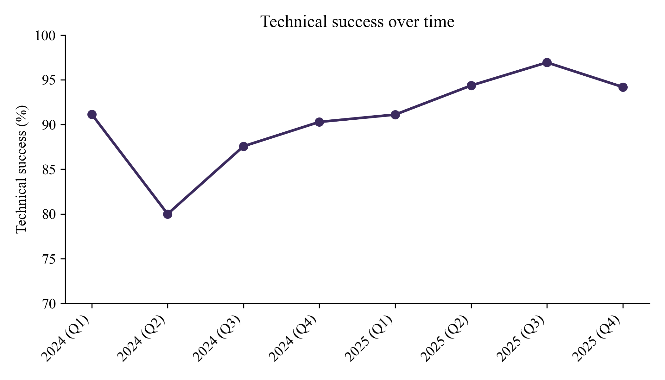
Supplementary Figure 3: Within-center learning curve
Center-reported technical success by within-center case-sequence tertile, pooled across all 2,335 procedures (first tertile 88.8%, second 93.0%, third 96.2%; pooled Spearman ρ +0.06, p = 0.004). Among the 30 centers with at least 20 procedures, the case sequence correlated positively with success in 6 and negatively in none (median ρ 0.16). Technical success is center-reported and not independently adjudicated, so this pattern is consistent with a learning curve but is hypothesis-generating.
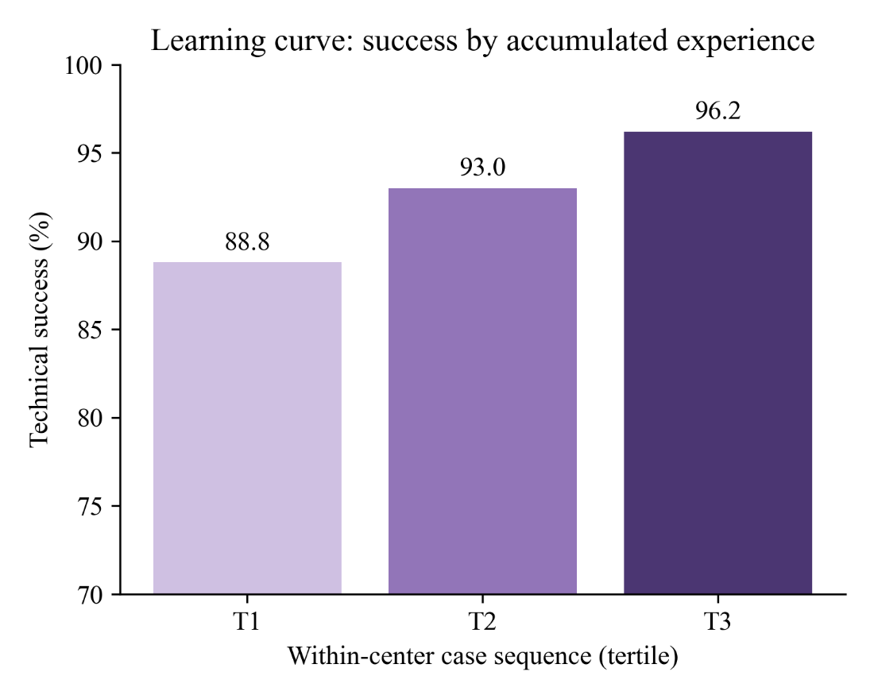

Supplementary Figure 4: Geographic distribution of GAE procedures by federal state
Circle area is proportional to the number of procedures. One 2025 procedure without a recorded federal state is not shown.
