SUPPLEMENTARY DATA FOR
Data-driven irrigation scheduling increases the crop water use efficiency of Cabernet Sauvignon grapevines

Rochelle Schlankª, Catherine M. Kidman^{b}, Deepak Gautam^{a,}, David W. Jefferyª and Vinay Pagayª*
ªThe University of Adelaide, School of Agriculture, Food and Wine, Waite Research Institute, PMB 1, Glen Osmond, SA 5064, Australia
^{b}Wynns Coonawarra Estate, Memorial Drive, Coonawarra, SA 5263, Australia

Table of Contents
Page
Table S1: Dates for phenological stages of growth for each experimental
season of the trial 2
Table S2: Calculated k_{c} values that were used to direct irrigation for the ET
treatment according to soil type 2
Table S3: Results for the three-way ANOVA applied as per Fig. 1 3
Fig. S1: Preliminary data used to define gs thresholds as per the PWS treatment 4
Fig. S2: Seasonal progression of leaf area index (LAI) and porosity
(t) across each experimental season and soil type 5

Table S1.
Dates for phenological stages of growth for each experimental season of the trial (S1, 2018/2019; S2, 2019/2020; S3, 2020/2021).
Phenological stage | E-L stage | S1 | S2 | S3
Budburst | 4 | 2nd Oct 2018 | 24th Sept 2019 | 21st Sept 2020
Flowering | 19 | 20th Nov 2018 | 18th Nov 2019 | 20th Nov 2020
Fruit set | 27 | 12th Dec 2018 | 17th Dec 2019 | 7th Dec 2020
Pea sized | 31 | 16th Jan 2019 | 13th Jan 2020 | 4th Jan 2021
Véraison | 35 | 12th Feb 2019 | 5th Feb 2020 | 9th Feb 2021
Pre-harvest | 37 | 7th Mar 2019 | 10th Mar 2020 | 18th Mar 2021
Harvest | 38 | 11th Apr 2019 | 8th Apr 2020 | 14th Apr 2021

Table S2.
Calculated k_{c} values that were used to direct irrigation for the ET treatment according to soil type in 2019/2020 (S2) and 2020/2021 (S3).
 | Terra Rossa (TR) |  | Rendzina (RN)
Phenological stage | S2 | S3 | S2 | S3
Flowering | 0.43 | 0.43 | 0.43 | 0.43
Fruit set | 0.50 | 0.65 | 0.46 | 0.61
Pea sized | 0.65 | 0.67 | 0.61 | 0.62
Véraison | 0.82 | 0.79 | 0.72 | 0.74
Pre-harvest | 0.82 | 0.78 | 0.72 | 0.74
Harvest | 0.82 | 0.74 | 0.72 | 0.68

Table S3.
Results for the three-way ANOVA applied as per Fig. 1. T = treatment, ST = soil type and P = phenological stage.
2018/2019 (S1)
Parameter | T | ST | P | T⨯ST | P⨯ST | P⨯T | T ⨯ ST ⨯P
Ψ_{PD} | * | * | *** | ns | ns | ** | ns
Ψ_{S} | ** | ns | *** | * | ns | *** | ns
g_{s} | ** | ns | *** | ns | ns | *** | ns
A_{n} | ** | * | *** | ns | ns | ** | ns
E | * | ns | *** | ns | ns | ** | ns
WUE_{i} | ns | *** | ns | ns | ns | ** | ns
2019/2020 (S2)
Parameter | T | ST | P | T⨯ST | P⨯ST | P⨯T | T ⨯ ST ⨯P
Ψ_{PD} | ns | *** | *** | ns | ** | ns | ns
Ψ_{S} | ns | ns | *** | ns | *** | ns | ns
g_{s} | * | *** | *** | * | ** | ns | ns
A_{n} | * | ns | *** | ns | ns | ns | *
E | ns | *** | *** | ns | * | ns | ns
WUE_{i} | ns | * | *** | ns | ns | ns | ns
2020/2021 (S3)
Parameter | T | ST | P | T⨯ST | P⨯ST | P⨯T | T ⨯ ST ⨯P
Ψ_{PD} | *** | ** | *** | ns | ns | * | ns
Ψ_{S} | ** | ns | *** | ns | ns | * | ns
g_{s} | *** | ns | *** | ns | ns | ns | ns
A_{n} | *** | ns | *** | ns | * | * | ns
E | ** | ns | * | ns | ns | ns | ns
WUE_{i} | ns | ns | *** | ns | ns | ns | ns

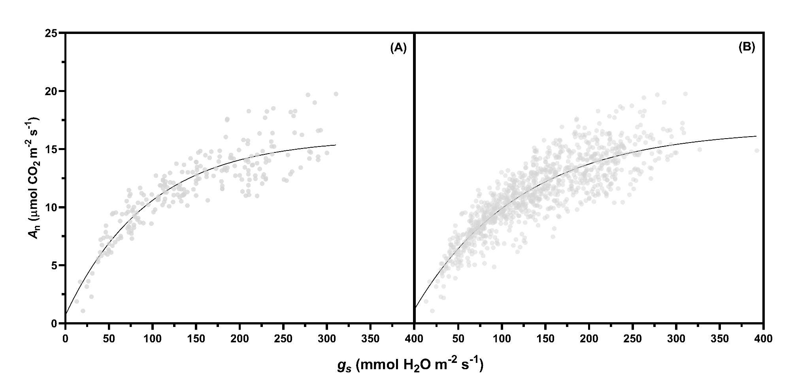
Fig. S1. Panel A represents the empirical relationship between A_{n} and g_{s} in 2017/2018. This initial relationship was established as a part of a preliminary study and was used to inform irrigation decisions for the PWS treatment across both TR and RN in 2018/2019. At solar noon (11:00 – 14:00 hr) across multiple points over the 2017/2018 season, 231 gas exchange measurements were carried out using a portable infrared gas analyser (LI-6400XT; LI-COR, Inc., Lincoln, Nebraska USA) across both soil types. The relationship is represented by the equation: A_{n} = (0.6847 – 15.94) ⨯ exp^{(-0.01046 ⨯ gs}) + 15.94, whereby 120 mol H₂O m⁻² s⁻¹ corresponds to approximately 75% of max A_{n} (r² = 0.80). Panel B represents the relationship between A_{n} and g_{s} over 4 growing seasons (2017/2018 – 2020/2021), including measurements from both TR and RN for a total of 973 data points. This relationship is represented by the equation: A_{n} = (1.234 – 16.73) ⨯ exp^{(-0.00817 ⨯ gs}) + 16.73, whereby 147 mol H₂O m⁻² s⁻¹ corresponds to approximately 75% of max A_{n} (r² = 0.75).

Fig. S2. Seasonal progression of leaf area index (LAI) and porosity (t) across each experimental season and soil type. Means ± SEM are depicted according to pre- and post-véraison phenological stages. Tukey’s HSD multiple comparison test (α = 0.05) was used to assess differences between multiple groups. Significant differences between treatments within the same vineyard and season are denoted by lowercase letters a and b, and significant differences between soil types (comparing the same treatment) are denoted by α and β. Significant differences between pre and post veraison values for the same treatment are denoted by a single asterisk (*) on top of the pre veraison bar point.

*Corresponding author. Email address: vinay.pagay@adelaide.edu.au Present address: Research Institute for the Environment and Livelihoods, Charles Darwin University, Casuarina, NT 0810, Australia

